Quarterly Report

Over the past quarter, Karachi United has implemented community-based initiatives focused on women’s health, wellbeing, gender empowerment, and holistic athlete development for both male and female athletes and coaches. Through sports-led programming, capacity building, and strategic collaborations, these initiatives address key issues related to physical and mental health, gender equality, and inclusive development, while fostering safe spaces for leadership, personal growth, and gender-responsive community engagement.

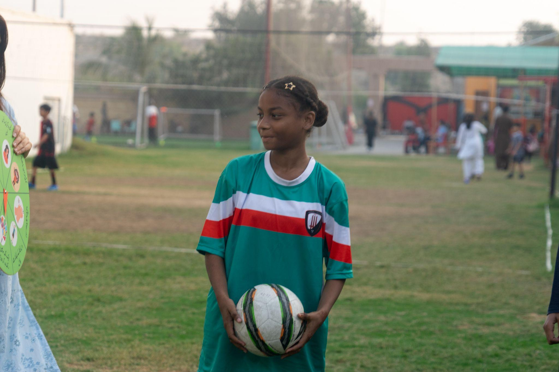

United for Women’s Health and Wellbeing
Karachi United has collaborated with Al-Basma Foundation, implementing United for Women’s Health and Wellbeing project with a strong focus on women’s sexual and reproductive health.With support from The Al Basma Foundation, Karachi United is empowering 100 adolescent girls from marginalised communities in Karachi, using football as a lever to promote health, wellbeing, and sexual and reproductive health and rights while building their confidence, leadership, and life skills. Through safe play spaces, mentorship, and holistic learning, young girls are gaining the knowledge, resilience, and voice they need to grow into strong, informed, and empowered leaders in their families and communities.
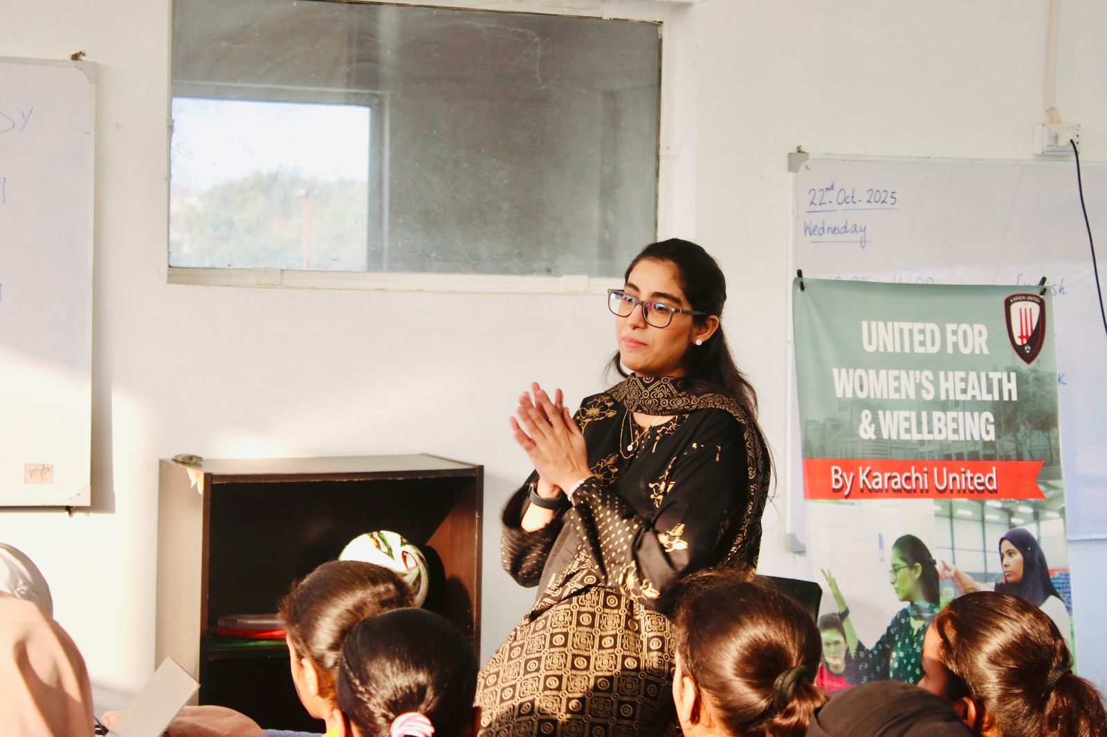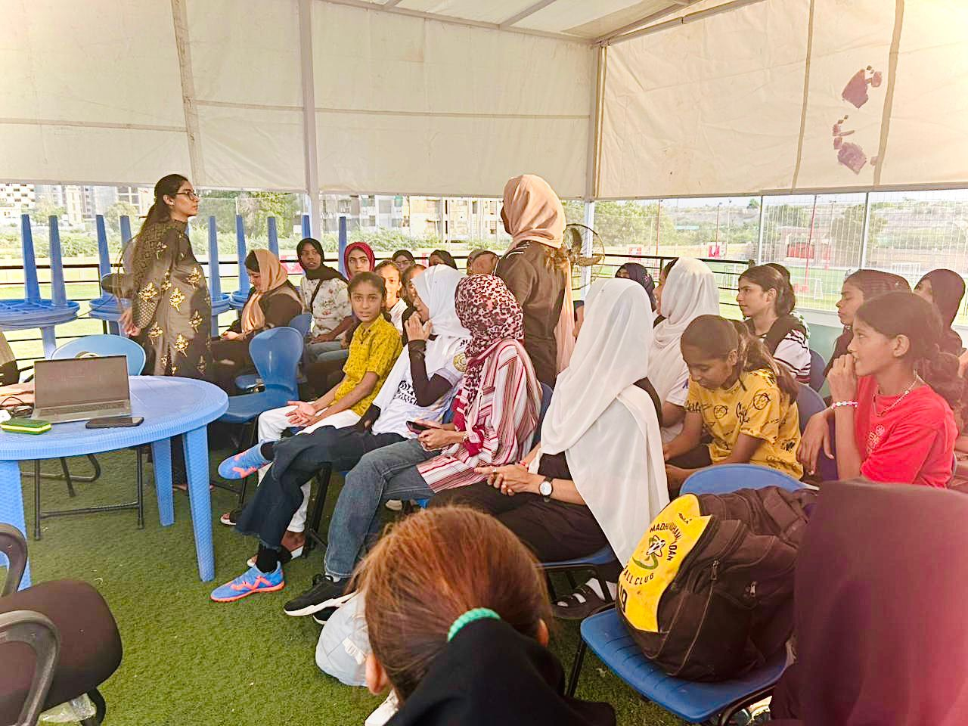
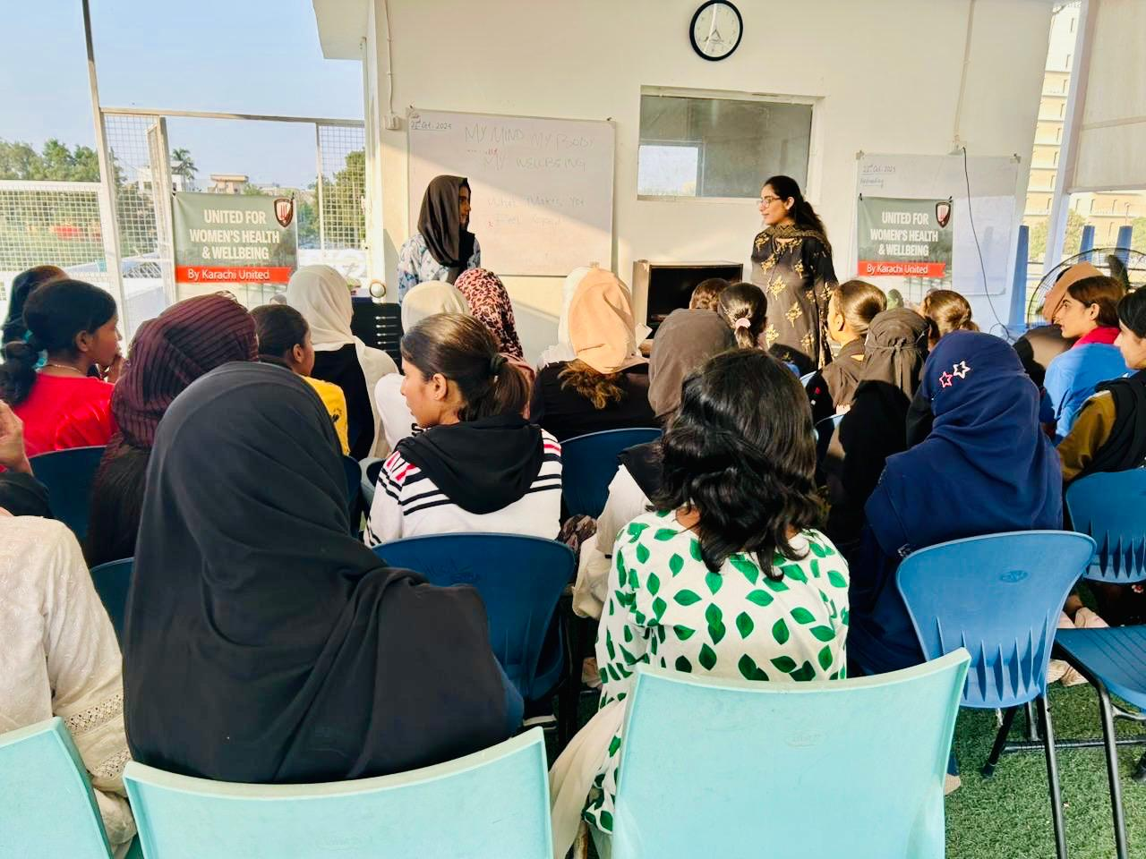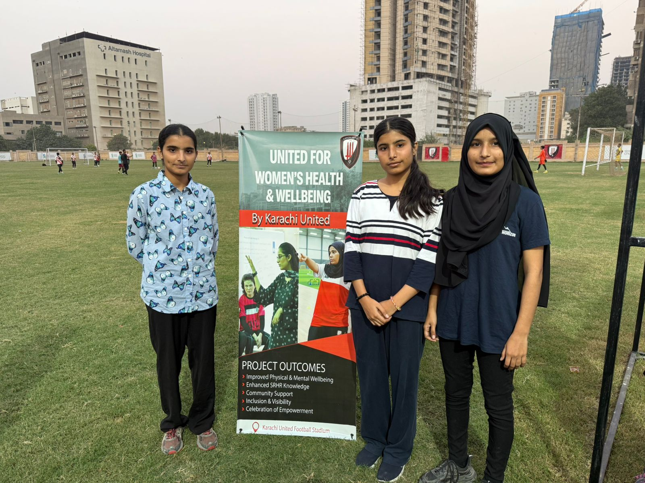
Mental Health Support for Women in Sport
Under the United for Women’s Health and Wellbeing project, Karachi United, in continued collaboration with Saviara, conducted mental health and holistic wellbeing sessions for female athletes. The sessions engaged women footballers in guided discussions and activities focused on stress recognition and management, gender-based challenges, and women’s empowerment. By integrating mental health support within a sports environment, the initiative contributes to improved emotional resilience, confidence, and overall athletic performance, while reinforcing safe and inclusive spaces for women in sport.

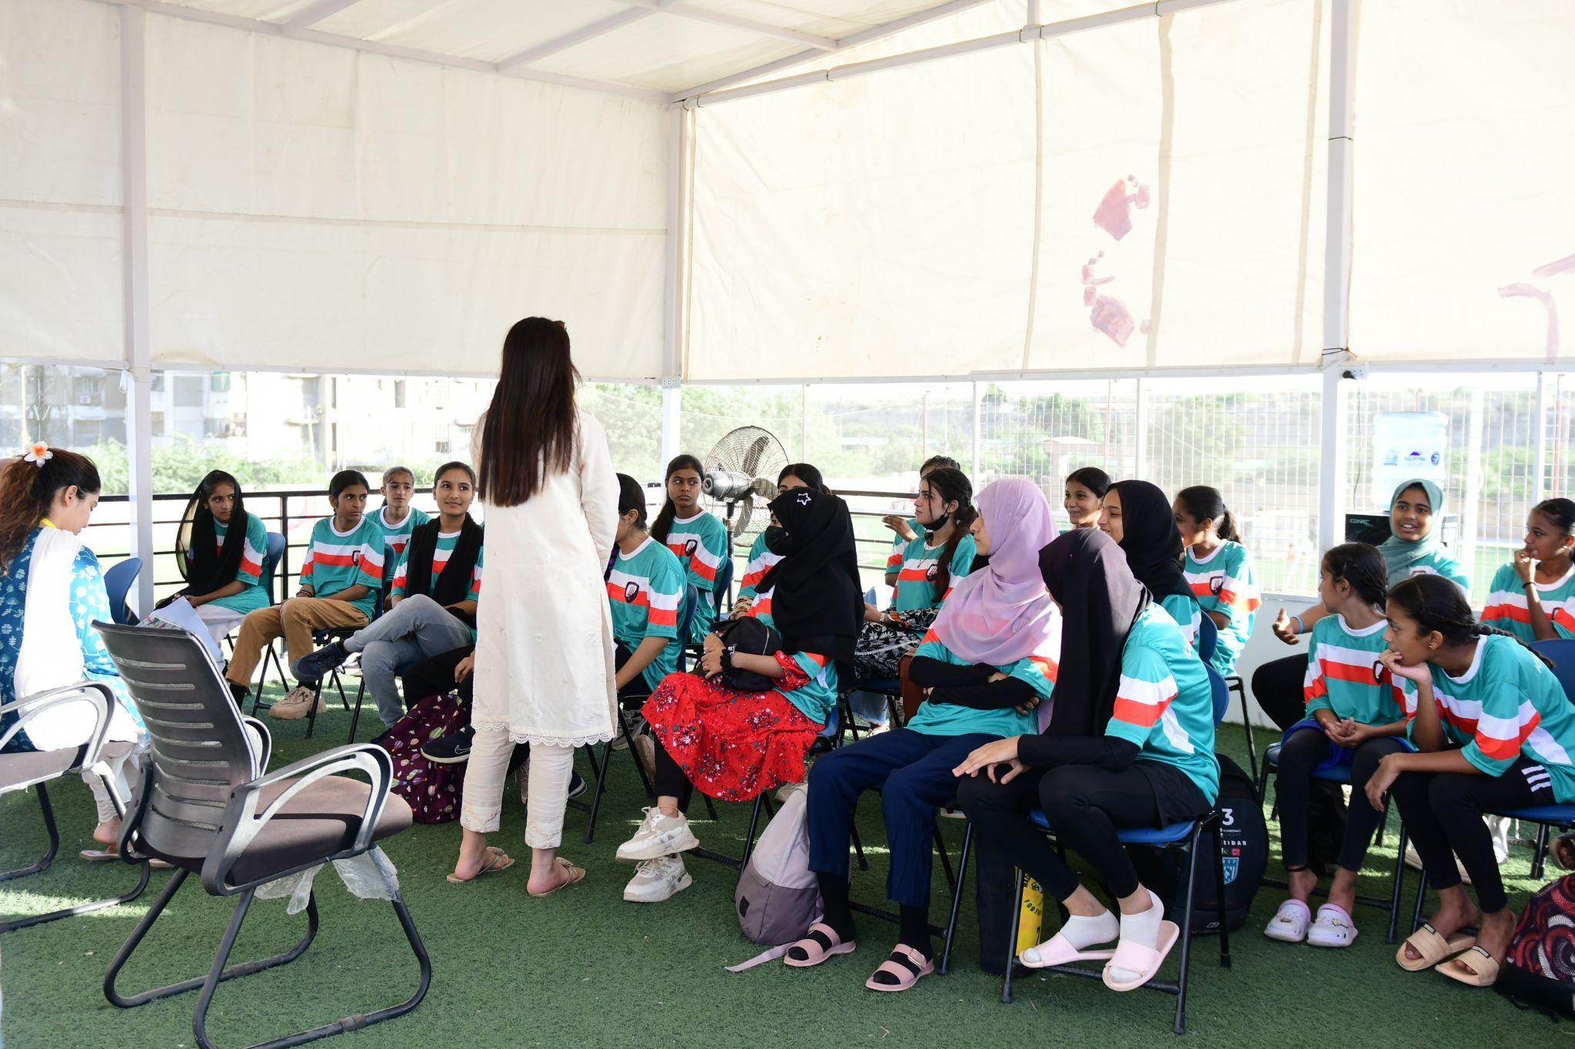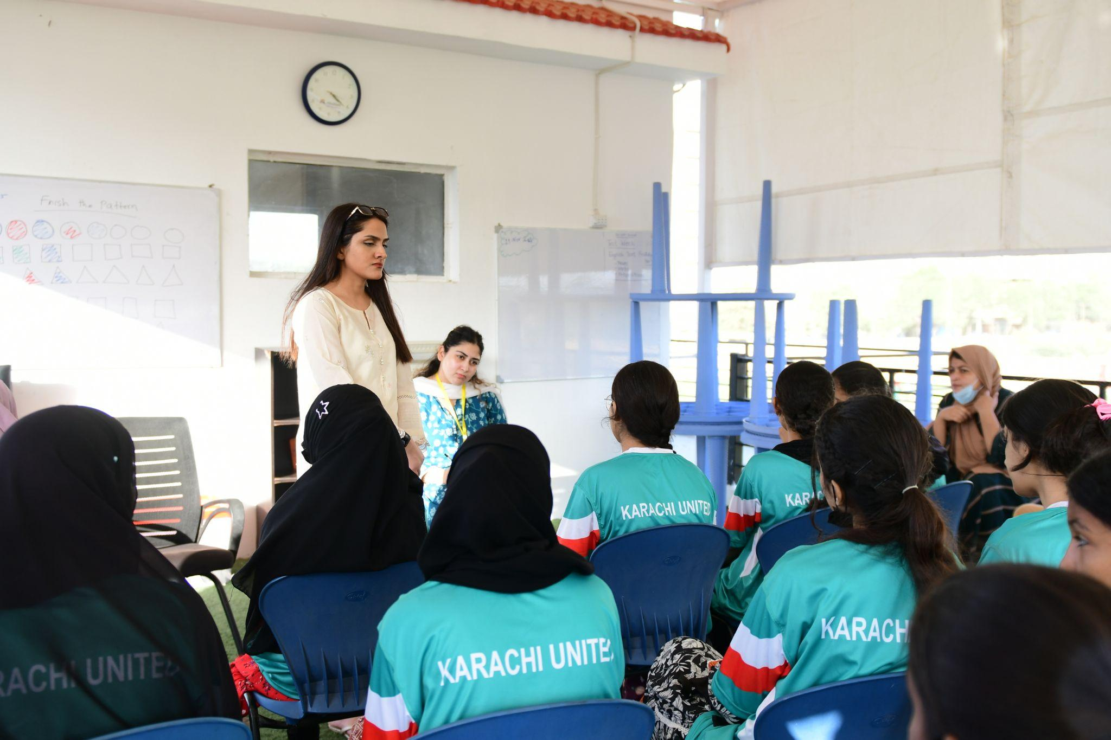

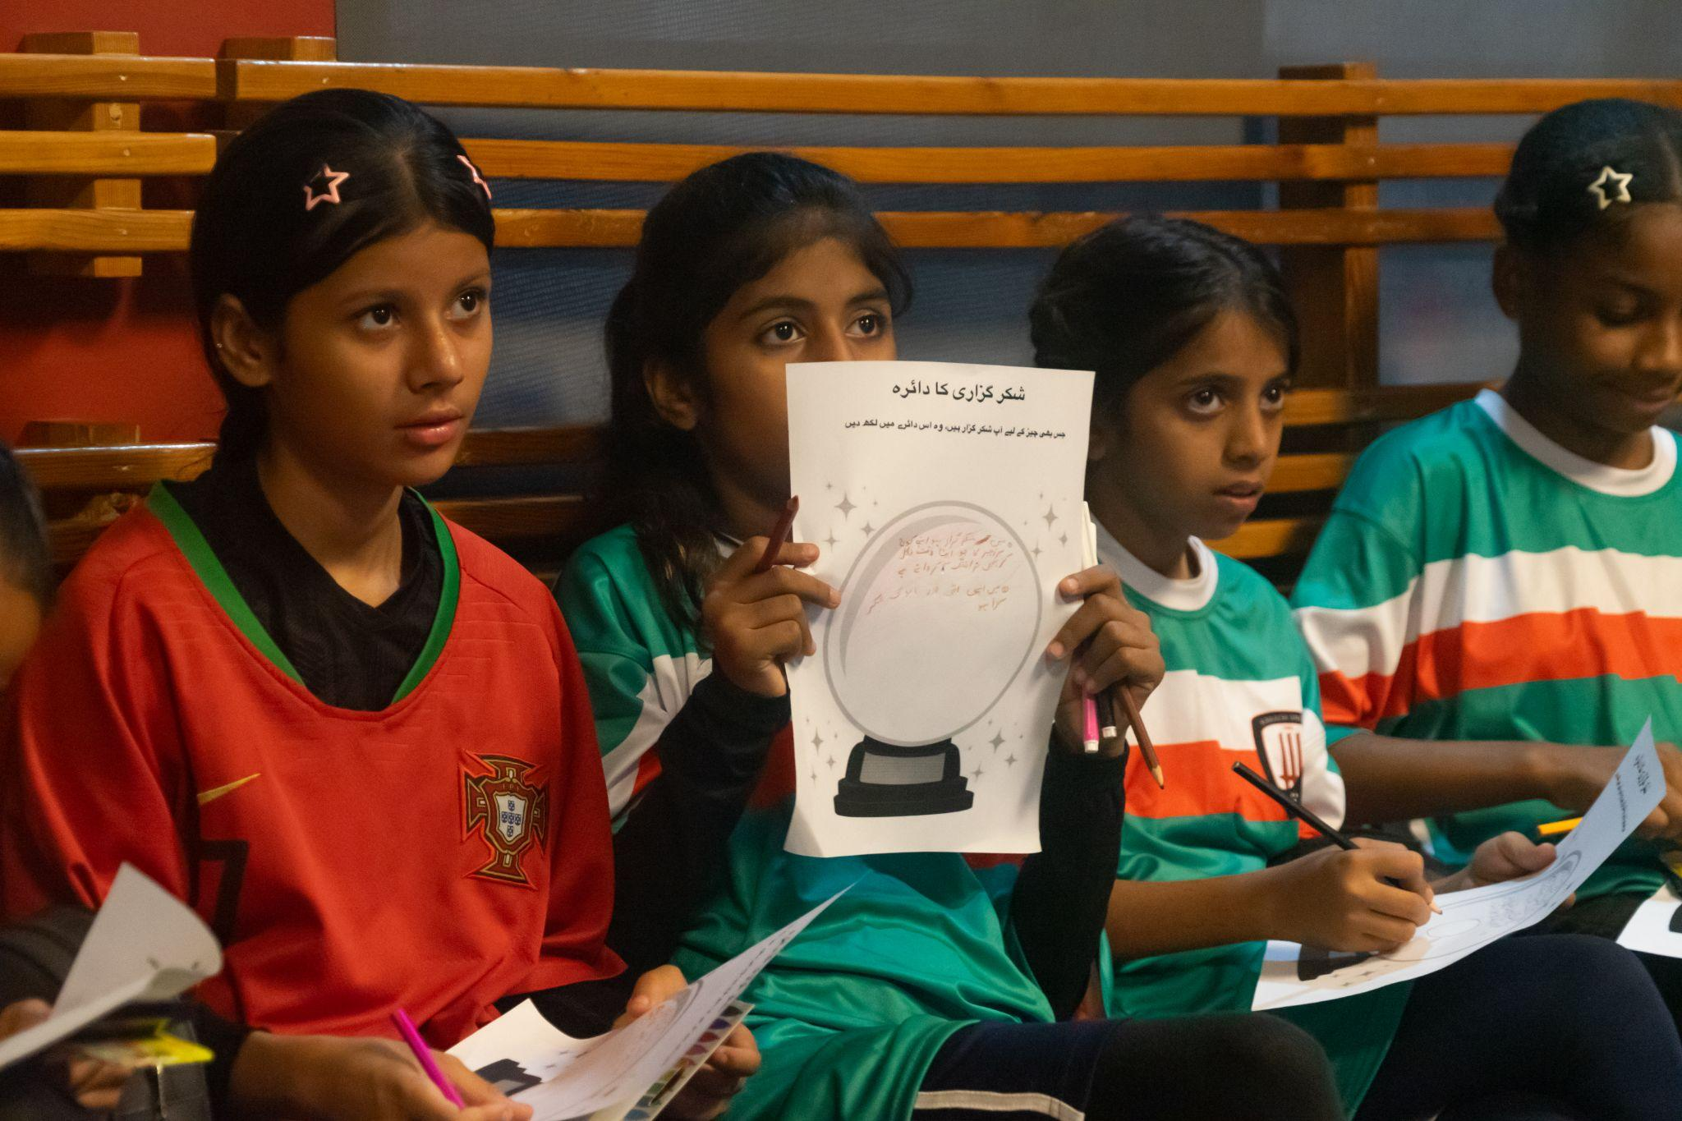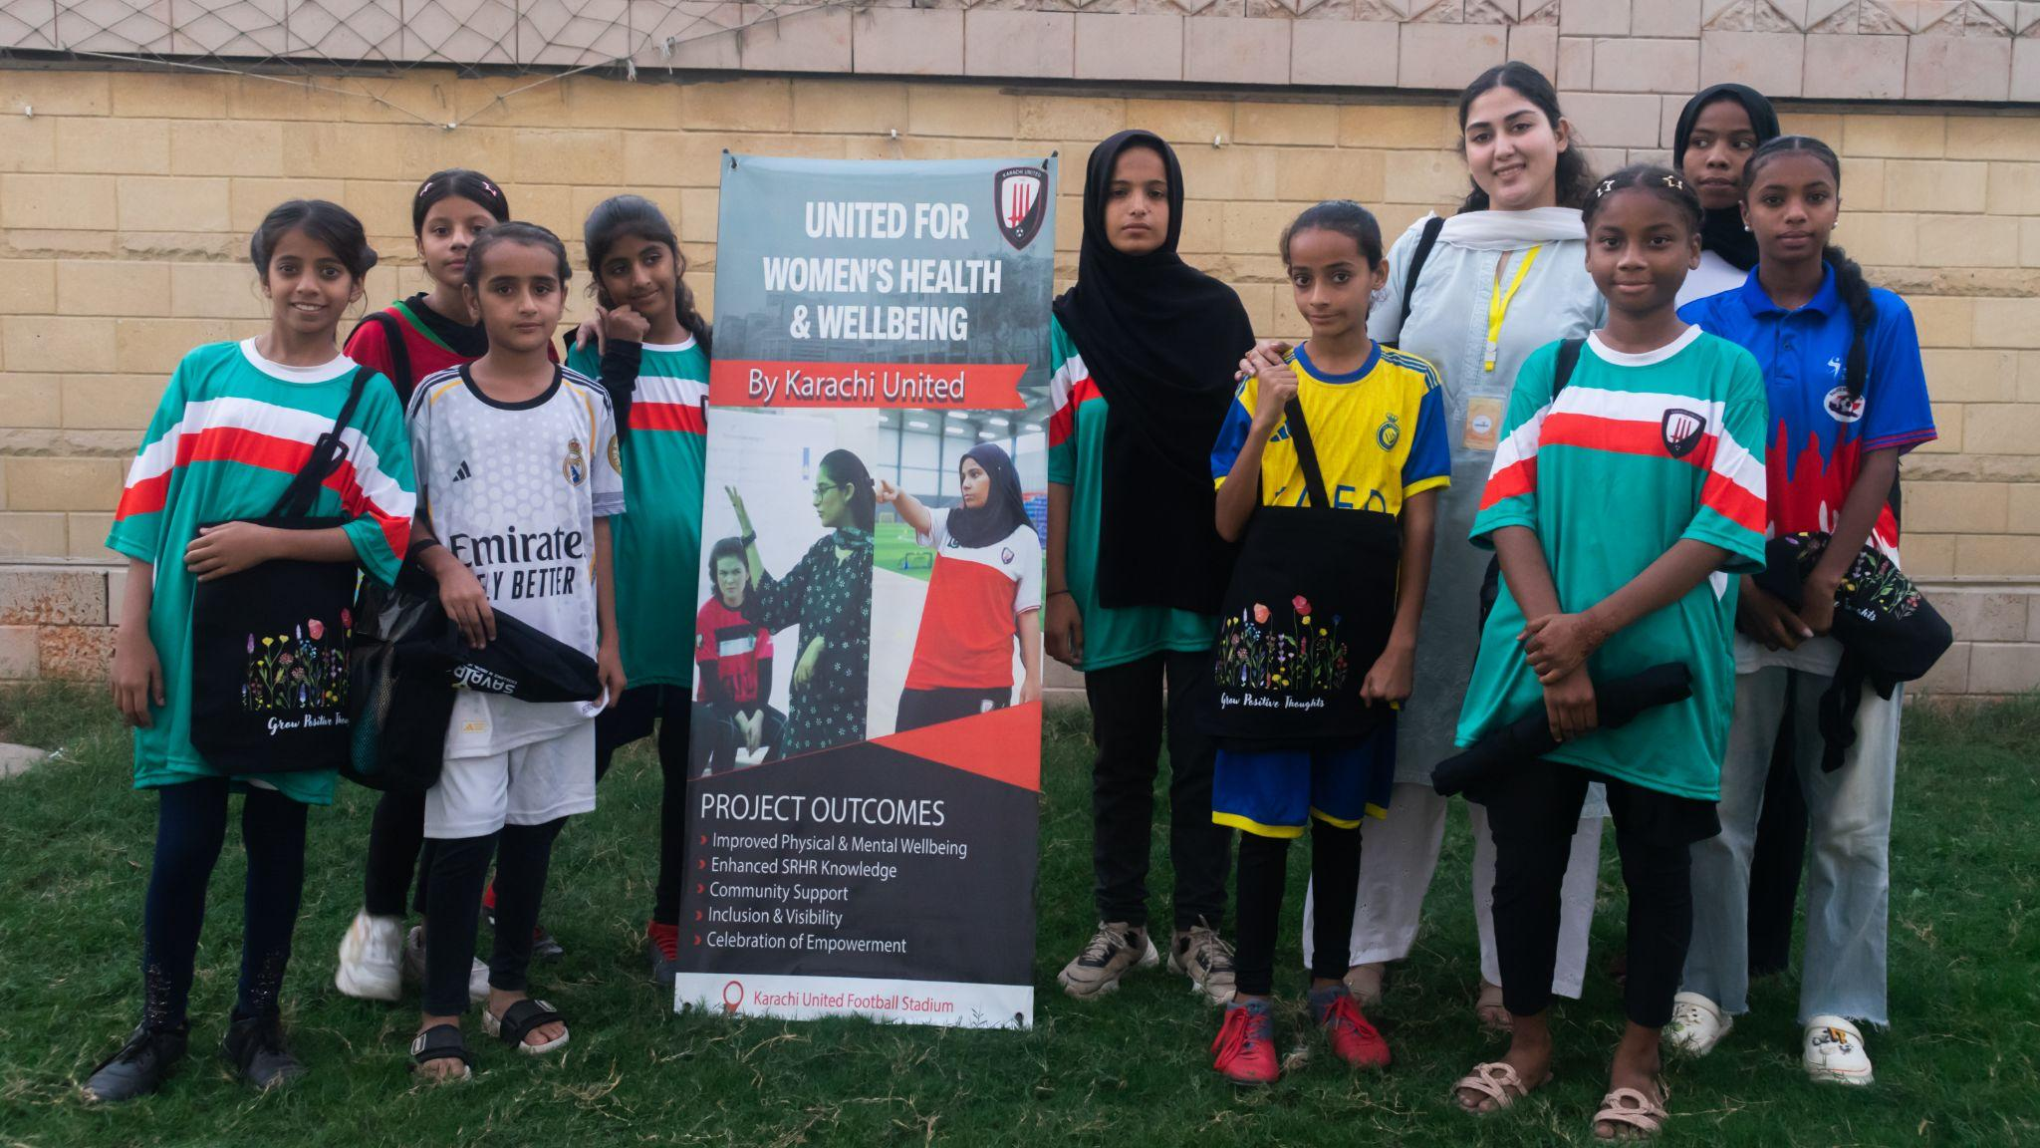

Women’s Football Training & Sports Engagement
Alongside the health component, Karachi United is providing weekly football coaching sessions for women, ensuring consistent sports engagement as part of a holistic development approach. The regular training creates safe and inclusive spaces for women to build physical fitness, teamwork, and leadership skills, while reinforcing confidence and sustained participation in sport. This integrated model strengthens both physical wellbeing and social empowerment, complementing the project’s broader gender-equality objectives.
