**Quarterly Report**

**SCB Youth League March**

The 7th edition of the Standard Chartered Karachi United Youth League concluded successfully in February 2025 after three months of competitive and spirited football. Building on the momentum from late 2024, the league brought together over 6,000 boys and girls from diverse backgrounds across Karachi. The final phase featured high-energy matches and saw remarkable performances, particularly in the girls' category, underscoring the growing interest and talent among young female players. The league provided a structured platform for football development and encouraged teamwork, discipline, and inclusion values, further reinforcing Karachi United’s commitment to community empowerment through sport.

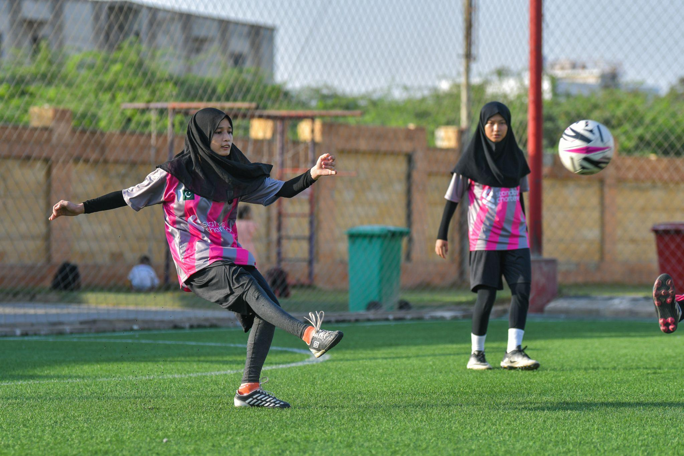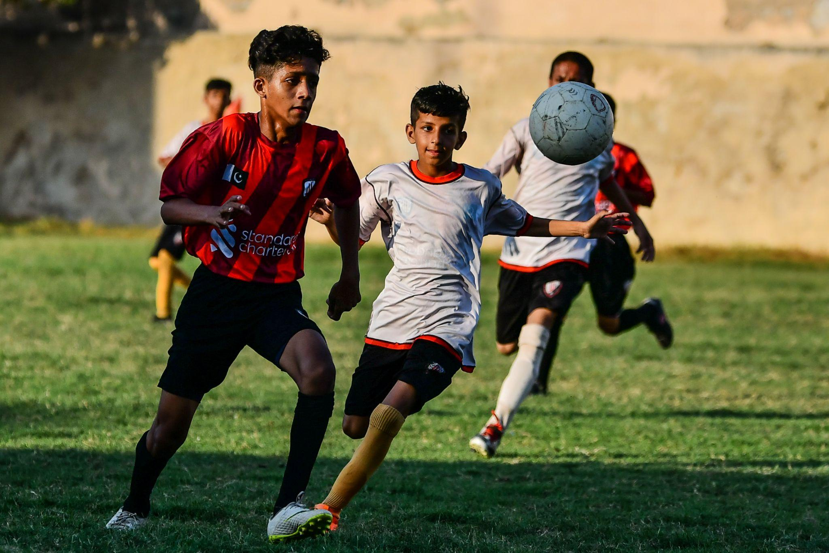

**Football Training and Life Skills session at Community centers**

Karachi United runs 12 community centers that provide young players with football coaching and life skills training. Situated in underserved neighborhoods with limited educational resources, these centers aim to level the playing field by offering equal opportunities for youth to pursue their passion for football. Life skills sessions are held three times a week at each center, helping players build confidence and prepare for local and international competitions.

These sessions focus on developing critical values such as leadership, teamwork, communication, problem-solving, and decision-making, equipping participants to grow as athletes and empowered individuals.

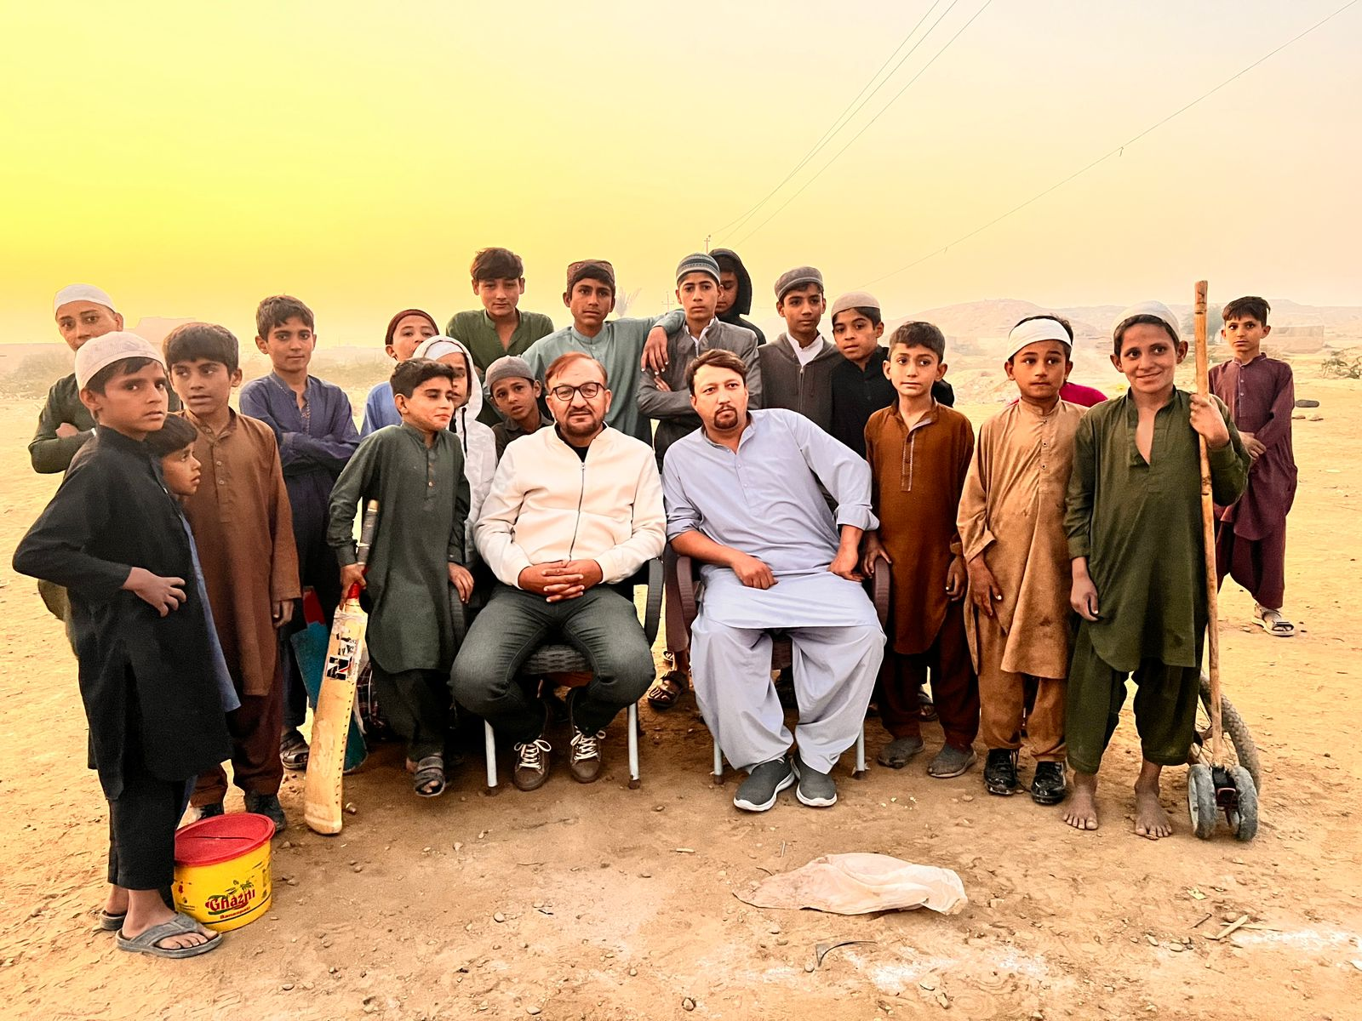

**Promoting Social Cohesion between Afghan Refugees and Host Communities**

**Afghan Refugee Youth Football Program**

In January 2025, Karachi United launched weekly football training sessions for 19 Afghan refugee girls, with sessions held at the KU Football Ground in Clifton. Training centers were selected in high-refugee areas such as Sohrab Goth, Ayesha Manzil, and Hussain Hazara Goth to reach girls with limited access to sports. Simultaneously, weekly football sessions began for refugee boys in Sohrab Goth and Gadap Town (Afghan Basti, UC-5), conducted within their communities.

These sessions offer structured football coaching and mentorship, fostering technical skill development, teamwork, confidence, and emotional well-being in a safe environment. The initiative provides marginalized youth with opportunities to engage, learn, and grow through sport.

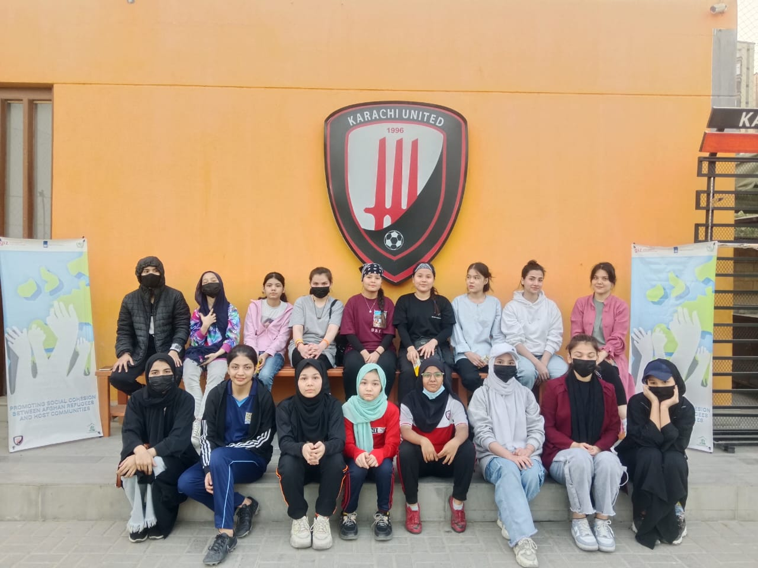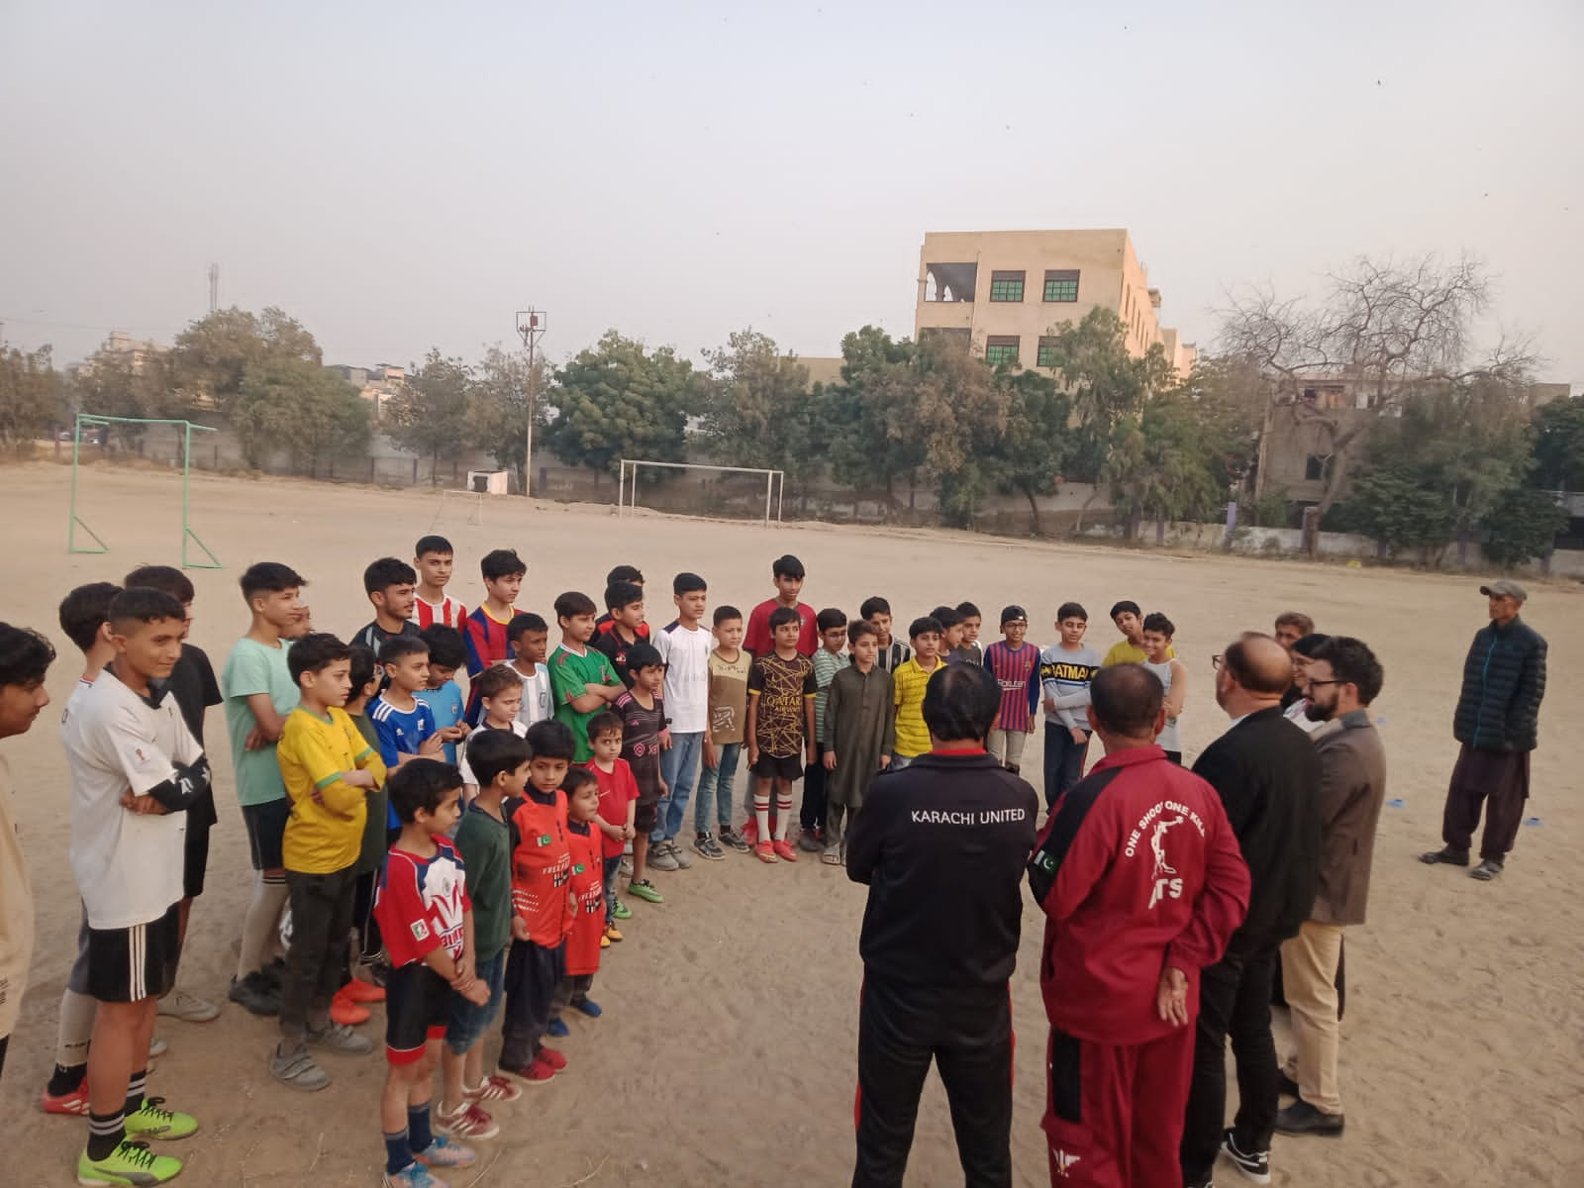

**Training of Trainers (ToT) Program**Held on 6th, 7th, and 11th January 2025, the ToT program equipped 12 community coaches with advanced coaching skills. Led by KU UEFA-B licensed coach Sheikh Hamdan and coach Daniyal Naeem, the training focused on tactical planning, player development, and sports event management. It also emphasized using sport for social cohesion and inclusion, preparing coaches to build stronger, more inclusive communities through football.

