Quarterly Report

SCB Youth League

Karachi United successfully concluded the 6th edition of Standard Chartered Karachi United Youth League. The closing ceremony was held at KU stadium and brought together players, coaches, families, and supporters to reflect on the accomplishments of the current edition and honor the dedication and sportsmanship displayed by all participants. The event featured a variety of activities, such as mentorship sessions, finals, and awards presentations.

Throughout the 6th edition of the standard chartered Karachi United Football League, hundreds of young footballers from various communities in Karachi competed in competitive matches, showing their skills and passion for the game. The league provides a platform for players from different walks of life to develop their talent, build friendships, and learn important life lessons through sports. As the 6th edition of SCB Youth League closes, Karachi United looks forward to building on this season's success and continuing to positively impact young people's lives through football.

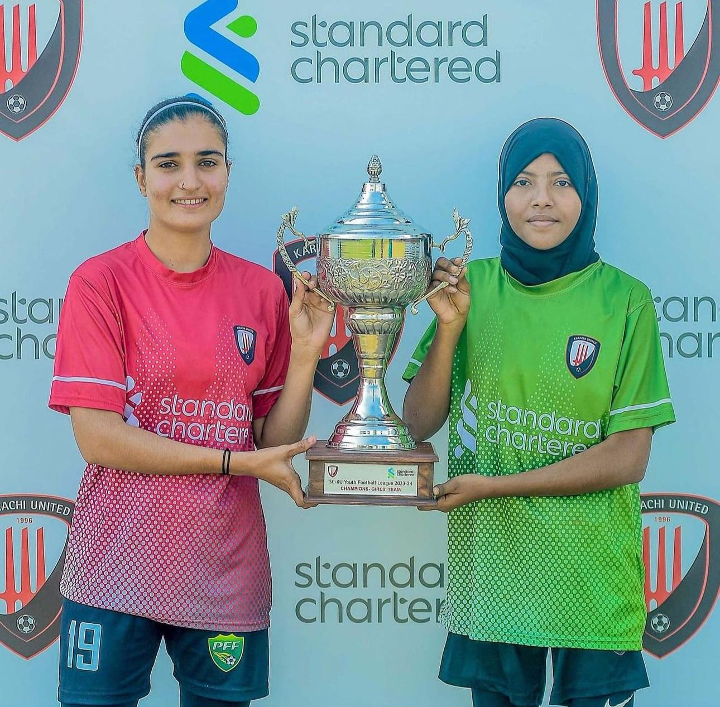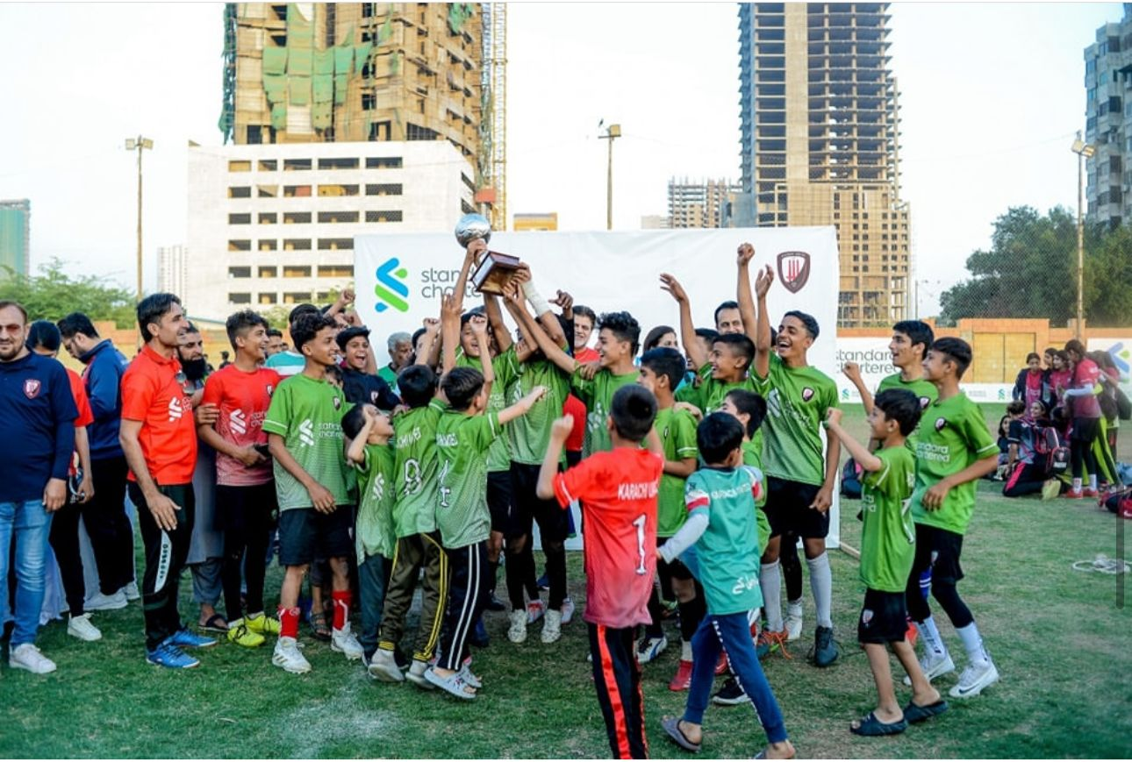

Karachi United Inaugrates 13th Community Center at Ibrahim Hydri

Karachi United inaugurated its 13th community center in Karachi, located at Ibrahim Hydri, in April 2024. Already, 60 players have enrolled, benefiting from complimentary football and life skills sessions. This achievement marks a significant milestone following the successful launch of the 12th center in 2023. The expansion to a 13th center significantly enhances access to football platforms, allowing a greater number of individuals to engage with the sport. This initiative is particularly important in areas where opportunities for structured sports participation are limited. By providing these facilities, Karachi United aims to make football and quality education accessible to to as many people as possible and work on creating happy, healthy and empowered communities.

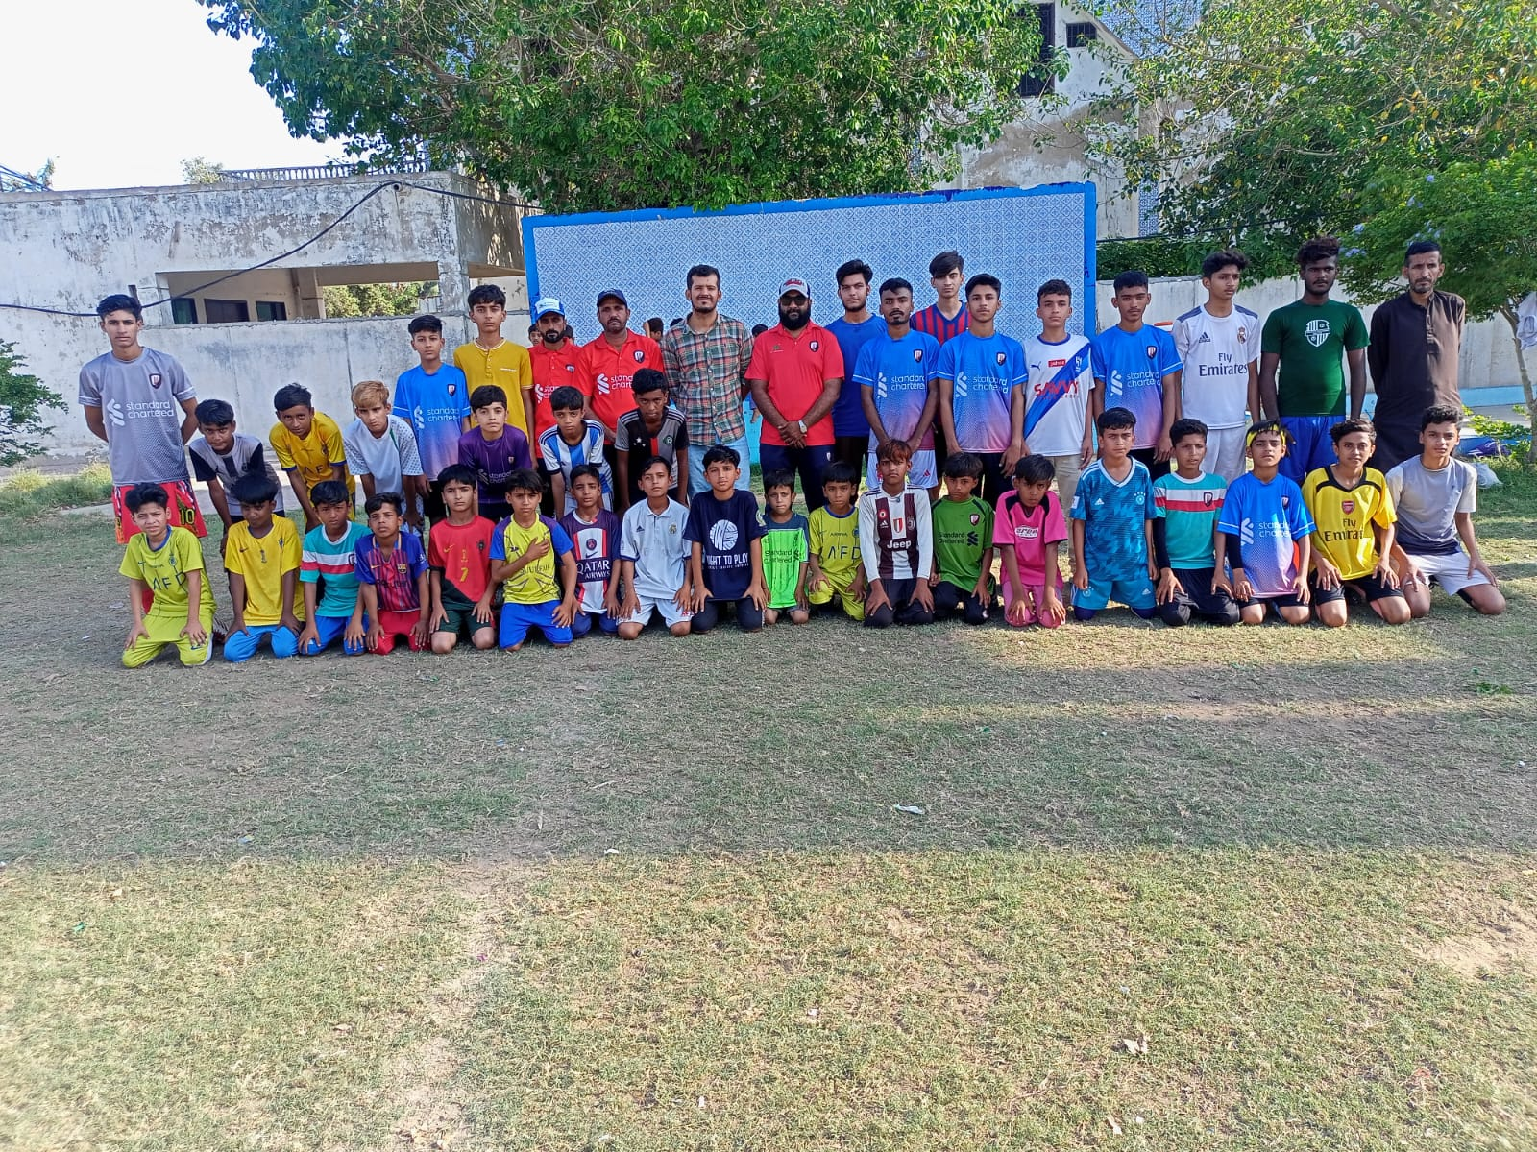

Football Training and Life Skills session at Orangi Town

Karachi United offers football and life skills training at its 12 community centers. These life skills sessions are conducted thrice a week in each community center. The centers are located in less privileged areas where the socio-economic background of players is low, and quality education is not up to the mark. These life skills sessions aim to enhance the players' confidence and skills for local and international tournaments, providing them equal opportunities to excel in the sport they love. Additionally, these sessions instill crucial values in players, such as leadership, teamwork, communication, problem-solving, and decision-making processes, which would help them become better individuals and professionals in the future. One of the main centers that was established recently is organi town community center, where football training and life skills session are currently going in full zeal and the participation ratio has increased by more than 60 percent.

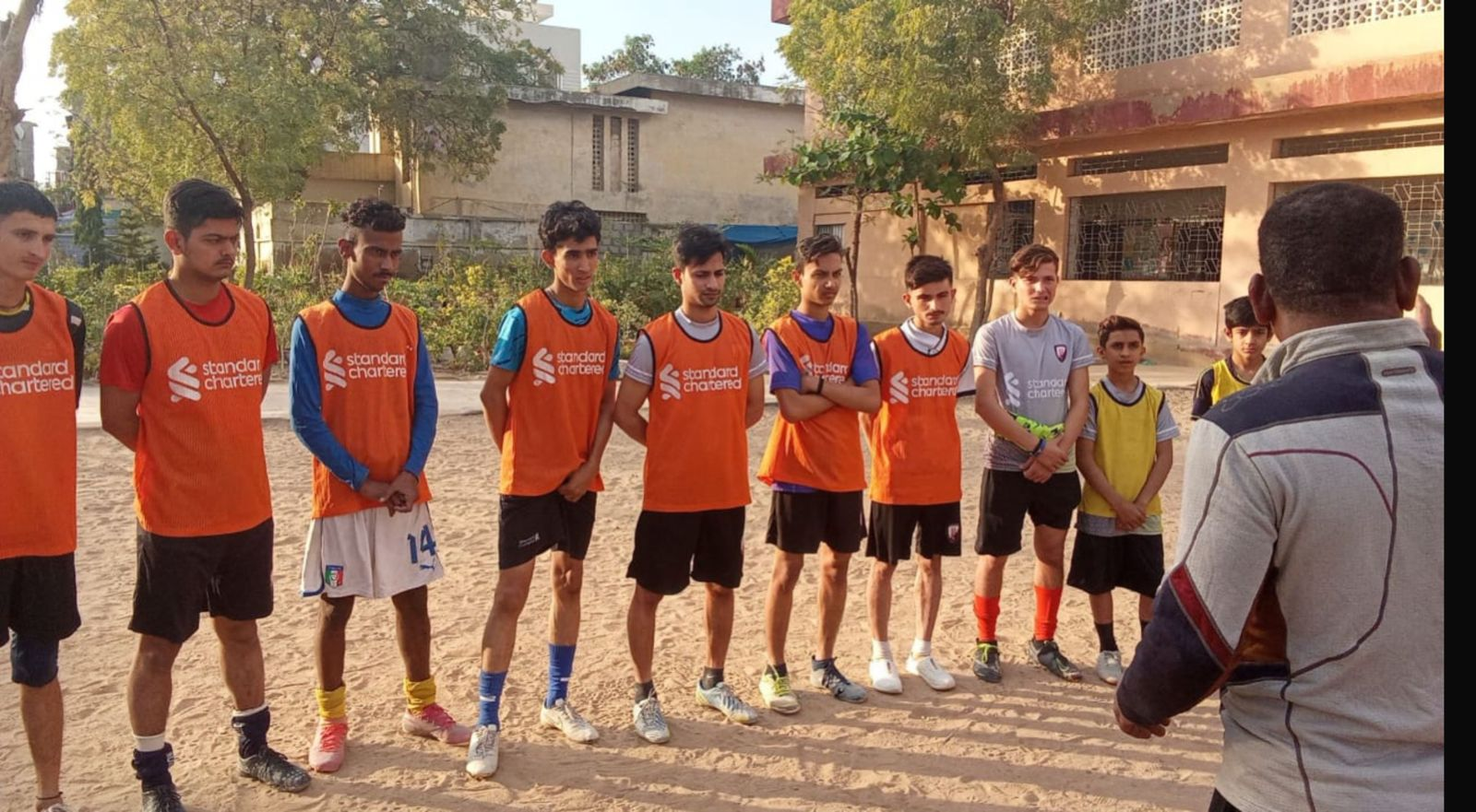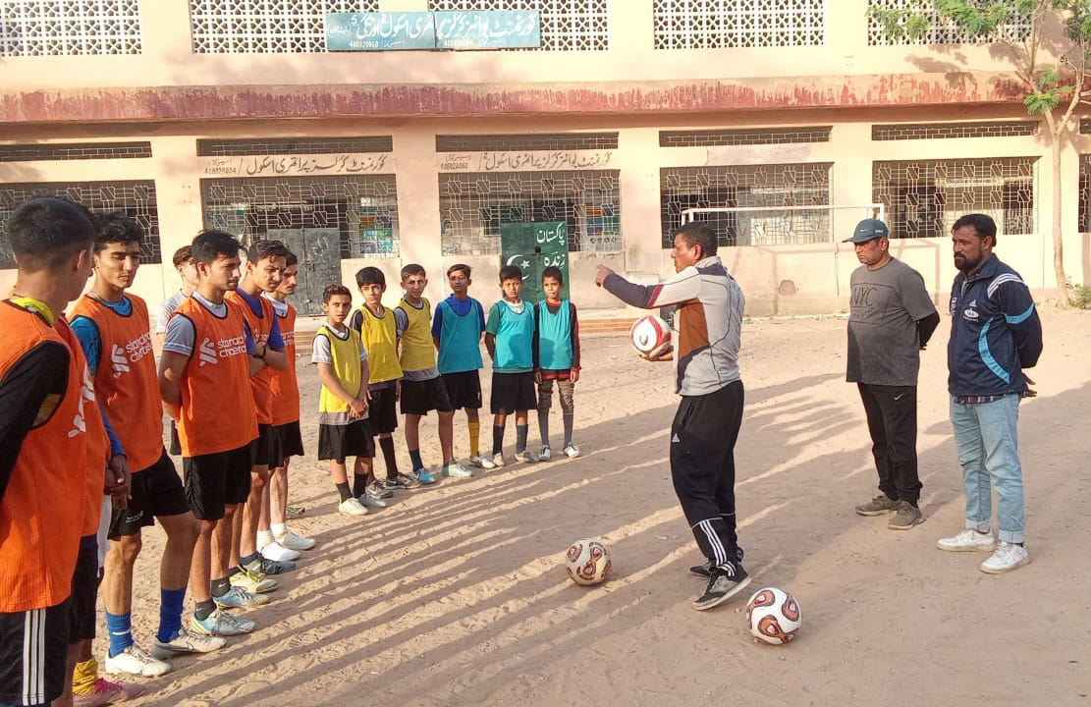

Turkish media team visited Karachi United Lyari community center

Karachi United recently hosted a special visit at its Lyari community center, welcoming a Turkish media team for an insightful discussion on the state of football in Lyari. Once a region plagued by extremism and political violence in Karachi, Lyari has now emerged as a beacon of hope for the sport. During the visit, there was a detailed conversation with Coach Wasim Sarbazi regarding the future of football in the area. The focus was on making football more sustainable and implementing initiatives to provide marginalized communities with greater access to football platforms. This collaborative effort underscores Karachi United's commitment to nurturing talent and fostering positive change in the community through sports.

