Quarterly Report

SCB Youth League

Karachi United participated in the Standard Chartered Youth League, a collaboration between Standard Chartered Pakistan and Karachi United. The league allows young Karachi United players to engage in friendly football competitions, promote player development, and bridge the gender gap through football. The league is open to youth of all brackets and aims to increase participation in football, encourage female participation, and promote player development. In the girls' category, the Karachi United Women's team performed exceptionally well, winning all three matches in the Standard Chartered Youth League.

Participating in such leagues has had an important impact on Karachi United players.
It allows them to learn new skills and techniques, play against different teams, and make new friends. It also helps them gain confidence, develop leadership skills, and improve physical fitness.

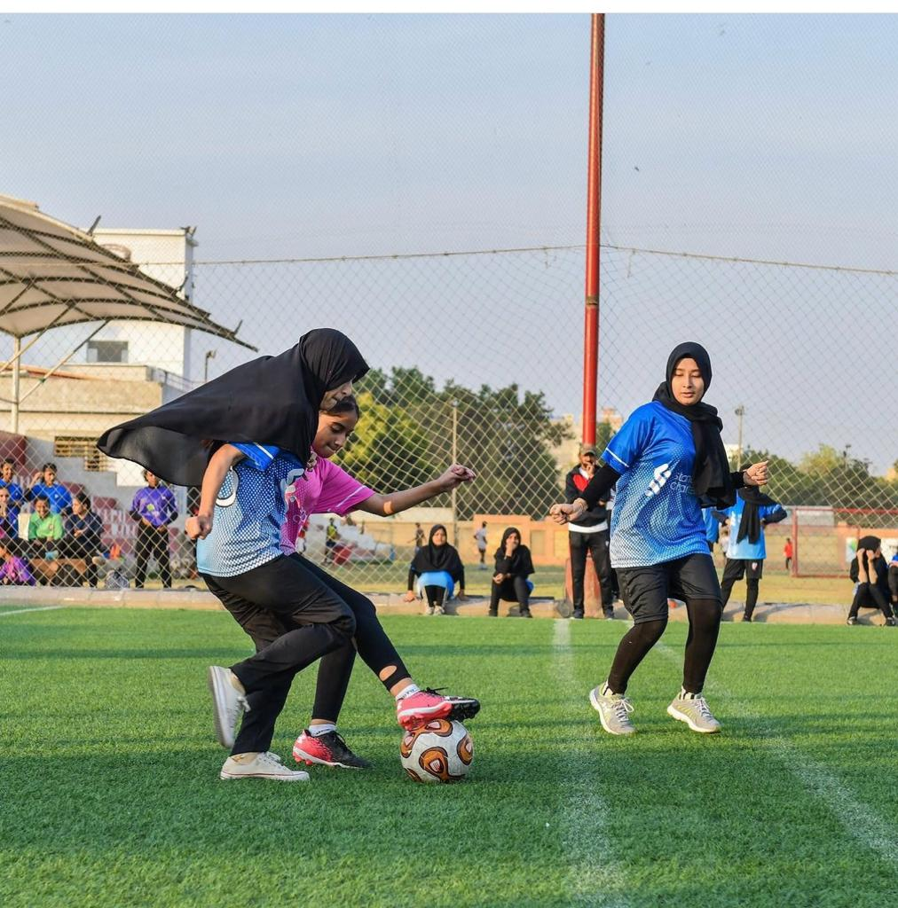

Monthly Visits and Data Collection at Community Centers of Excellence
The Karachi United operational team conducted monthly visits to community centers of Excellence. The primary aim of these regular visits is to observe the performance of young players closely, interact with coaches to gather valuable feedback, assess overall performance levels, and gather crucial data for future enhancements and innovative initiatives.
This initiative allows Karachi United to understand the challenges players face to improve its initiatives and development programs at the grassroots level. Most of the players enrolled in these community centers of excellence belong to low socio-economic status, with an affordability of less than three meals a day. Engaging in rigorous football training and life skills coaching is pivotal for their personal development, skill enhancement, and future prospects. Furthermore, it enables these young talents to impact their communities substantially.

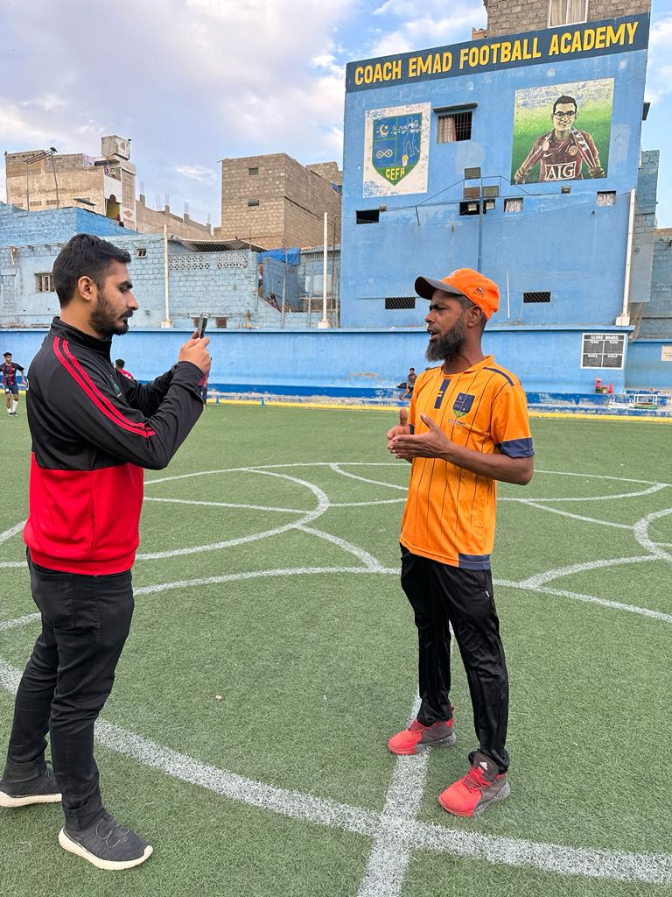

Life Skills Training Sessions

Karachi United offers football and life skills training at its 12 community centers. These life skills sessions are conducted thrice a week in each community center. The centers are located in less privileged areas where the socio-economic background of players is low, and quality education is not up to the mark. These life skills sessions aim to enhance the players' confidence and skills for local and international tournaments, providing them equal opportunities to excel in the sport they love. Additionally, these sessions instill crucial values in players, such as leadership, teamwork, communication, problem-solving, and decision-making processes, which would help them become better individuals and professionals in the future.
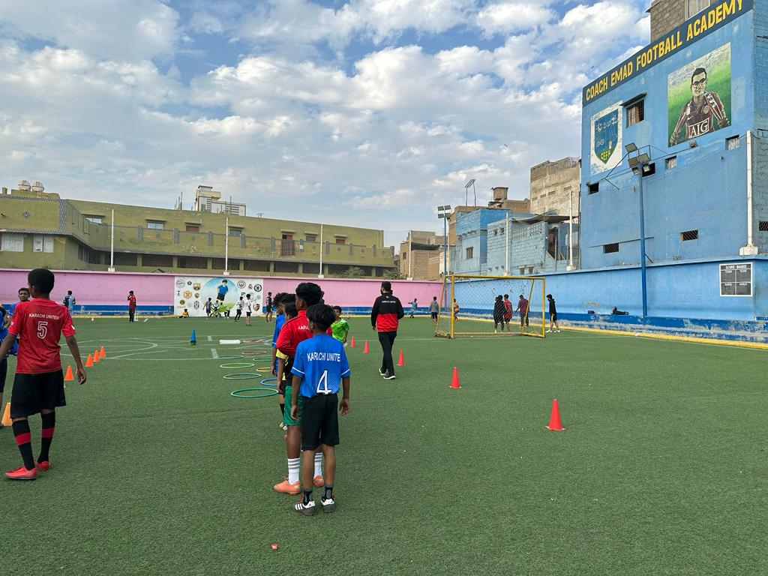

Football Sessions at Community Centers

Karachi United provides free football training to young aspiring players in 12 community centers in low socio-economic areas. These training sessions are held thrice a week in each community center, where youngsters aged 4-20 are coached in football tactics and skills. Most players who participate in these training sessions have a low standard of living, so getting football mentorship and training plays a pivotal role in their lives.

In addition to football training, KU provides these youngsters equal opportunities to participate in football tournaments and friendly competitions, such as open youth tournaments and youth leagues. These events promote teamwork, leadership qualities, and diversity among these players since the quality of education in public schools is not good, and they fail to equip players with these qualities.

In October 2022, some of the players representing Karachi for the Qatar tour were also selected from these academies, owing to the latent hard work and skills of these young players.

