**Quarterly Report: August to October 2019**

**Uplift the Community through Football**

**Life Skill Sessions:**

Karachi United conducted a total of 16 life skill sessions conducted in each community centre during this period. Trainer discussed the inspiring stories of the Neymar, Messi and Angel Di Maria during the sessions and motivated the players to chase their dream. Trainer shared the number of hardships these footballers have faced to emerge as football superstars. Trainer discussed the family background of the players as they faced sheer poverty but they never gave up on their dreams. These life skill sessions filled the hope in the kids and encouraged them to deal the hardships of life optimistically.

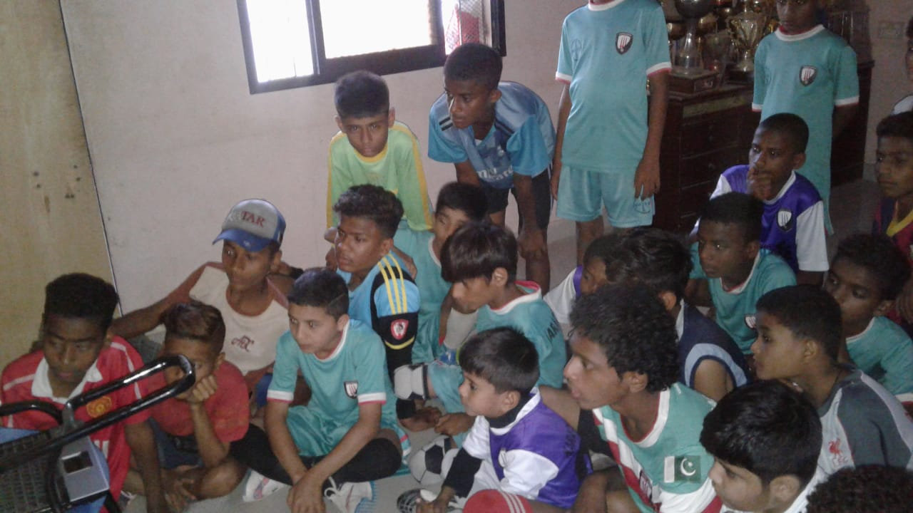Trainer also explained that every sport requires self-confidence and team work. He gave the example of Croatia who qualified for the final in FIFA World Cup 2018. He explained that even though Croatia is a small country and did not have renowned players like other teams but the team work, passion, and confidence made them stand out. Croatia beat the powerful teams like Germany, Brazil and Portugal and qualified for the final. It shows that dedication and passion can make you stand out no matter where you come from. The speaker further added that Pakistan needs to work hard to compete at the international level and you all have to make efforts to make your country proud.

Figure 1 Players are watching inspiring success story of Messi during life skill session

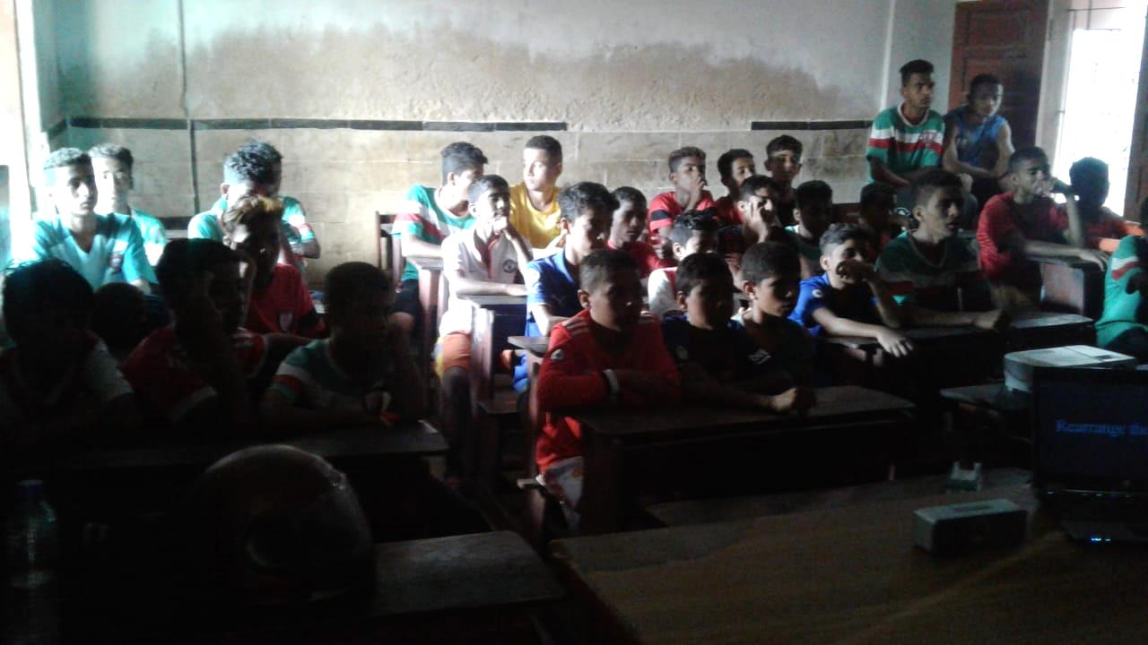

Figure 2 Players are attending life skill session

**Parental Engagement Session:**

The 4th parental engagement session took place on 19th August, 2019 at Karachi United Football Stadium. A total of 30 parents were present during the session. Ms. Zahera Tariq, Principal of City School, was invited as a guest speaker who discussed the role of parents in child growth and development. She started the session with her introduction and then she asked the parents about the age group of their children. She explained the child psychology according to age group of their child. She explained that when a child is between 1-7 years he/she totally depends on their parents. You have to take care of their needs and you have to listen to your child patiently. She further added that when a child is between 8-14 years this is the phase when parents should more focus on their mannerism. They should teach them to respect every individual regardless of their ethnicity, social class, language, and culture. She emphasized the parents to encourage their kids to help others voluntarily and make them capable enough to differentiate between right and wrong. This is the age when parents should teach their kids values and make them realize their responsibilities. She further added that parents should engage their kids in constructive activities and also inculcate the value of time in them.

The speaker explained that responsibility of the parents gets double when a child reaches the age between 15-21 years because at this age, children are looking for identities and they can get influenced easily by peers so parents should keep sharp eyes on their activities. Parents should develop cardinal relation with their children and involve them in decision making. Parents should provide their children a peaceful and friendly environment so children can share their problems with their parents without any fear.

Mr. Talib Hussain, Program Manager, gave closing note in which he thanked Ms. Zehra for giving her precious time. Mr. Talib requested the parents to encourage their kids to take part in healthy activities. He further added that Karachi United cannot bring positive change without their support so we should make collective effort to make the society healthy and prosperous. At the end, feedback was taken and lunch was served to parents.

**Beneficiaries Quotes:**

*“It was a useful session I learnt child psychology and speaker explained the how role of the parents should change as child grows up” ~Ilyas from Khadda Memon~*

*“Karachi United has engaged my kid in positive activities and I realized I should also encourage the kid to show up for football training regularly”. ~Nabeel from Chakiwara~*

*“The speaker shared some useful tips which is going to be helpful in parenting process. ~Shakeel from Baldia Town~*

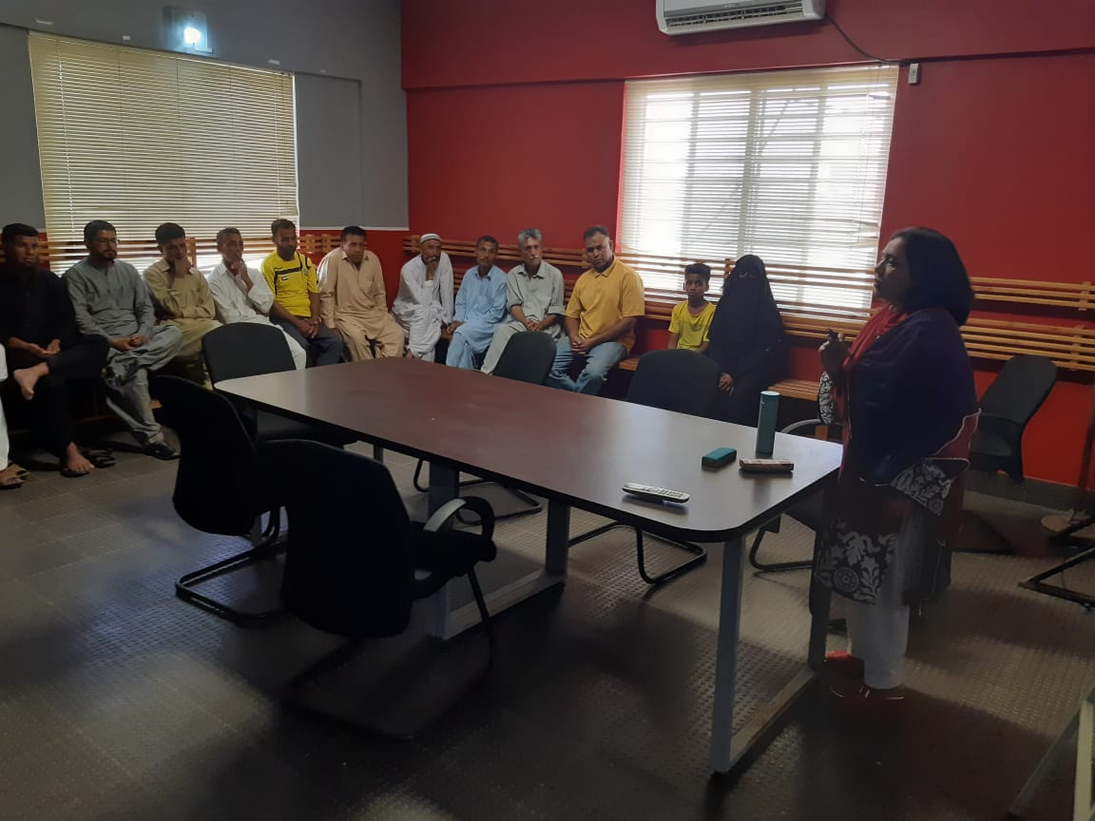

Figure 1 Zhera Tariq, guest speaker, is addressing to parenting during session on 4th May at Karachi United Stadium

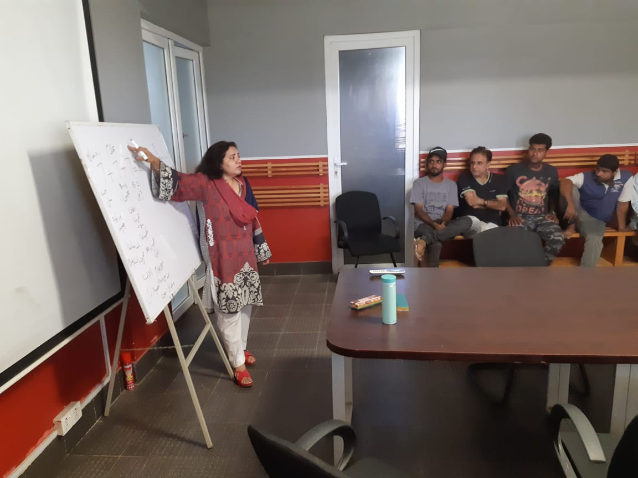

*Figure 2 Ms. Zahera is explaining parenting tips during the session*

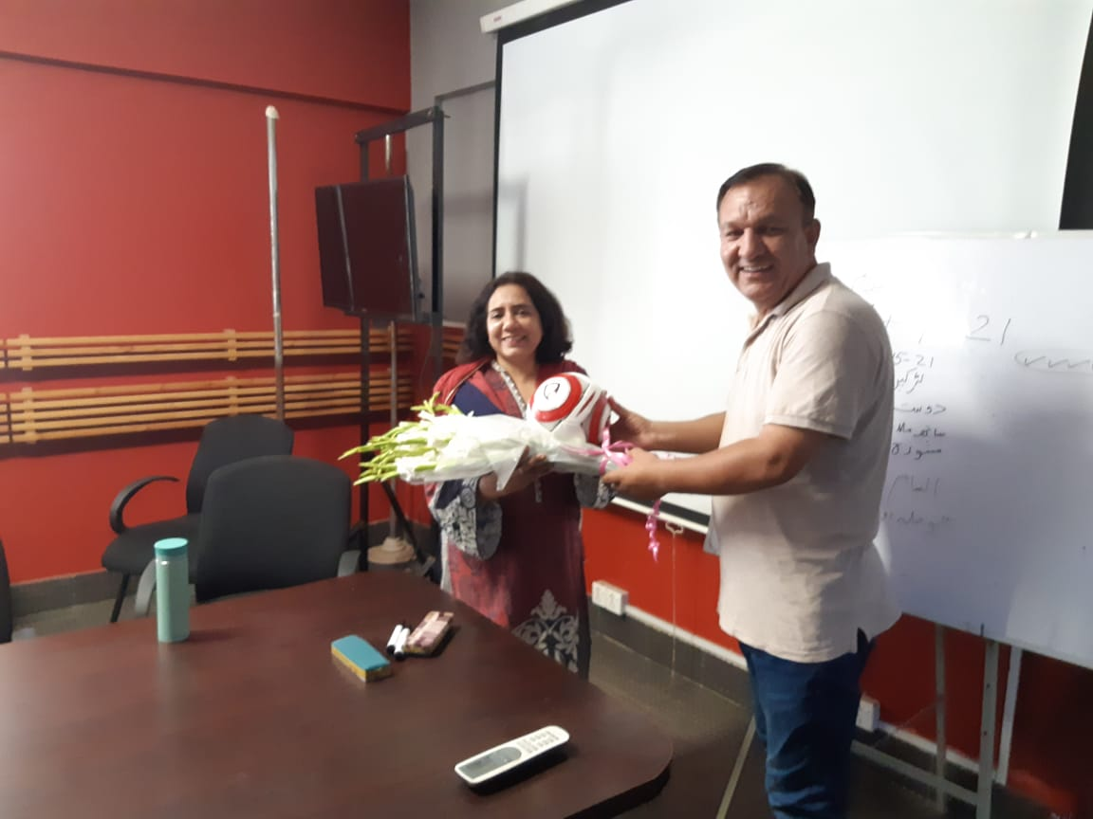

Figure 3 Mr. Talib, Program Manager is presenting token of appreciation to guest speaker

**Standard Chartered – Karachi United Youth League 2019:**

Karachi United in collaboration with Standard Chartered Bank launched Youth League in September 2019. With the remarkable success and very positive feedback from the last two years, Standard Chartered again in partnership with Karachi United, kicked off the 3rd “Standard Chartered Karachi United Youth League” to promote sports among children. This league provides a platform for Youth football teams from across the under-served areas of Karachi to come together, break barriers and inculcate the spirit of competition.

Youth League is successfully running right from September and the pace of it continued in October with full spirit. Youth League is mainly categorized in 3 groups i.e. U-10, U-12 & U-14. U-10 is divided into following groups:

|  |  |  |  |  |  |
| --- | --- | --- | --- | --- | --- |
| **GROUP A** | | **GROUP B** | | **GROUP C** | |
| Old Golimar | Baldia Town | Shireen Jinnah | Korangi Academy | Lyari General | Malir |
| Orangi Town | Lyari Kakri | KU Academy | KU Youth Clifton | Manghopir | Mauripur |

The competition also includes girls’ tournament to be played on a single league basis in a 7-a-side format with the top two teams competing in the final. This youth league offers an array of benefits but the benefits extends well beyond the field. They start learning to communicate with peers, can build strength and speed that will aid their overall physical development as they grow. It also encourages the young players to embrace the diversity. Karachi United has booked three football grounds for group matches and Karachi United is also providing the transportation facility to community center players. A total of 24 football matches have been played as of writing date of this report. This league has created the wave of euphoria amongst the players and they are enjoying the thrilling matches. The feedback of the players is given below:

**Beneficiaries Quotes:**

“*This League has taught me that failure and success are the part of the life but the important is to stay positive and keep trying”. ~ Ans~*

“*As I am the trainer so I observe one thing in youth that is lack of hope. Our youth is becoming pessimistic day by day because they do not get the opportunity that can help them grow. I see SCB KU Youth League as a hope for youth that is inculcating sprit of competition, confidence and passion and assist them to strive for the best*”. *~Nasir Arab coach~*

*“Youth League gave me a chance to interact with children of different ethnicities, languages and religion”. ~Samad Hussain~*

*“I believe that football leagues should be organized more often as it provides the chance to demonstrate talent, hard work and dedication of the players”. ~Muhammad Sharif~*

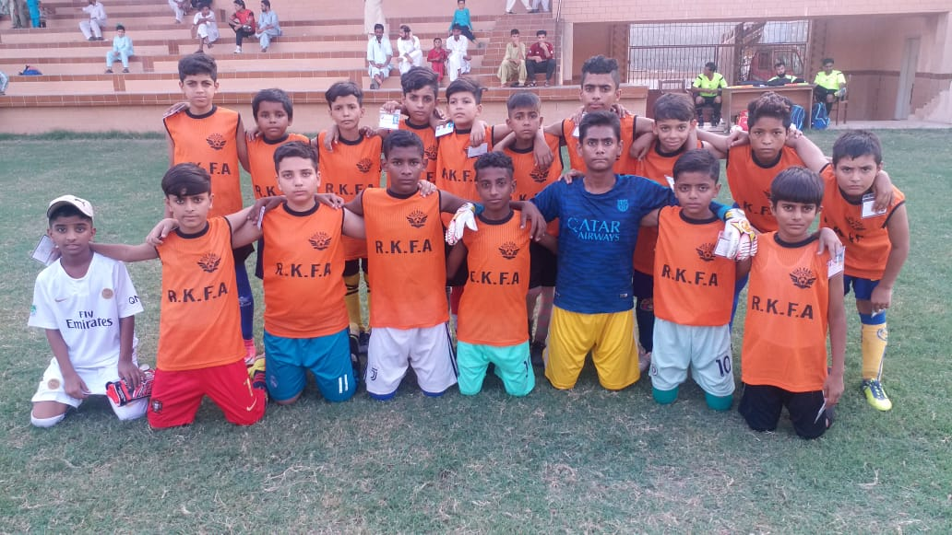

Figure 1 RKFC Under-12 players pose for a group photo before the match at Baldia Town

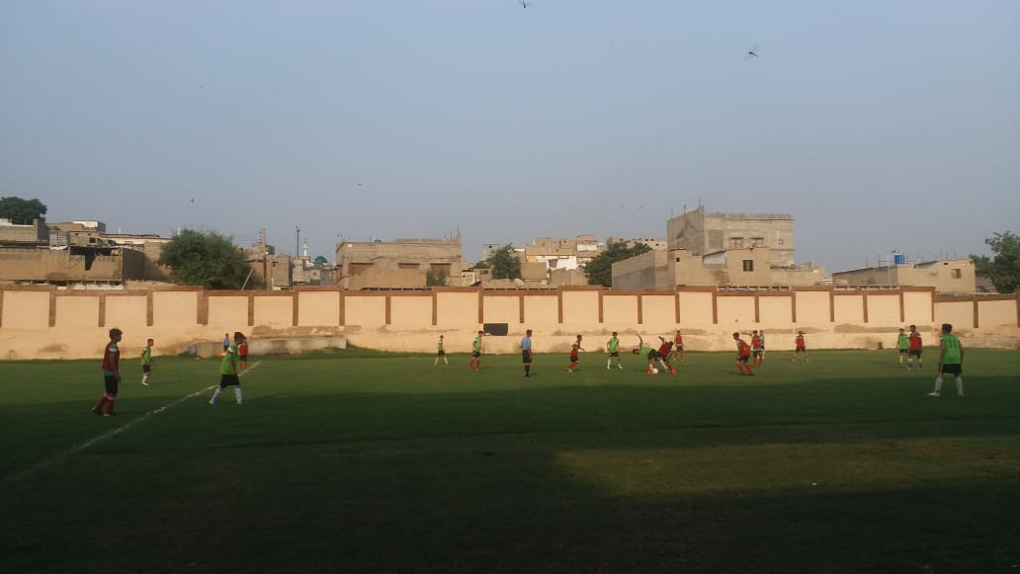

Figure 2 Orangi team faces Maripur team at Baldia football ground

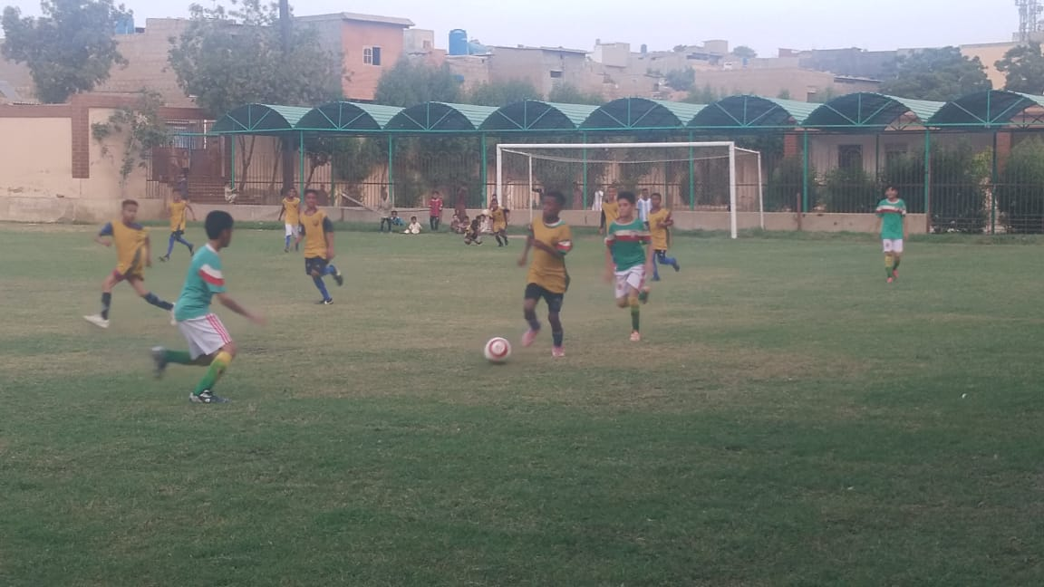

Figure 3 Teams are in action during the round match of SC-KU youth league 2019