**Quarterly Report**

**Uplift Community through Football**

**Standard Chartered Karachi United Youth League:**

Karachi United and Standard Chartered Bank run a youth league every year to promote football. The main objective of this league is to pull out the children from destructive activities and positively utilize their talents. Players in the SC KU league, come from the less privileged segment of society where they get the least chance to participate in sports activities. This three-month-long and structured league provides a professional experience to young lads and polishes their skills. The 5th SC KU league will commence in the end of September 2022 and matches will be held in Karachi United Stadium as well as other nearby grounds. Teams are excited and are preparing hard to give tough competition to each other.

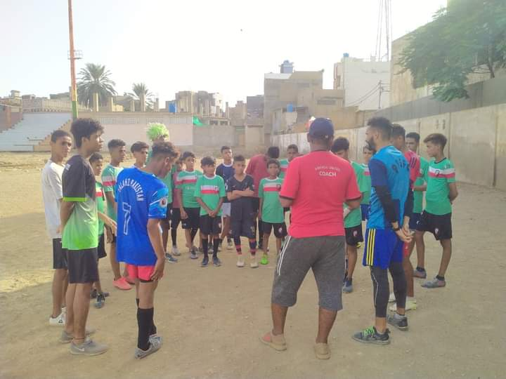

Figure Coach is giving tips for the upcoming SC KU youth league

**Football Tournament with Juveniles:**

Karachi United engaged juveniles from Central Jail in Football matches with its Old Golimar center and Moin Star Football Academy during this period. After five-month coaching sessions, these matches allowed juveniles to participate in healthy competitions and reflect their hard work, dedication, and merit irrespective of their background. The main objective of this one-day tournament was to encourage them and keep them engaged in positive activities.

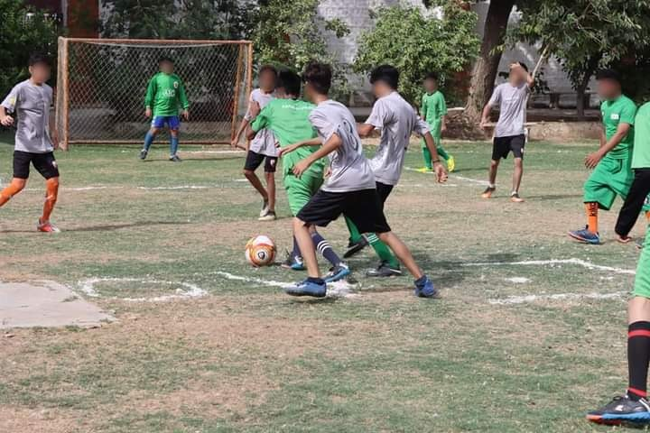

Figure 1 Teams are in action during the match

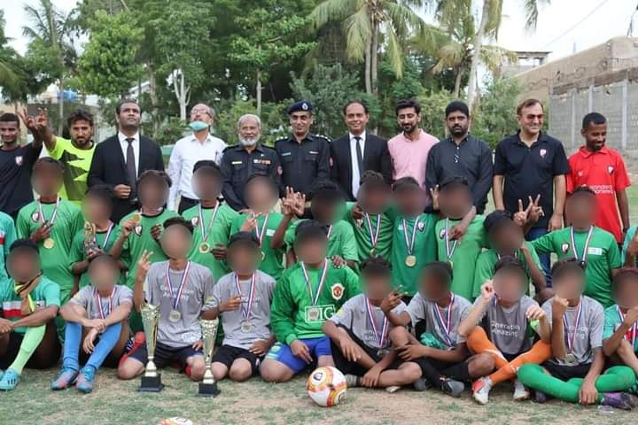

Figure Teams and other officials pose for a group photo after the prize distribution ceremony

**Football and life Skill Training Session:**

Football is one of the most effective tools of community empowerment and Karachi United is humbled to contribute to this mission. Karachi United offers weekly football and life skill sessions at community centers. Football training aims to build confidence in the players and polish their untapped talent. Football training sessions prepare the players to perform well in various football tournaments arranged by local clubs, domestic and international tournaments. Whereas, life skill sessions inculcate values in the players and motivated them to be good human beings. The life skill sessions also encourage them to face the difficulties of life with confidence.

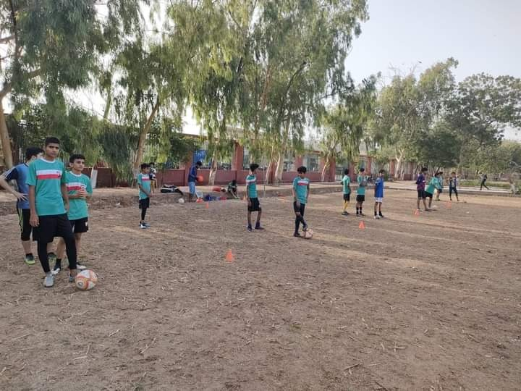

Figure Players are engaged in a football training session at Golimar Center