Quarterly Report
Uplift community through Football

Standard Chartered Karachi United Youth League 2021:
Karachi United and Standard Chartered Bank organize Youth league every year. This league provides the players a platform to showcase their football talent. Players are encouraged to participate in the league as it creates environment of healthy competition and it also boosts up players’ confidence. This amazing and sensational KU Youth league had to be suspended for a month due to Covid-19 but now this league has been restarted. League is going on with lots of exciting and thrilling matches. A total of 99 matches have been played as of writing date of this report.

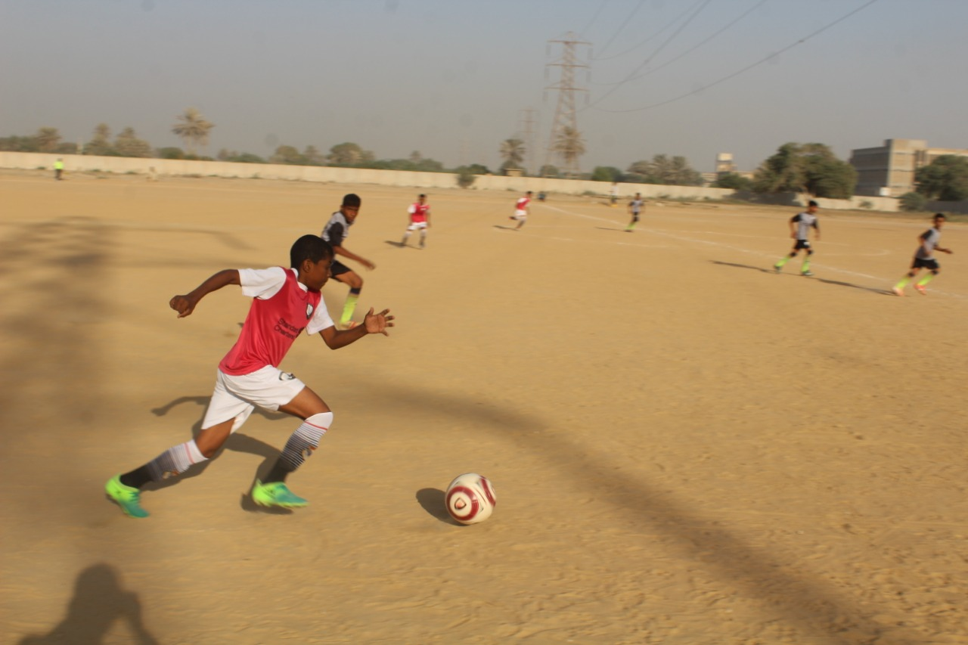

Figure 1 Players are in action during the match

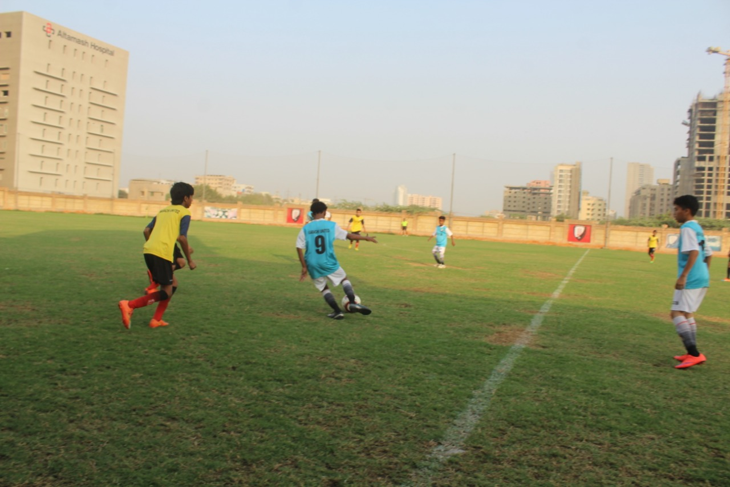
Figure 2 Players are in action during the match

Distribution of Ration Bags:
Karachi United is running community centers where players come from less privileged segment of society. Karachi United is not only engaging these kids in healthy activities but also provide assistance in their education and building their character. Other than that, Karachi United keeps running different drives to raise funds for their well-being. As these kids belong to destitute families who struggles to run their kitchen. In order to help them, Karachi United distributed 50 ration bags among the players and coaches. Each ration bag contains flour, tea, sugar, oil and lentils.
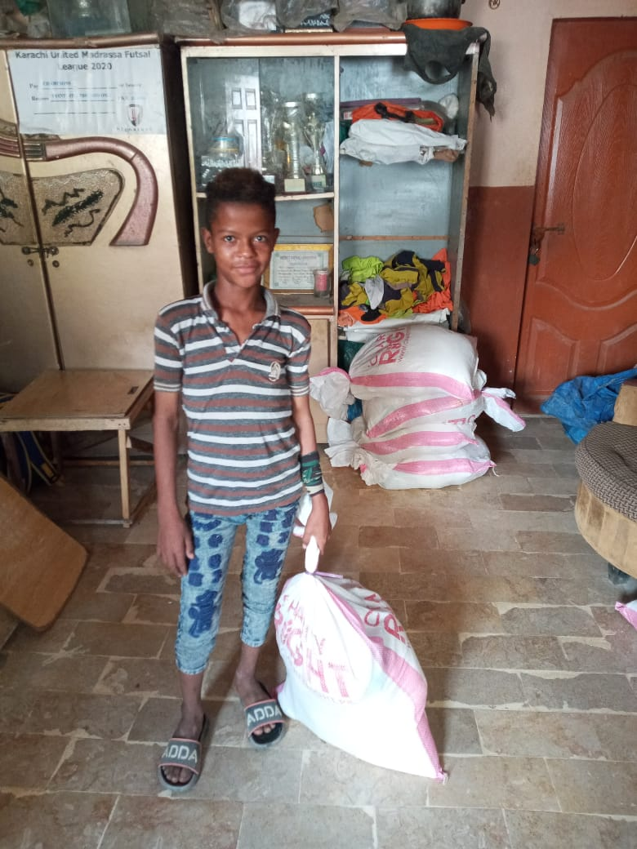
Figure 1 Player posed for a photo after receiving ration bag

