**Quarterly Report: November to January 2020**

**Uplift the Community through Football**

**Life Skill & Football Training Sessions:**

Karachi United conducted a total of 16 life skill and 16 football training sessions conducted in each community centre during this period. Karachi United coaches teach football skills such as dribbling, ball shooting, ball passing, ball controlling and goalkeeping techniques during the sessions. Whereas, life skill sessions were based on inculcating the good habits in the kids, trainer discussed the importance of good habits and how good habits make a person successful. Group activities were also performed during the sessions. Trainer also discussed the process of decision making in which he explained how situation is evaluated and what are the main factors one should consider before making any decision. In order to encourage the kids towards positivity, trainer shared inspiring stories of famous footballers such as Angel de Maria, Victor Moses, and Sanchez. Trainer shared the number of hardships these footballers have faced to emerge as football superstars.

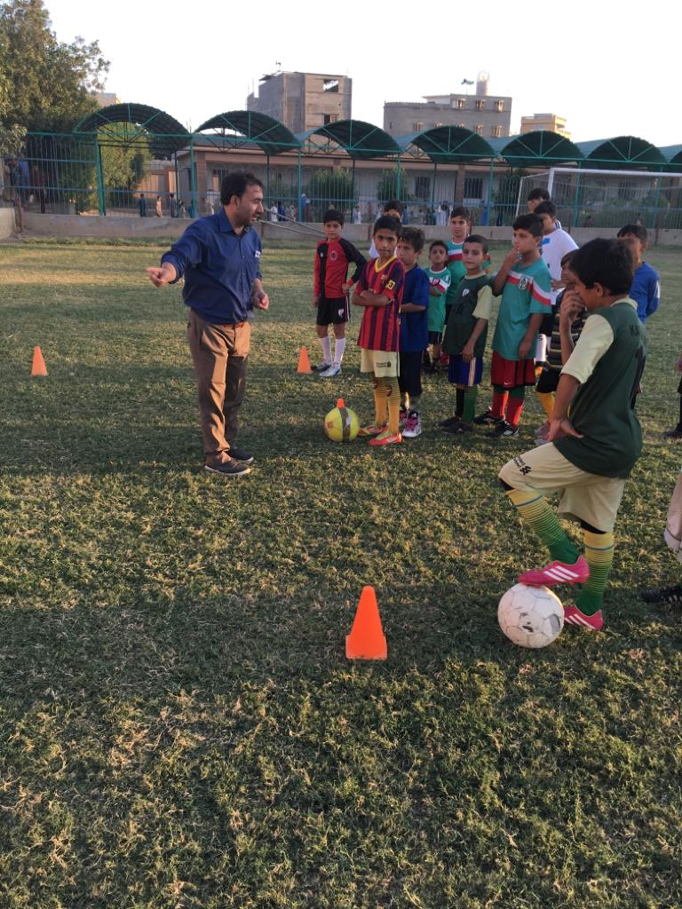

Figure Trainer is conducting life skill session before football training

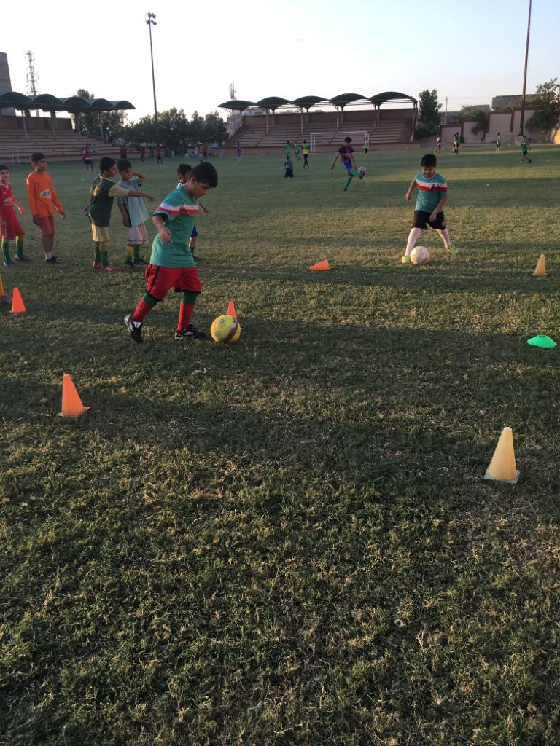

Figure Kids are attending football training session

**Standard Chartered – Karachi United Youth League 2019:**

The SCB KU Youth League, which aims at promoting sports amongst children, and pulled them out of destructive activities such as kite flying, marbles, card, drug abuse which are very common in under developing areas of Karachi, will end on 15th January. The real motive of this league is to give these players who usually do not get the chance to play high level competitions, a chance to get the feel of international professional events. In order to increase the standard of the league, official referees and match commissioners were appointed for every match. A total number of **720** boys and **80** girls participated in the three-month long football league that involved 44 teams – 36 boys and eight girls. The boys were from the age category of U-10, U-12 and U-14, each category having 12 teams each. The girls had eight teams and over a three months period these team played **128 matches** but were also involved in building the players’ character and improving their skills that helped them in making their life better.

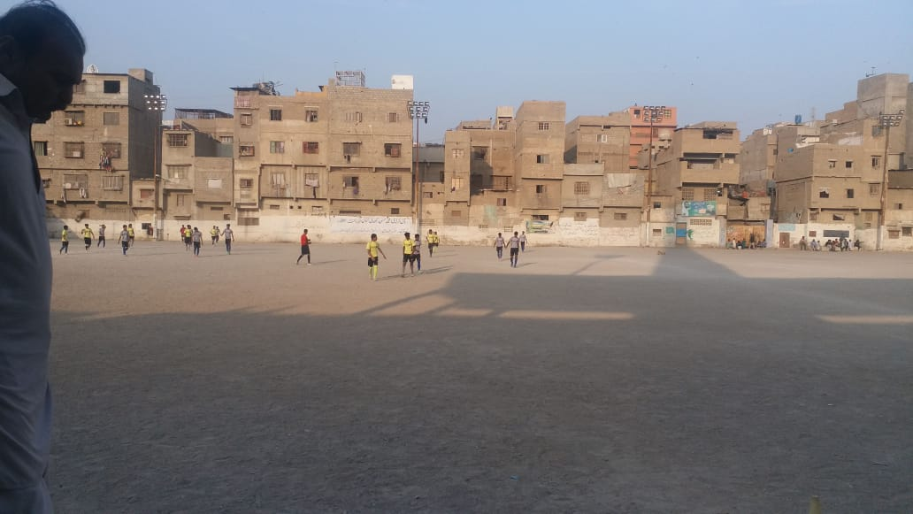

Figure 1 Team Chakra Goht vs CEFA are in action dueing SCB youth league 2019

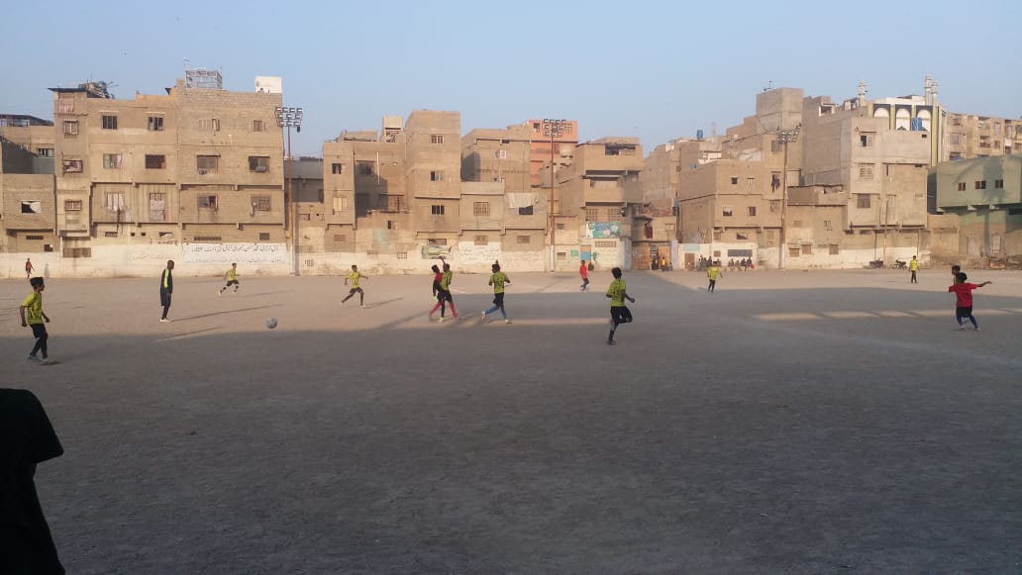

Figure 2 Players are in action during match

**Opened New Community Center:**

Karachi United is not only evoking football passion in conventional institution students but also engaging madrassa students in sport activities. Students attending religious institute get least chance to participate in sport activities. In order to give Madrassa students (Religious Institute) a platform to polish their football skills, Karachi United has taken Madrassa Abbu Huraira onboard during this quarter. Karachi United is providing football coaching sessions with madrassa students thrice a week. Karachi United is also giving them chance to play friendly matches with community centers. The main purpose of organizing friendly matches is to promote peace and brotherhood among madrassa (religious) and conventional students.