**Quarterly Report**

**Karachi United Standard Chartered Youth League:**

The SCB KU Youth League, which was aimed at promoting sports amongst children, and pulled them out of destructive activities such as kite flying, marbles, card, drug abuse which are very common in under developing areas of Karachi, ended during this period. CEFA U-10, KU Academy U-12, KU Maripur U-14, Nobel Academy School, Lyari Football Academy U-16 and KU girls lifted the champion trophy of this league. The real motive of this league was to give these players who don’t get the chance to play high level competitions, a chance to get the feel of international professional events. In order to increase the standard of the league, official referees and match commissioners were appointed for every match. It was 4 months long football league which consists of 74 teams. The boys were from the age category of U-10, U-12, U-14, and U-16 each category having 12 teams each and the girls had eight teams. Over this four-month period these team played 313 matches.

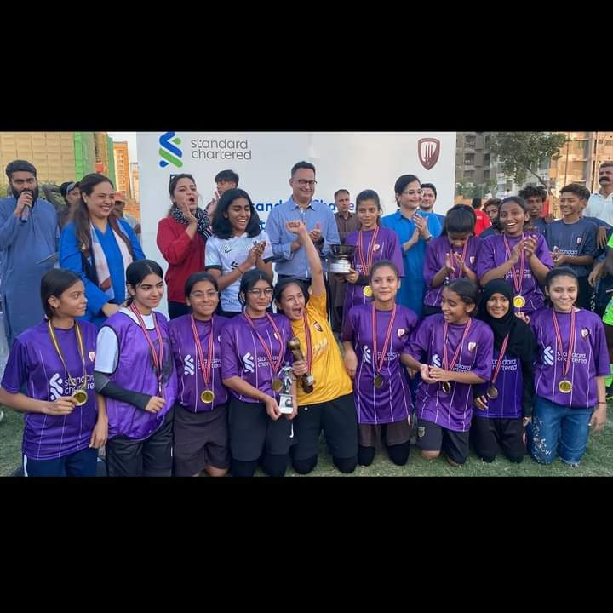

Figure Players are celebrating their victory

**Qatar Tour:**

Karachi United creates an environment in which children from lesser privileged backgrounds develop their football and life skills in order to enable them to utilize sport as a meaningful career choice to break out of their existing circumstances. Karachi United keeps providing them different platform such as KU- SCB Youth League, Karachi United School Championship as well as other tournaments and events in an effort to find new talent as well as raise the standard of football within the country. Qatar tournament was also an opportunity for young footballers to showcase their potential on international level which Karachi United provided them a platform.

Aspire Academy (Qatar National Academy) Invited Karachi United to play a friendly series with the Generation 2011 and 2012 players. Karachi United Academy Generation 2011 won the series 2-1 and the Generation 2012 lost 1-2. Engro was the sponsor of this series. Players hailing from Karachi United Community Center of Excellence showed splendid performance in all matches. The KU players have shown great confidence and their football talent has been appreciated by the top international coaches present at the Aspire Academy. The performance of the players proved that Karachi United is capable of producing football talent in Pakistan.

It is important for Karachi United to continue to compete with clubs outside of Pakistan and build football network so that one day a pathway can be created for the Academy graduates. The boys did an outstanding job and performed to the best of their ability. Apart from the competitive matches, the boys benefited from the experience of being in a professional environment and understood the lifestyle required to be a top athlete.

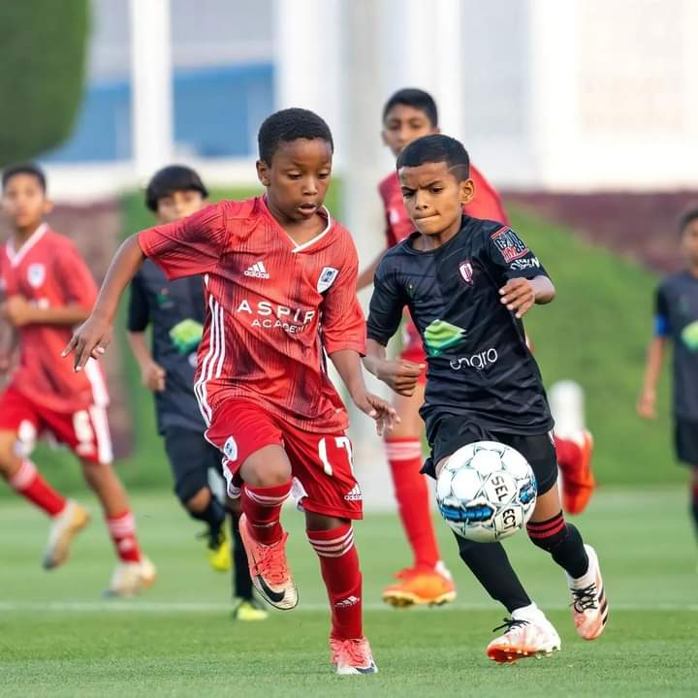

Figure Players are in action during the match

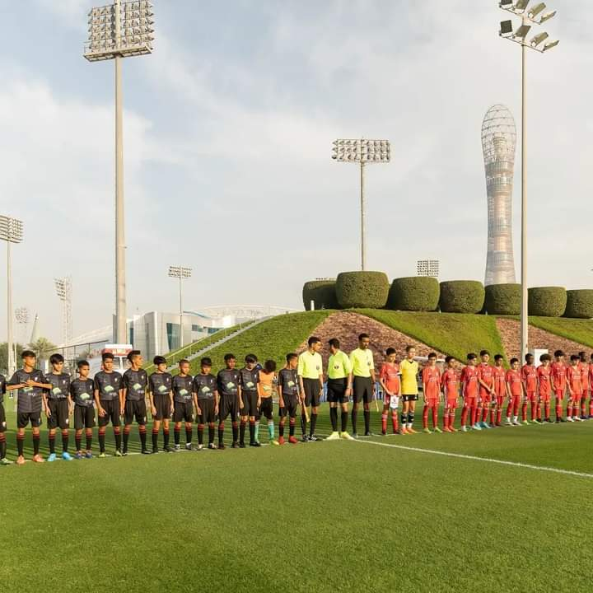

Figure Teams pose for the group photo before the match

**Football and Life Skill Training Session:**

Football is one of the most effective tools of community empowerment and Karachi United is humbled to contribute to this mission. Karachi United offers weekly football and life skill sessions at community centers. Football training aims to build confidence in the players and polish their untapped talent. Football training sessions prepare the players to perform well in various football tournaments arranged by local clubs, domestic and international tournaments. Whereas, life skill sessions inculcate values in the players and motivated them to be good human beings. The life skill sessions also encourage them to face the difficulties of life with confidence.

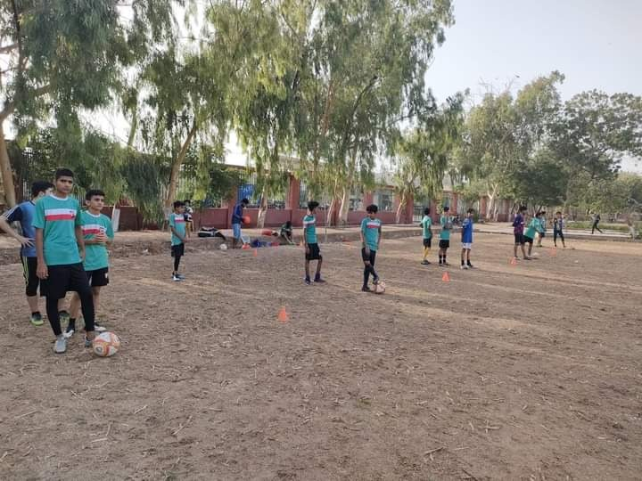

Figure 3 Players are engaged in a football training session at Golimar Center