Quarterly Report
Uplift community through Football

Uniting Women for Peace Project:
United conducted “Uniting Women for Peace Project”. The objective of this project was to empower women and encourage them to take up sport. These females do not get opportunities to engage in healthy and productive activities beyond their classroom. Karachi Through this project, females could get sports coaching and learn the importance of diversity, team values, cooperation, and harmony through sports. Participants also got opportunities to take actionable steps to promote peace to community members through civic action projects.
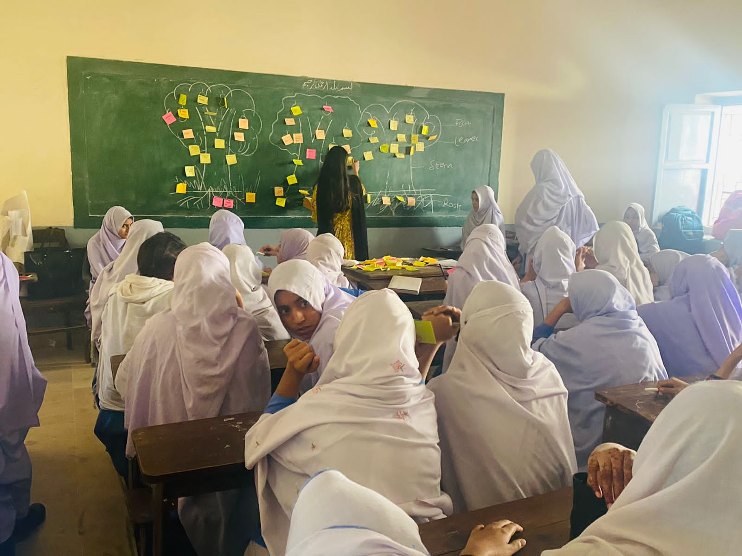
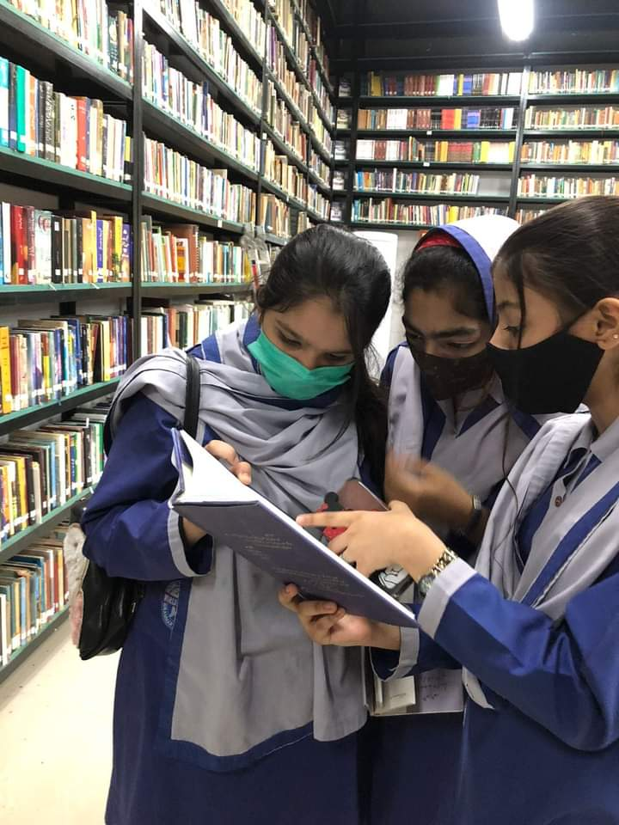
Figure 2 girls are sharing their feedback after CVE session
Figure 1 Girls during the diversity tour

SCB- KU Youth League 2021
The prize distribution ceremony was held during this period at Karachi United stadium. It was 3 months long league which included 62 teams and consist of 199 matches. This league was aimed at promoting sports amongst children, and pulled them out of destructive activities. The real motive of this league was to give these players who don’t get the chance to play high level competitions, a chance to get the feel of international professional events.
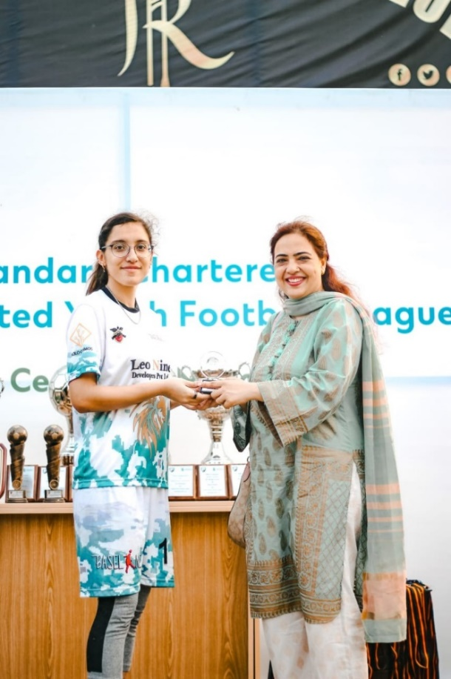
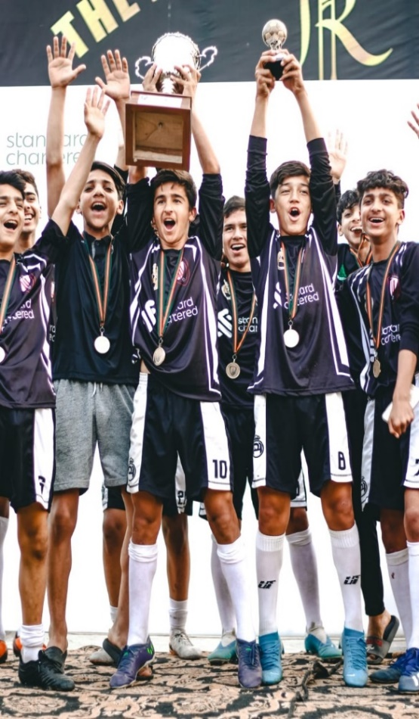
Figure 1Girl is receiving the award during ceremony
Figure 2 team is celebrating their victory

Graphic Representation of SCB-KU Youth League:

Equipment Distribution:
Karachi United is running 12 community centers in underserved areas of Karachi. Children from destitute family come and attend life skill and football training sessions. In order to run the centers, Karachi United provide them all the facilities. Karachi United distributed the kits amongst the players so they can attend the training in proper manner.
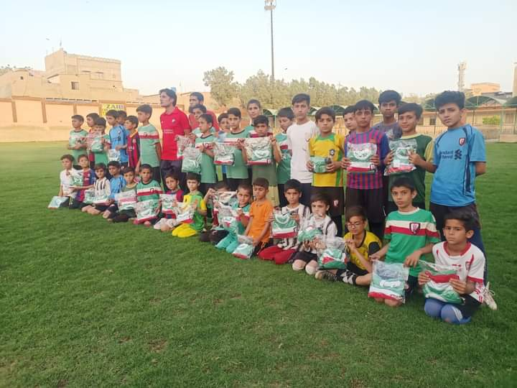

Figure 3 kits Distribution among the players

Comminuty Visits:
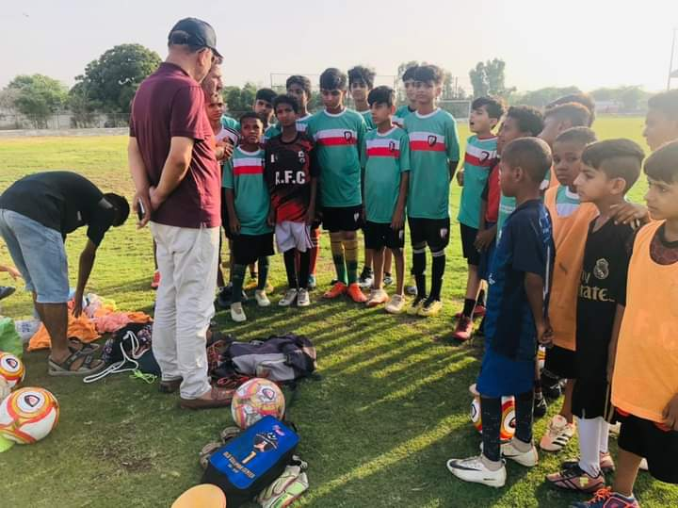
Karachi United has its community centers across Karachi, working to promote sports and life skills training to youngsters and provide them opportunities to engage in healthy sporting activities. KU conducted visit to its community centers in Baldia, Lyari and Old Golimair during this period. These visits were followed by fruitful conversations with beneficiaries and gaining a deep understanding of the KU’s impact in communities.
Figure 4 Kids are sharing their feedback during the visit

