Quarterly Report
Uplift community through Football

Standard Chartered Karachi United Youth League 2021:
Karachi United in collaboration with Standard Chartered Bank launched 4th Youth League on 19th, March 2021. With the remarkable success and very positive feedback Karachi United has been organizing this league in collaboration with Standard Chartered from the last three years. The opening ceremony of the league was held on 19th, March at Karachi United Stadium. This league provides a platform for Youth football teams from across the under-served areas of Karachi to come together, break barriers and inculcate the spirit of competition. This youth league offers an array of benefits but the benefits extends well beyond the field. They start learning to communicate with peers, can build strength and speed that will aid their overall physical development as they grow. It also encourages the young players to embrace the diversity. Karachi United has booked three football grounds for group matches and Karachi United is also providing the transportation facility to community center players. A total of 5 football matches have been played as of writing date of this report. Total of 62 teams are participating in this league and these teams were divided into following four categories:
Categories | Number of Teams
Under-10 | 8
Under-12 | 12
Under-14 | 12
Under-16 | 12
Girls | 10
School | 8

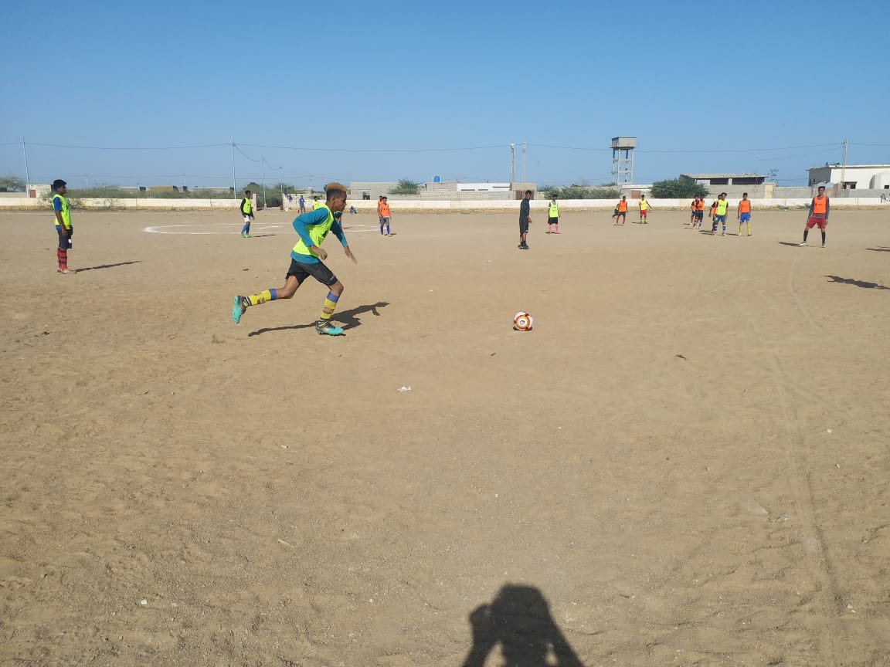
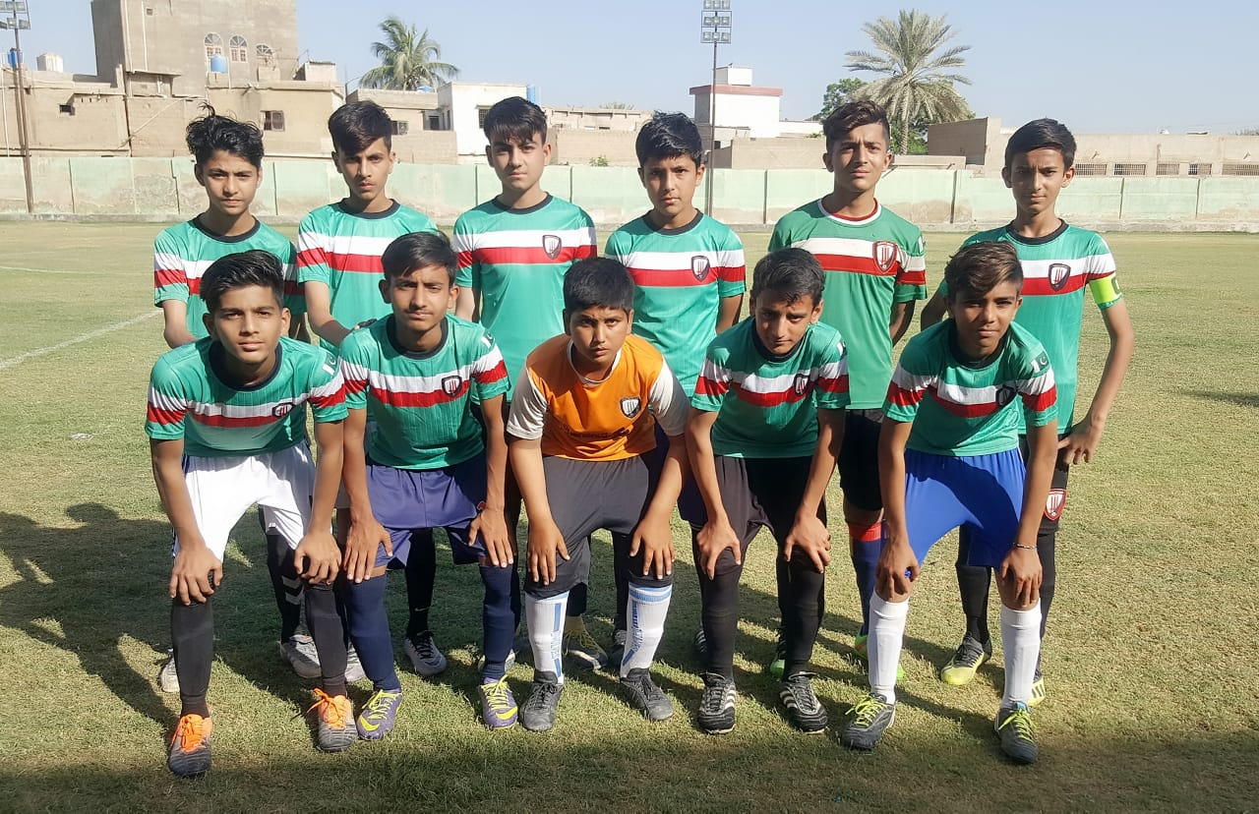
Figure 2 Players are in action during the match
Figure 1 Team Baldia pose for group photo before the match

Distribution of Iftar Boxes:
Ramadan is the month of giving, sharing and helping others. Karachi United encapsulates these values by continuing its charitable work and distributed 1500 iftar boxes to all KU Community Centers. Karachi United took this initiative in the collaboration with Pie in the Sky Bakers. Kids in our community centers come from very less privileged segment of the society and destitute families live from hands to mouth. Karachi United supported these families so they can enjoy the blessing of the Holy month of Ramadan.

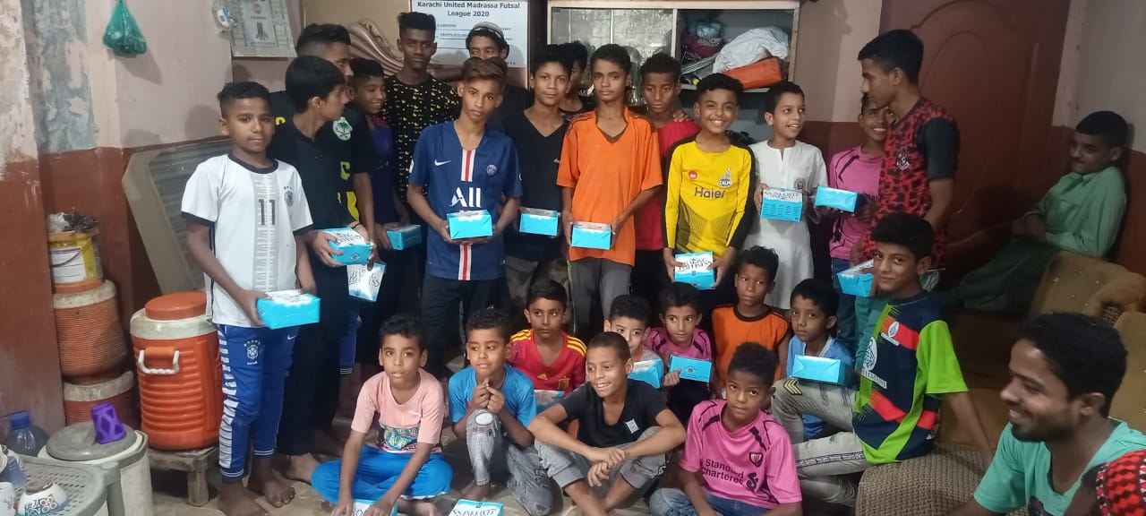
Figure 1 Community players pose for group photo after receiving the iftar boxes

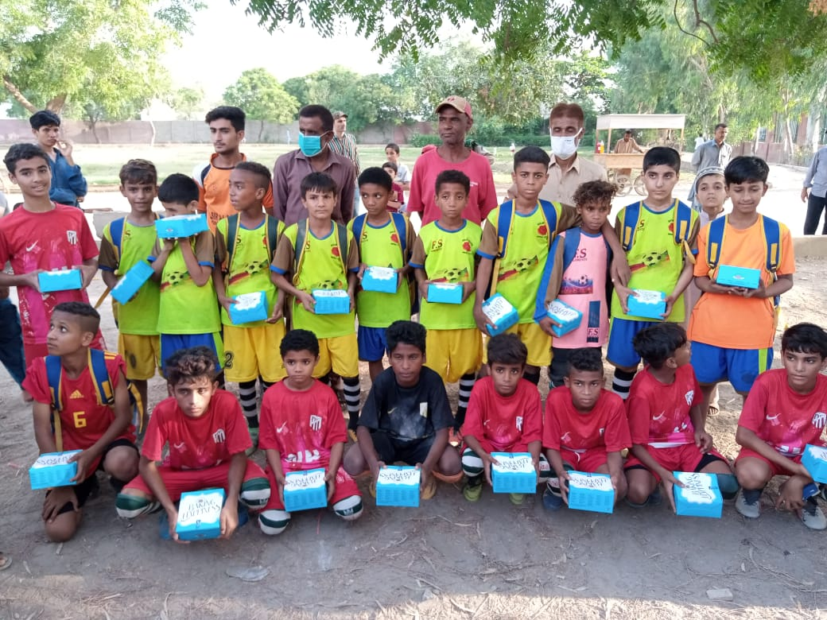
Figure 2 Iftar boxes distribution at KU community centers

