**Quarterly Report: May to July 2019**

**Uplift the Community through Football**

**Life Skill Sessions:**

Karachi United conducted a total of 16 life skill sessions conducted in each community centre during this period. The main purpose of these sessions was to encourage the players to resist any negative influence and equip them with positive role models. These sessions taught them like in football, there is no room for prejudice – everyone involved has to anticipate the behaviour of teammates purely on the basis of their abilities regardless of their cultural background. Similarly we should apply this learning in our daily life and should not form negative perception about any community.

Youth workers discussed the consequences of passing judgments without knowing actual facts during session. Youth worker shared the story of a lady who were angry at man who ate her cookies but later she found her bag of cookies in her purse which means she was eating that man’s cookies. After sharing the story, youth worker discussed the key learnings and explained that most of us rush to pass judgment without knowing the whole situation. The main objective of sharing this story was to encourage players to be rational and analyse the situation thoroughly before making any decision.

In order to develop civic sense in players, youth worker shared the success story of Ronaldo. Youth worker showed some video clips of this renowned footballer during the session and also shared the charitable work of Ronaldo. Youth worker explained that Ronaldo has contributed for different causes and he is helping the less fortunate people all around the world. It indicates that when you are blessed with something you should share it with others. Youth worker further added that it is our prime responsibility to make this world a better place to live, so we should serve the society in our own capacity.

During life skill sessions, youth workers explained that football is a game that smash the ethnic difference and promote inclusion in teams. He gave the example of renowned footballers Kylian Mbappe and Lukaku and explained that these players have set the examples that if you have talent and skills then nothing can come in your way of success. He shared the struggles these players faced in the beginning of their career as people used to make fun of Lukaku’s accent. Youth worker further added that in order to get success, we all have to face some challenges but we have to stay positive and determinant.

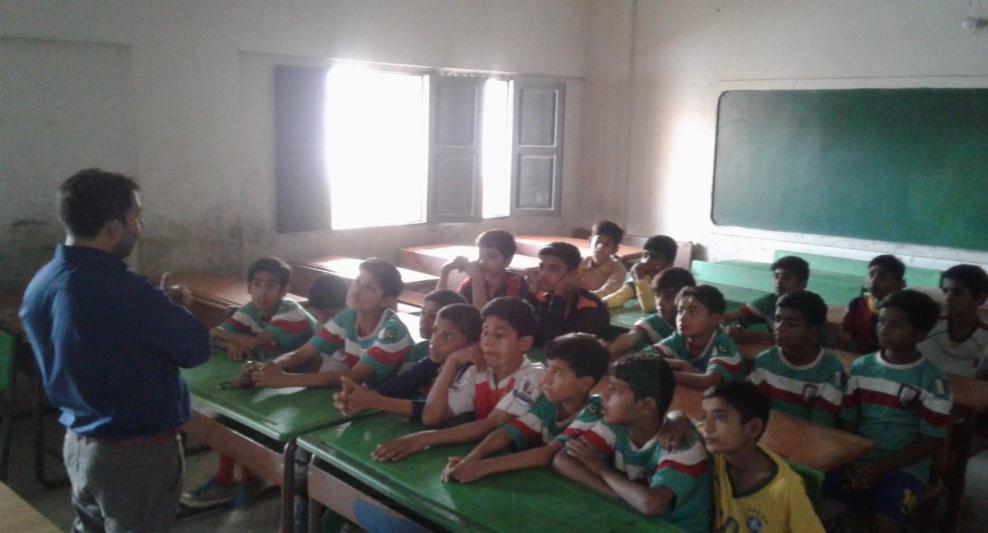

Figure 1 Youth worker is conducting CVE session at Baldia Town (Saeedabad)

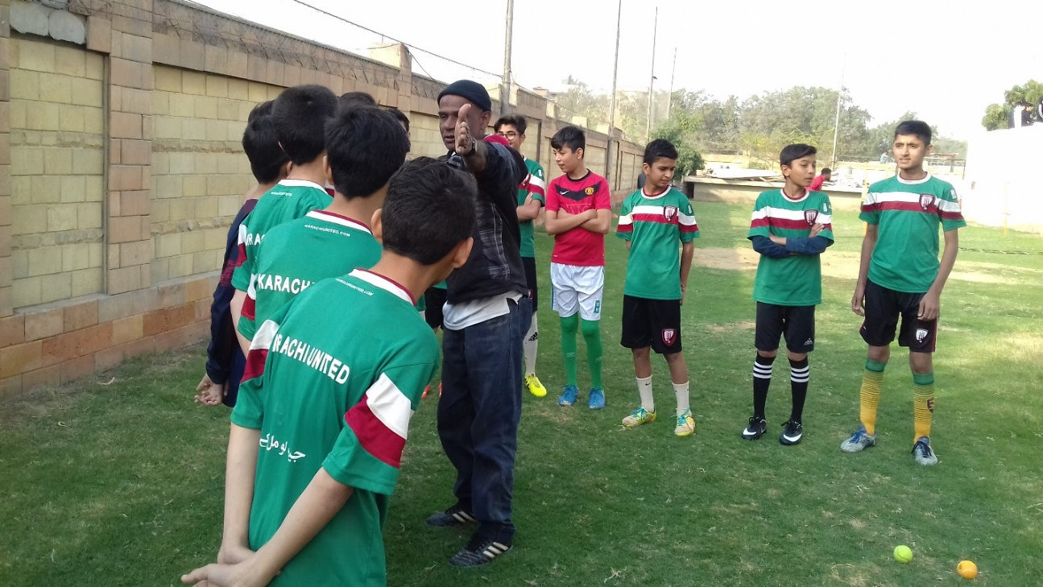

Figure 2 Youth worker is explaining group activity to boys during life skill session

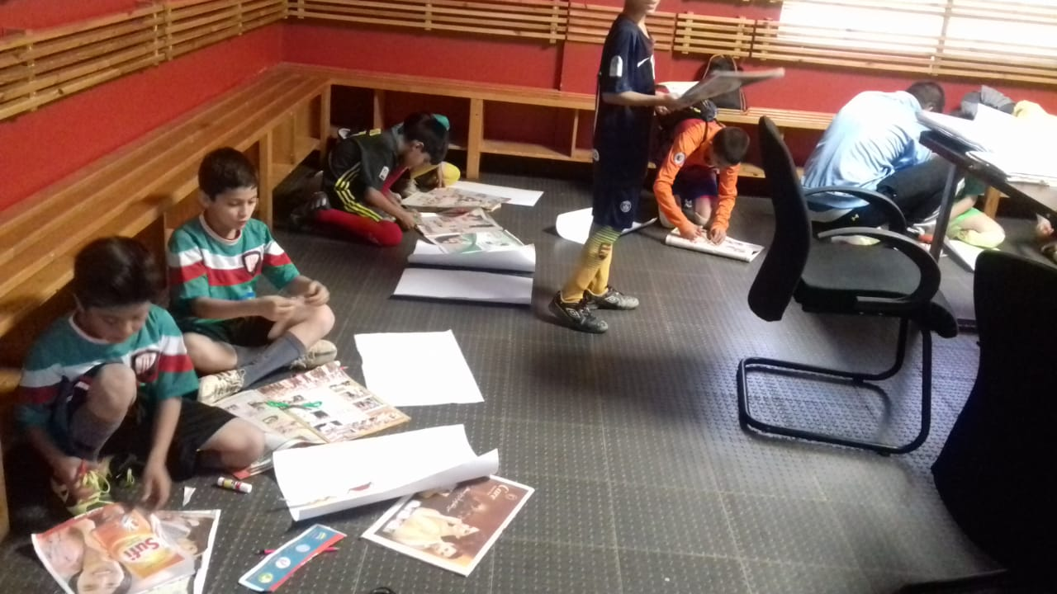

Figure 3 Boys are engaged in group activity during life skill session

**Parental Engagement Session:**

The parental engagement session was conducted during this period at Karachi United Football Stadium. It was interactive and activity based session in which 65 parents participated. Mr. Sufiyan, Teacher & Trainer, was invited as a guest speaker who shed the light on diversity and role of parents in shaping up the character of their children. Speaker explained that it is prime responsibility of parents to educate their child and their role is not limited to home but involvement in school and other activities too. Speaker also encouraged parents to teacher their child to see the diversity as a beauty and make them realize that diversity is not a pretext for conflict but is a treasure that enriches us all.

Mr. Talib, Program Manager, thanked the parents for their active participation. Mr. Talib also thanked the guest speaker and presented souvenir. After the session, parents were requested to celebrate Pakistan Day by showing unity through friendly matches. Parents were divided into team and they played friendly matches. The purpose of this activity was to create strong bond among parents and encourage them to stay active and participate in physical activities. After friendly matches, lunch was also served to the parents.

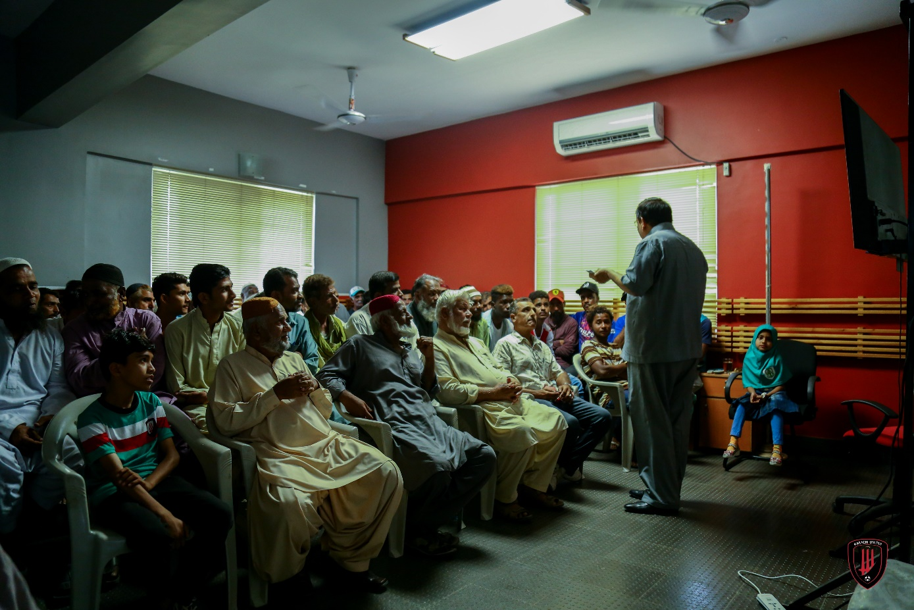

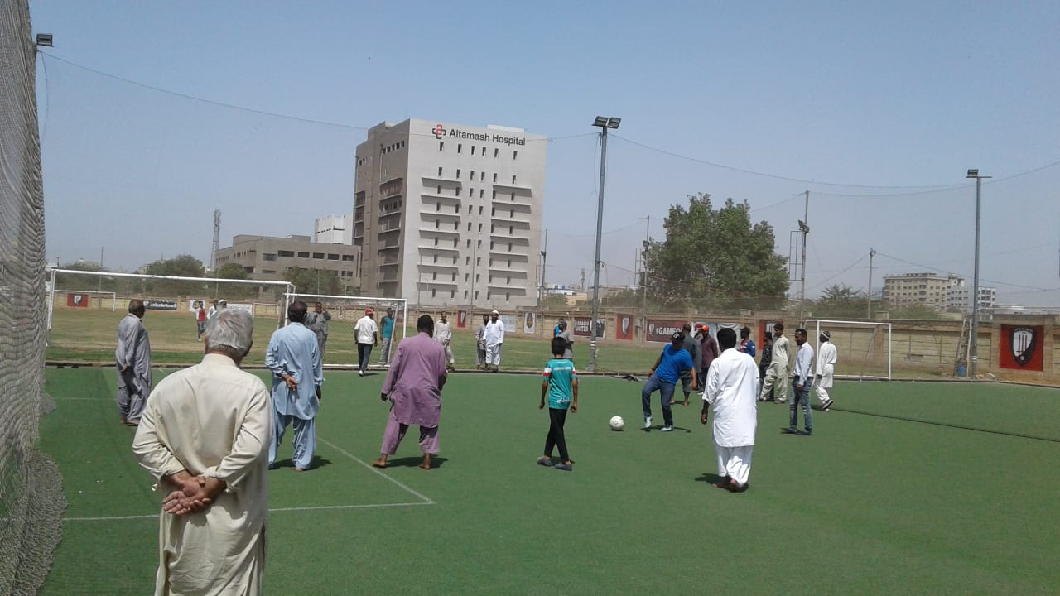Figure 1 Guest speaker is addressing to parents on at Karachi United Stadium

*Figure 2 Parents are playing friendly* *match after the session*

**Second Quarterly Tournament:**

2nd quarterly tournament took place during this period. A total of 8 teams having 160 participants competed in 2nd quarterly tournament. The teams were divided into two groups; each group consists of four teams with 20 players. The round matches were played at Rehaman Baba football ground while semi-final and final took place at Baloch star football ground. Teams who participated in the tournament are as follows:

**Group ‘A’ Group ‘B’**

1. Ibrahim Hyderi 1. Muaripur
2. Chakra Goht 2. Saeedabad
3. KUFF Academy 3. Lyari Khadda Memon (Kakari)
4. Shireen Jinnah 4. Lyari Chakiwara (Gen)

This tournament played a vital role in bringing communities together as players get the chance to play outside their community where they interacted with the players of other teams who they do not meet normally. The tournament also provided the opportunity to the players get the feel of international professional events as football standards were followed during the tournament e.g. scrutiny before match, match reports, yellow cards, red cards, first aid medical facilities and light refreshment at the end of each match. Karachi United also appointed, official referees and match commissioners for every match that helped the players in polishing their skills. A total of 16 matches were played throughout the tournament and each match was 45 minutes long. The tournament proved to be a roller coaster ride as 8 teams went neck-to-neck from April 26 to May 4, 2019, to decide who the champion of 2nd quarterly tournament was. Following table summarizes the result of the tournament:

|  |  |  |  |  |  |  |
| --- | --- | --- | --- | --- | --- | --- |
| **Match** | **Venue** | **Date** | **Team** | **Results** | | **Team** |
| 1 | Rehman Baba Football Ground | 26-April-19 | Saeedabad | 1 | 0 | Khadda Memon |
| 2 | Rehman Baba Football Ground | 26-April-19 | Chakiwara | 2 | 1 | Maripur |
| 3 | Rehman Baba Football Ground | 26-April-19 | Ibrahim Hyderi | 0 | 0 | Shireen Jinnah |
| 4 | Rehman Baba Football Ground | 27-April-19 | Saeedabad | 1 | 0 | Maripur |
| 5 | Rehman Baba Football Ground | 27-April-19 | Khadda Memon | 0 | 0 | Chakiwara |
| 6 | Rehman Baba Football Ground | 27-April-19 | KU Academy | 4 | 1 | Ibrahim Hyderi |
| 7 | Rehman Baba Football Ground | 28-April-19 | Chakra Goth | 0 | 2 | Shireen Jinnah |
| 8 | Rehman Baba Football Ground | 28-April-19 | Saeedabad | 2 | 1 | Maripur |
| 9 | Rehman Baba Football Ground | 1-May-19 | Shireen Jinnah | 1 | 0 | KU Academy |
| 10 | Rehman Baba Football Ground | 1-May-19 | Chakra Goth | 0 | 0 | Ibrahim Hyderi |
| 11 | Rehman Baba Football Ground | 1-May-19 | Khadda Memon | 3 | 0 | Maripur |
| 12 | Rehman Baba Football Ground | 1-May-19 | Saeedabad | 0 | 1 | Chakiwara |
| 13 | Star Baloch | 3-May-19 | KU Academy | 2 | 0 | Chakiwara |
| 14 | Start Baloch | 3-May-19 | Saeedabad | 4 | 0 | Shireen Jinnah |
| 15 | Start Baloch | 4-May-19 | Shireen Jinnah | 3 | 0 | KU Academy |

The final took place between Saeedabad and Chakiwara on 4th March, 2019 at Star Baloch football ground. It was an intense match in which both teams gave their best in 45 minutes. Both teams were unable to produce any goal within given time so result was decided through penalty shoot-out in which Saeedabad team scored 3 goals while Chakiwara team managed to produce 4 goals and regained their tile. Both teams performed very well and went neck to neck to win the tournament. The prize distribution ceremony was held after the final. Chief guests were invited who distributed trophies and medal amongst the players. The winners of 2nd quarterly tournament are as follows:

|  |  |
| --- | --- |
| **Category** | **Name** |
| Winner | Chakiwara |
| Runners Up | Saeedabad |
| 3rd Position | Shireen Jinnah |
| Best Coach | Mr. Farooq from Maripur Center |
| Best Player | Azaan from KU Academy |
| Best Goalkeeper | Kashif from KU Academy |
| Fair Play Award | Ali from Chakra Goth |

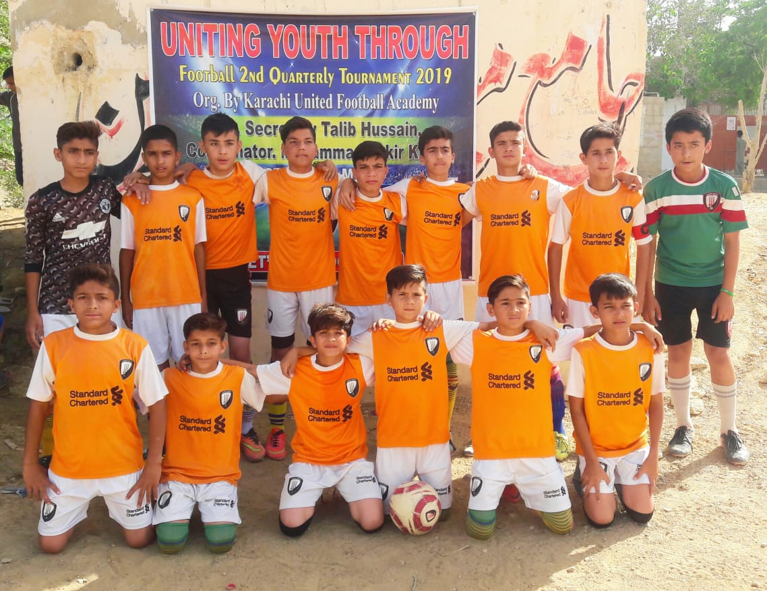

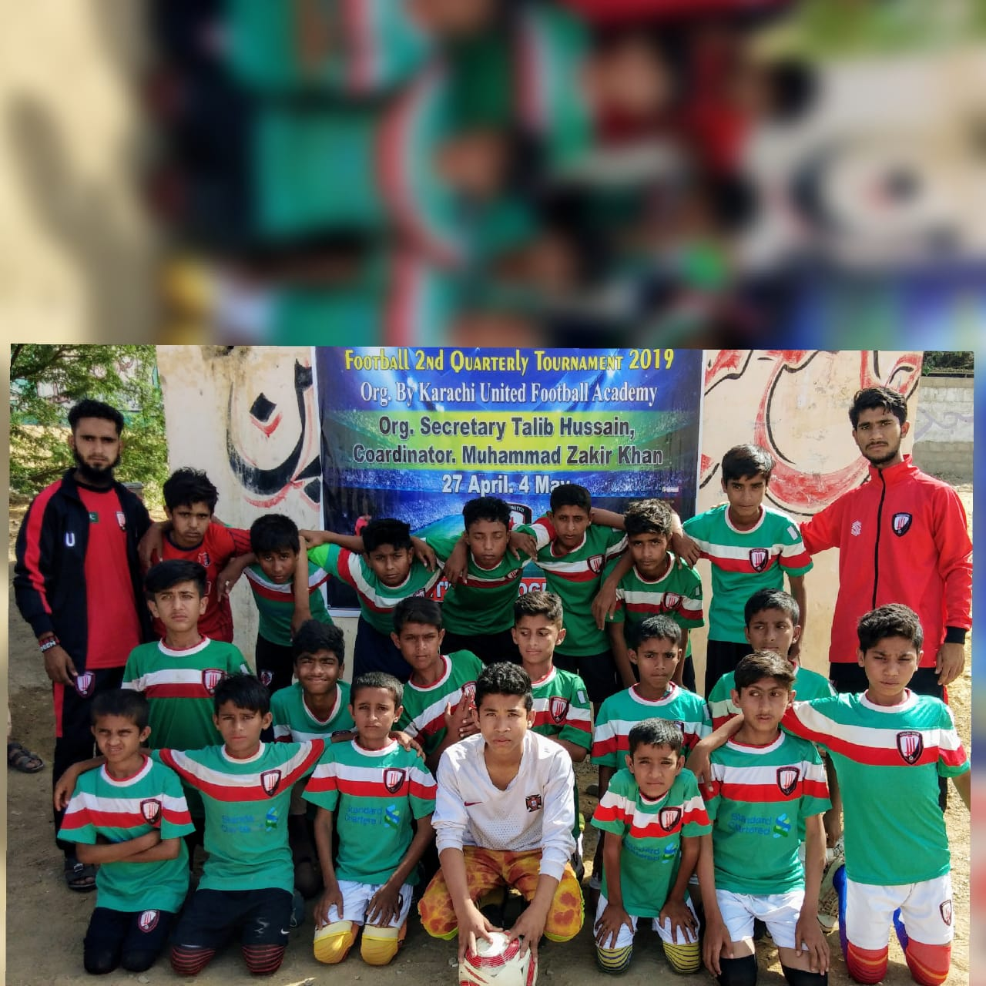Figure 1 Players of Shireen Jinnah pose for group photo before match

*Figure 2 Saeedabad Team pose for group photo along with coaches before matches*

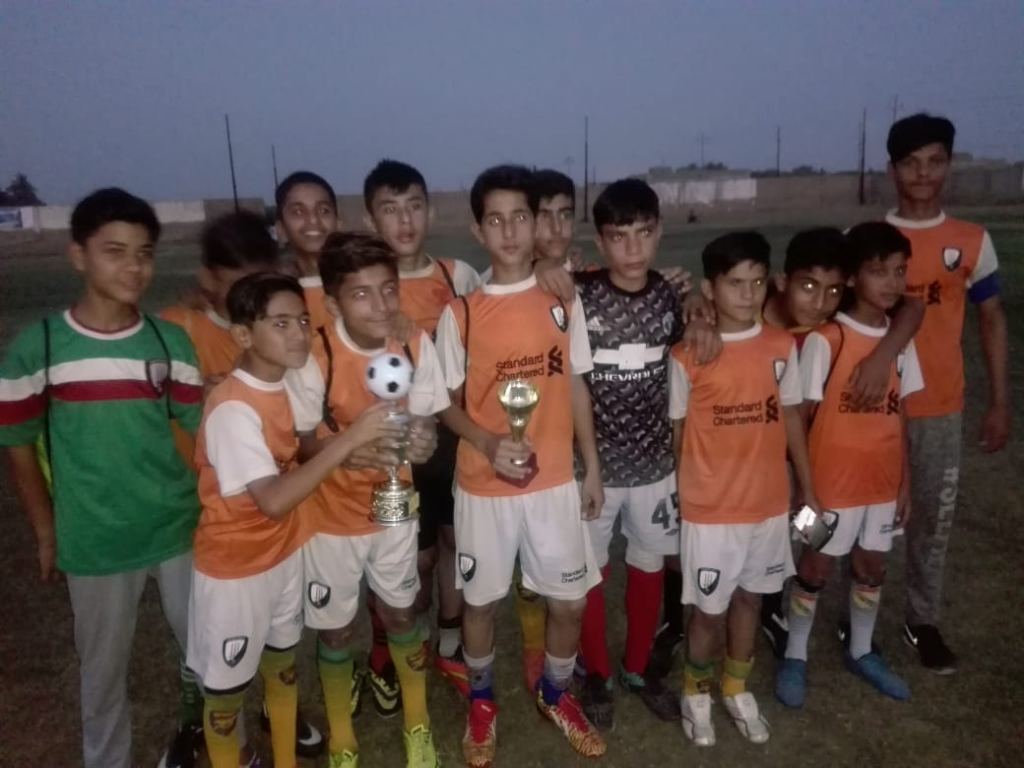

Figure 3 Shireen Jinnah team pose for group photo with trophy after scoring 3rd position