**Quarterly Report: May to July 2020**

**Uplift the Community through Football**

**Ration Drive:**

Karachi United initiated ration distribution drive among deserving players during this difficult pandemic period. 50 percent of the Karachi (Pakistan) population live in slums and during this Covid-19 pandemic, these families are facing the starvation. A total of 870 ration bags has been distributed out of which 110 ration bags were given to the girls who are the part of Karachi united. Ration bags containing essential food item were distributed amongst community centers players, junior staff, *Madrassa* (religious institutions) players and community coaches, who come from underprivileged areas of Karachi (Pakistan). This step has been taken to provide financial support to the families who live on daily basis earning and are suffering due to current pandemic.

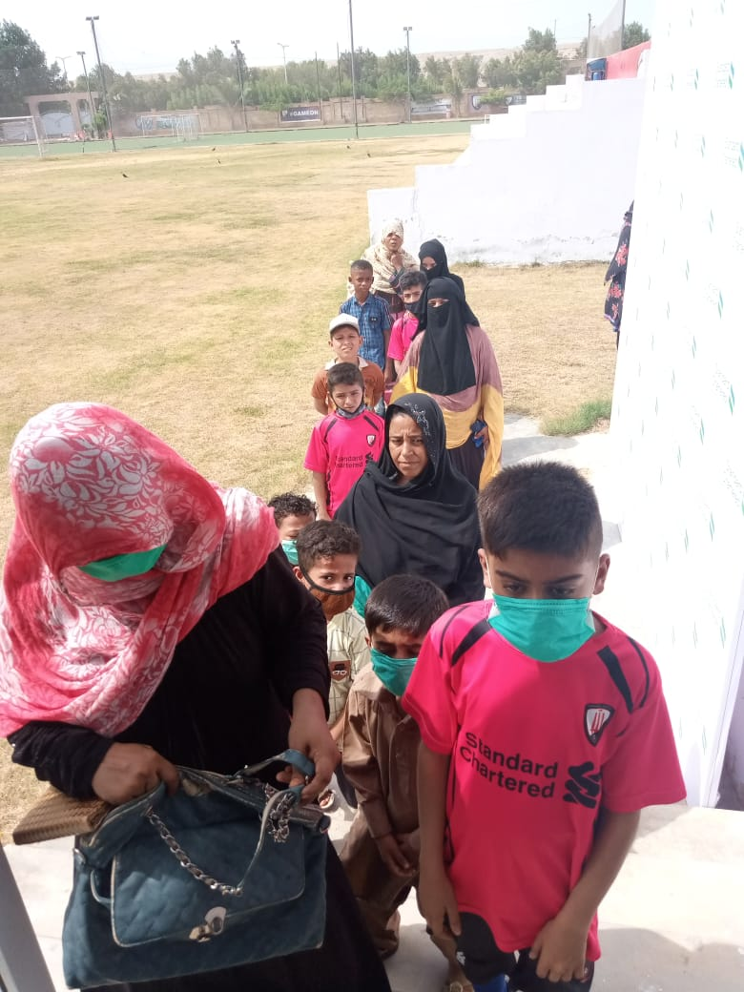

Figure Ladies are waiting for their turn to collect the ration bags at Karachi United Stadium

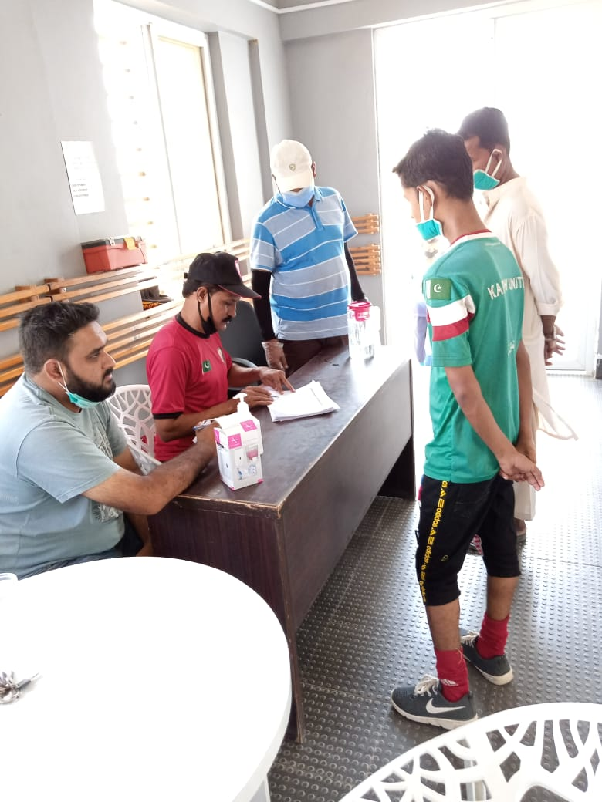

Figure Community centers’ players are collecting ration bags from the counter at Karachi United Stadium

**Partnership between Karachi United and Storm Fiber**

Karachi United is going through the financial challenges during this Covid-19 pandemic. It has been almost 4 moths that all operations of Karachi United are suspended. Therefore, retaining all coaches was a difficult task for Karachi United but Karachi United does not want to leave their coaches alone in this uncertain situation. Thus, Karachi United collaborated with fiber storm and provided Karachi United 14 community coaches, who have the skills other than coaching, a job opportunity in fiber storm such as technicians and call agents. Now, these 14 coaches are working for Fiber Storm. Out of the 14 coaches two coaches, Daniyal and Najeeb, are the Karachi United Academy coaches.

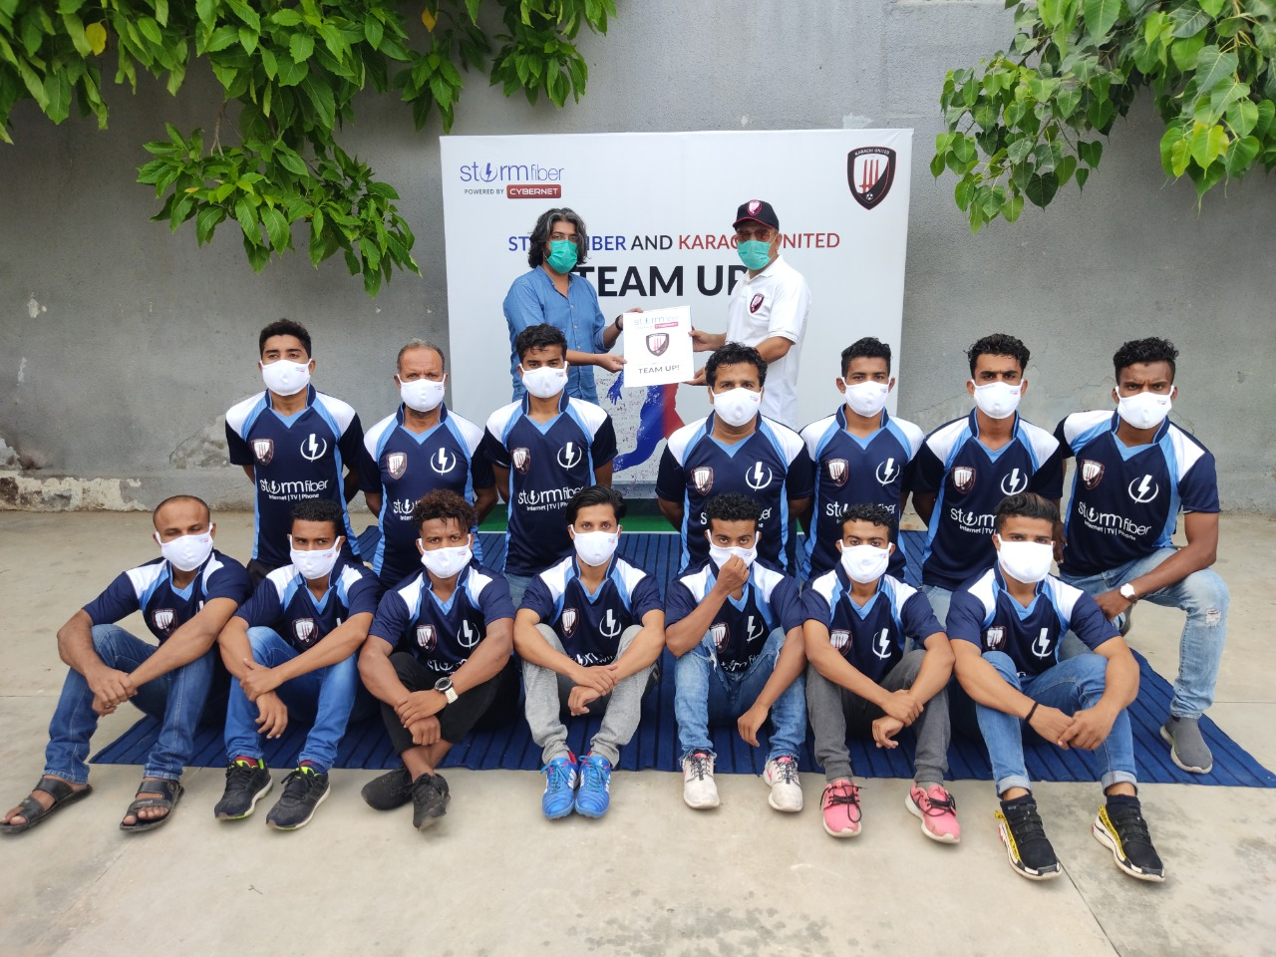

Community coaches are posing on the first day of the job at Fiber Storm Head Office on 20/7/202