**Quarterly Report**

**Uplift Community through Football**

**Karachi United Standard Chartered Youth League 2022:**

Karachi United in collaboration with Standard Chartered Pakistan successfully launched the 5th “Standard Chartered Karachi United Youth League” as part of the community service mandate to promote sports amongst young and passionate children.

This League is sponsored by the Standard Chartered Bank since its inception in 2017 and has supported over 4000 children through sports to empower and train them to live their dream. The Youth League provides this opportunity to over 1000 children annually. This is one of the mega events that provide platform to young girls and boys to showcase their football talent. Before the commencement of the league, players attend proper training and prepare them for this league. The opening ceremony of the league took place on 25th, Nov, 2022 at Karachi United Football Stadium. It will be 3 months-long league in which teams from various community will take part. The main objective of this league is to pull out youth from injurious activities and equip them with platform where they can utilize their energy in positive manner.

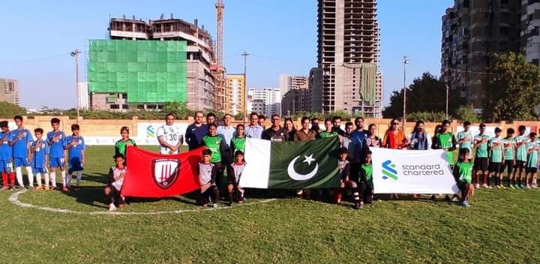

Figure 1 Opening ceremony of youth league at Karachi United Football Stadium

**Voice against Tobacco:**

Karachi United signed a MoU with Voices Against Tobacco (VAT) alongside Indus Hospital & Health Network (IHHN) to advocate for Tobacco Control during this period. Our Coaches will be working closely with VAT to carry out their advocacy duties. This will aid the efforts of anti-tobacco to reach a larger scope by creating youth advocates from diverse backgrounds.

Karachi United staff and coaches attended a training session hosted by Voices Against Tobacco (VAT) at Indus Hospital & Health Network as part of our on-going collaboration to empower healthier communities. The training focused on key facts, raising awareness, and how to support players to quit the use of tobacco and nicotine products. By creating a sustainable model through such trainings, the anti-tobacco message will reach a much greater audience from a wide array of backgrounds.

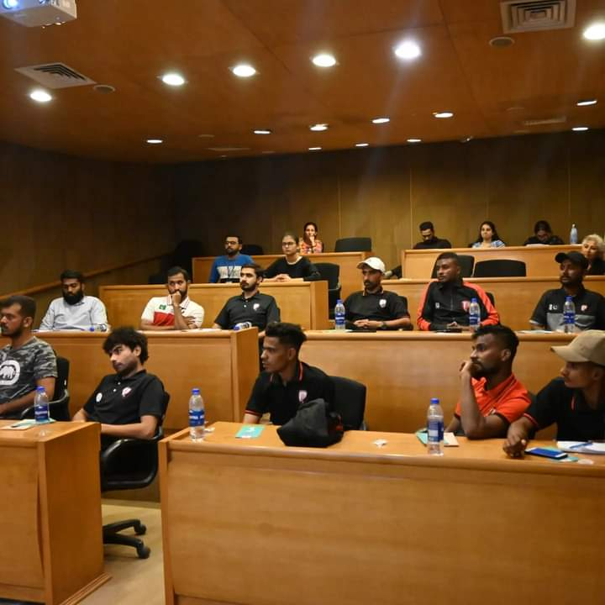

Figure Karachi United Staff and Coaches attended training Sessions at Indus Hospital

**Football and Life Skill Training Session:**

Football is one of the most effective tools of community empowerment and Karachi United is humbled to contribute to this mission. Karachi United offers weekly football and life skill sessions at community centers. Football training aims to build confidence in the players and polish their untapped talent. Football training sessions prepare the players to perform well in various football tournaments arranged by local clubs, domestic and international tournaments. Whereas, life skill sessions inculcate values in the players and motivated them to be good human beings. The life skill sessions also encourage them to face the difficulties of life with confidence.

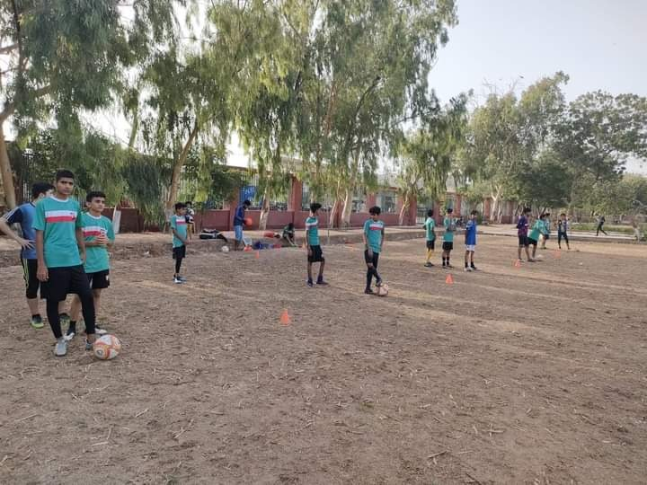

Figure Players are engaged in a football training session at Golimar Center