Quarterly Report
Uplift community through Football

Women Empowerment Cup:
Karachi United in partnership with Engro organized women empowerment cup during this period. The cup was begun on 9th January and ended on 22nd January. Girls are often barred from fields for various sport in developing countries like Pakistan. The main objective of this cup was to encourage the girls to take up the sports. Karachi United always believes in gender equality and provide equal opportunities to men and women. A total of 8 team participated in Women empowerment cup and each team consist of 9 players. This cup has given the girls strength and confidence and encouraged them to pursue their dreams.
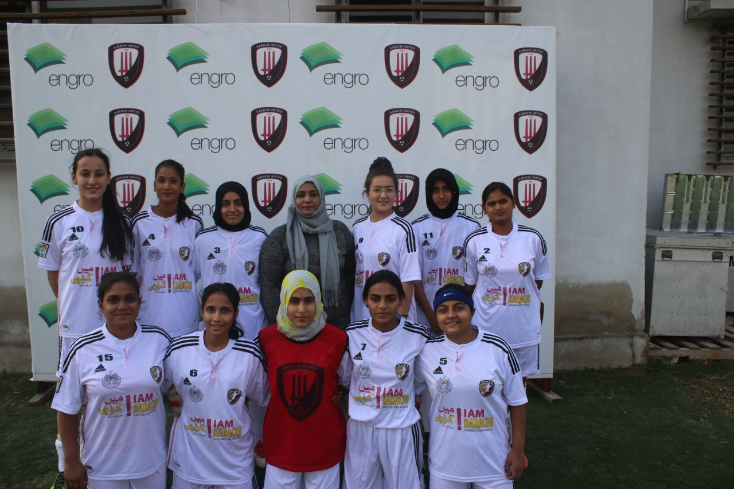
Figure 1 Players pose for a group photo

Standard Chartered Karachi United League:
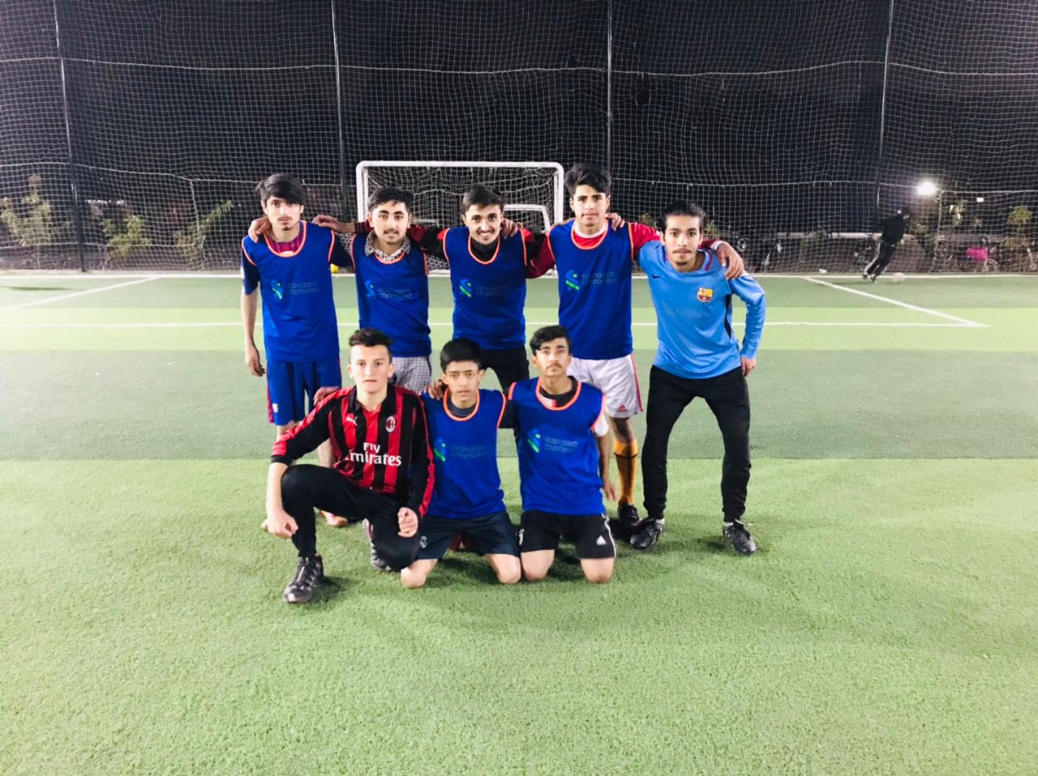
The SCB KU Youth League, which is aimed at promoting sports amongst children, and pull them out of destructive activities such as kite flying, marbles, card, drug abuse which are very common in under developing areas of Karachi, started in January. A total number 28 team participated in these 3 months long football league which consists of 22 boys and 6 girls’ teams. The boys were from the age category of U-10, U-12 and U-14, each category. Teams will play 170 matches during three months period and 26 matches have been played so far.

Figure 1 team pose for a group photo before starting match

