**Quarterly Report: February to April 2019**

**Uplift the Community through Football**

**YOIS Football Tournament:**

Karachi United believes that prison should be about rehabilitation; a place to create opportunities for healing and personal transformation. With this view, Karachi United formed partnership with Committee for the welfare of Prisoners-Legal Aid Office & Women Development Department, Government of Sindh organized two days “YOIS Football Tournament” to promote football among Prisoners. The main purpose of this tournament was to provide a platform for juvenile prisoners to enhance their social & intellectual skills, moral values, personality progress and character building inside prison.

Final took place between YOIS Karachi Prison team and Old Golimar Center. Both teams performed very well, juvenile prisoners exhibited great spirit of sportsmanship. After a tough match, the YOIS Karachi Prison team won the final through penalty shootout. I.G Prisons Sindh, Mr. Muzaffar Alam Siddiqi, Chairman CWP-LAO, Justice (R) Nasir Aslam Zahid, Secretary Women Development Department, Alia Shahid and DIG Qazi Nazeer Ahmed distributed the trophies among winning team & runners up team.

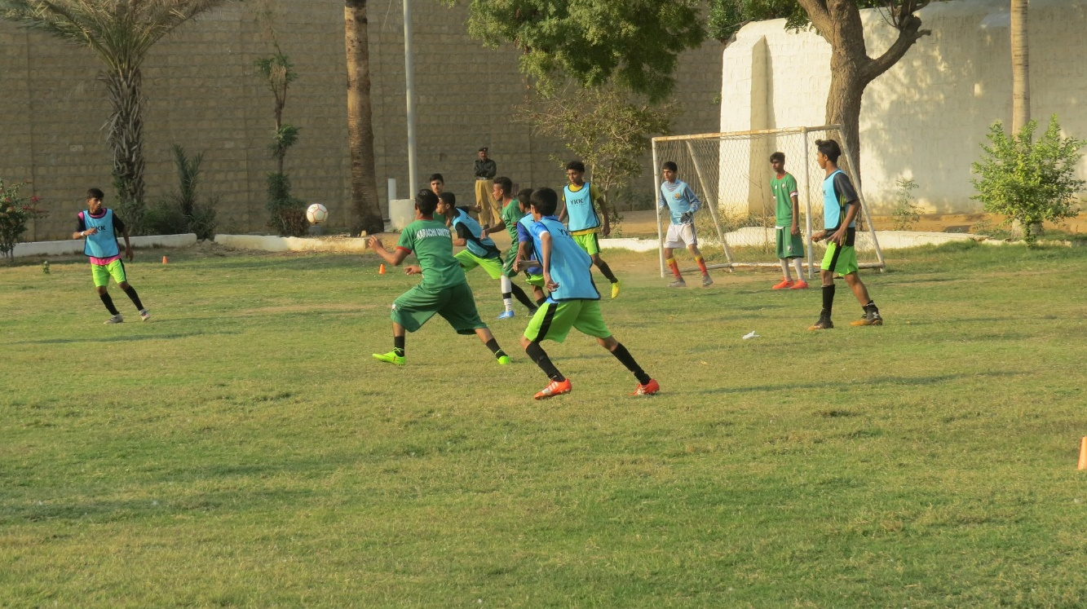

Figure final match between Old Golimar Center & YOIS Karachi Prisoner Team on 13/2/19 at Central Jail

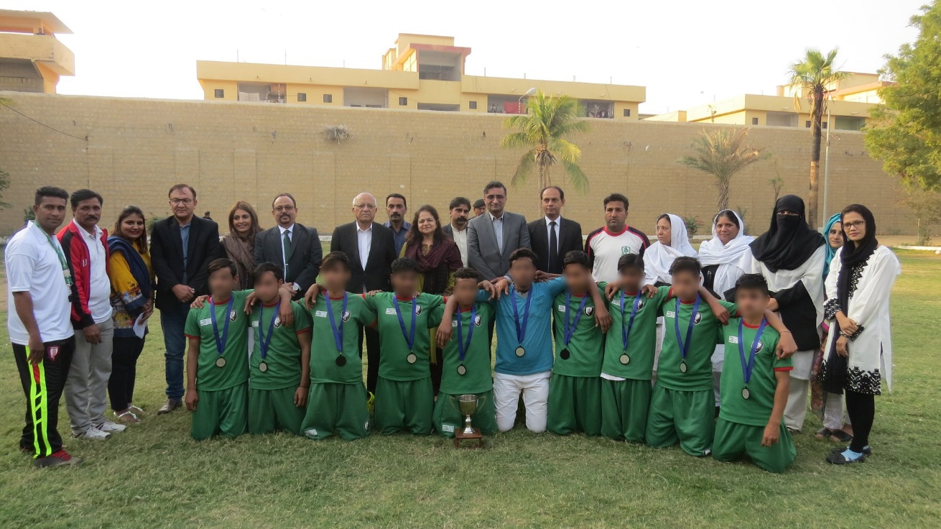

*Figure 2 A group photo of YOIS prisoner team with guests and organizers*

**Parental Engagement Session:**

Parental engagement session was conducted on 10th March, 2019 at Karachi United Football Stadium. It was an activity based session in which more than 80 parents of youth from different centers were present. Mr. Talib, Program Manager, commenced session with the introduction of KUFF. He explained that KUFF has taken initiative to counter violence and extremism through football. He further added that KUFF has opened football centers in those areas where youth is being manipulated towards malpractices. KUFF engages vulnerable youth in constructive activities like football which nurture their creativity and make them a better person. Mr. Talib put emphasizes on the role of parents and requested them to spend time with their child and talk about his/her day activities. He further added that parents should also ask their children about their friends because VE groups first offer friendship to youngsters then indulges them into immoral activities. It is a prime responsibility of parents to keep an eye on the companionship of their children. Youth workers also spoke on this occasion and encouraged the parents to support Karachi United in moving youth towards right direction.

A group activity was conducted during the parental session. Parents were supposed to stand in a circle and a ball of yarn was given to them. They have to introduce themselves and child too, one good habit and another one habit which he wants to change, hang onto the end of the string and tossed the ball to someone else in the circle. The receiving person did the same until everyone in the group has become part of the web. The main objective of this group activity was to break the ice among parents so they can know about each other. It was also discussed that a web was formed because every individual supported if any of them left the foundation, the web got weak; similarly to make society a better place to live, we have to develop strong bond with each other. We have to support every ethnicity, religion, race and gender so they contribute in the betterment of the society. At the end of the session, lunch was served to parents.

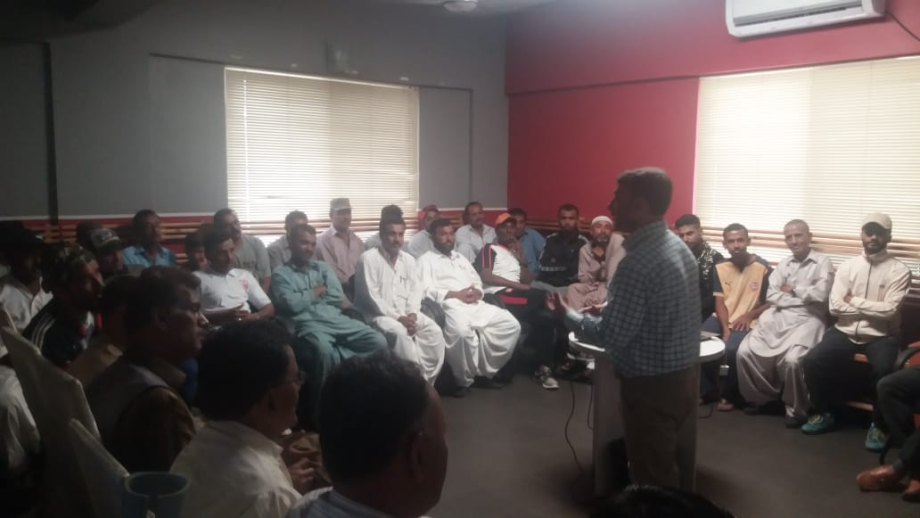

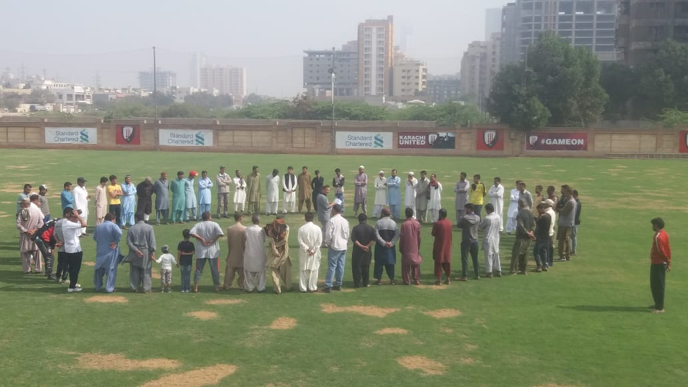Figure 1 Youth worker is addressing to parents at Karachi United Stadium

Figure 2 Parents are standing in a circle for group activity

**Karachi United School Championship XIV:**

Statistics show that students participating in team sports are more likely to have higher grade point averages. Students involved in sports seem to have a more positive attitude toward school and in many cases, are higher achievers. School-based sports programs can bring out noticeable positive reactions and behaviors in students. Karachi United provides platform for students from different schools to have healthy competition and opportunity to pursue their passion professionally. This years’ event was the 14th event of its kind being held by KU since 2005. A total of 52 teams played qualifying matches out of which 24 teams qualified for the main KUSC.

KUSC XIV proved to be a roller coaster ride as all teams went neck to neck to become the champion. KUSC XIV was full of thrilling and exiting matches that grabbed the interest of the audience throughout the tournament. A total of 171 matches were played during KUSC. Elimination of Bahria College in the quarter final was a shock exit because Bahria College showed outstanding performance throughout the competition and it also qualified for final last year. Cedar College beat Agha Khan College in semifinal, held at Karachi United Stadium. Whereas defending champion, Nixor College faced Foundation Public School in semifinal and won the semifinal by 1-0 goal. KUSC XIV final was held between Cedar College and Nixor College at Karachi United Stadium in which Cedar college thrashed, the last year champions, Nixor College by 1-0 goal to clinch the championship trophy title. Students of Cedar and Nixor College showed up to cheer up their teams. Saddam Hussain, Captain of Pakistan football team, was also present on the occasion. All matches from quarter final stage were screened on the Karachi United Facebook page along with Sports Vision YouTube channel.

KUSC XIV girls and junior school were also held during this month. A total of 16 girls’ team and 20 junior boys’ team participated in the competition. The final of girls KUSC took place between Agha Khan School and Generation school at Karachi United Stadium in which Agha Khan beat Generation by 3 goals. Whereas Foundation Public School and St. Micheals Convent School qualified for final in junior boys KUSC. Both teams could not score any goal within given time resulting in a draw. The winner of the tournament was declared through penalty shoot-out in which St. Micheals Covent School scored 2 goals while Foundation Public School scored 3 goals and won the championship. Mr. Saddam Hussain, Captain of Pakistan football team and Mr. Umair, Director of Cedar College, were the chief guests of the event and they distributed prize amongst the players. The winners of KUSC XIV are as follows:

|  |  |  |  |
| --- | --- | --- | --- |
| **Category** | **Boys** | **Junior Boys** | **Girls** |
| **Winner** | Cedar College | Foundation Public School | Agha Khan School |
| **Runners up** | Nixor College | St. Micheals Covent School | Generation School |
| **Golden Boot** | Najam Naqvi from Foundation Public School | Ibrahim from St. Micheals Covent School | Shumaila from Agha Khan School |
| **Most Valuable Players** | Fasih from Cedar College | Hassan Naeem from Foundation Public School | Maryam Zehri from Agha Khan School |
| **Golden Glove** | Bilal Imran from Cedar College | Usman Amir from Foundation Public School | Amina Butt from Agha Khan School |

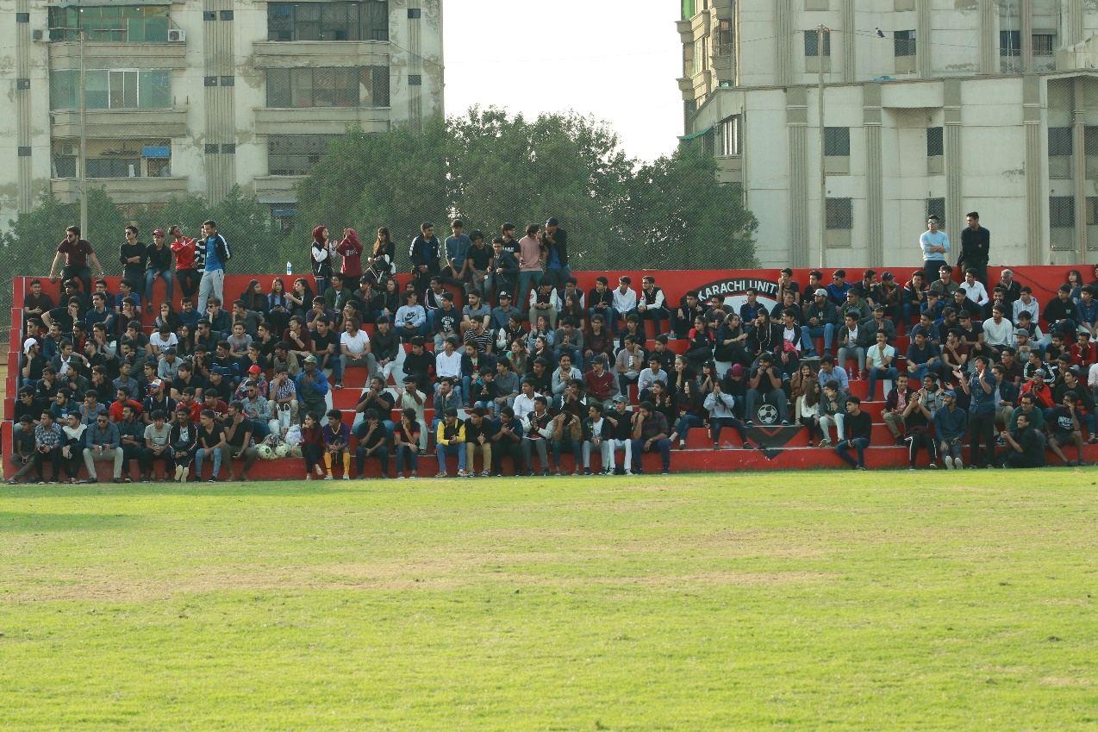

Audience is enjoying KUSC XIV final at Karachi United Stadium

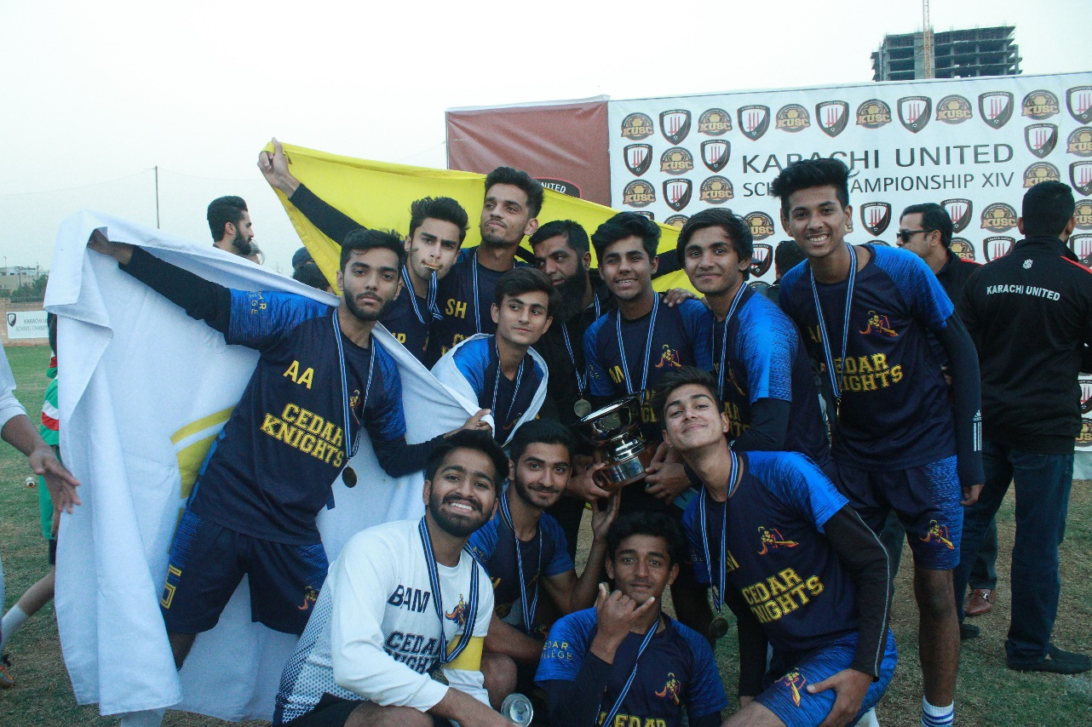 *Players of Cedar College pose with trophy after winning KUSC XIC*

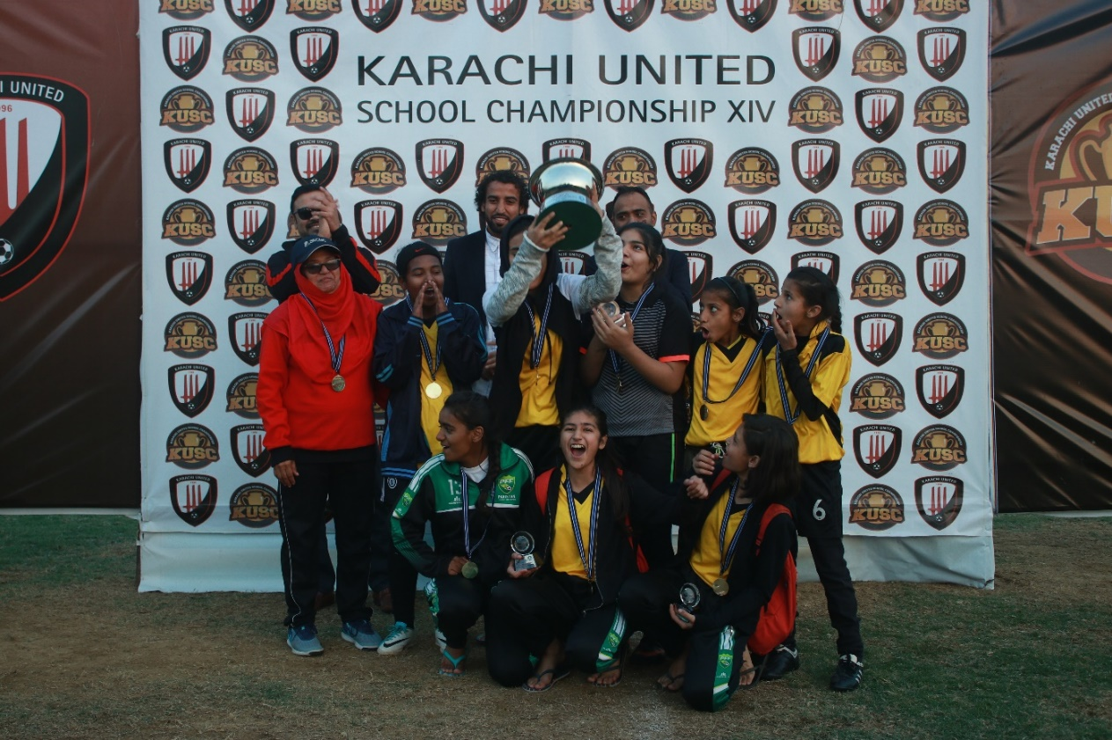

Figure 4 Agha Khan School lifts the champion trophy of KUSC XIV

**First Quarterly Tournament:**

Karachi United organized first quarterly tournament in which a total of 8 teams participated who belong to different demographics. The main objective of this tournament was tobring the youth closer who lack interaction due to demographic distance between different areas. Youth today has very less opportunities where they can interact and get to know each other better. Karachi United provided them a platform where they showcased their football talent as well as they got chance to interact with the players outside their community which bridged the gap between different communities. Teams were divided into following groups:

**Group ‘A’ Group ‘B’**

1. Ibrahim Hyderi 1. Muaripur
2. Chakra Goht 2. Saeedabad
3. KUFF Academy 3. Lyari Khadda Memon (Kakari)
4. Shireen Jinnah 4. Lyari Chakiwara (Gen)

Matches were organized at Karachi United Stadium, Baloch Mujahid and Baldia football ground. The tournament was a great opportunity for the players to enjoy friendly competition in a safe and professional environment as they usually don’t get the chance to play high level competitions. In order to increase the standard of the tournament, official referees and match commissioners were appointed for every match. Football standards were followed during the tournament e.g. scrutiny before match, match reports, yellow cards, red cards, first aid medical facilities and light refreshment at the end of each match. A total of 16 matches were played and each match was 60 minutes long. Following table summarizes the result of the tournament:

|  |  |  |  |  |  |  |  |
| --- | --- | --- | --- | --- | --- | --- | --- |
| **Results** | | | | | | | |
| **Match** | **Venue** | **Date** | **Group** | **Team** | **Results** | | **Team** |
| 1 | KU Stadium | 22-Feb-19 | A | Ibrahim Hyderi | 1 | 1 | Chakra Goth |
| 2 | KU Stadium | 22-Feb-19 | A | Shireen Jinnah | 0 | 0 | KU Academy |
| 3 | Baldia | 22-Feb-19 | B | Maripur | 0 | 3 | Chakiwara |
| 4 | Baldia | 22-Feb-19 | B | Khadda Memon | 1 | 0 | Saeedabad |
| 5 | Baloch Mujahid | 23-Feb-19 | A | Shireen Jinnah | 0 | 1 | Chakra Goth |
| 6 | Baloch Mujahid | 23-Feb-19 | A | KU Academy | 2 | 0 | Ibrahim Hyderi |
| 7 | Baldia | 23-Feb-19 | B | Khadda Memon | 0 | 3 | Chakiwara |
| 8 | Baldia | 23-Feb-19 | B | Saeedabad | 2 | 1 | Maripur |
| 9 | Baloch Mujahid | 24-Feb-19 | A | Shireen Jinnah | 1 | 1 | Ibrahim Hyderi |
| 10 | Baloch Mujahid | 24-Feb-19 | A | Ku Academy | 3 | 1 | Chakra Goth |
| 11 | Baldia | 24-Feb-19 | B | Khadda Memon | 0 | 3 | Maripur |
| 12 | Baldia | 24-Feb-19 | B | Saeedabad | 1 | 1 | Chakiwara |

The semi-final was held on 1st March at Karachi United football stadium in which KU Academy faced Saeedabad. It was a thrilling and exciting match that captured the interest till the last moment. Both teams could not score any goal within given time and result was decided through penalty shoot-out in which KU Academy scored 5 goals and Saeedbad scored 4 goals. Chakra Goth played 2nd semifinal against Chakiwara in which Chakiwara beat Chakra Goth by 1 goal. The final took place between KU Academy and Chakiwara on 2nd March 2019 at Karachi United Stadium. Both teams performed very well and went neck to neck to win the tournament. Both teams could not score any goal so to declare the winner of the tournament through penalty shoot-out, both teams were given the 5 chances to score the goal in which KU Academy could score only 3 goals while Chakiwara scored 4 goals and became the champion of the first quarterly tournament. The prize distribution ceremony was held at Karachi United Stadium. Mr. Asad Esa, Manager of Youth Program, and Mr. Sadiq, Football Coach at National Bank of Pakistan were invited as a chief guest who distributed trophies and medal amongst players. The winners of first quarterly tournament are as follows:

|  |  |
| --- | --- |
| **Category** | **Name** |
| **Winner** | *Chakiwara* |
| **Runners Up** | *KU Academy* |
| **3rd Position** | *Saeedabad* |
| **Best Coach** | *Dostain from Maripur Center* |
| **Man of the Match** | *Sameer from Chakiwara Center* |
| **Best Player** | *Azaan from KU Academy* |
| **Best Goalkeeper** | *Kashif from KU Academy* |
| **Fair Play Award** | *Ali from Chakra Goth* |

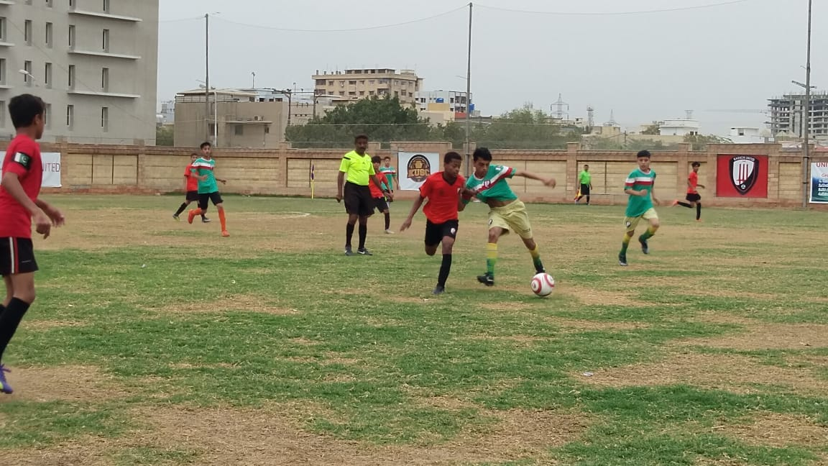

Figure 1 Semifinal between KU Academy and Saeedabad on 1/3/19 at Karachi United Stadium

**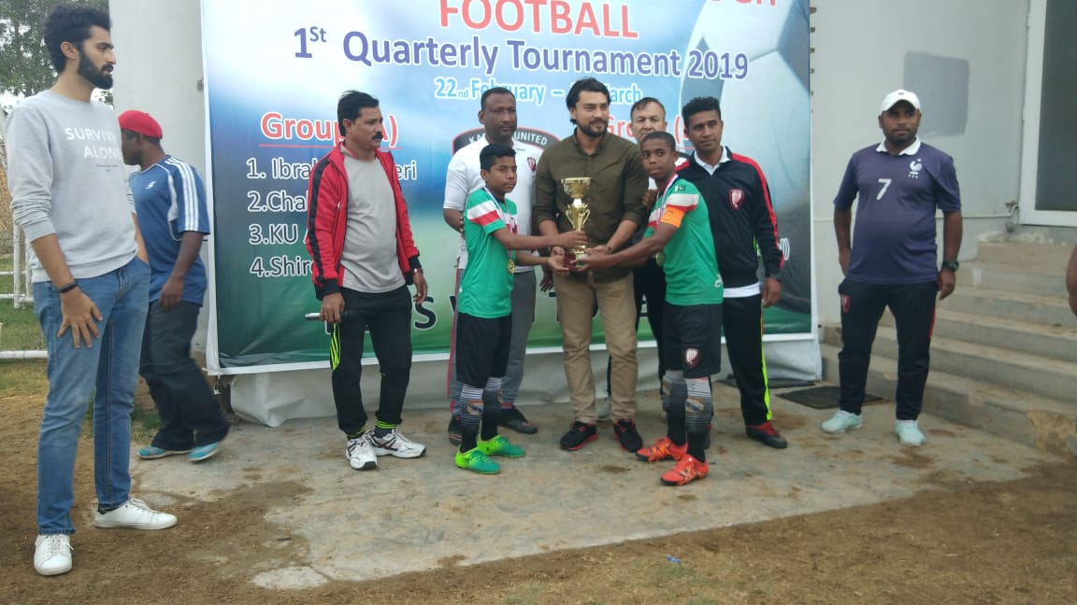***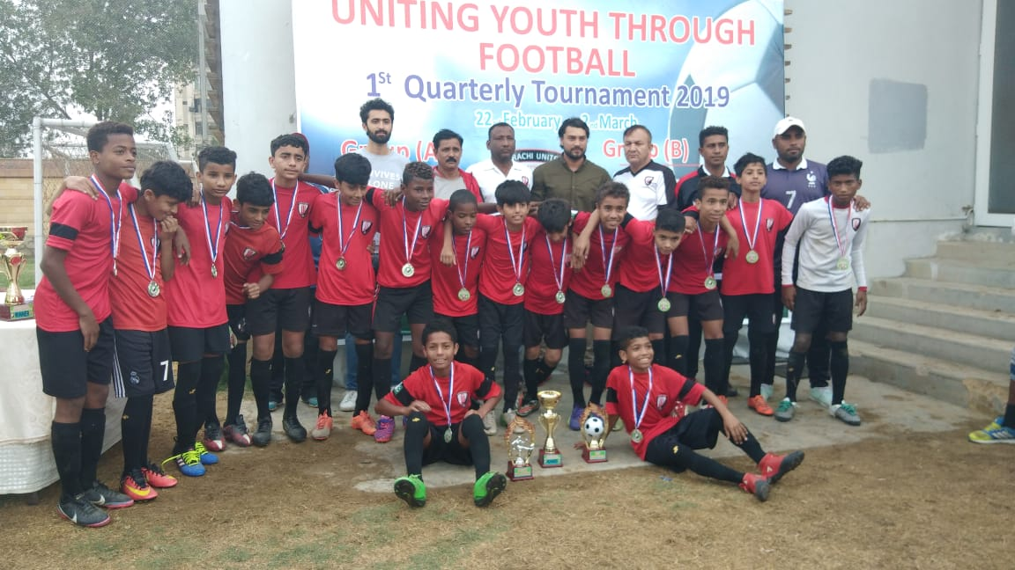Figure 4 Players of Karachi United Academy pose with trophy*

Figure 3 Mr. Asad, Manager of Youth Program, is handing over the trophy to the winning team (Chakiwara)