**Quarterly Report: February to April 2020**

**Uplift the Community through Football**

**Inclusive Football League:**

With the remarkable success and very positive feedback from the last year inclusive football league, Karachi United, kicked off 2nd inclusive football league during this period. The aim of this league is to promote sports among underprivileged children as well as young students of *Madrasah* (religious institutions). This league provides a platform for Young football teams from across the under-served areas of Pakistan (Karachi) to come together, break barriers and inculcate the spirit of competition.

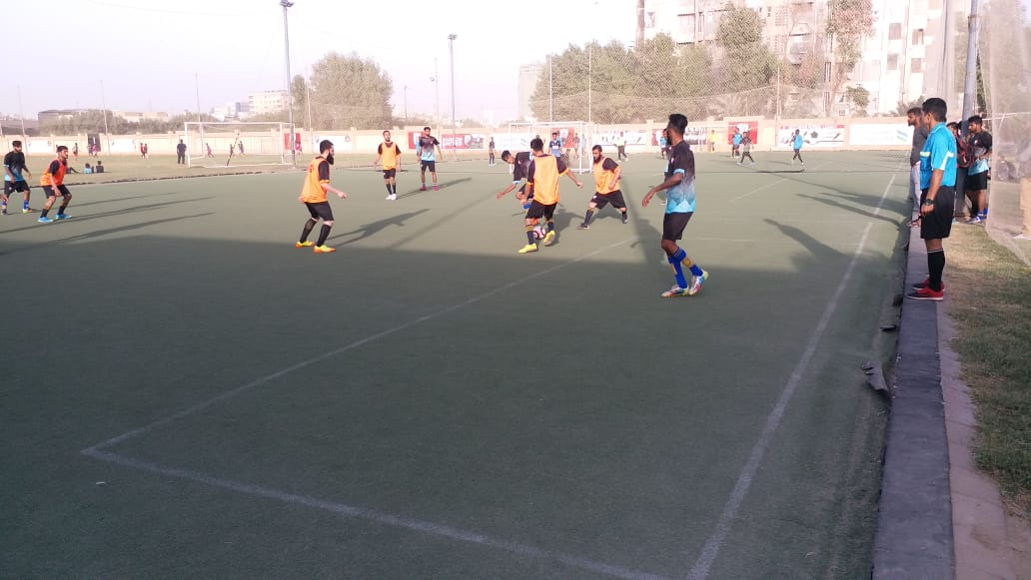Group matches of inclusive football league II take place on every Thursday and Friday at Karachi United Football turf. Karachi United is providing transportation facilities to all teams and also providing light refreshment at the end of each match. Teams are showing fabulous performance as there were some matches in which teams scored equal goals which indicates that kids have football potential and they need platform through which they can showcase and polish their football skills. A total of 30 matches have been taken place as of writing date of this report.

Figure 1 Ibrahim Hyderi center and Qurtaba are in action during the match

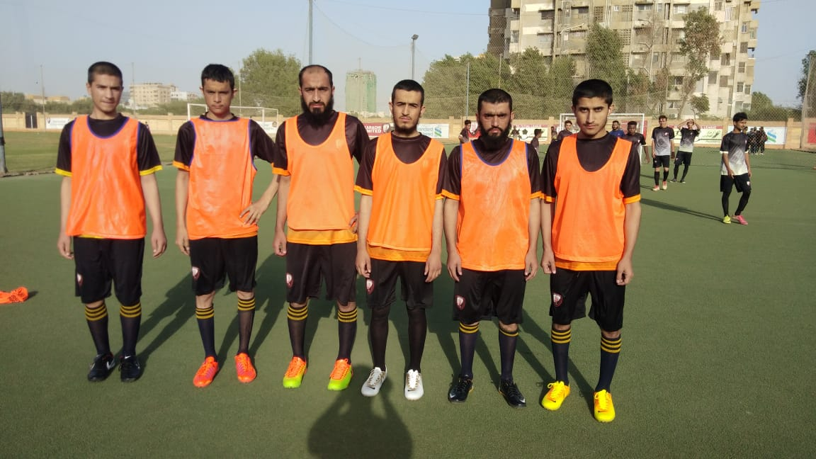Figure 2 Madrasah players posed for a group photo before the match

**Maripur Football Tournament:**

Karachi United Maripur community center organized a football tournament during this quarter. It was two week long tournament in which 8 football teams participated and these teams belong to Maripur area. The main purpose of organizing this tournament was to promote football and to engage the youth in constructive activities. According to organizers, Maripur is one of the areas where youth is deprived of sport activities and young kids are indulged in violent act. This football tournament was held in order to prevent the youth from violence. A total of 16 football matches were played during the tournament. The final was held between Maripur Center and a local Maripur football club in which Maripur Center beat the local club team by 4 goals and became the champion of the tournament. Trophies and Medals were distributed amongst the players of runner-up and winner team.

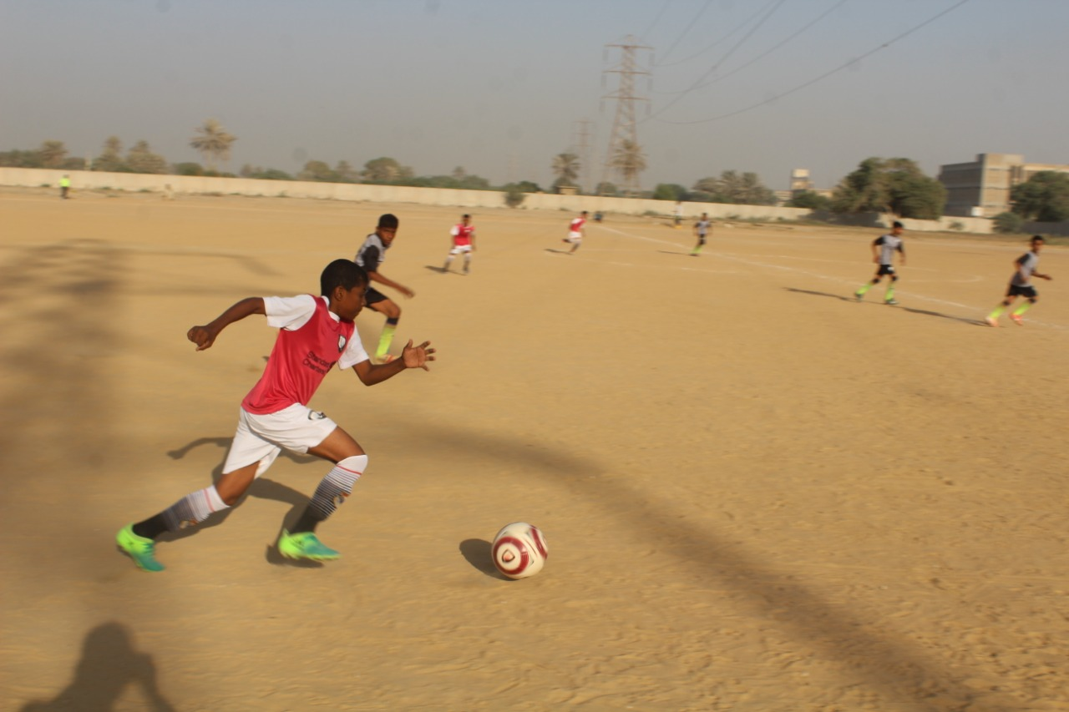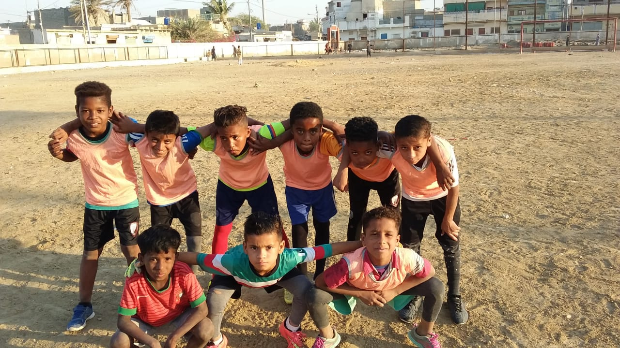

Figure 2 Teams are in action during tournament

Figure 1 Players posed for a group photo before the match

**Liverpool Football Club Training:**

Standard Chartered Bank provided the opportunity to 12 Karachi United coaches to attend “Train the Trainer Workshop” held in Dubai from 20th to 24th February. 2 UEFA A Licensed Coaches from Liverpool FC International Academy conducted the program in which they shared different coaching techniques and methods. These 12 coaches work with the 1000+ children from underserved areas of Karachi who participate in different football tournaments and this training program has up-skilled them and they can now educate the children better about the football fundamentals.

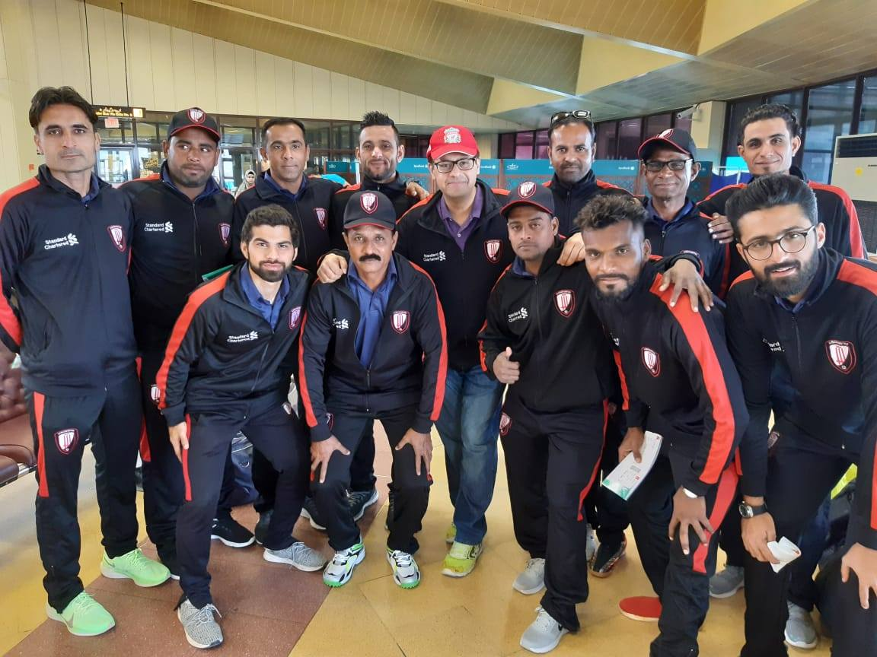

Figure 1 Karachi United coaches posed for a group photo before departing for the workshop

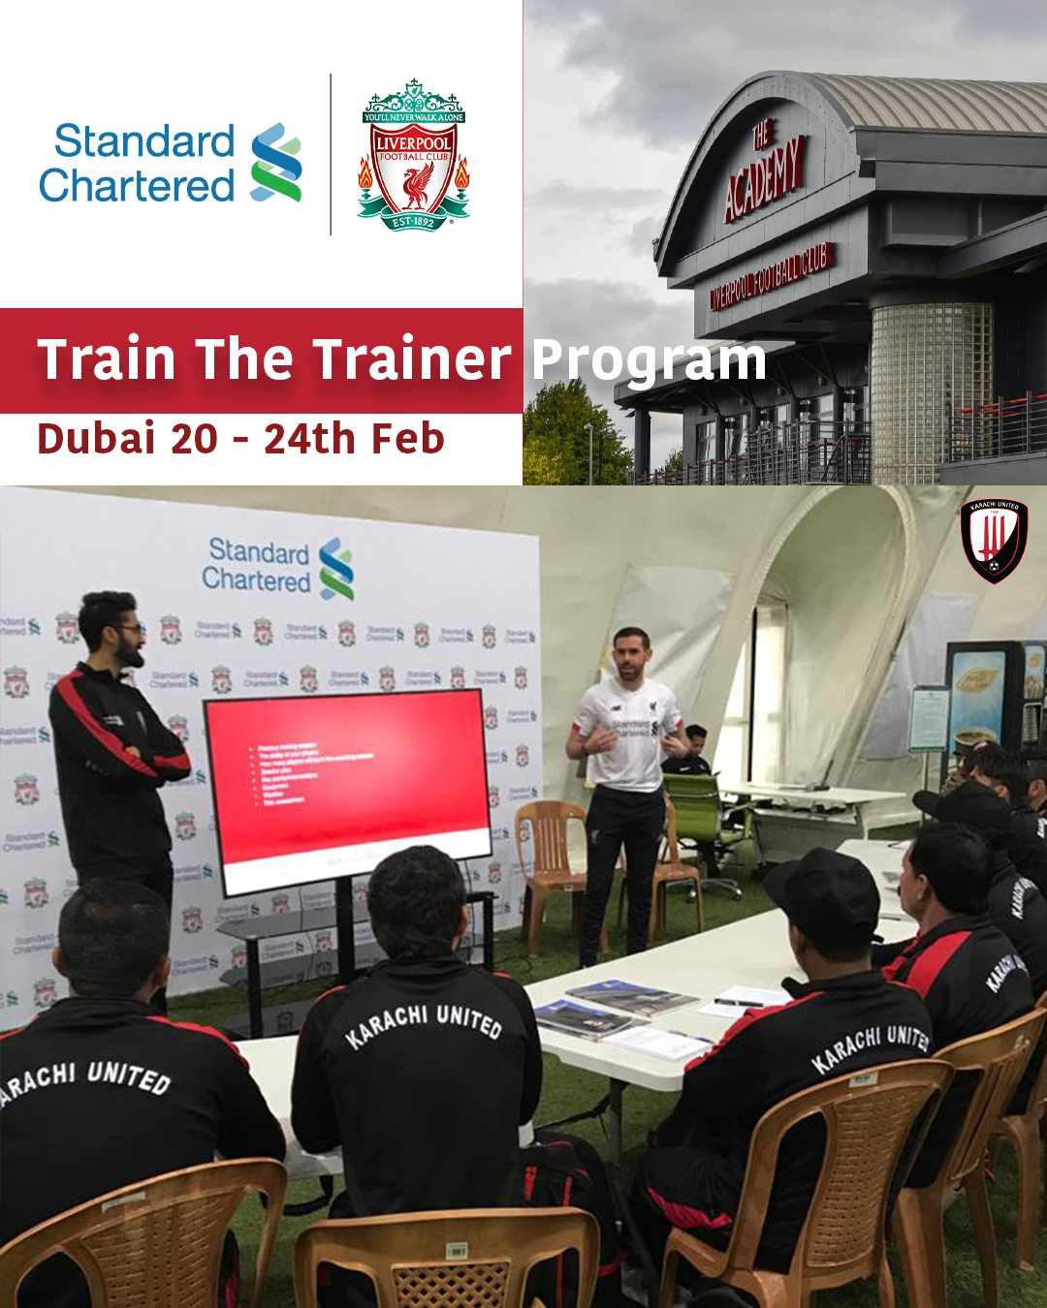

Figure 2 Karachi United coaches are attending the workshop in Dubai