Quarterly Report: November to January 2019
Uplift the Community through Football

Health Camp & CPR Training:
To be efficient, competitive, result oriented and to keep the momentum remains; football players have to be mentally and physically fit. Thus along with training and practice they need proper diet and medical check-ups in due time. Karachi United considers all these factors specially the health of players, therefore a medical camp was organized in month of November at Karachi United Stadium, Old Golimar, Malir, Maripur Centers and Al-Qadir Girls School. Karachi United Team organized health screening and medical training sessions in collaboration with Agha Khan Hospital. It was 3 hours long camp consist of health screening, ECG (Electrocardiogram) and training on CPR (Cardiopulmonary resuscitation). More than 200 players attended the Camp. For health screening, the doctors developed the questionnaire based on American Heart Association format to collect the medical history of the players and their family. After collecting the medical history, they were taken to have an ECS to detect the cardiac problem in them. During the session, doctors shared certain sports injuries and to overcome with that by also demonstrating and giving some life saving tips.

Usually Sudden Cardiac Arrest (SCA) is the leading cause of sudden death in athletes during sport. Sometimes rigorous playing on the fields may sustain severe traumatic injuries causing sudden cardiac attacks among players and waiting for arrival of medical professional can be malignant. By the time medical personnel reaches the spot it would be too late for the player to survive. During such medical emergencies knowledge of CPR can save the life of the victim so that training on CPR was given in which step to perform CPR such as verifying breathing and heart rate, calling ambulance, position of hands, and chest compressions were shown to players.
Health Camp for the Parents of the Players of Community Centers:
Karachi United organized health camp for the parents in the month of December. Parents from Shireen Jinnah, Malir and Maripur showed up and shared their health issues with doctors. Doctors also talked about causes of common health problems like blood pressure, diabetes, stress and acne and what healthy changes they should make in their daily life to avoid such health issues. The main objective of this activity was to educate parents about healthy practices and motivate parents to make healthy choices to stay active.
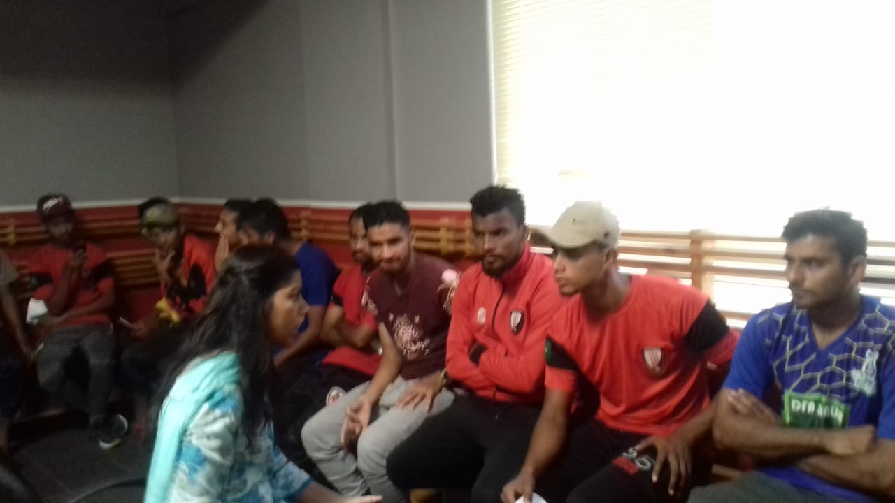
Figure 1 Medical Camp Session being conducted at Karachi United

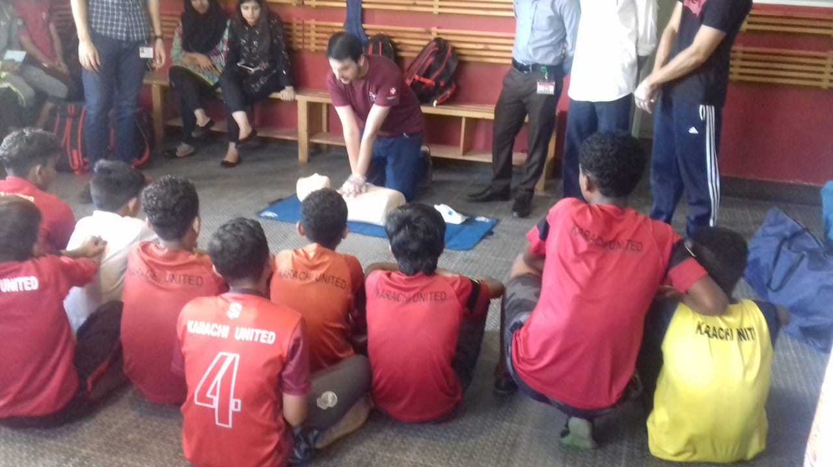
Figure 2 Doctor is performing chest compression technique on dummy during CPR training

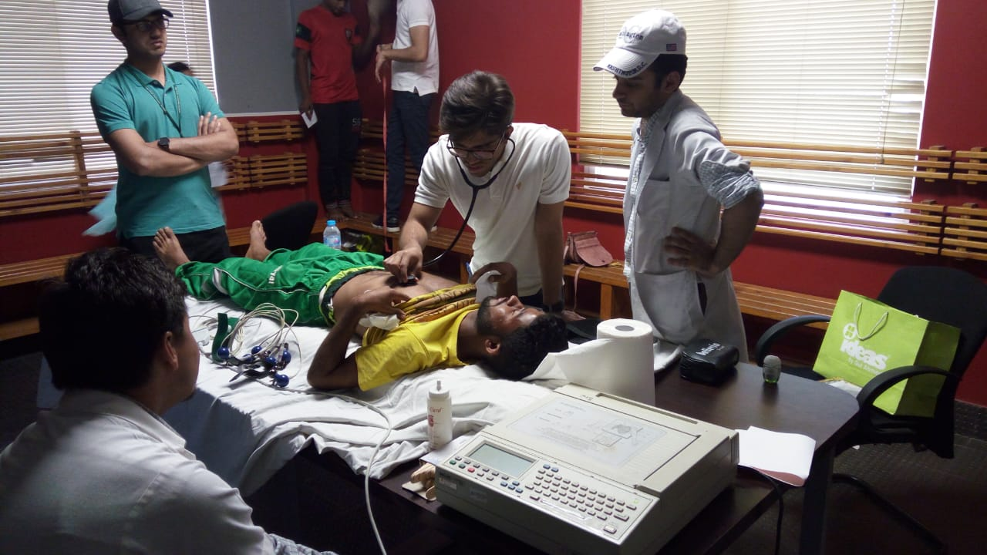

Figure 3 Doctor performing ECG test of the athlete on 17/11/18

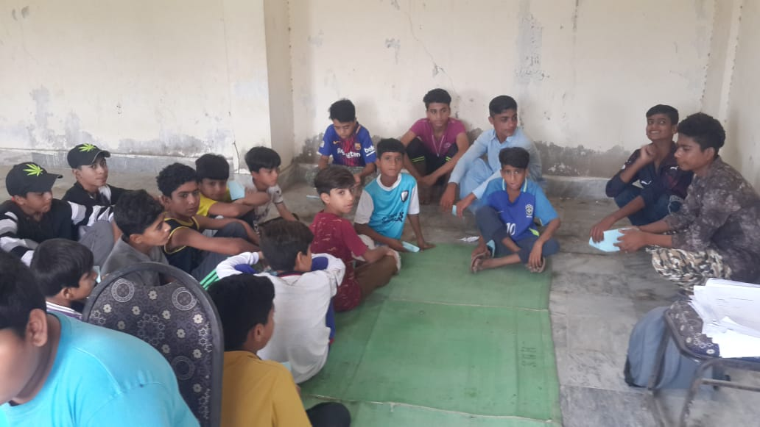
Figure 4 Boys are attending CPR training at Malir Center

Parental Engagement Session:
The Role of the parents in developing the positive attribute in a child is inevitable as their actions, beliefs, and attitudes become integrated into the children’s way of being; therefore, it is very important that they should be very intentional about what behaviors they model for their children. Keeping this in view, Karachi United held the parental engagement session on 15th December at Karachi United Academy. It was 2 hours long session in which 40 parents were present. The main objective of this session was to brief the parents about the football and life skill training session and role of the parents in promoting the positive emotional health of their kids. Mr. Talib, Program Manager, explained that the main objective of the program is to develop the tolerance & acceptance in youth because this youth face formidable challenges like unemployment, corruption, political influence which increase the risk of internal conflict and violent extremism. He further added that today the youth is surrounded with negativity and despondency so they are in dire need of a path that can assist them to embrace diversity and become pessimistic towards the hardships of the life.
Karachi United has taken a step to provide the youth a platform where Karachi United is not only polishing football skills of youth but also inculcating positive attributes in them through life skill sessions. He explained that the life skill sessions are conducted once in a week at each Center in which youth worker shares the success stories of the world renowned footballers like Ronaldo and Lukaku. The purpose of sharing the inspirational stories is to provide the youth the positive role models and demonstrate boys that passion, determination, and hard work are key factors to success irrespective of financial status, language, ethnical, religious, and racial differences.
Youth workers also spoke on the occasion and encouraged parents to have positive interaction with their children as it contributes to the longevity of their social and emotional development. Youth workers also highlighted that parents should provide friendly environment in which children should be encouraged to share their problems he/she is facing outside. This will boost up their confidence and will sharpen their cognitive skills that are essential to perform well in academia as well as other sport activities. Youth workers requested parents to be supportive with Karachi United in eradicating the negativity and brining positive change in youth because without the parental support the long lasting positive change cannot be brought in the society.

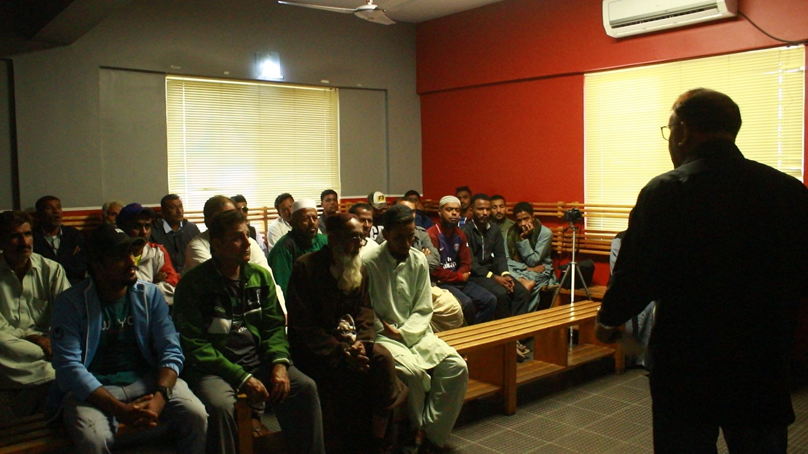

Figure 1 Mr. Talib, Program Manager, is explaining the objective of the project to the parents

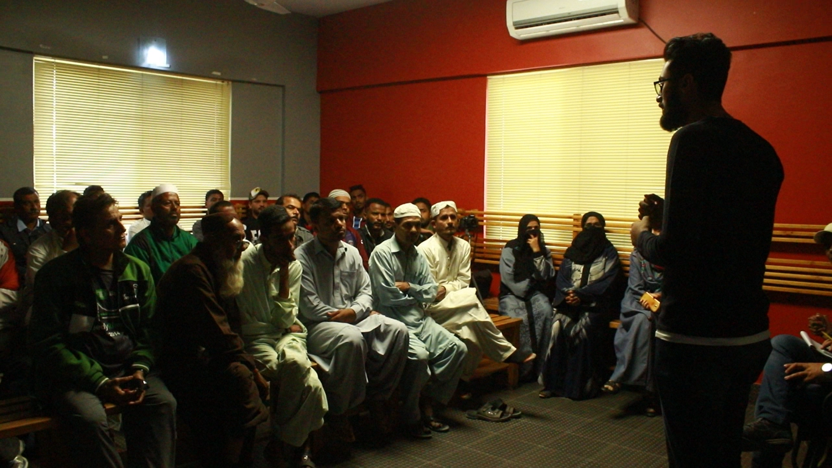

Figure 2 Youth Worker is explaining the objective of life skill sessions to the parents

SCB-KU Youth League 2018:
The SCB KU Youth League, which was aimed at promoting sports amongst children, and pulled them out of destructive activities such as kite flying, marbles, card, drug abuse which are very common in under developing areas of Karachi, ended during the month of December. Baldia U-10, KU Academy U-12, Lyari Kakri U-14 and Agha Khan Girls School lifted the champion trophy of this league. The real motive of this league was to give these players who don’t get the chance to play high level competitions, a chance to get the feel of international professional events. In order to increase the standard of the league, official referees and match commissioners were appointed for every match. A total number of 720 boys and 80 girls participated in the three-month long football league that involved 44 teams – 36 boys and eight girls. The boys were from the age category of U-10, U-12 and U-14, each category having 12 teams each. The girls had eight teams and over a three months period these team played 128 matches but were also involved in building the players’ character and improving their skills that helped them in making their life better.
The prize distribution ceremony was held on 17th December at Karachi United stadium. Mr. Imran Ali, CEO of Karachi United and Shazad Dada, CEO of Standard Chartered were also preset on the occasion and distributed the prizes amongst the team and players. The winners of the SCB KU Youth League are as follows:
Category | Boys Under-10 | Boys Under-12 | Boys Under-14 | Girls
Winner | Baldia Center | KU Academy | Lyari Kakri Center | Agha Khan School (Kharadar)
Runners up | Malir Center | Malir Center | KU Academy | Al Qadir School
Top Scorer | Ubaid Adeel from Lyari General | Sameer from KU Academy | Anzala from KU Academy | Maryum from Agha Khan School
Most valuable Player | Hafeezullah from Baldia Center | Murad from Malir | Ahmed from Baldia Center | Mishal from Al Qadir School
Golden Glove | From Orangi Town | Kashif & Uzair from KU Academy | Jasim from Lyari Kakri Center | Shumaila from Agha Khan School
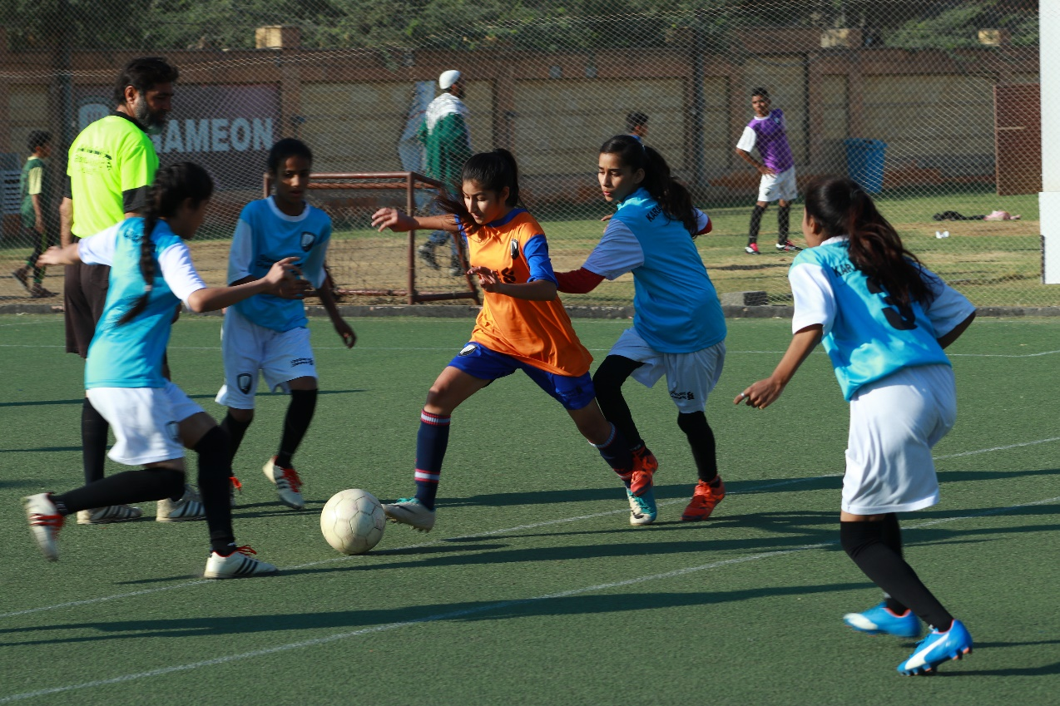

Figure 1 Agha Khan School faced Al-Qadir School in final of SCB - KU Youth League 2018
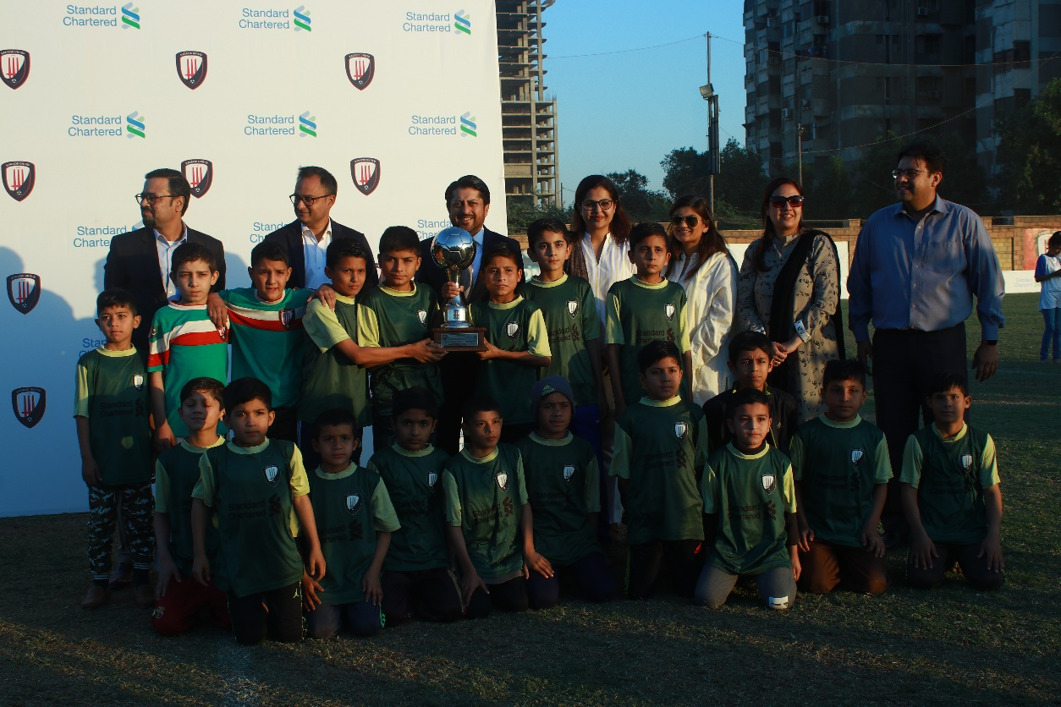

Figure 2 Players of Baldia Center U-10 pose with trophy after winning SCB -KU Youth League 2018

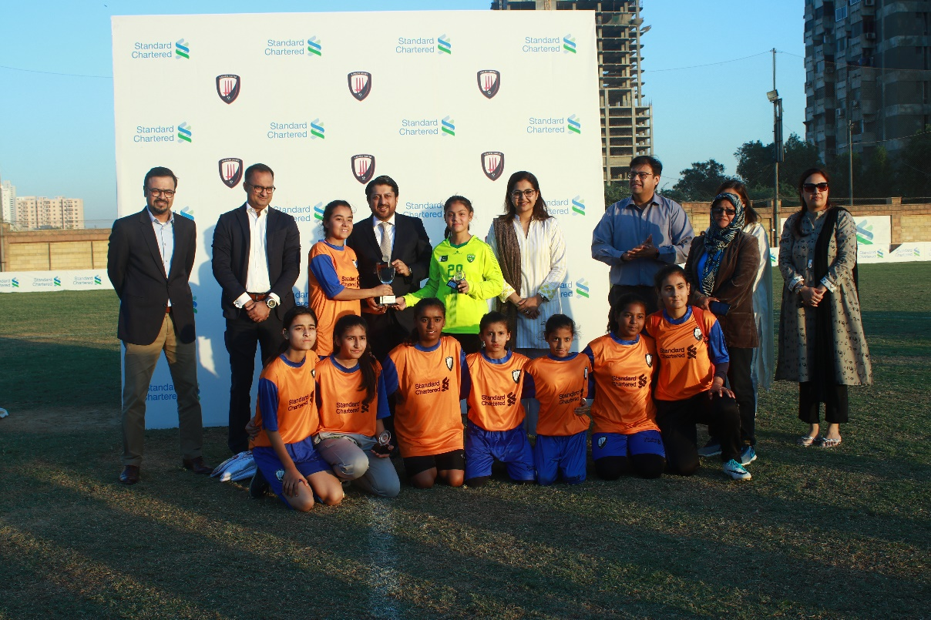

Figure 3 Mr. Shazad Dada, CEO of SCB, presents the winners’ trophy to the captain of Agha Khan School
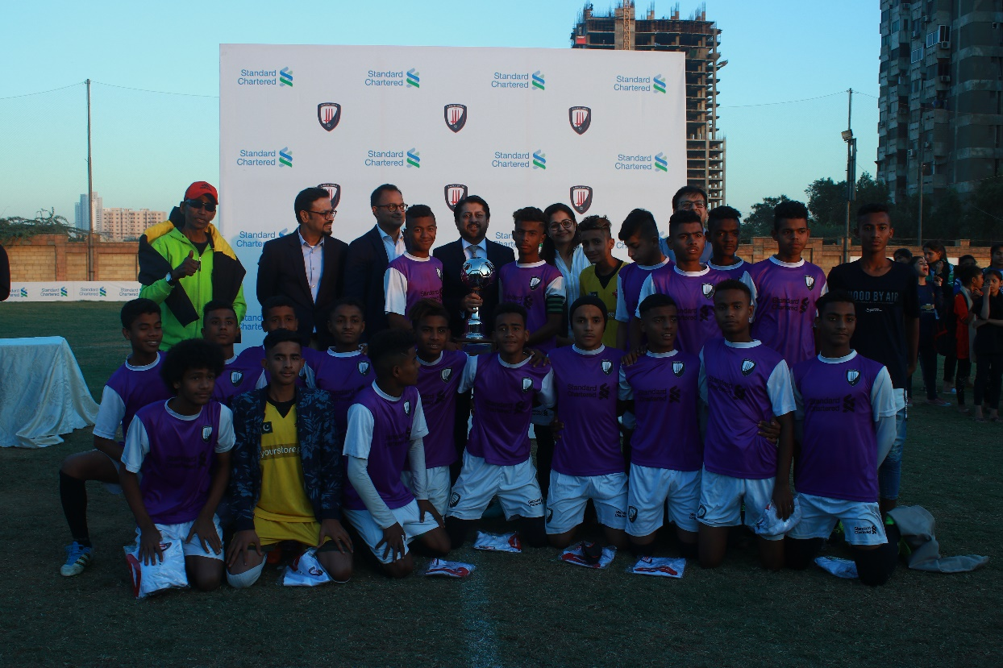

Figure 4 Mr. Shazad Dada, CEO of SCB, presents the winners’ trophy to the captain of Lyari Kakri

