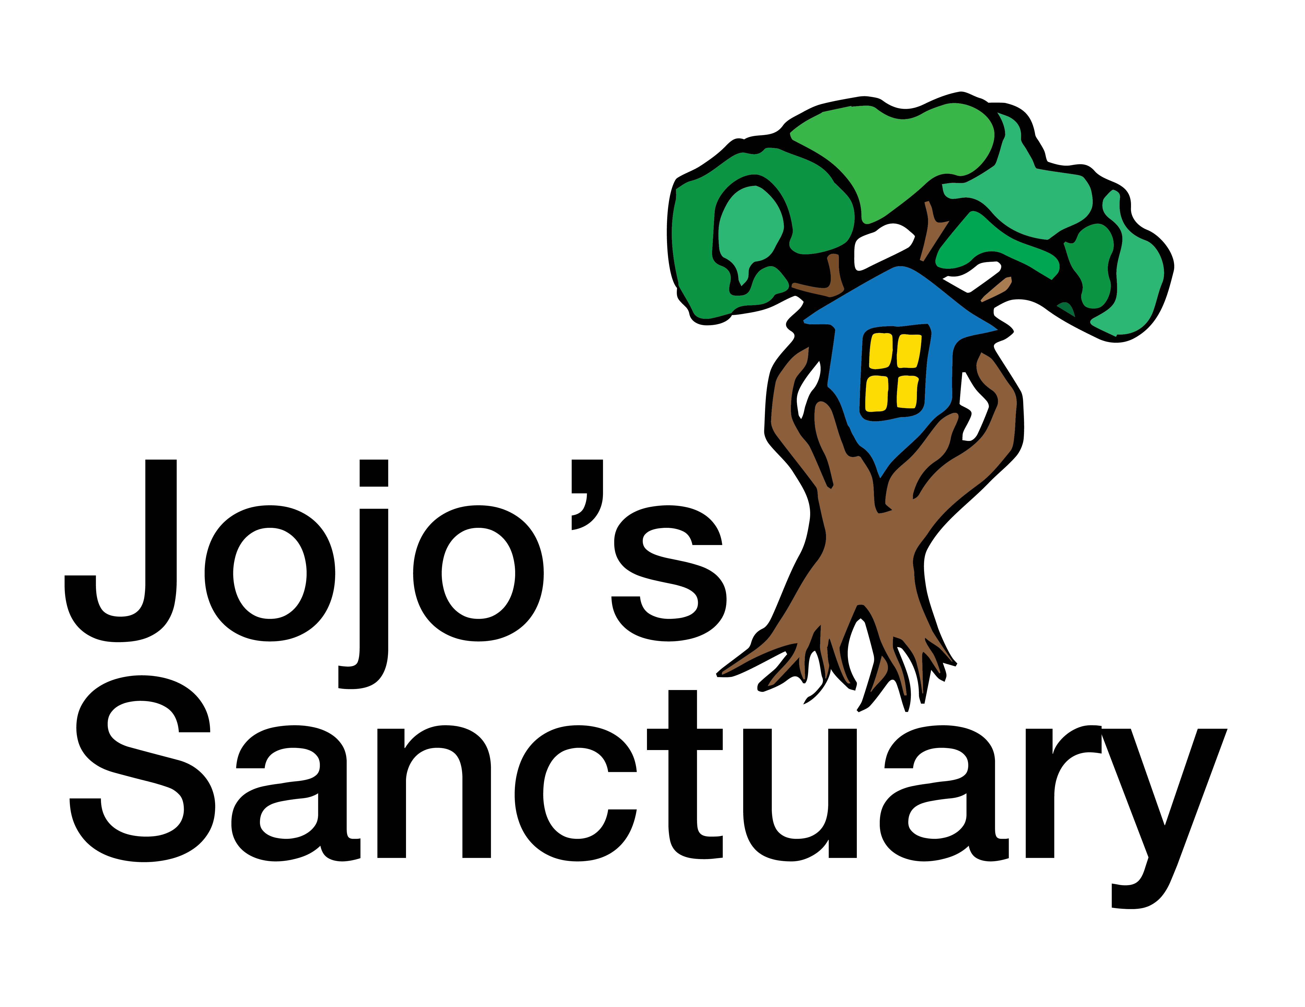

Jojo’s Sanctuary was founded in January 2017 and is a project of CORD Ministries International, {operating in Thailand as Family Connection Foundation}. Jojo’s Sanctuary aims to educate, protect and empower vulnerable children, families and communities in Thailand.
The Child and Family Empowerment Program was conceived and designed to educate rural children and their families or caretakers about trafficking and other forms of exploitation, including sexual abuse. This program consists of six sessions: UN Rights of the Child, Internet Safety, My Body is My Own (teaching about safe, unsafe and confusing touch), Healthy Relationships and Reproductive Health, Trafficking and Substance Abuse Awareness and Parenting with Positive Discipline Techniques.
This program has received positive feedback from both children and caretakers in the four locations that served as our pilot program. We would like to continue sharing this program in other rural communities as well as train caregivers in children’s homes how to implement the trainings themselves to magnify our impact.
The goal of this program is to keep children from dropping out of school and running away to the bright lights of the big city by educating them of the dangers they may face in doing so. Some families cannot afford to send their children to school beyond the sixth grade, and instead send their children into the city to find work. To counter this issue, we also offer scholarships for either school uniforms or tuition to families in need who would otherwise not send their children on to complete high school.
In 2018, we will be partnering with the Thai government to institute grassroots education of local communities about foster care. The government is beginning the transition from orphanages and children’s homes to family-based foster care of orphaned and vulnerable children. We will provide informational presentations to communities to raise awareness of the need for foster families. Once people have been approved by the government to be foster parents, we will provide follow up training for new and prospective foster parents.
Since this is a new venture for the Thai government and their political situation is currently unstable, there is no money allocated for this type of community outreach. If we can provide this service to the Thai government, it will help move children out of institutions and into families much more quickly, diminishing the harmful effects of institutional care on Thai children and society.

