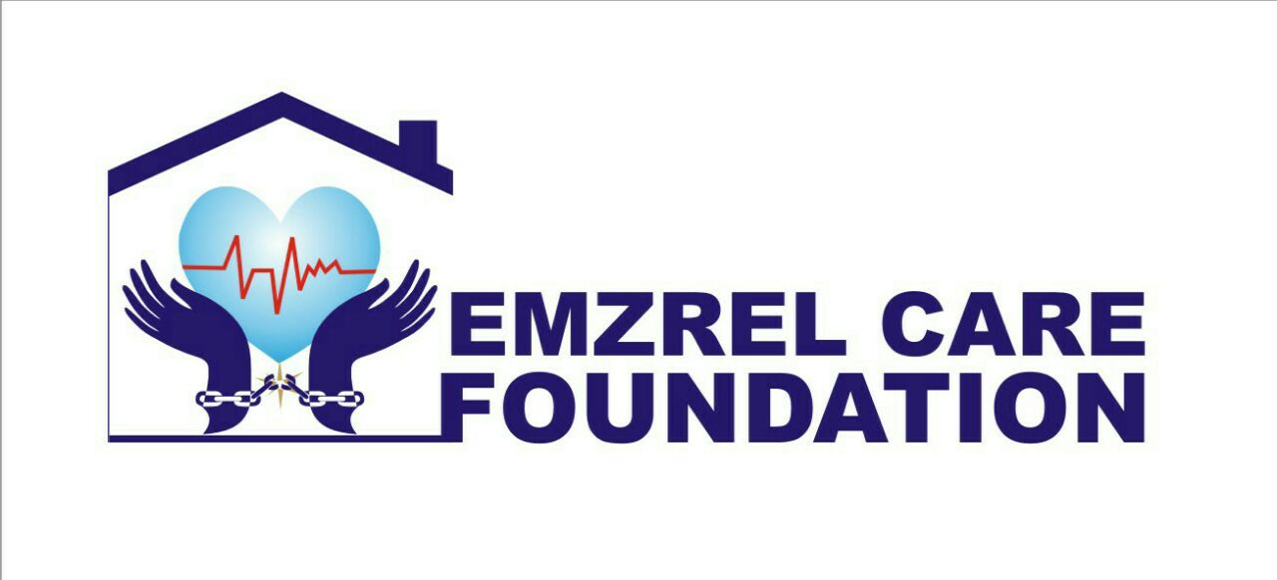

Emzrel Care Foundation

Project/Budget

**Table of Content.**

1. **Introduction**
2. **Vision**
3. **Mission**
4. **Aim**
5. **Legal representation.**
6. **Who are we**
7. **Our Team**
8. **General Issues**
9. **Cultural Consequence.**
10. **Rehabilitation**
11. **Why is Rehabilitation Necessary.**
12. **Conclusion.**

**INTRODUCTION**

This proposal is prepared by ***Emzrel Care Foundation*** with RegistrationCAC/IT/No.96095which was incorporated under the Companies and Allied matters Act 2004 of the Corporate Affairs Commission (CAC) on the 21st Day of March, 2017.

(***Centre for the wrongfully convicted***)

1. **THE PROJECT OBJECTIVES.**

This project will be covering majorly Libya and Nigeria and probably China. If you're moved by the stories of the wrongfully convicted, please consider the innocent men, women and children who remain behind bars for a crime they did not commit and help us help them.

**The Vision**

Obtaining justice for the wrongfully convicted.

**The Mission**

We shall set out to almost all parts of the world, starting from our home country Nigeria, where it is assumed that our people (Citizen) are denied access to good legal representation and cannot stand for themselves anymore and all verified evidences points to the innocence of the said persons.

**The Aim**

Our goal at Emzrel Care Foundation is to give new hope to the unjustly imprisoned ones by helping them with their long awaited freedom, rehabilitating them, provide shelter and jobs for them; also reunite them with their families.

**LEGAL REPRENTATION**

Emzrel Care Foundation provides legal and investigative services to individuals seeking to prove their innocence of crimes for which they have been convicted, as well as working to re-dress the causes of wrongful convictions.

EMZREL CARE FOUNDATION will consider cases that meet the following criteria:

1. **A claim of actual innocence**: The person seeking assistance must be in on way responsible for the crimes of which he or she is being convicted.
2. **Post-conviction status**: The trial must be completed and have resulted in a conviction and sentence.
3. **Illegal detention of Nigerians outside the country:** Research was carried out by our legal team to ascertain the approximate number of victim of wrongful imprisonment and the discovery was shocking,about 89% (Eighty-nine per cent), of Nigerians in prison abroad are innocent but helplessly kept behind bars.

**WHO WE ARE**

Emzrel Care Foundation is a Non-profit organization dedicated to calling attention to the wrongs people unjustly convicted and wrongfully imprisoned. We have first hand experience working with the wrongfully convicted. It is through this experience we are able to create awareness of wrongful convictions within our justice system.

**Our Team**

The ECF team is made up of vibrant Nigerians who are passionate about the vision and dream of the foundation.

**Mr Emmanuel Ayegba Okpanachi** (Chairman/Founder)

**Mrs Ethel Ngozi Emmanuel**  (Vice Chairman/Co-Founder)

**Barr. Joseph Achile Abu** (Director Legal)

**Barr. Luke Okoh** (Head Legal)

**Mr. Sunday Samuel Rotimi** (PRO)

And others who are totally dedicated to the course of making unlawful or unjust imprisonment a thing of the past.

We are criminal justice advocate, Our primary focus is to create awareness within the legal community, news media, and general public of wrongful convictions.

**General Issues**

Causes of miscarriages of justice include:

* Plea bargains that offer incentives for the innocent to plead guilty, sometimes an innocent prisoner’s dilemma
* Withholding or destruction of evidence by police
* Confirmation bias on the part of investigators
* Biased editing of evidence
* Prejudice against the class of people to which the defendant belongs
* Fabrication of evidence or outright perjury by police or prosecution witnesses
* Misidentification of the perpetrator, by witnesses or victims
* Overestimation/underestimation of the evidential value of expert testimony
* Contaminated evidence
* Faulty forensic tests
* False confessions due to police pressure or psychological weakness
* Misdirection of a jury by a judge during trial
* Perjured evidence by the real guilty party or their accomplices (frame up)
* Perjured evidence by the alleged victim or their accomplices
* Conspiracy between court of appeal judges and prosecutors to uphold conviction of the innocent.

One of the risk of miscarriages of justice is that, condemned persons are executed promptly after conviction and the most significant effect of a miscarriage of justice is irreversible. Even when a wrongly convicted person is not executed, years in prison can have a substantial, irreversible effect on the person and their family.

**Cultural consequences**

Wrongful convictions appear at first to be "rightful" arrests and subsequent convictions, and also include a public statement about a particular crime having occurred, as well as a particular individual or individuals having committed that crime. If the conviction turns out to be a miscarriage of justice, then one or both of these statements is ultimately deemed to be false. During this time between the miscarriage of justice and its correction, the public holds false beliefs about the occurrence of a crime, the perpetrator of a crime, or both. While the public audience of a miscarriage of justice certainly varies, they may in some cases be as large as an entire nation or multitude of nations.

In cases where a large-scale audience is unknowingly witness to a miscarriage of justice, the news-consuming public may develop false beliefs about the nature of crime itself. It may also cause the public to falsely believe that certain types of crime exist, or that certain types of people tend to commit these crimes, or that certain crimes are more commonly prevalent than they actually are. Thus, wrongful convictions can ultimately mould a society's popular beliefs about crime. Because our understanding of crime is socially constructed, it has been shaped by many factors other than its actual occurrence.

Mass media may also be faulted for distorting the public perception of crime by over-representing certain races and genders as criminals and victims, and for highlighting more sensational and invigorating types of crimes as being more newsworthy. The way a media presents crime-related issues may have an influence not only on a society's fear of crime but also on its beliefs about the causes of criminal behaviour and desirability of one or another approach to crime control. Ultimately, this may have a significant impact on critical public beliefs about emerging forms of crime such as cybercrime, global crime, and terrorism.

It has been shown that there are unfavourable psychological effects, even in the absence of any public knowledge. In an experiment, participants significantly reduced their pro-social behavior after being wrongfully sanctioned. As a consequence there were negative effects for the entire group. The extent of wrongful sanctions varies between societies.

1. **EVALUATION PLAN.**

The evaluation plan is a continuum from the project objective, whereby after the imprisoned person regains his or her long awaited freedom the steps below will then apply.

**Rehabilitation**

The moment any of the wrongfully accused person wins in court or a place of jurisdiction and is released, ECF will follow up with rehabilitating him to fit back into the society, by providing adequate healthcare in case of those with injury, provide them a temporary accommodation pending when ECF gets them a job, after which they will go and start fending for themselves.

**Why Is Rehabilitation Necessary?**

Rehabilitation is necessary to avoid giving them the room to practice what they have learnt over time while in prison.

**Conclusion**

The Emzrel Care Foundation (ECF) will consider requests for representation received via email or over the phone by going to the country where the person is held in prison, to do all the necessary findings and to engage fully in the Legal procedures, that are required according to the law of the Land.

Also, all requests must come directly from the person seeking representation, although we will accept supplemental materials from third parties(Proxy).

At the Center on Wrongful Convictions, our ability to help the innocent in prison is directly proportional to the support we receive from individuals and institutions committed to correcting miscarriages of justice, justice reform and reforming the criminal justice system.

At ECF, we are committed in representing persons who have been subjected to tyrannical or arbitrary rulings or edict in violation of constitutional,human right abuse and civil rights under the democratic maxim reminiscent of the Nation

We are ready at all times to trace the clarion call of any citizen of any nation to any geographical location in the world, to provide assistance as best as we can and to make wrongful and unlawful detentions a thing of the past.

**For More information:**

[www.emzrelcarefoundation.org](http://www.emzrelcarefoundation.org)

[contact@emzrelcarefoundation.org](mailto:contact@emzrelcarefoundation.org)

ethel@emzrelcarefoundation.org

mobile line: +234 09053516377, 08136848921.

