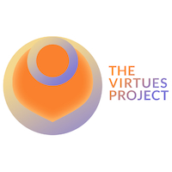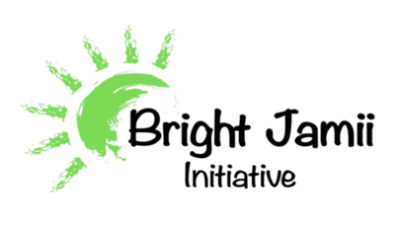

**Report on the Integration of The Virtues Project (TVP) in Community Health Workers (CHWs) Training for Nurturing Care**

**Introduction and Rationale**

Community Health Workers (CHWs) play an essential role in ensuring access to nurturing care for families with children under five. As frontline providers in Mbeya Council, CHWs support over 300 families, promoting early childhood development and responsive caregiving, crucial for children’s holistic growth. Integrating **The Virtues Project (TVP)** into CHW Early Childhood Development (ECD) training introduces practical, virtues-based strategies to enhance caregivers’ capacity in nurturing care practices. The focus on “Speaking the Language of Virtues,” “Noticing and Using Teachable Moments,” and “Setting Clear Boundaries” aligns with Tanzania's Childcare Campaign, supporting the domains of responsive caregiving, early learning, and safety and security.

**My Role as ECD Specialist and Virtues Project Master Facilitator**

In my role, facilitating ECD training to CHWs empowering them to support families they visit to adapt the practice of Nurturing Care, I integrated and facilitated sessions designed to familiarize CHWs with three of TVP’s five strategies. Each strategy was selected for its applicability to CHWs’ interactions with caregivers, reinforcing positive, constructive caregiving approaches:

* **Speaking the Language of Virtues**: CHWs practiced acknowledging and reinforcing caregivers' virtues such as patience, compassion, and commitment, which contribute to a supportive caregiving environment.
* **Using Teachable Moments**: CHWs learned to recognize and respond to everyday moments as learning opportunities for caregivers, encouraging consistent, nurturing behaviors in their care practices.
* **Setting Clear Boundaries**: CHWs explored methods for guiding caregivers to establish safe and healthy boundaries within the home, directly enhancing child safety and security.

**CHWs’ Plans for Integrating TVP in Community Visits**

Equipped with these foundational strategies, CHWs plan to introduce TVP concepts to caregivers during routine home visits. By encouraging caregivers to embody virtues and recognize teachable moments in daily caregiving, CHWs support responsive, values-driven caregiving practices. These approaches are expected to foster nurturing environments that prioritize children’s holistic growth, promote early learning, and ensure child safety.

**Conclusion and Recommendations**

The integration of TVP’s strategies empowers CHWs to foster positive, nurturing environments in families they support. By building caregivers’ capacity in virtues-based approaches, CHWs contribute to improved responsive caregiving and a safer, more stimulating environment for young children.

**Recommendations**:

* **Further Training**: Expand CHWs' training on the remaining TVP strategies to deepen their skills.
* **Regular Reflection Sessions**: Facilitate quarterly reflections for CHWs to share experiences and refine TVP applications in their caregiving support.

Through sustained TVP integration, CHWs can support caregivers in shaping the foundational virtues that promote positive childhood outcomes and contribute to Tanzania’s broader nurturing care objectives.

**The Summary:**

The **Virtues Project (TVP)** integration into Community Health Workers (CHWs) training in Mbeya equips over 300 families with nurturing care skills through core strategies, fostering essential child development. As CHWs provide responsive caregiving support, they apply "Speaking the Language of Virtues," "Noticing Teachable Moments," and "Setting Clear Boundaries" to promote a virtues-based approach for caregivers, enhancing child safety, emotional support, and learning environments. This effort aligns with Tanzania's Childcare Campaign, emphasizing virtues like compassion and patience as foundations for improved caregiving and early childhood development outcomes.

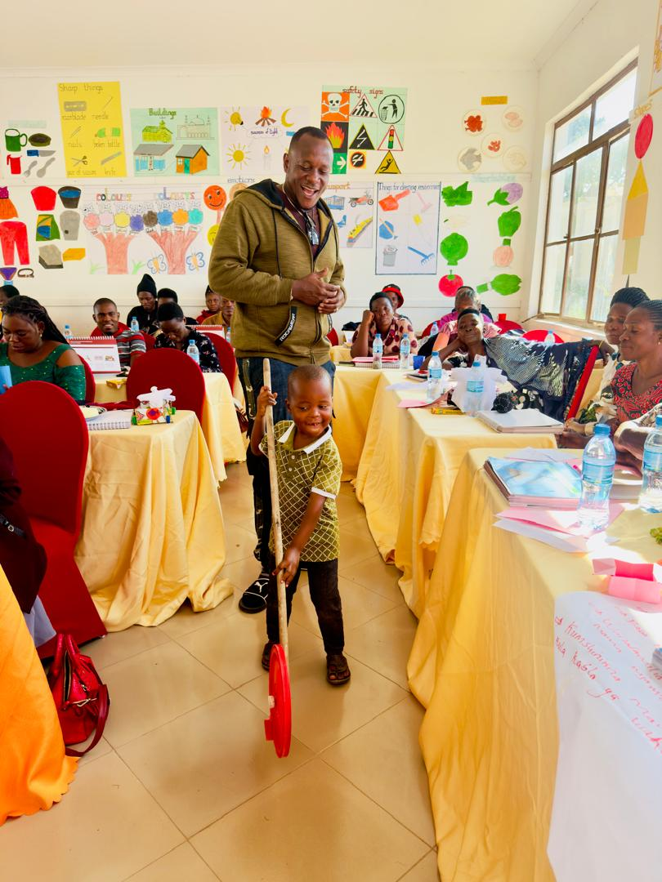To sustain and expand this impactful program, the report recommends increased training on additional TVP strategies and regular reflection sessions to optimize CHWs’ skills. With your support, we can extend this model, enhancing CHWs’ abilities to empower caregivers to adopt nurturing care. These contributions will directly support a healthier, safer future for Tanzanian children, setting a strong precedent for lifelong resilience and learning.

