Lessons from Tanzanian Virtues Project Schools
Strategies to Support the Elimination of Corporal Punishment in Schools

Tanzania’s Aspirations to Reduce Violence in School Settings
United Republic of Tanzania aims to end corporal punishment in schools and other care settings. Unfortunately, current law contravenes this aspiration. is not promoted to end violence in care settings remains at odds with existing law. The May 2017 Country report for United Republic of Tanzania articulates a desire to eliminate the conundrum of having both a strategy for changes begins, “Prohibition of corporal punishment is still to be achieved in the home, some alternative care settings, day care, schools, some penal institutions and as a sentences for crime.” Article 13 of the Law of the Child Act from 2009 and article 14 from the Children’s maintains the option for “justifiable correction”.
- Laws that seek to limit the severity of corporal punishment serve to authorize its use only which encourages practitioners of its legitimacy and benefit.
- Legal definitions of corporal punishments have been determined to exclude caning in school in order to preserve the practice.
- Caning in school is seen as a match for parental punishment provided in the home.
In contrast, the Tanzania Education and Training Policy of 2014 recommends peaceful conflict resolution practices for all educational and training curricula.

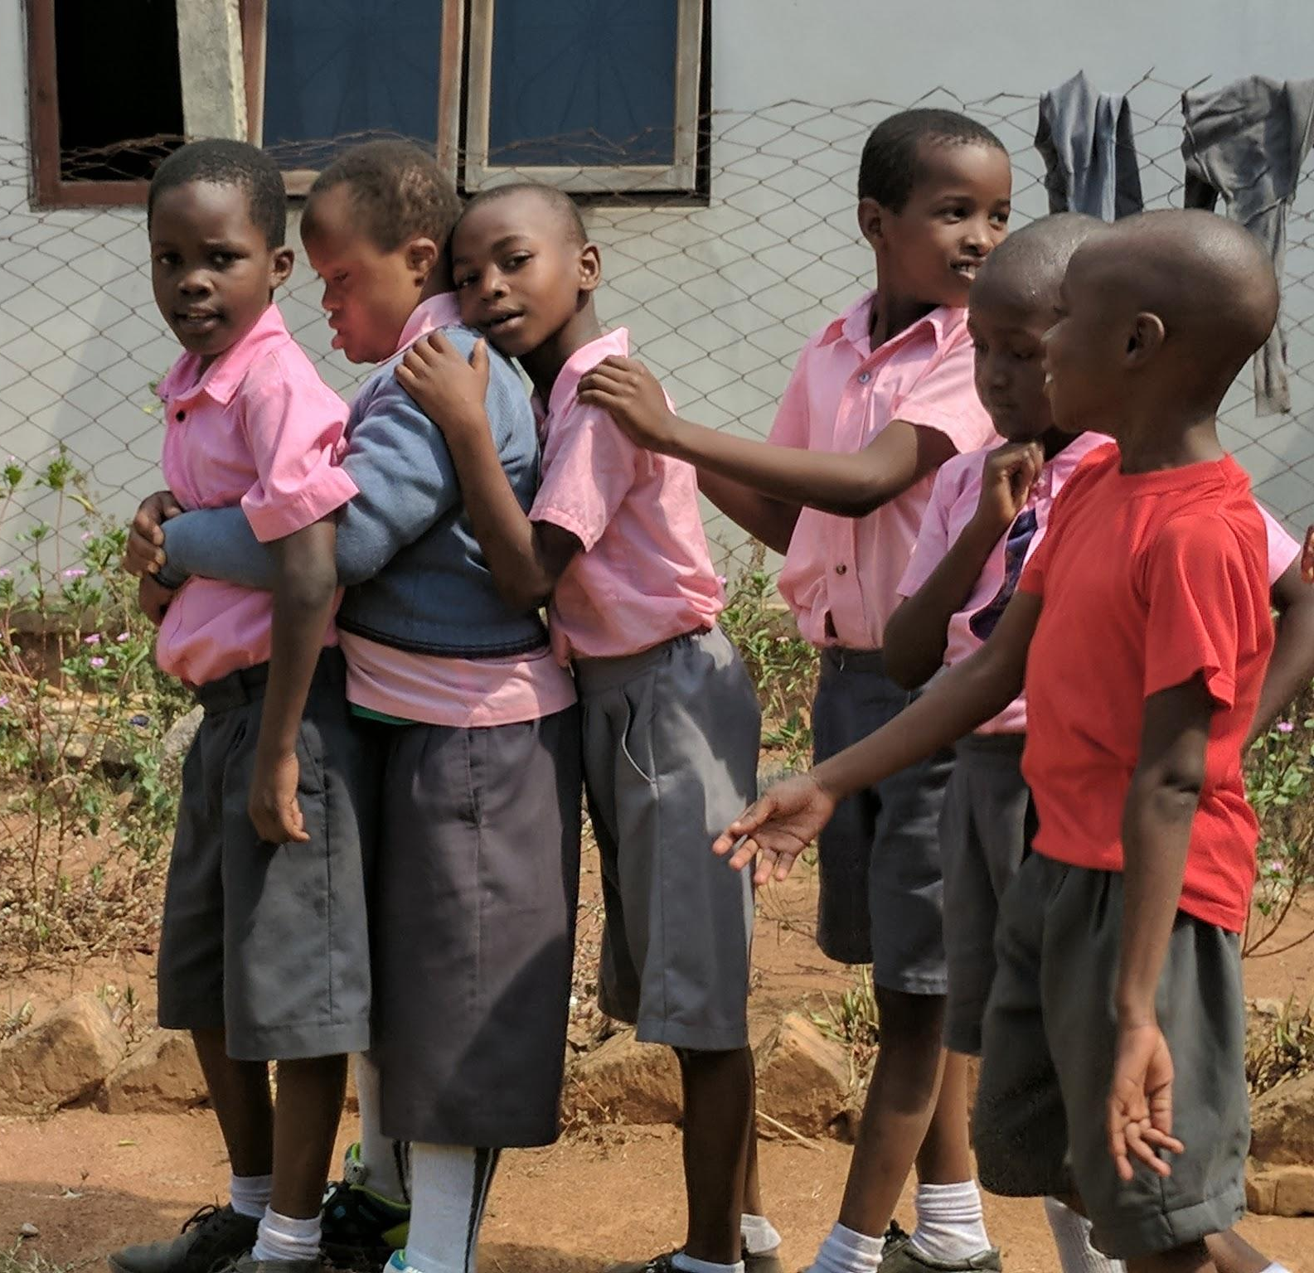
- Tanzania needs a set of strategies to uphold peaceful conflict resolution and promote positive school climate.

The Virtues Project Supports Peaceful Schools
The Virtues Project ™ is a global grassroots initiative that aims to support the development of positive school climate through the development of virtues within both students and teachers. Virtues belong to every culture, philosophy and belief system, however, we need mechanisms or strategies to strengthen them. The Five Strategies of the Virtues Project articulate mechanisms for identifying, developing and expressing our highest qualities--qualities essential to the healthy mind that govern the highest level of human achievement. These universal, positive qualities of character, when reinforced through proper education, nurture 21st century skills essential to the progress of Tanzania: curiosity, creativity, empathy, initiative and perceptiveness.

Virtues Project Programs in Independent and Community Schools
Tanzanian Virtues Project Master Facilitator, Godwin Mongi partnered with fellow Master Facilitator and program evaluation expert, Dr. Geri Lynn Peak of Two Gems Consulting Services, to conduct a small, voluntary exploratory study of 5 schools using the Virtues Project both to assess training needs and to begin gathering perceived and observable impacts. The Inter-Religious Council for Peace Tanzania agreed to serve as the umbrella organization and the work was funded via voluntary and crowd source funding spearheaded by Two Gems Consulting Services and supplemented by crowd source funding implemented by Virtues Project International Association.

The evaluation conducted site visits and interviews at five independently owned and operated schools across Tanzania which have used the Virtues Project as a mechanism to improve school climate without reliance upon corporal punishment. The schools were located in 4 different regions of the country: 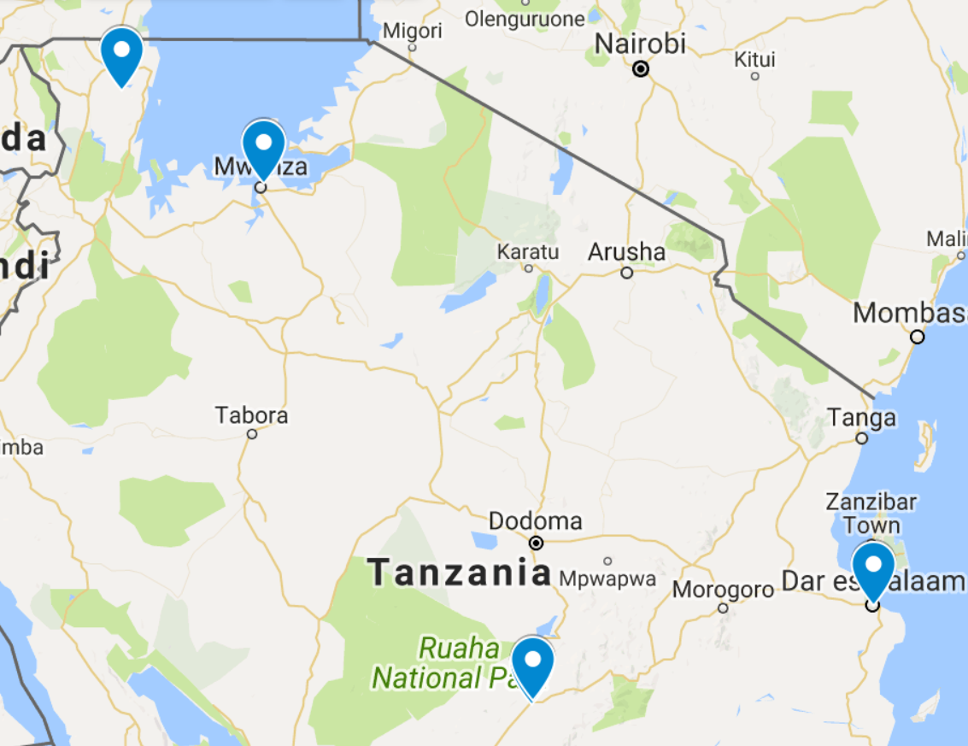
- Dar es Salaam: Red House Pre-Primary, n = ~65
- Mwanza: Joyland Pre - Grade 3, n = ~45
- Mugajwale: New Vision Pre & Primary, n = ~150
- Iringa: Two Wings Pre - Grade 4, n = ~70; Tender years, Flexible grade levels, n ~10

All of the schools specifically forbid any form of child abuse, including caning and harsh language. They all intentionally use the VP for both character development and to manage behavior. One school specifically uses VP for professional development of staff, however, positive impacts on both teachers and students are noted at all schools. All of the schools have at least one director or teacher who has had a full training in the VP. Students were not in attendance at two sites due to school breaks.

Findings
EVALUATOR OBSERVATIONS:
- Students are universally well behaved. Those who engage in mischief are quietly called back to order.
- Students are acknowledged for their good behavior at some of the sites
- Students of all levels are able to identify virtues and share how they use them to be helpful to others at school.
- Some of the teachers, and in some cases, only the director, have had specific training in the Virtues Project. Directors coach new hires in the practice of the Virtues Project at their site.
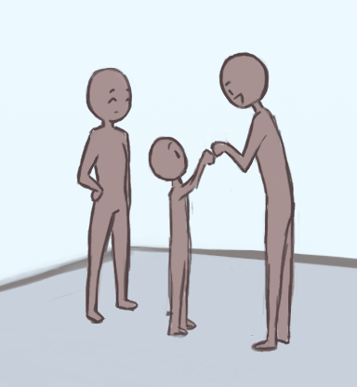
- Most sites practice only one or two of the Five Strategies intentionally, either by Speaking the Language of Virtues--reinforcing character development and positive behavior through the exploration of specific virtues weekly or monthly; Recognizing Teachable Moments--identifying the virtue that is needed and guiding young people back to appropriate behavior and/or by Setting Clear Boundaries based on virtues that clarify how students should conduct themselves.
- At one site, parents were observed visiting to inquire about enrollment of their child based on recommendations from other families.
- At one site, a child with a developmental difficulty was treated with such respect and dignity, even by children who themselves were somewhat mischievous in class.`

ACCOMPLISHMENTS NOTED BY FACULTY:
- Students excel in comparison to their local counterparts.
- Pre-primary schools report increased demand because students fare better upon enrollment in primary schools.
- Parents notice improved behavior at home. They report improved language as well.
- Directors and/or faculty in the two larger schools (in Mugajwale and Iringa) are eager to share the Virtues Project with their colleagues locally.
- Students improve behavior over time without beating or chastising. In one case, a parent contacted the school specifically because no one at school or in the neighborhood was complaining about their child anymore.
- Older students see themselves as leaders and guides to younger students.
- Students who have failed in other venues, learn to cooperate, achieve and excel at Virtues Project schools.

RELEVANT CHALLENGES:
- Consistency in implementation.
- Accessing training and coaching for new teachers and ongoing staff development, including training non-teaching staff.
- New teachers (and parents also) must be convinced of the legitimacy of the practices

Recommendations: Implications for Government-sponsored Schools
- Support expansion of Virtues Project as a set of strategies and mechanisms for eliminating corporal punishment including legally sanctioned “justifiable correction.”
- Consider a secondary analysis outcome study to document whether perceived academic outcomes between Virtues Project schools hold up in comparison to their local counterparts.
- Set up a pilot in government schools to test Virtues Project Five Strategies.
- Support full implementation of the Virtues Project in schools and the training of on-site or regional facilitators.

