**|| LOKAHA SAMASTAHA SUKHINO BHAVANTHU ||**

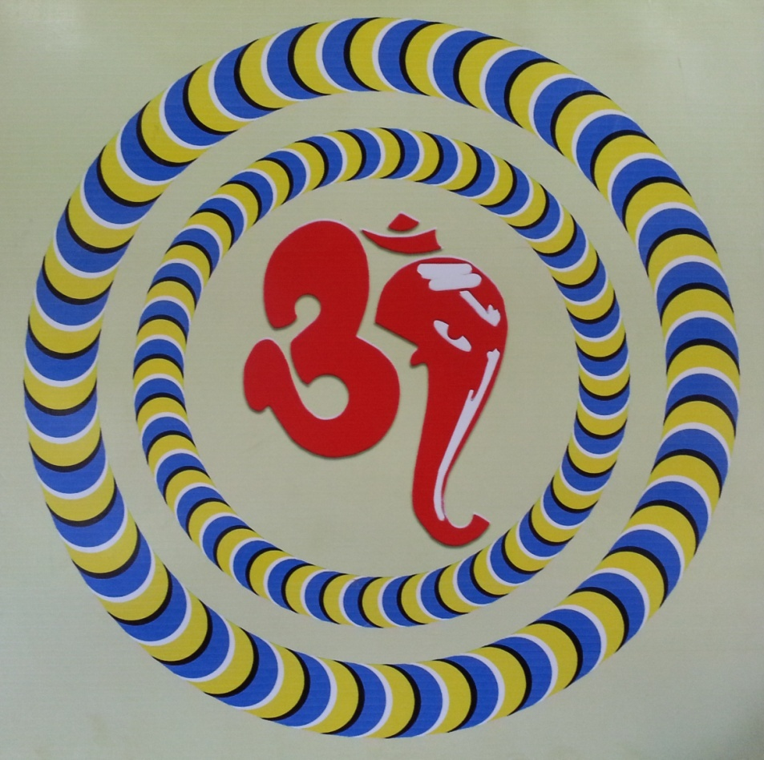

OM SEVA KENDRA®

**#83, “Leelananda”, 3rd A main road,**

**Syndicate Bank Colony,Herohalli main road,**

**Vishwaneedam post , Bangalore – 560091**

**Mail us at –** [**omsevakendrablr@gmail.com**](mailto:omsevakendrablr@gmail.com)

**sanmathiosk@gmail.com**

**Visit us on –** [**www.omsevakendra.org**](http://www.omsevakendra.org)

**Contact – 9845035084, 9483181155, 080 23245555/29775535**

Om Seva Kendra *is a troop of volunteers working as a non-profit service oriented system.*

Aim:

*Helping others without expecting returns is a meaningful expiation which has no alternate.*

*All activities of Om Seva Kendra aim to minimize the mental and physical suffering of the fellow human being in the society through its projects.*

The beginning:

*The founder of Om Seva Kendra, Sri. C.N. Krishna* who had lots of interest in social service since his schooldays. After his education he worked in some companies related to medical science. He noticed patients suffering from delayed diagnosis and diagnosis problems during his work. Those pain of patients deviated Sri C.N. Krishna to study drugless therapy. He started research on drugless therapy and taken initiation from Divine Himalayan Experts. By such blessings the experimental treatments of Sri C.N. Krishna resulted by reverenced tears in patients.

This journey of social service started in 2001 with ***around 50 varieties*** of drugless therapy. Many likeminded joined sharing their hands in his service and entitled the group in the name of “Om Sava Kendra” in 2004.

Registrations:

In view of expanding the activities of Om Seva Kendra in many wings, the troop of volunteers registered the group as a Public Charitable Trust in 2006. As the Trust planned its many projects along with time, it has registered accordingly under many banners as details furnished below:

* Registered as a Public Charitable Trust

**LAG-4-36-2012-13 CD.No.LAGD177/23.8.2012 R.No.421/2006-07**

* Registered under 12 A

DIT (E)/12A/VOL.|||/O-47/W-2/2007-2008 dated 20.8.2007

* Registered under 80G

DIT(E)BLR/80G®/248/AAATO1702D/ITO(E)-2/Vol 2008-2009 dated 09.09.2008

* P A N : AAATO1702D
* FCRA

094421546 dated 30.09.2013

* Registered with Global Giving ( 501(C )(3)) receipts for foreign donors
* Registered with Impact Guru
* BBMP (Bruhath Bengaluru Mahanagara Palike)

Reg.No.RR04072645149523952

* Dept. of Women & Child Development &Empowerment of Differently Able & Senior Citizens - Reg.No.019 dt 15.06.2016
* Logo registration : Appli.No.3220041 dated 26.03.2016

The Projects of Om Seva Kendra are:

* Drugless Therapy Centre – *Not only for today’s disease it is for tomorrow’s health too.*
* **Sanmathi *– A school for Special Children***
* Ashraya (Makkala Mane) - *Old Age Homes*
* Chaitanya - *Care centre for handicaps*
* Daya - *Care centre for Orphanages*
* Samatha - *Care centre for Transgender*
* Asare - *Rehabilitation centre for HIV / AIDS Patients*
* Sadhruda - *Yoga, Pranayama and Meditation classes*
* *Amrutha – Save & Care water resources*
* *Camps of Blood Donation, Book Donation, Eye Donation, Body Donation, Cloths Donation, Yogic way living awareness programs, Spiritual & Health related discourses and also extending hands for needy in natural calamities etc.,*

**Drugless Therapy Centre**

Not only for today’s disease, for tomorrow’s health too.

*Since 2001 Om Seva Kendra is providing the service of Drugless Therapy and more than 14,000 people are benefited from this till now, not only in Karnataka, India but from different countries too.*

*Sri C.N. Krishna has delivered many discourses and conducted many workshops in other countries also. Yoga, Pranayama, Meditation & healing is daily routine in batches.*

Counselling:

For any kind of Physical / Mental / family problems

Sri C.N. Krishna conducts privacy assured confession program to people coming voluntarily. In result to this numerous people are living happily forgetting their past character / problem.

***The Project of “SANMATHI” – a SCHOOL FOR SPECIAL CHILDREN is explained herewith:***

**|| WE BELIEVE EVERY HUMAN BEING IS UNIQUE ||**

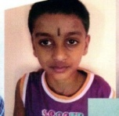

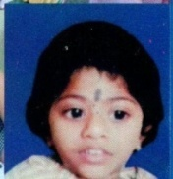 **We are special** 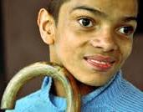

***but***

***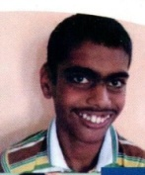* rare and precious** 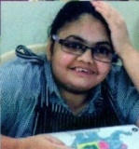

***So***

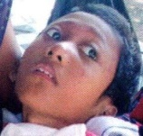 **We need a *special touch*** 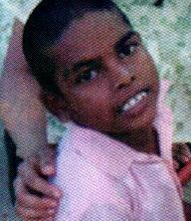 **Project submitted by:**

**Om Seva Kendra (R.)**

**#83, “Leelananda”, 3rd A main road,**

**Syndicate Bank Colony,Herohalli main road,**

**Vishwaneedam post , Bangalore – 560091**

**Mail us at –** [**omsevakendrablr@gmail.com**](mailto:omsevakendrablr@gmail.com), **sanmathiosk@gmail.com**

**Visit us on –** [**www.omsevakendra.org**](http://www.omsevakendra.org)

**Contact – 9845035084, 9483181155, 080 23245555/29775535**

**Project in brief :**

To enhance the life quality of intellectually disabled children by providing special care through ‘*Residential* *Care Facility’* to enable them to live and function independantly in daily routine.

**Project Details :**

Many times Bangalore is referred as the “Silicon Valley” of India and City of Home for IT gaints . Also it is true that Bangalore is home to many educational and research institutions in India. ***The proposed initiative seeks to provide Residential care Facility to the intellectually disabled children by providing the beneficiaries with appropriate health, therapies, psychological, vacational, educational and other social services. Om Seva Kendra(R.) has started a school (Day care) for special children to start with***. The parents actually have expressed that their children could not be managed, controlled or counselled by them in their respective hours. These children are fully dependant on their parents / others because of their underdeveloped disabilities and have to be attended for their basic needs. Hence it is the wish of Om Seva Kendra to provide a safe, healthy and friendly place in the name of ***“SANMATHI”*** for such neglected children whom many parents think that they are ‘*heavy’*  for them because of many reasons of their own.

The centre is planning to provide supportive care through Drugless therapies, speech therapy, yoga, physio therapy, nutrition, transportation, periodical health checkups, regular medical care, self help training and many more through specialised and trained educators, therapists and professionals. Of course at present 15 – 16 children are already enrolled and attending the school and the centre is providing the basic facilities at its limited source.

**Target area and Beneficiaries:**

The project is focused on the intellectually disabled children from Bangalore city. The children will be selected from the families belonging to the economically weaker section and poor financial background. Around 16 children are registered under Om Seva Kendra Trust and this initiative would benefit their children and their family members.

*The intake could increase over the period of time as per the need of the community and the economical condition of the trust.*

**Rationale and problem statement:**

Internationally, the definition of mental retardation which is now called Intellectual disability has moved away from a medical model to that of an educational model which is functional and support based and emphasized the rights of the individual.

The American Association on mental retardation defines mental retardation as a “disability” characterized by significant limitations, both in intellectual functioning and in adaptive behavior, as expressed in conceptual, social and practical adoptive skills, the disability originating before the age of 18”. The World Bank report on Disability in India (2007) gives the percentage of Disabled people at 4.8%, around 40-90 millions individuals. It is shocking and alarming fact that appropriately 2.5% to 3% of the total population are mentally retarded which in most cases is a livelong condition. World Health Organization estimates that community based surveys conducted during the past 2 decades in India showed that the total prevalence of psychiatric disorder was around 5.8%. Also, 10% of the world’s population has some form of mental disability and 1% suffers from severe incapacitating mental disorders.

**Intellectual Disability:**

It has been estimated that about 70% of the mentally retarded population is based in the rural area where no help is provided to them. In most of the rural schools and some urban areas many of the borderline cases of mental retardation are bypassed as dull students. Children with disabilities in India are subject to multiple deprivations and limited opportunities in several dimensions of their lives. Their families and caregivers also go through lot of stress and challenges in having a person with disability at home which ultimately leads to grave discriminatory practices towards these children. Despite improvement in the health care system in the country, their situations remain deplorable, particularly in rural areas and among the lower social-economic population. They are subjected to multiple deprivations and limited opportunities in several dimensions of their lives. Some of these include, not being enrolled to schools, lower employment rates, limited awareness of entitlements and services available and lack of social welfare support.

A study by NGO, Wadhwani Foundation, confirms that, parents of intellectually special children are mostly daily wage earners and due to their poor economic condition the parents are unable to send their children to special schools and provide them with proper nutrition, care etc,. They do not have the time to spend with their special children since both the parents are forced to go for work and also due to lack of awareness they are unable to provide proper care to their special children. Hence these children are at home without the proper attention and care, which they require to enhance their quality of life.

**Overall Objective:**

To provide infrastructure support / residential care facilities to improve the quality life of intellectually disabled children to enable them to live and function independently as possible on a day to day basis.

**Sustainability :**

The initiative of setting up a residential centre would be managed and implemented within the guidance / protocol laid down as part of the disability rehabilitation policy. This action would contribute to the overall state / national strategy to address the challenges of intellectual disability. So long as intellectual disability continues to be a challenge the momentum would continue. The project would continue to be a part of Om Seva Kendra ownership and the organization would try to mobilize resources from Government and other corporate / non-corporate sources.

**An appeal :**

*Om Seva Kendra is having a big dream of bringing all activities of these projects in one place. The overall cost of project mentioned is estimated about Rs.4, 00,00,000 crore.*

*Please join your hands with us and support our cause to bring a bright future for our very special targeted needy.*

|  |  |
| --- | --- |
| ***FOR DOMESTIC FUNDS*** | ***FOR INTERNATIONAL FUNDS*** |
| ***OM SEVA KENDRA***  ***SB A/C NO. 64130255422 OR***  ***SANMATHI***  ***SB A/C NO. 64191808171***  ***State Bank of India***  ***Sunkadakatte Branch (40657)***  ***IFSC : SBIN0040657***  ***MICR : 560006098*** | ***OM SEVA KENDRA***  ***SB A/C NO. 30089470323***  ***State bank of India***  ***Bharathnagar Branch (05198)***  ***Bangalore - 560091***  ***IFSC : SBIN0005198***  ***MICR : 560002093***  ***SWIFT CODE:SBININBB113*** |

**“Your generous gesture will make our dream a reality”.**

Thanking you,

C N Krishna

Founder President and Managing Trustee

E-mail : [cnkrishna@hotmail.com](mailto:cnkrishna@hotmail.com) M: 9845035084

Budget Summary (detailed budget annexed)

|  |  |  |  |  |  |  |  |  |
| --- | --- | --- | --- | --- | --- | --- | --- | --- |
| **KEY ACTIVITIES** | **Q1** | **Q2** | **Q3** | **Q4** | **Q1** | **Q2** | **Q3** | **Q4** |
| Setting up of a Residential Care Centre |  |  |  |  |  |  |  |  |
| Recruitment of team |  |  |  |  |  |  |  |  |
| Orientation/training of project staffs/team |  |  |  |  |  |  |  |  |
| Development/adaptation of Education/learning tool |  |  |  |  |  |  |  |  |
| Transportation – pick up and drop facilities |  |  |  |  |  |  |  |  |
| Profiling, listing, and preparation of data base of the beneficiaries to address the special needs |  |  |  |  |  |  |  |  |
| Special education (formal and informal) sessions using Audio Visual aid |  |  |  |  |  |  |  |  |
| Multi sensory activities through physiotherapy, speech therapy, yoga therapy |  |  |  |  |  |  |  |  |
| Quarterly assessment of child’s learning skills/ capacity |  |  |  |  |  |  |  |  |
| Interactive sessions with parents/guardians |  |  |  |  |  |  |  |  |
| Medical check up |  |  |  |  |  |  |  |  |
| Observation of special days, birth days |  |  |  |  |  |  |  |  |
| Vocational training/sessions (paper bag/cup making, toy, candle making, doll making, painting, poster/card making etc.,) |  |  |  |  |  |  |  |  |
| Liaoning referral with health facilities to cater to their health needs |  |  |  |  |  |  |  |  |
| Liaoning with school for mainstreaming with the school |  |  |  |  |  |  |  |  |

|  |  |  |  |  |  |
| --- | --- | --- | --- | --- | --- |
| **Human Resource costing** | | | | | |
| **Particulars** | **#of units** | **Unit cost** | **No. Of Months** | **Year 1** | **Year 2** |
| Project Manager | 1 | 25000 | 12 | 300000 | 300000 |
| Special Educators/teachers | 8 | 20000 | 12 | 1920000 | 1920000 |
| Speech Therapists | 3 | 20000 | 12 | 720000 | 720000 |
| Physiotherapists | 3 | 20000 | 12 | 720000 | 720000 |
| Admin cum Finance officer | 1 | 15000 | 12 | 180000 | 180000 |
| Data entry operator | 1 | 10000 | 12 | 120000 | 120000 |
|  |  |  | **Total** | **3960000** | **3960000** |

|  |  |  |  |  |  |
| --- | --- | --- | --- | --- | --- |
| **Admin costs** | | | | | |
| **Items** | **No. of Units** | **Unit cost** | **No. of Months** | **Total (Year 1)** | **Total (Year 2)** |
| Monthly office running costs – fuel, electricity, repair, photocopy, local transport etc | 1 | 200000 | 8 | 1600000 | 2400000 |
|  |  |  | **Sub Total** | **1600000** | **2400000** |
|  |  |  | **Grand Total** | **4000000** | |

|  |  |  |  |  |  |
| --- | --- | --- | --- | --- | --- |
| **Monitoring and Evaluation** | | | | | |
| **Activities** | **No. of Units** | **Unit cost** | **No. of Months** | **Total (Year 1)** | **Total (Year 2)** |
| Travel support (local) for Liaoning, meeting with school authority, Hospital visits, outdoor activities | 1 | 60000 | 8 | 480000 | 720000 |
| Reporting and documentation/ data analysis | 1 | 30000 | 8 | 240000 | 360000 |
| End project workshop | 1 | 106625 | 1 |  | 106625 |
|  |  |  | **Sub Total** | **720000** | **1186625** |
|  |  |  | **Grand Total** | **1906625** | |

|  |  |  |  |  |  |  |
| --- | --- | --- | --- | --- | --- | --- |
| **Project IMPLEMENTATION COST** | | | | | | |
| **Activities** | **No. of Units** | **Unit cost** | **No. of Months/days** | **Total ( Yr 1 or 8 months)** | **Total Yr 2 – 12 months** | **Yr 1=8 months & Yr 2 = 12 months** |
| Setting up costs for in-house Residential care facilities – one time | 1 | 11300000 | 1 | 11300000 | 0 | One time |
| Putting up banners, direction boards etc., | 5 | 15000 | 1 | 75000 | 0 | One time |
| Inauguration of the Residential centre | 1 | 70000 | 1 | 70000 | 0 | One time |
| Purchase of Vehicle for transportation | 3 | 500000 | 1 | 1500000 |  | One time |
| Maintenance of Vehicles | 3 | 50000 | 8 | 1200000 | 0 | 8 months in yr 1 & 12 months in yr 2 |
| Infrastructure costs – Chairs, tables, almirahs, entertainment toys, stationery etc., (one time), and other disability related aids like wheelchairs etc., | Lump  sum | 950000 | 1 | 950000 |  | One time |
| Computers (one time cost) | 4 | 40000 | 1 | 160000 | 0 | One time |
| Audio-Visual aid, Screen/projector, TV sets, speakers, sound systems including repair/maintenance | 1 | 100000 | 1 | 100000 |  | One time |
| Medical kits/equipment costs | Lump  sum | 250000 | 1 | 250000 | 250000 |  |
| Nutrition support costs | 25 | 300 | 240 | 1800000 | 2737500 | Rs. 300/25 per day for 240 (8months) in Yr 1 and 365 days in Yr 2 |
| Medical Doctors | 2 | 25000 | 8 | 400000 | 600000 | For 8 months in Ye 1 and 12 months in Yr 2 |
| Para medical staffs – Nurse/attendant | 4 | 10000 | 8 | 320000 | 480000 | Same |
| Support staffs | 5 | 5000 | 8 | 200000 | 300000 | Same |
| Drivers | 3 | 7000 | 8 | 168000 | 252000 | Same |
| Clothes and Uniforms – in-house , sports, winter/summer clothing’s – 4 types of clothing’s | 25 | 2000 | 4 | 200000 | 200000 |  |
| Interactive session with parents/guardians | 30 | 1000 | 8 | 30000 | 360000 | 4 times |
| Development/adaptation of Education/learning tool, leaflets, broachers | Lump  Sum | 700 | 300 | 210000 |  |  |
| Monthly special activities like birthday celebration/outings/ picnics or other outdoor activities | 25 | 500 | 8 | 100000 | 150000 | 8 months in Yr 1 and 12 months in Yr 2 |
| Vocational sessions/training –Hiring resource persons | 1 | 2500 | 8 | 20000 | 30000 | Once a month sessions |
|  |  |  | **Sub Total** | **19053000** | **7159500** |  |
|  |  |  |  | **Grand Total** | **26212500** |  |

|  |  |  |
| --- | --- | --- |
| **Budget Summary** | | |
| **Heads** | **Year 1 costs** | **Year 2 costs** |
| Human resource (1) | 3960000 | 3960000 |
| Project Implementation costs (2) | 19053000 | 7159500 |
| Admin costs (3) | 1600000 | 2400000 |
| **Total (1+2+3)** | **24613000** | **13519500** |
| Total Year 1 and year 2 | **38132500** | |
| M&E Costs (5% of the total project costs for 2 years) | **1906625** | |
| **Grand Total** | **40039125** | |