**Successful repatriation of 31 victims of Human Trafficking**

**“*We were expected to work for long hours. If you showed signs of weakness, they would threaten that they would give you up for organ harvesting*”**

**…. recalled a survivor as she shared her experience with HAART Kenya**

Nairobi, on 31st of August, 2022 HAART received a call for help via social media and email: A relative informed us that his family member had been lured with false promises to work in Thailand but then had been trafficked to Laos, together with other Kenyans. The alarmed relative asked HAART to intervene in the rescue and repatriation of a group of Kenyans

HAART reached out to various government agencies including embassies in the respective countries. On the 12th of September 2022, we received a positive call from Ambassador Lindsay Kiptiness and Deputy Ambassador Nancy Mwangi from the Kenyan Embassy in Thailand informing us they had rescued 31 Survivors in Laos and Myanmar.

We sought support from O.U.R (Underground Railroad) with repatriations of the survivors back to Kenya. O.U.R is an NGO that has been assisting in this area and thanks to their help with air tickets and personal effects, the survivors could be brought back to their home countries. For a few survivors from Myanmar, the families were able to pay for the tickets. Among the 31 (16 males, 15 female) survivors, 29 were Kenyan citizens, 1 was from Uganda, and 1 was from Burundi. More than half of the survivors were male demonstrating that male individuals are also at a high risk of trafficking and that the reported cases may not be an accurate reflection of the actual situation with regard to male victims of human trafficking. This remains a significant grey area as there isn’t enough research in this area.

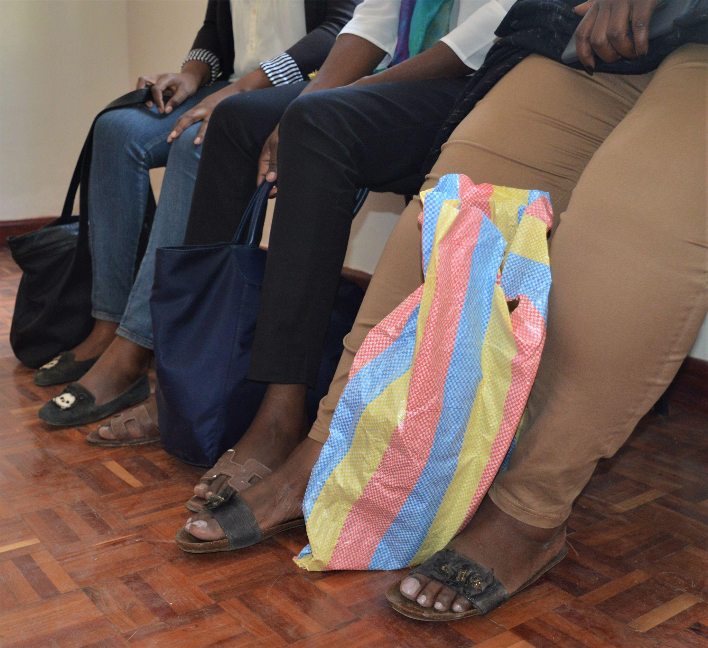

The group of survivors arrived safely in Kenya still in the month of September (*see below links to media reports*). HAART members went to the airport to receive them and coordinate the next steps, a few of them could travel to their families, and some needed shelter.

The victims of human trafficking were forced into cybercrime and sextortion, including threatening people with exposing their sensitive information if they failed to send money (mostly in the US).

*Survivors awaiting support upon arrival to Kenya*

The traffickers targeted computer-literate individuals and individuals who can speak English. **The following was shared by some victims on the condition of anonymity:** *After a long journey via Ethiopia and Thailand, they landed in Laos and were brought to a big secured compound from where they were not allowed to leave. Their phones were confiscated, and instead of being introduced to the jobs they expected, they were told about the real purpose of coming to Laos*.

The victims recalled observing scary events inside the compound and witnessing how people were beaten and abused. They were threatened with the same or worse treatment if they did not meet their targets for the online criminal activities. The threats included organ removal and sale in the black market.

HAART Kenya accompanied and supported all repatriated survivors according to their individual needs and with a holistic approach. All survivors will be assisted by our caseworkers through counselling, medical screening, basic needs coverage as well as educational and economic empowerment to reduce the risk of re-trafficking. This process can take up to 2 years. So far, 24 of the 31 survivors have received medical screening.

After the repatriation, HAART had a consultation with Ambassador Washington Oloo, the Director of Diaspora and Consular Affairs. HAART Founder and CEO Dr. Radoslaw Malinowski and Head of Protection, Mercy Otieno discussed the challenges that Kenya Embassies face in offering assistance to survivors of human trafficking, the possibility of a national reintegration plan for victims, and the need for safe migration in general. HAART has also pointed out that these issues are of grave concern to many Kenyans who sought work in Saudi Arabia.

Dr. Radoslaw Malinowski stated that *“Partnership between different institutions and organizations is key in eradicating Human Trafficking. This case is a good example of how protection of victims of human trafficking is achieved through the harmonious collaboration between the government, civil society, and international organizations”*.

The Kenya Embassy in Thailand has been supportive and quick in the repatriation of the victims: *“Kenyans who fell into the hands of traffickers abroad often depend on the Kenya Embassy as their first point of contact for rescue”,* said Mercy Otieno while describing the crucial role played by embassies. HAART recently raised a subject of concern in the constructive dialogue with the United Nations Office on Drugs and Crime (UNODC). In the October UNODC session, HAART highlighted this case as an outstanding example of cooperation between state and non-state actors. “*The knowledgeable, speedy and committed support Kenyans and their fellow victims from East Africa received from the Kenya Embassy in Thailand was best practice and one that should be emulated by other embassies*.”

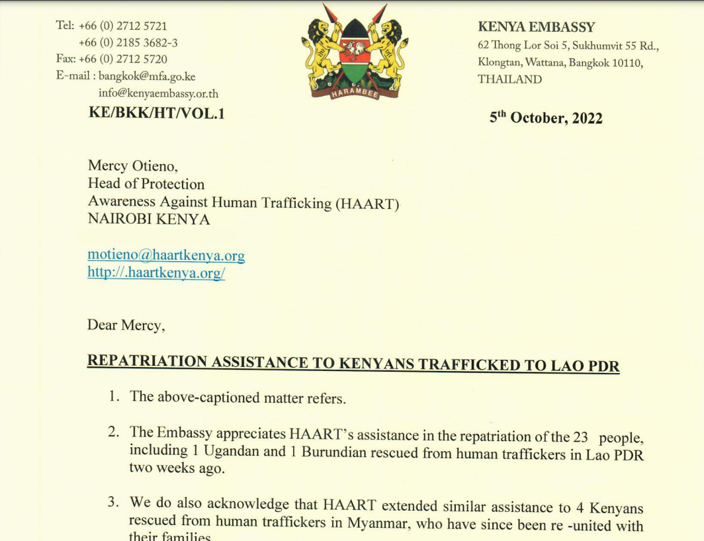

*A section of an appreciation letter from the Kenyan Embassy in Bangkok to HAART Kenya*

This successful rescue highlights the importance of a multisector approach. The combined efforts of government authorities, intergovernmental agencies, and NGOs has resulted in the repatriation of victims.

Finally, the sector needs to continue with sensitization and the creation of awareness against human trafficking. Whereas the risks of trafficking and exploitation in the Gulf States rightly attract more attention, the general public in Kenya is still not well informed of the human trafficking issue within the country or across East Africa.

Since 2010, we have reached more than 90,000 individuals through our awareness creation engagement and reintegrated more than 1,000 survivors, a process that can take up to 2 years.

**As HAART we are dedicated to fighting against Human Trafficking and we will continue striving for impact in collaboration with various Stakeholders!**

**Thank you for supporting our mission!**

Related Media Articles:  
CITIZEN: [Gov’t rescues 22 Kenyans from Human Trafficking in Laos](https://www.citizen.digital/news/govt-rescues-22-kenyans-from-human-trafficking-in-laos-n306178)

The East African: [22 Kenyans rescued from Human Traffickers in Laos](https://www.theeastafrican.co.ke/tea/news/east-africa/human-trafficking-victims-rescued-laos-3958888)