**GOING GREEN**

Ever since HAART acquired the new shelter, the management remained committed to maintaining and retaining the environment as conducive as ever.

One of the primary goals for the shelter was to install solar panels to produce emission-free and renewable energy. In December 2021, HAART realized this goal and had 24 solar panels installed. Through the initiative, the shelter will head in the direction of self-sustenance, a long-term goal of the project. In line with the positive impact the solar system has on the environment and shelter residents, it will significantly reduce the energy costs and the savings will be channeled to catering to the needs of the girls we get to journey with at the shelter.

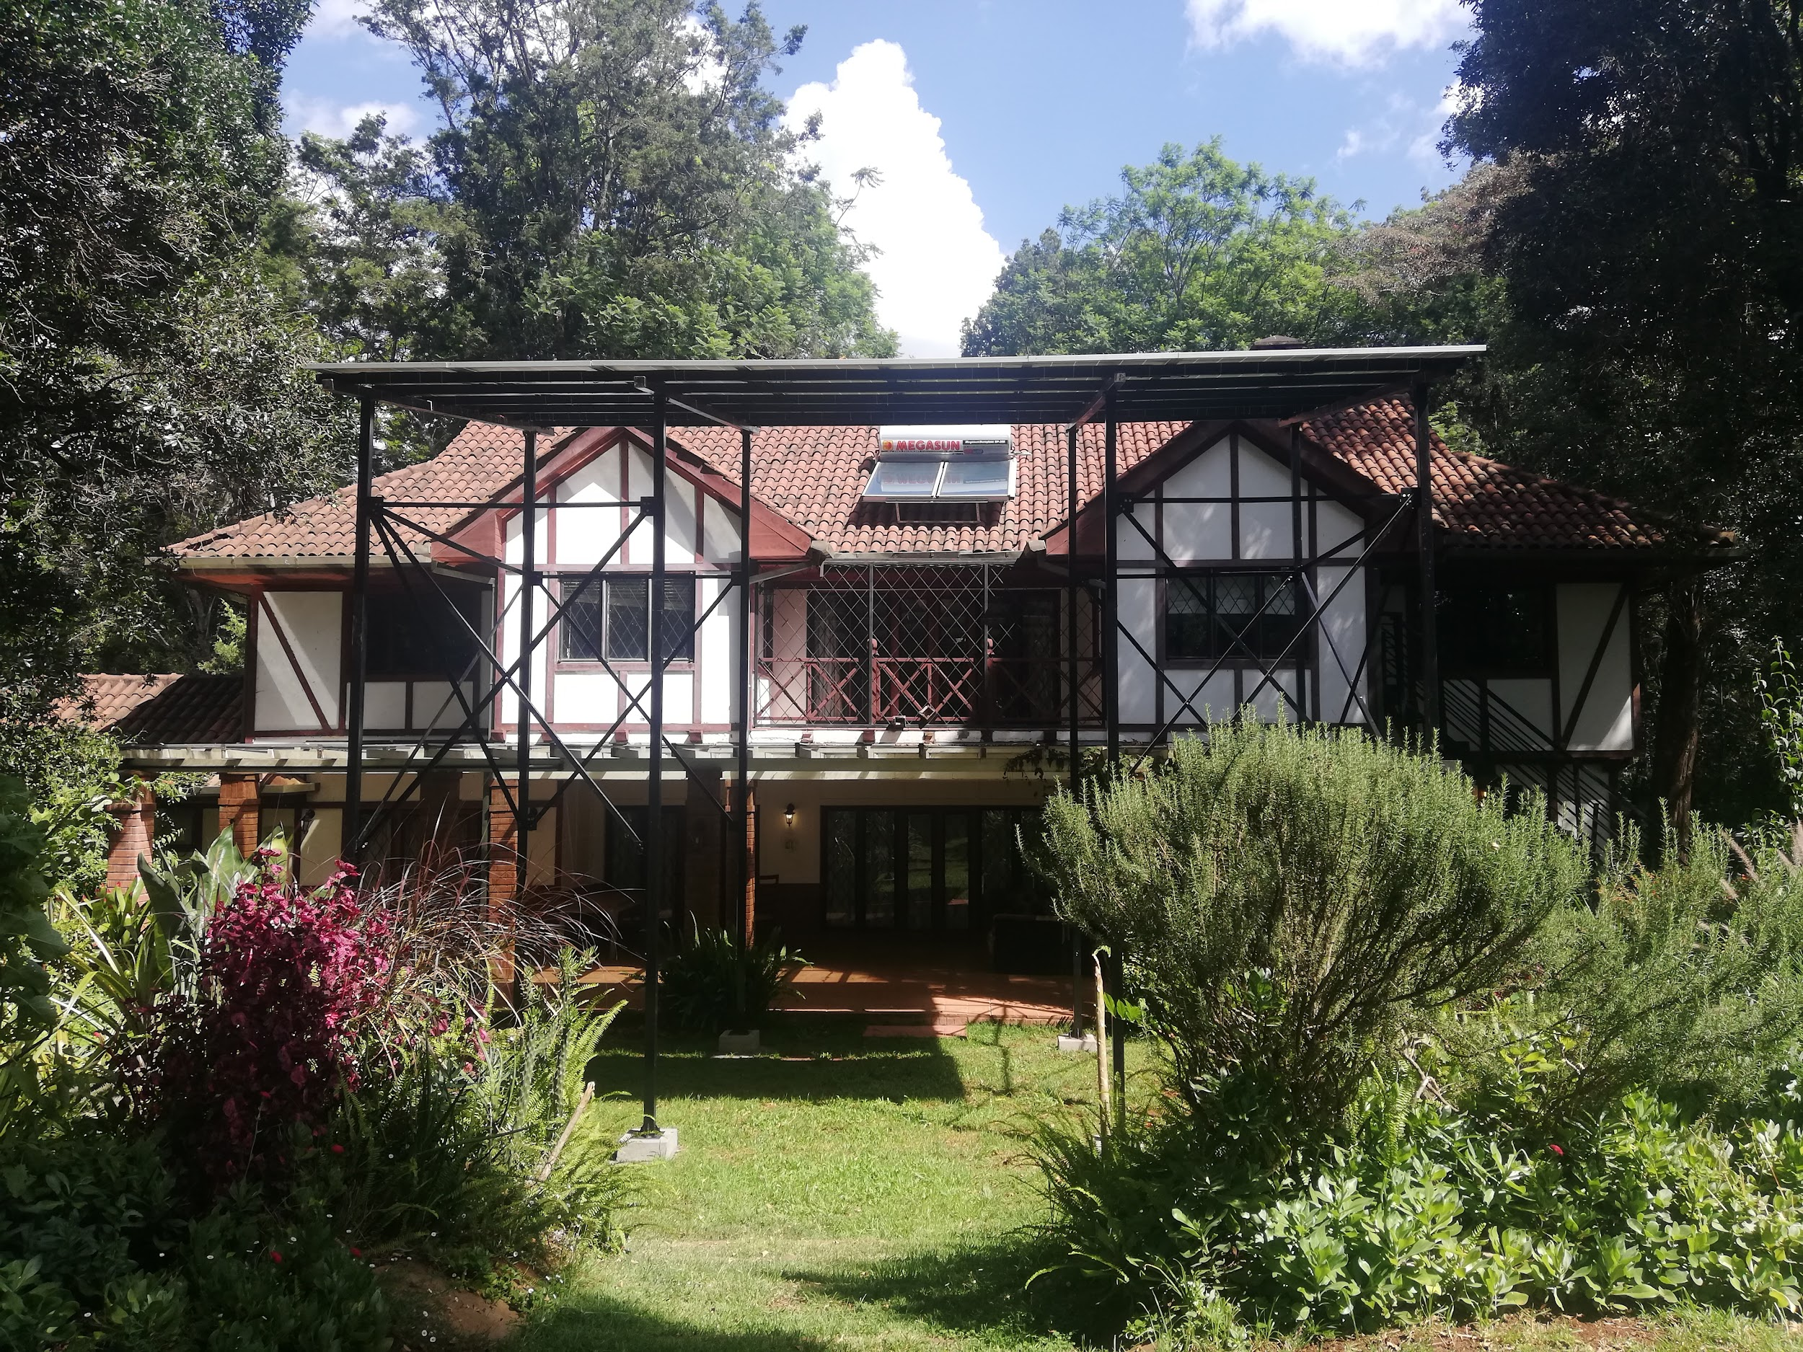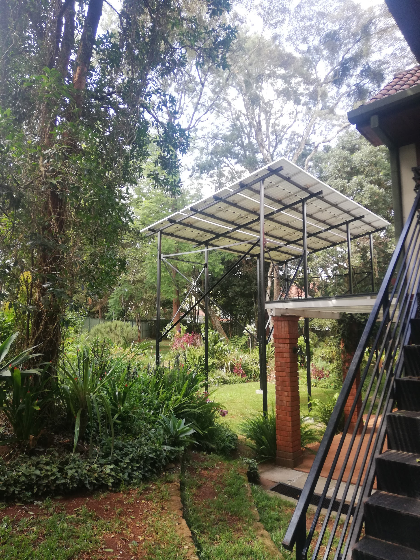

The climate within the shelter area is sometimes very cold. With this new source of energy, hosted girls will have constant access to hot water, uninterrupted power supply and simultaneously keep the hefty electricity bill low. In the long run, electricity costs across the country are likely to go up.

The installation of the solar panels is a safe and easy path to contribute to a sustainable future for the HAART Shelter. Our next goal is to implement a greenhouse project to grow our vegetables. Hosted girls will be trained in farming, as a possible source of income after their reintegration.

HAART remains committed through small steps, to take care of our environment to positively impact the lives of future generations