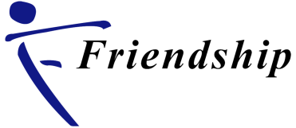
Emergency Response to Flood 2017
(Report on Friendship’s Initiatives till October 2017)

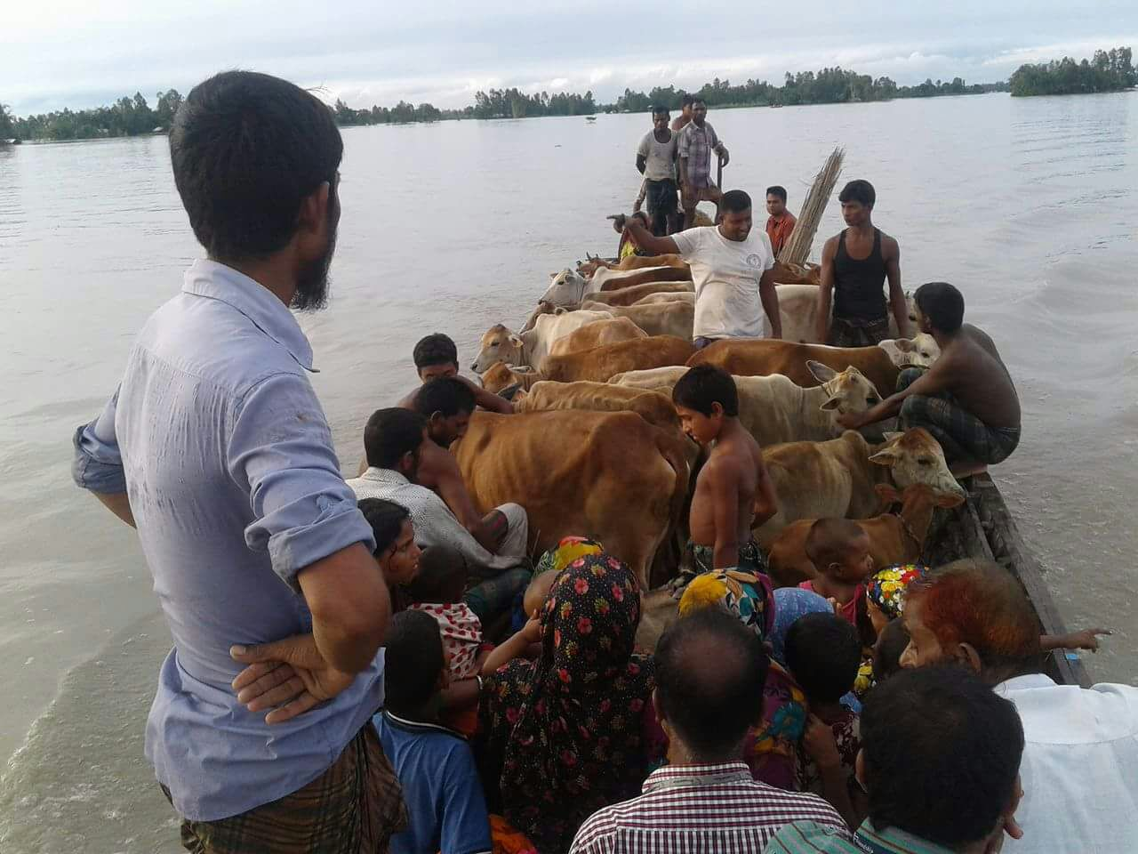

K-14/2A, Baridhara North Road, (Kalachadpur)
Dhaka- 1212, Bangladesh
Telephone: +88 02 881 2746
Fax: +8802-8814851
Email: info@friendship-bd.org
Website : www.friendship-bd.org

Executive Summary

This report describes the initiatives Friendship has implemented as part of an emergency response to the flood occurred in August, 2017. Situation Report dated 20 August 2017, by Ministry of Disaster Management and Relief (MoDMR), Bangladesh has been summed up with the following table which reflects the impacts of this devastating flood that hit the northern parts of Bangladesh:

People died | 114
People affected | 6.9 million
Districts affected | 31
Crops fully damaged | 582,091 ha
Crops partially damaged | 15529 ha
Roads totally or partially damaged | 6,610 km
Embankments fully or partially damaged | 96 km
Bridges/culverts destroyed | 446
Houses fully damaged | 77,272
Houses partially damaged | 524,374
Primary schools or community schools damaged | 2,292

Flood impacts in Friendship’s working areas - Kurigram and Gaibandha districts - deteriorated rapidly since its beginning on August 12, 2017 with heavy incessant rainfall leading to rise the water level of major rivers beyond their pre-established danger level. Flood Impact Assessment conducted by the Friendship Field Team reflects the following losses and damages:

- 72,131 households affected where women, children and elderly people were at risk
- 20,376 acres of crop lands submerged
- 7, 117 tube-wells damaged
- 10,434 latrines damaged
- 1,092 cattle died
- 61 schools partially and fully damaged
- 35 legal booths partially and fully damaged
- 7 Vocational Training Centers (VCTs) partially and fully damaged
- 567 houses partially damaged while 56,163 houses fully damaged

Friendship’s Response

With the assistance of ERIKS Development Partner, SMC/SIDA, Friendship Luxembourg (FLux), Friendship France, Friendship Holland, Carrefour, Sunbeams School and individual donors, Friendship has been able to extend immediate humanitarian assistance (mentioned below) to the flood affected areas:

- 278 families (228 men, 245 women, 104 boys and 113 girls) and 270 cattle rescued
- People assisted to dismantle the houses and schools to avoid damages by erosion, and emergency boats provided for shifting the housing materials
- 760 people, 258 cattle and 568 poultries sheltered on Friendship’s 6 plinths, while 781 people sheltered in 12 Friendship’s schools
- 30 temporary water points installed to ensure access to safe drinking water, while 50 temporary latrines installed to ensure appropriate sanitation
- Emergency dry food distributed to 1,500 families
- 83 emergency health camps organized where 9,056 people advantaged with healthcare and medicines reducing the spread of water and vector borne diseases
- Food relief distributed to 12,000 households where special assistance extended to pregnant women, elderly and disable people for carrying relief materials
- Nutrition support provided to 400 children and 100 pregnant and lactating mothers for 20 days
- 50 tube-wells to be installed, and tool boxes for repairing and maintenance to be distributed to the communities
- 50 sanitary latrines to be installed
- 70 damaged tube-wells or water points and 75 damaged latrines to be repaired and reconstructed
- 26 Friendship schools repaired, and repairs 30 schools and reconstruction of 5 schools to be completed by November, 2017
- 32 damaged legal booths repaired, and 3 booths to be shifted to another places by the middle of October, 2017
- Repairs and reconstruction of 7 partially and fully damaged vocational training centers in progress

Friendship has successfully responded the flood situation to bring the normalcy into the lives of the flood affected communities of selected areas through providing rescue support, healthcare services, clean water, sanitation and food materials. Friendship has maintained transparency and accuracy in procurement, beneficiary selection and distribution of components. Repairs and reconstruction of damaged Friendship schools, legal booths and vocational training centers are underway with small scales, and concerns remain for strengthening these structures for future disasters through raising schools plinths and installing relevant logistics. Through the assessment, the urgency of repairing and reconstructing houses have appeared among the affected people. As half millions of people have been the victims of river erosion, construction of plinths to home the homeless families with basic human needs and provision of sheltering people in emergency situation with livestock and poultry can be one of the possible solutions to get prepared for responding to future floods. Water and sanitation supports are required for ensuring access to safe drinking water and proper hygiene. Creating alternative livelihood sources and meeting the nutritional demands of the affected families can be possible through distributing vegetable seeds, fingerlings, poultry and livestock components.

1. Overview of the Flood 2017

With the heavy rainfall leading to rise of the water level of major rivers (Teesta, Dharla and Jamuna) beyond their pre-established danger level, the flood affected the northern parts of Bangladesh severely on August 9, 2017. It has been revealed from the assessment by WFP and NDRCC that till August 18, 2017, eighteen rivers have been observed to be above danger level.

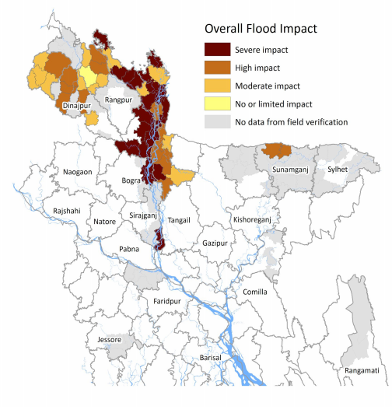
Fig.1. Overall impact of flood occurred on August 9, 2017

Friendship’s working areas - Kurigram and Gaibandha - are being severely affected by the flooding with the damages of crops, latrines and tube-wells leading the people to food shortages, health-related crises and scarcity of safe drinking water. In addition, river erosion and waterlogging situation are pushing the affected communities to migrate to other chars. To be noted that river erosion in this year in isolated chars is working as ‘pushing factor’ to drive about 1,000 vulnerable households migrate to other places hopelessly just for the sake of surviving.

Friendship has monitored the situation intensively in coordination with government and community organizations, and contributed to the situational updates throughout the workforces of different locations.

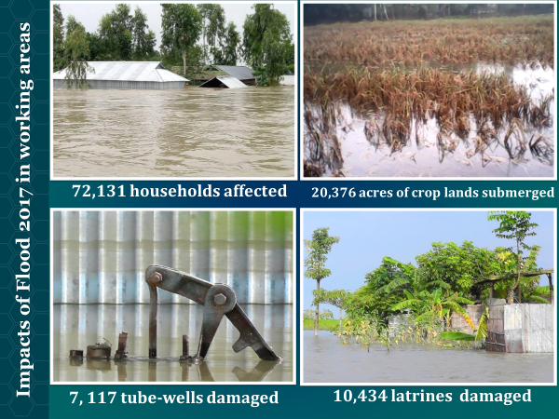

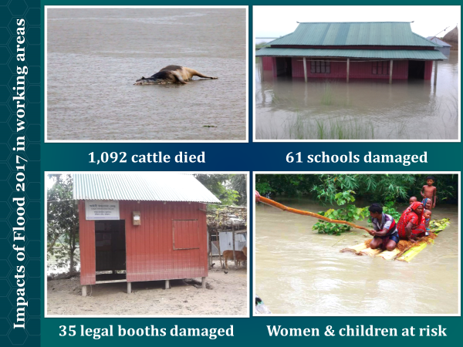
2. Friendship’s Immediate Response to Flood 2017

Flood situation has been carefully monitored by the Field Team of Friendship in coordination with the relevant government departments and NGOs. Immediately after the flooding in August 9, 2017 in Friendship’s working areas:

- Communication Tree activated to strengthen the information flow before and during emergency period from field to Head Office
- Logistic preparation (i.e., existing resources and some shelter facilities) reviewed
- Emergency boats prepared for rescuing households and cattle and shifting them to safe places
- Friendship’s Health Team prepared to provide healthcare services through organizing Emergency Medical Camps
- Friendship’s plinths opened for the distress to use as shelters
- Emergency Coordination Meeting held at Friendship Head Office while Emergency Response Team (ERT) held at Friendship Field Office

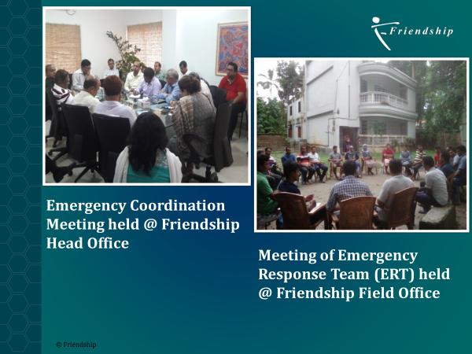

3. Initiatives taken by Friendship through several projects

Friendship has extended humanitarian assistance in its working areas to rescue, shifting, shelter arrangement, healthcare services, food support and water and sanitation facilities.

Rescue
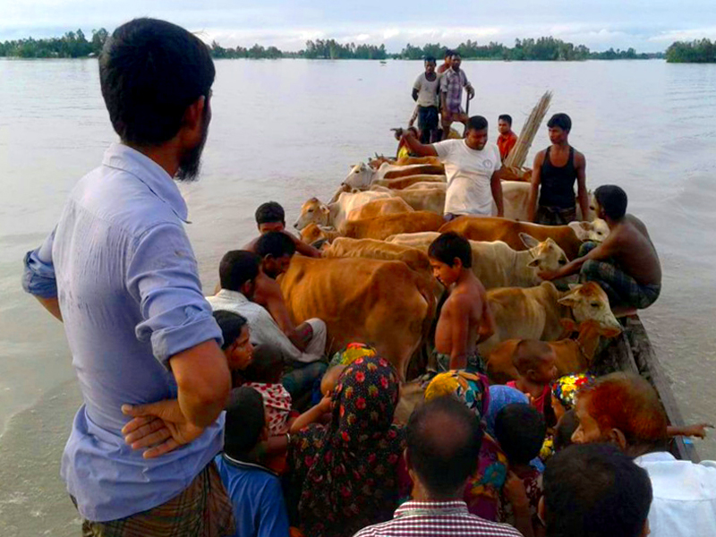
278 families (228 men, 245 women, 104 boys and 113 girls) and 270 cattle rescued

House Shifting
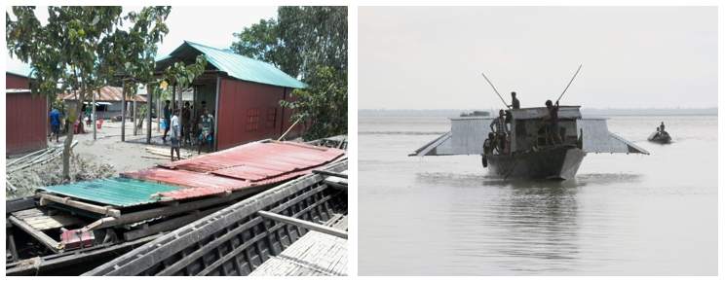
People assisted to dismantle the houses and schools to avoid damages by erosion, and emergency boats provided for shifting the housing materials

Sheltering
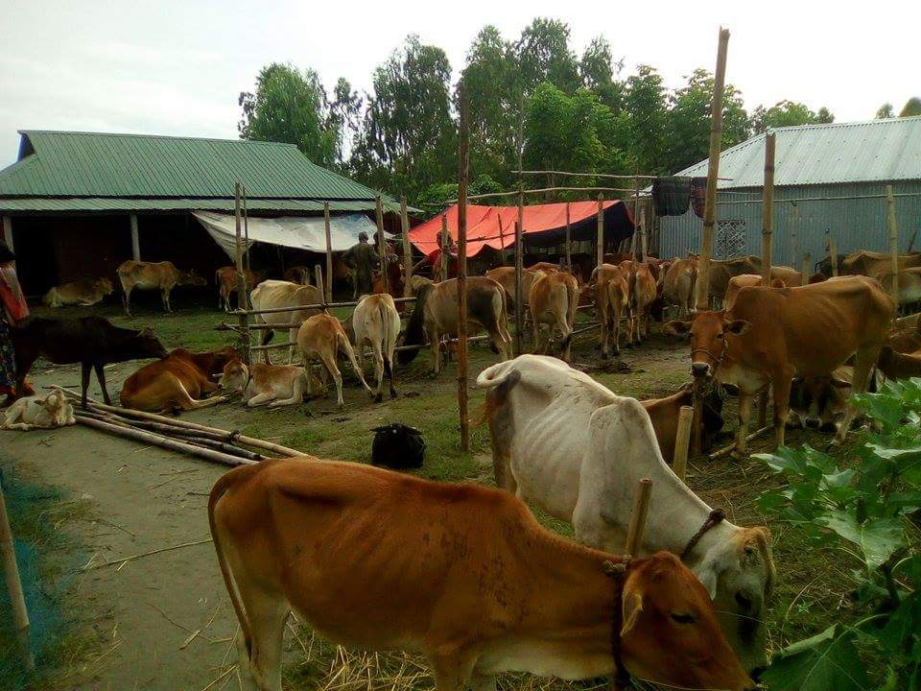
760 people, 258 cattle and 568 poultries sheltered on Friendship’s 6 plinths, while 781 people sheltered in 12 Friendship’s schools

Temporary Tube-wells
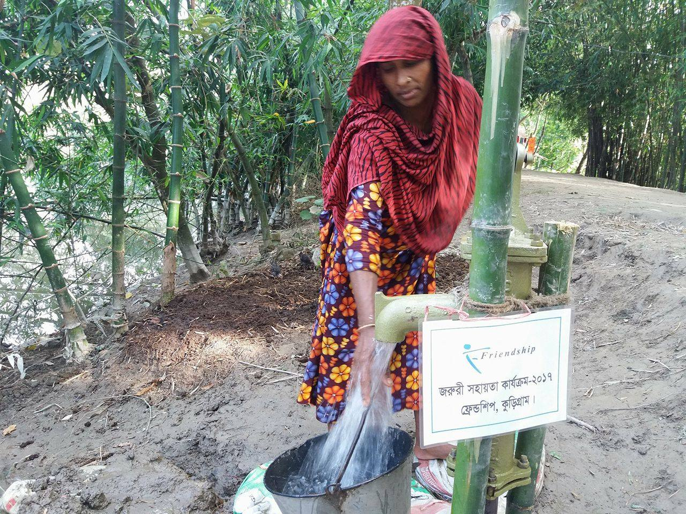
30 temporary water points installed to ensure access to safe drinking water

Temporary Latrines
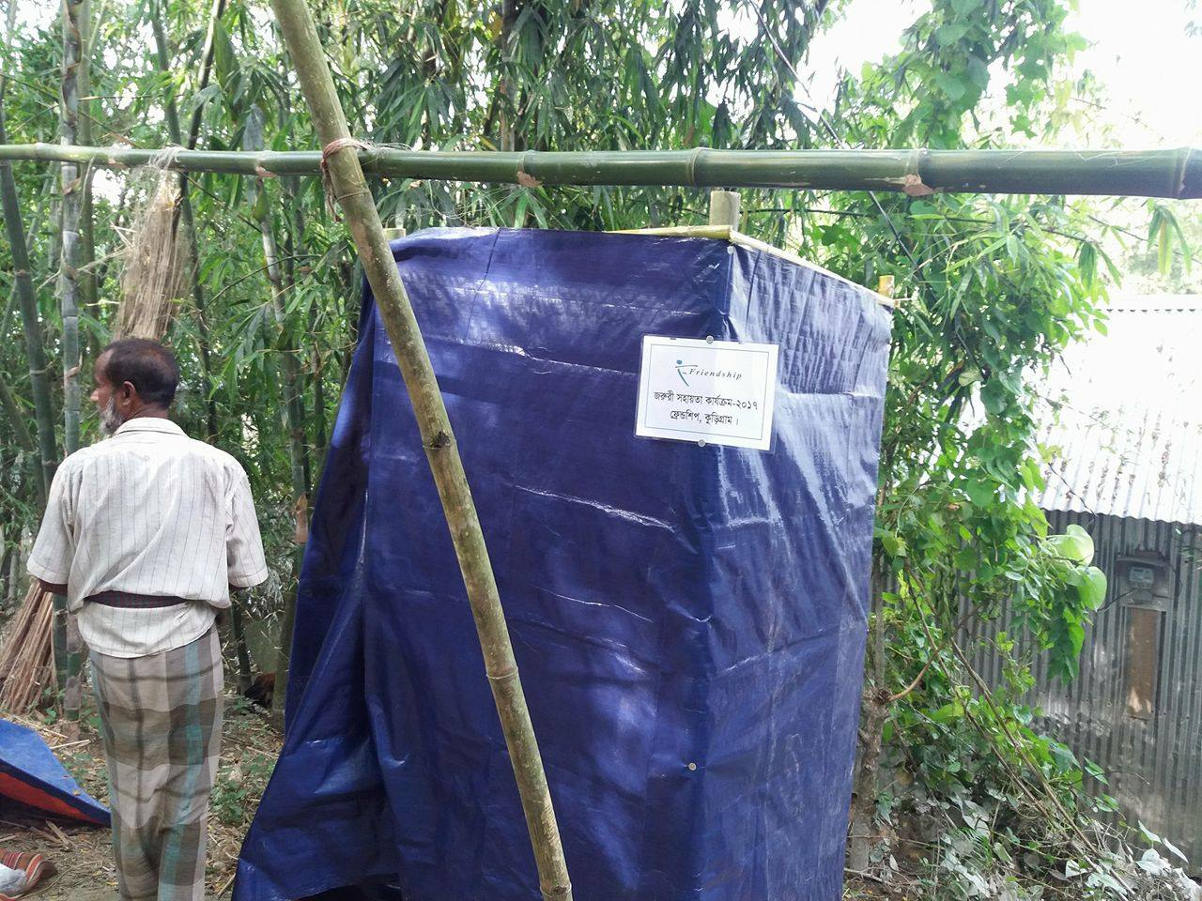
50 temporary latrines installed to ensure appropriate sanitation

Emergency Dry Food
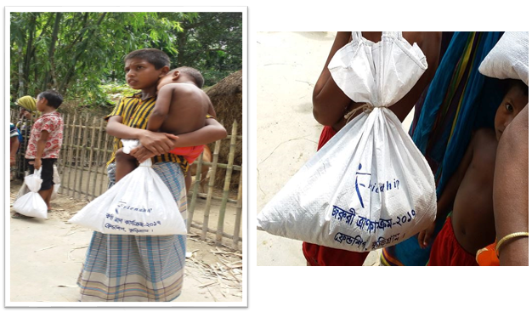
Emergency dry food distributed to 1,500 families

Emergency Health Camps
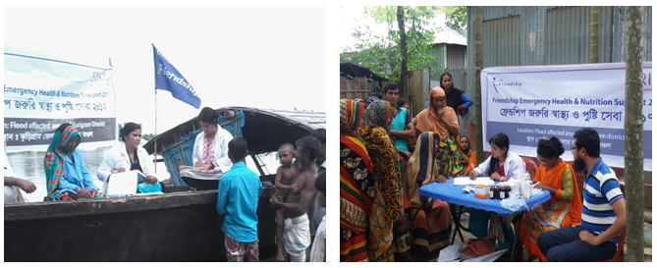
83 emergency health camps supported 9,056 people with supplies of medicines

Food Relief
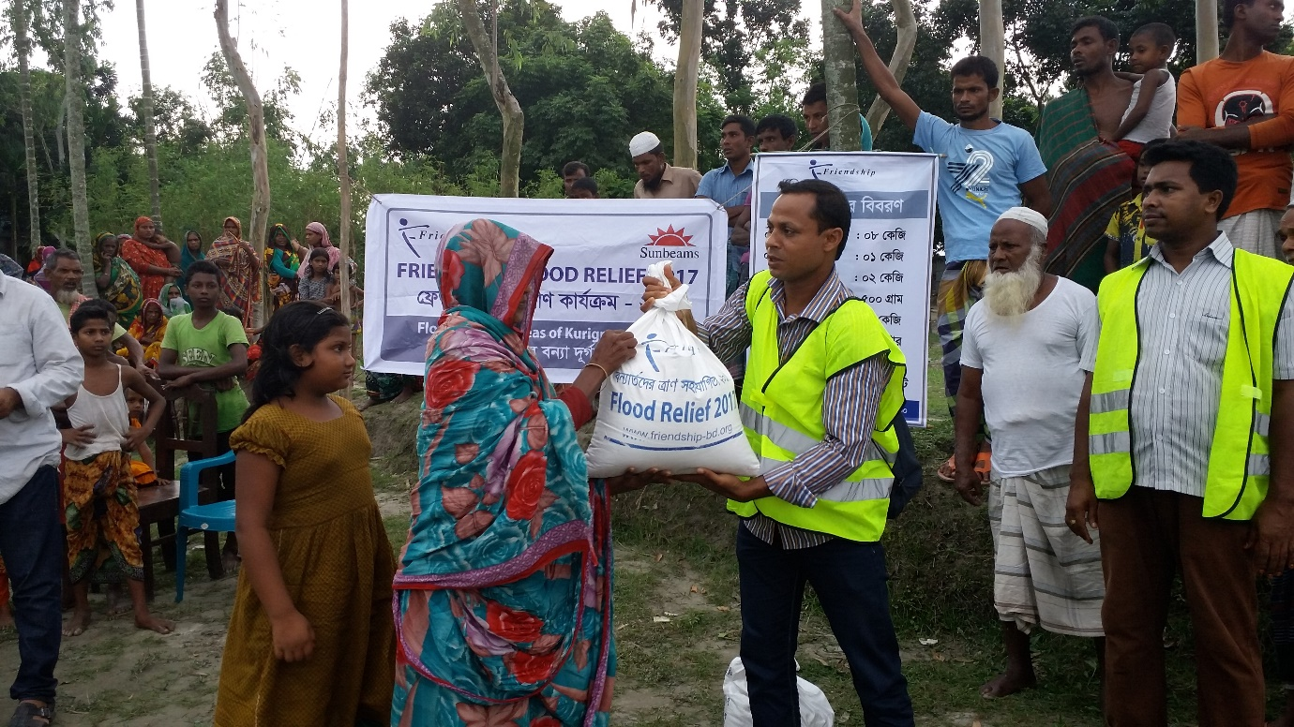

Food relief distributed to 12,000 families

Nutrition Support

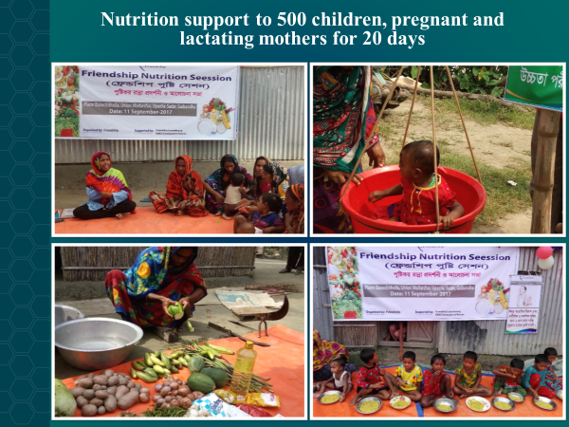

Repairs and Reconstruction

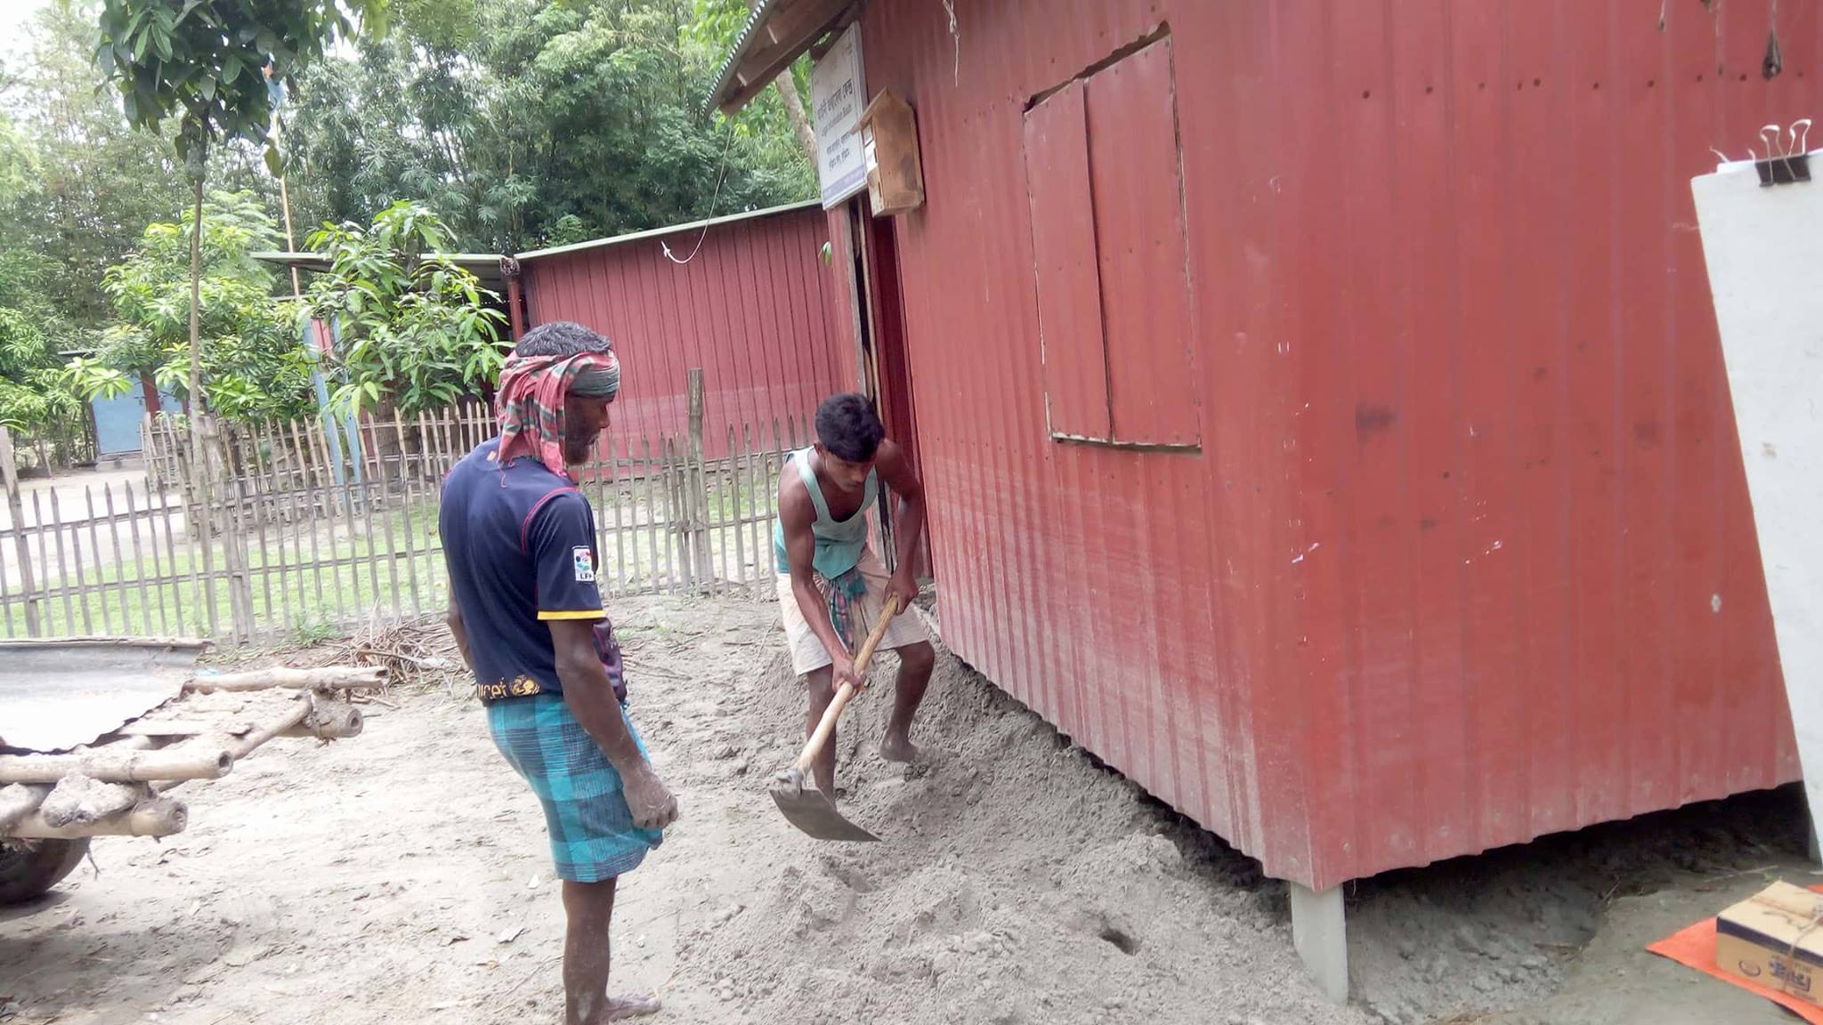
61 damaged schools, 35 legal booths and 7 vocational training centers are in progress to get repaired and reconstructed with small scales

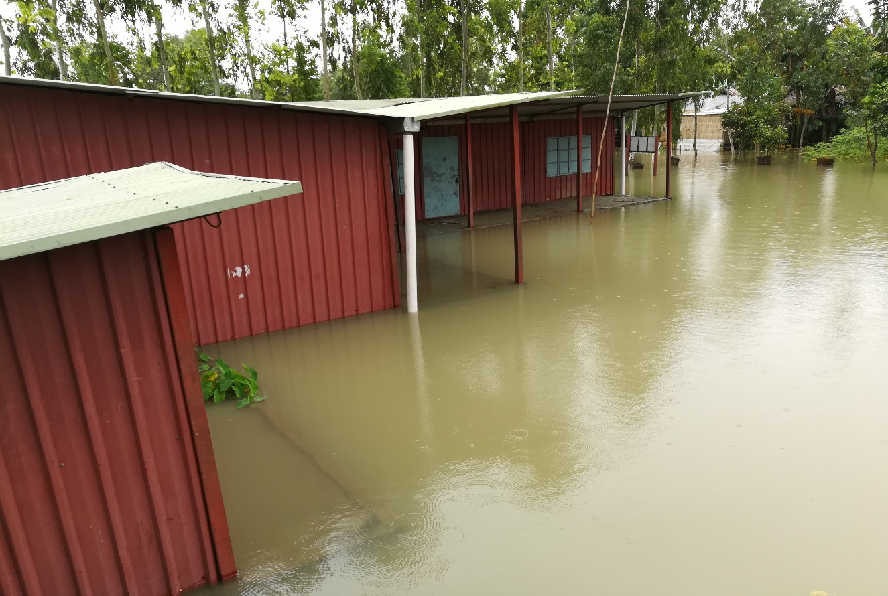
Bozradiarkhata Primary School at Chilmari affected by flooding and education programme stopped

The plinth of the school is being raised, and the doors and windows are being repaired to bring it in better condition in comparison to the pre-flood level situation so that the school can withstand in future disaster. Thus, Sunbeams School played significant role in bringing the functionality of lives of 300 families and smiles of 59 students including their parents and teachers.

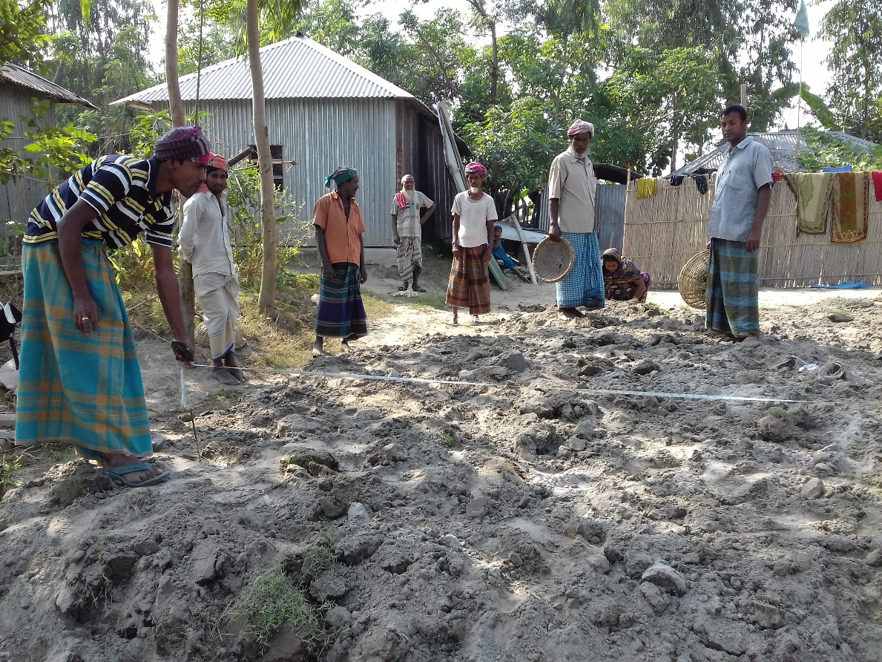
Plinth of damaged school raised to bring it in better condition

4. Process of Flood Relief Distribution

Friendship has followed a certain process regarding the emergency food relief distribution. The steps of the emergency food relief distribution process are as follows:

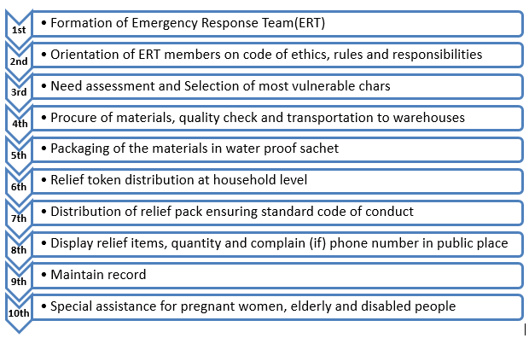

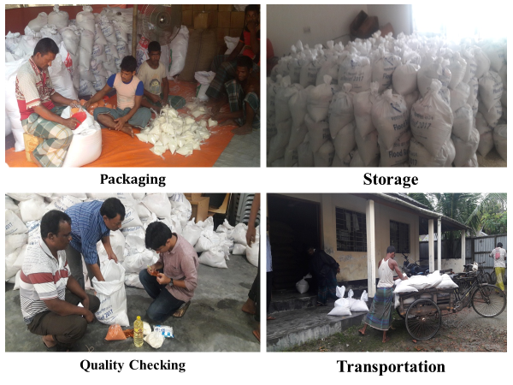

Relief materials procured with proper quality checking, transported to warehouses and packaged with water proof sachets

5. Further supports needed

Through the Field Assessment by Friendship Field Staff, the following areas have been identified for the betterment of the affected communities with aim of making them resilient for future disasters:

- Repairs and construction of damaged houses
- Strengthening the Friendship’s schools, legal booths and vocational training centers through heightening the plinths and installing relevant logistics
- Construction of plinths with provision of sheltering facilities
- Creating alternative livelihoods options through distributing agricultural components
- Ensuring water and sanitation facilities through installing and repairing tube-wells (water points) and latrines

6. Conclusion

Friendship with its collaboration and networking with diverse donors, individuals, NGOs, foundations, public development agencies and major corporations, has been able to meet immediate food and nutrition needs and reduce risk of epidemic by providing water and sanitation facilities and healthcare services to flood affected people of 30 unions in Kurigram and Gaibandha districts of northern Bangladesh. Friendship can ensure the transparency of all funds received with a view to responding to the Flood 2017. Friendship is sincerely thankful to the donors who has extended their supports to bring the normalcy and functionality into the lives of the flood affected people.

