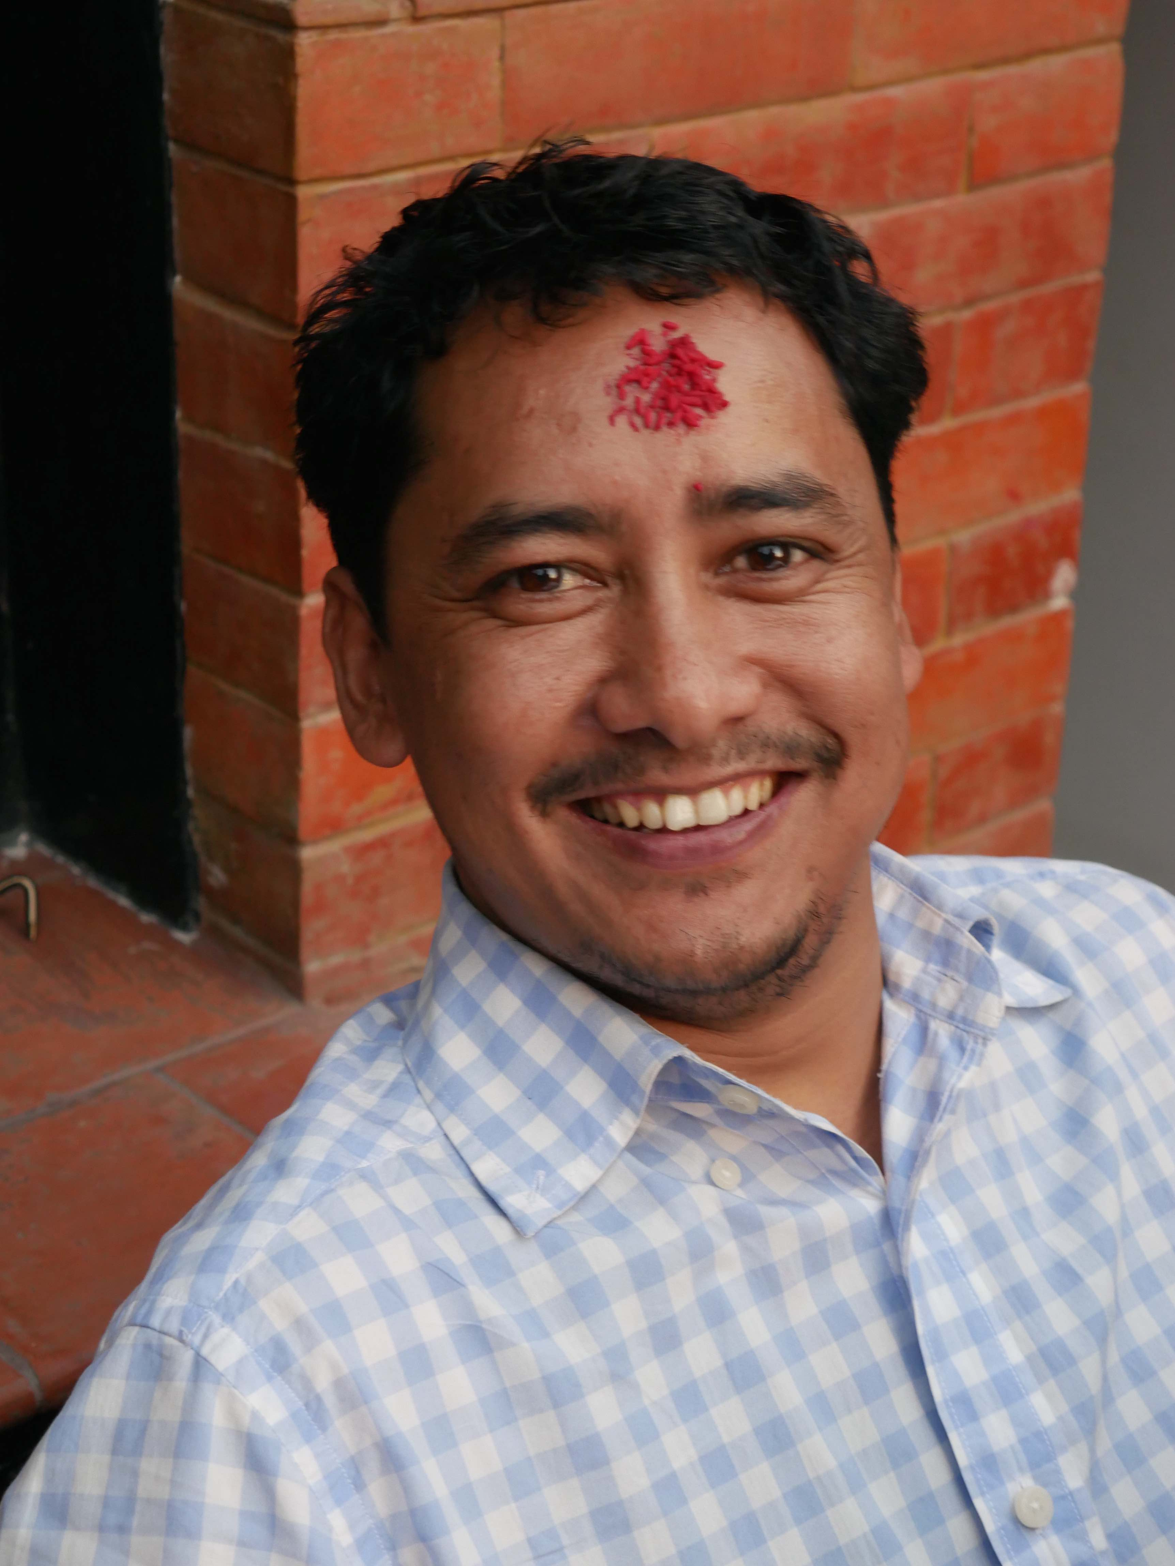
Dear Sponsors,

I was born in the western part of Nepal, in an isolated and remote village called Kalicot in the Karnali district. There were no medical posts or hospitals, no electricity, no roads and no secondary school in my village. My world was very limited to within the boundaries of the mountains and I could never have imagined life beyond the mountains. As I was growing up, because my parents couldn’t raise me, I was sent to live with my maternal Uncle in his village – I therefore never experienced the true love of my parents throughout my childhood. I was lucky though as I was sent to the local village school where I stayed until 5th Grade. I then went to a school in the next village until 10th Grade, which meant walking 2 hours there and back every day. I was bright and was lucky enough to win a science and medical scholarship to attend High School in Kathmandu. Then, after training as a Health Assistant, I worked with Médecins Sans Frontières where I met Dr Kate Yarrow, working together in a remote hospital in Manma. I bored Dr Kate with my huge desire to train as a doctor so that I could give back to my isolated village, but of course I couldn’t afford medical school fees. Dr Kate made me a promise there and then – if I managed to gain entry to medical school in Kathmandu, then she would sponsor my training. Thus Doctors for Nepal was set up and I will be forever grateful to Dr Kate and her charity.

I didn’t just want to become a doctor I needed to and had been dreaming about it for a very long time. I wanted to give back to my community because of the very poor health situation that existed in Kalikot at that time. I come from a very poor family in a very remote village – impossible to ever imagine that I could become a doctor – but I was the First Health Assistant amongst the 150,000 population of Kalikot district. There were no doctors, and I wanted to change that. I wanted to change the concept on health and disease at home, in my village, in my district, where people mostly relied on and believed in the traditional village healer. Thanks to Doctors for Nepal I graduated as a doctor, and took up my first posting as a trained doctor in Kalikot Hospital, where I worked for two years trying to implement my beliefs and to improve the hospital. I set up a mobile medical camp in different villages in the district and carried out thousands of consultations, thousands of procedures, around 500 vasectomies, and saved the lives of more then 100 mothers by doing emergency caesareans. However, I eventually realised that there are too many challenges and difficulties for a lone doctor such as myself to change the corrupted, outdated government health system. I also realized that I was going to have to train more as it is not possible for me to make such dramatic changes in my current position as a junior doctor. My knowledge and skill set are limited and I am unable to manage so many different problems in remote district hospital. So, after working for 4 years in a community hospital in the mountains, I realized the need to further my studies in General Practice and Obstetrics and Gynecology, to refine and upgrade my skill and knowledge, and to develop the management skills required to make a real difference in rural hospitals. My dream now is to become the very best rural doctor that I possibly can – to become a leader who can have an overall impact to improve the health conditions of remote populations. Almost 90% of rural district hospitals have no consultant doctors. Consultants are sent to District hospitals but no one wants to go to a rural hospital. 90% of consultants are based in major cities like Kathmandu and Pokhara. If I were able to gain my postgraduate training I would relish the chance to continue my rural service in the district mountain hospitals. With this training I would have the confidence to be part of the actual decision making of the government health system. I believe that my postgraduate training will not only support my personal career but also it will help to influence and improve the health of the rural populations, which of course is also the sole vision of Doctors For Nepal.

My financial situation: since becoming a doctor, my family’s financial situation has improved, as I am now able to support my four sisters and one brother in their paramedical education. I also support my wife and two children. However, doctor’s pay in Nepal is the lowest amongst all other Asian countries, and it is impossible for me to save money for my much needed postgraduate training which will cost approximately $50,000. However, working in rural hospitals in the mountains has its different rewards for me - saving the lives of dying women, children and traumatised adults is why I do it rather than for money. I am happy and completely satisfied with the work I have done over the past four years in rural district hospitals in the mountains, but it is impossible for me to continue to improve my skills and expertise via postgraduate training without your active financial support. I humbly ask that every kind-hearted person donate as much as they can, enabling me to pursue my dream of starting my postgraduate training. In return, I promise to pay back your generosity by saving the lives of the people who live in some of the most remote villages in the world. Thank you from the bottom of my heart - and thank you from the people of remotest Nepal.

With love and respect.
Dr. Lalit Jung Shahi
DFN first Scholar
