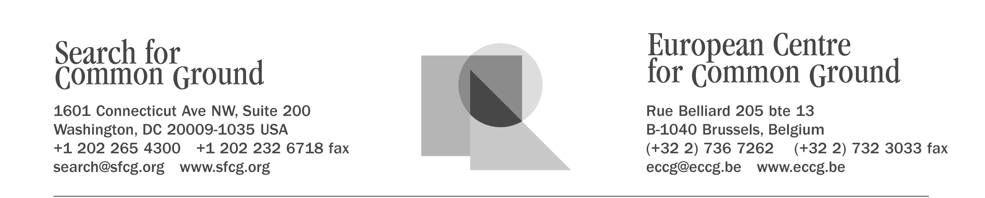
Search for Common Ground in Sierra Leone

Program Overview

Search for Common Ground has been engaged in Sierra Leone since mid-2000 with two projects: Talking Drum Studio-Sierra Leone (TDS-SL) and the Community Peacebuilding Unit (CPU). The overall goal of Search for Common Ground-Sierra Leone (SFCG-SL) is to reduce violence and promote collaborative peacebuilding among all groups in Sierra Leone.

Integrated, Multi-faceted Approach
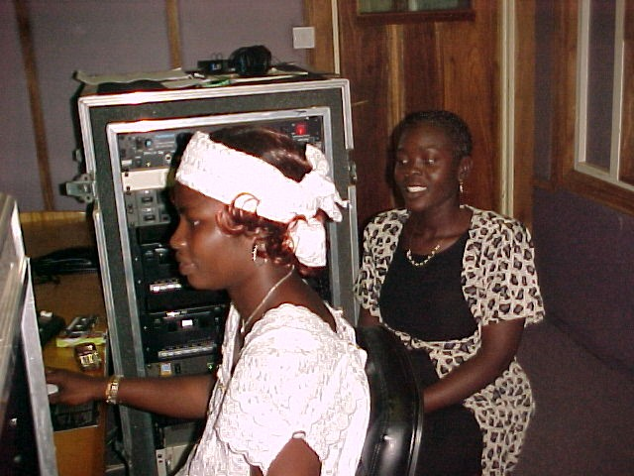
Conflicts and societies are multi-faceted and operate on many levels – personal, familial, ethnic, political, and social. To effectively respond to this, SFCG-SL uses a multi-faceted approach to expand beyond strategies that target only one sector of society or one element of conflict. By promoting reconciliation and peacebuilding in Sierra Leone through a variety of activities including radio programs, community radio outreach, peace carnivals, and coalition building, SFCG-SL has been able to impact some of the most affected and most influential segments of society across the country. SFCG-SL uses its multi-faceted approach in a highly integrated way that links grassroots efforts with national dialogues. TDS-SL creates national dialogues around critical issues and the CPU then complements the radio studio by engaging communities in local peacebuilding activities. In this integrated, multi-faceted approach, the media and non-media projects work in partnership at all levels of Sierra Leonean society to advance enduring peace.

Country Context
Conditions have vastly improved in Sierra Leone. President Ahmed Tejan Kabbah officially declared the war over in January 2002, and relatively free, fair, and peaceful presidential and parliamentary elections were held in May 2002. Root causes of the war, including corruption, disenfranchisement, and the lack of economic opportunity for the majority of the population, remain to be addressed. Further, peace in Sierra Leone cannot solidify without lasting peace in all three countries of the Mano River Union – Sierra Leone, Liberia, and Guinea. SFCG-SL works in close collaboration with SFCG-Liberia to share lessons learned and to coordinate efforts to achieve the greatest impact possible on the sub-regional level. Some of SFCG-SL’s media and non-media programs are highlighted below.

TALKING DRUM STUDIO-SIERRA LEONE
TDS-SL is a multi-media studio producing 10 radio programming strands for distribution to 11 local and international radio stations across Sierra Leone for a total of 82 hours of airtime per week. With the results of a January 2002 survey conducted by independent researchers rating TDS-SL’s listenership at 85% nation wide (97% in Freetown), SFCG-SL’s media work creates national dialogue around key issues and gives a voice to all sectors of society. The programs include:
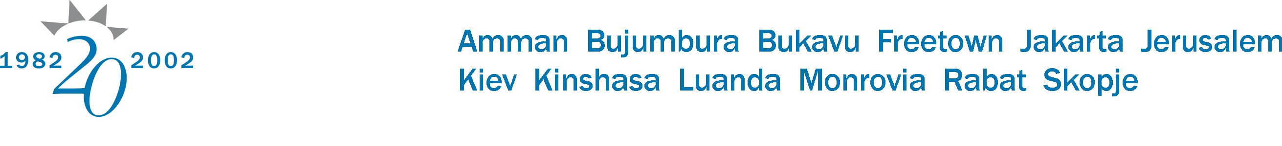
- Golden Kids News
This radio program engages networks of children of mixed backgrounds in eight locations who serve as producers, reporters and actors and who identify issues for and about children and advocate on their behalf.
- Atunda Ayenda (Lost and Found)
Atunda Ayenda marks the first use of soap opera in Sierra Leone. Originally launched to sensitize listeners, and particularly ex-combatants, on the disarmament process, Atunda Ayenda now addresses a range of social issues of concern, including corruption, HIV/AIDS, and human rights. In addition to numerous Sierra Leone FM stations carrying the program, it is also broadcast by a radio station in Banjul, The Gambia. This increases the impact of SFCG-SL’s sub-regional effort to facilitate discussion and build peace.

COMMUNITY PEACEBUILDING UNIT
The CPU uses a wide array of methods to do its work including community radio outreach, peace carnivals, coalition building, direct mediation, facilitation, live drama performances, soccer tournaments, training, and multi-media peace vehicles. The CPU stimulates grassroots searches for solutions to community problems and, in doing so, engages the government and other organizations in the process. This work feeds back into the media programming as community problem solving is brought to the forefront of national discussion. Activities include:
- Community Radio Outreach
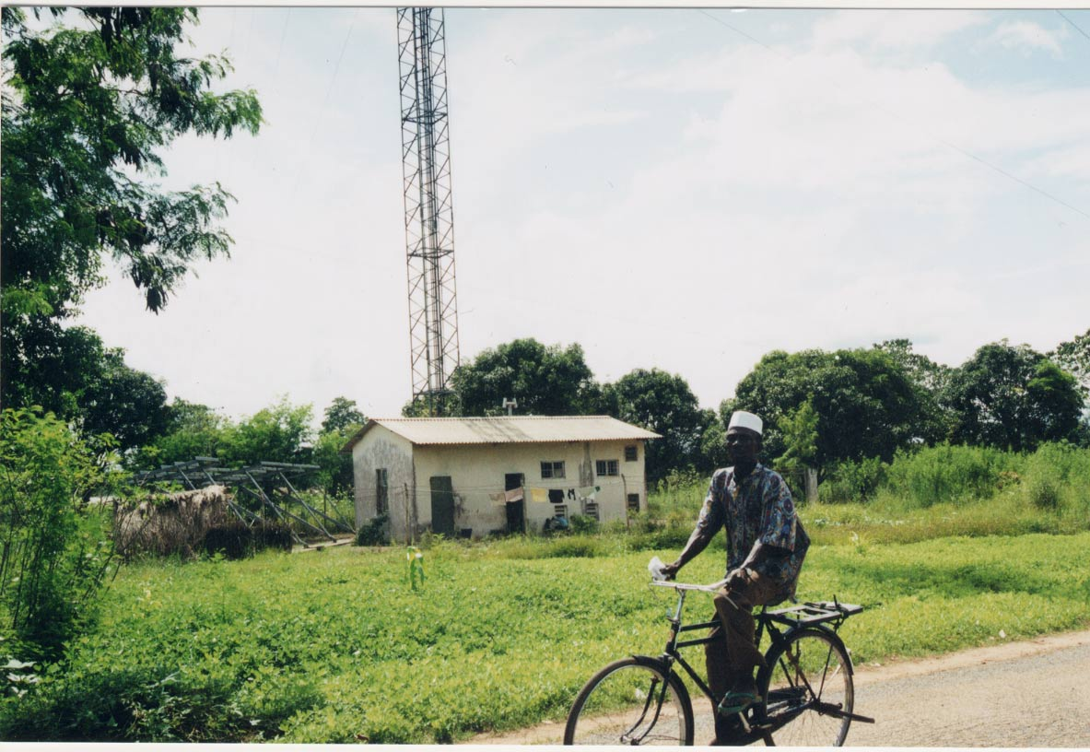
To increase local radio coverage of public information and national dialogue in Sierra Leone, SFCG-SL’s CPU facilitates communities developing their own radio stations. Project activities include facilitating community meetings, determining what residents are looking for in a radio station, coordinating work plans so that all stakeholders contribute to the founding process, and securing equipment for the station to function. The CPU brings together staff from various stations across the country to train each other and to share valuable experiences, enabling collaboration and new ideas to develop.
- Bo Peace Carnival
An annual event taking place every Easter in Bo, Sierra Leone, the Bo Peace Carnival brings together a variety of activities aimed at promoting community building and sustainable peace. SFCG-SL partners with local groups to host the carnival. Cultural groups and performers from around Sierra Leone participate, as well as drama troupes from secondary schools who perform plays around issues concerning youth. SFCG-SL staff gather the commentary and opinions of chiefs, women’s representatives, cultural artists, and civil society members. These comments and discussions, along with taped programming related to the carnival’s theme (varies annually), are broadcast to the various regions of Sierra Leone over the four-day period of the carnival.

Search for Common Ground in Sierra Leone is a program of Search for Common Ground and the European Centre for Common Ground, international NGOs working as partners in the fields of conflict resolution and media production. For additional information, see our website, www.sfcg.org, or contact West Africa Program, 1601 Connecticut Avenue, NW, Suite 200, Washington, DC 20009, USA; phone (+1)(202)265-4300; fax (+1)(202 232-6718; e-mail search@sfcg.org.

