Success Story: Ms. Amrita Chaudhary-Happy to be regular at school class and free from stress of flood (#29173)
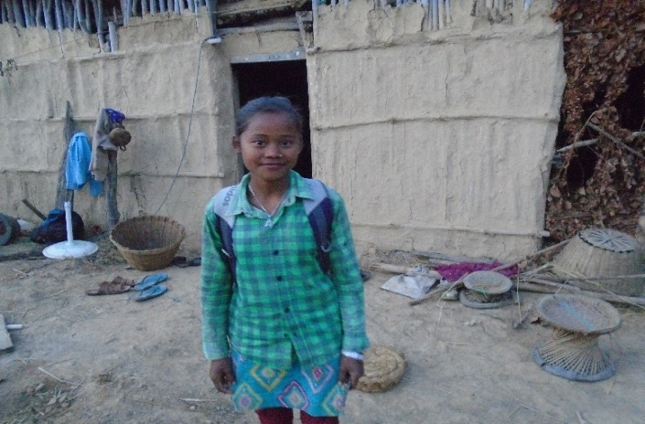
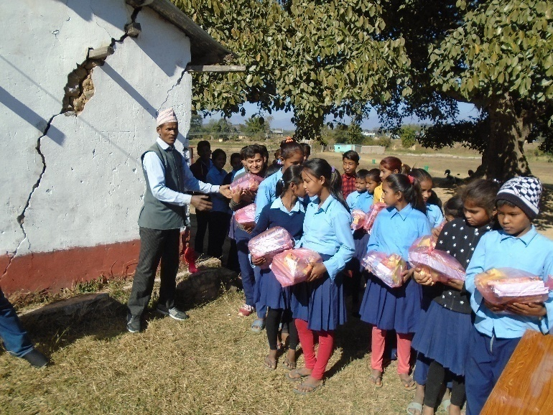
Due to the severe flood disaster of 13th August 2017 in Dang district caused the loss of human lives and brushed properties in different places and Rural Municipalities among those Phoolwari VDC (now Tulsipur Sub Metropolitan ward no 13) is one of them. The VDC was affected from two main rivers of Dang Babai and Tuikhola. The rivers destroyed the normal lifestyle of varies places of Phoolwari VDC. Community people suffered with different difficulties and hardness in life due to the damaged of the culvert and road, irrigational cannels, social structures, schools, community buildings, even houses. Ms. Amrita Chaudhary the daughter of Ait Ram Chaudhary and Narayani Chaudhary was living in Phoolwari VDCs. She is 12 years old and reading in grade 7 in Ambikeshori Secondary School Ambapur. There are 4 members in her family Father/Mother one elder brother who was reading grade 8 and herself.
The flood of Tuikhola has clashed their house, store clothes, grains and even about 2 hectors of maize from the field. They had nothing to eat and no place to stay. Her mother Narayani Chaudhary said, "I could not think what to do at that time. My husband had gone to outside of district city for livelihood; I was alone to manage the situation at that time. We felt so depressed during that time and had to suffer with so many difficulties to upbringing the family smoothly, caring two children. My Children didn't go their school for 2 weeks. Their school dressed was brushed by the flood, we don't have the grain for food, village sister support me for food and our community leader (Mahatawa) managed and provide his house to stay. I could not get any support from the government and other sectors except 25 kg rice provided by Red Crossed Society/Nepal in the lead of Parliament member Mr. Dilli Bahadur Chaudhary." She added that my husband sent some money from her income and we managed some food, clothes and school dress of my children after those children started their school. Few days ago, Backward Society Education (BASE) has provided some stationery (note books, pen, inks, geometric box and dictionary to the children) my little girl became very happy when she got the support. Though the support seems small but due to the support she (daughter) got encouraged to read and write and even being regular in school class.
Thanks.

