Project Completion Report on Recovery Support to Flood Victims in Nepal
Project # 29173
Prepared by:

Backward Society Education (BASE), Central Project Office
Tulsipur Sub Metropolitan City, Dang District, Nepal
Tele: +977-82520055
Email: info@nepalbase.org AND churna@gmail.com
Website: http://nepalbase.org

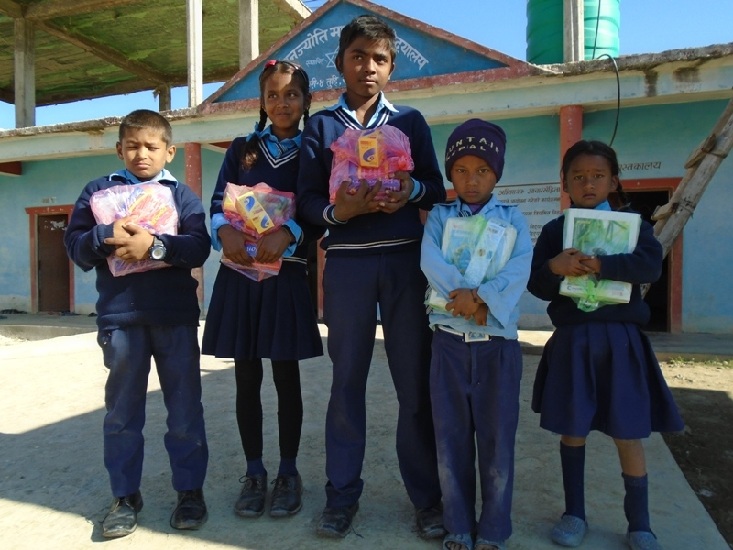
Report Submitted to:
GlobalGiving Foundation (EIN: 30-0108263)
Global Giving UK (Charity # 1122823)
1110 Vermont Avenue NW, Suite 550
Washington, DC 20005

Background:
Every year in western Nepal flood affects the lives of rural people causing loss of property, damage of infrastructures and sometimes human loss. On Aug. 12-15, 2017 massive floods affected more than 12733 families that became displaced, losing their goods and property. Backward Society Education (BASE) is a national NGO working in western Nepal since its establishment in 1991 and most of the flood affected families are BASE’s beneficiaries. Therefore, BASE explored sources of funding and posted an appeal to donors through GlobalGiving to support to flood affected families. They were in dire need regarding of food grain, temporary shelter, blankets, portable water, clothing, medicine and education material for children going to school.
Introduction:
This is the completion report for the project called Recovery Support to Flood Victims in Nepal project (# 29173). BASE has received donations on October 3rd, 2017 and October 29th, 2017 and provided educational material support to the children who have lost their education materials because of the flooding. Thanks to the Recovery Support project, the school education materials were provided to the school children in Dang district, Nepal. The total grant received USD $ 1593.00 (In words one thousand five hundred ninety three US Dollar). The details expenses of the report can be seen in another sheet.
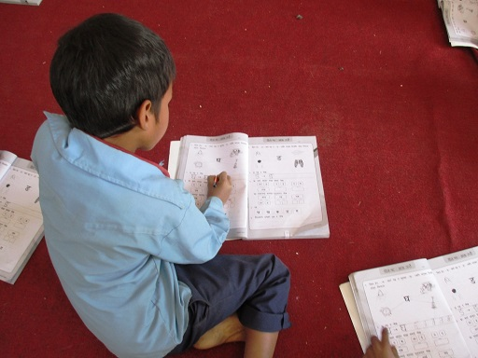
Children receive education material that have previously been lost during the flooding.
Brief summary about the activities enabled by the Recovery Support to Flood Victims in Nepal project:
- Meeting with school administrations for an authentic data collection of the flood affected children:
At first, a meeting was organized with the administrations and teachers of five schools that were affected by flooding in Dang district, Nepal, in August 2017. During the meeting, BASE’s field staff reported on the education materials support process and selection criteria for the flood affected children. The school administrations provided detailed data regarding the flood affected children through a formal report transmitted to BASE.
- Education material distribution ceremony:
In close coordination and cooperation with school administrations, BASE organized an education material distribution ceremony which started from Dec. 15, 2017 and concluded on 19, Dec. 2017. Altogether, 96 school students (57 girls and 39 boys) have been supported with that project During the educational material distribution ceremony, the parents of the children were also invited. Based on the data, BASE prepared the packages for the educational material for grade-wise children to enable those that lost everything by the flood to continue their education with appropriate material.
- Support to early childhood development kids:
Based on the discussions with parents and school administrations, it has been found out that the children were in dire need for warm clothes during schooling. With this project, 12 kids from five different schools enrolled in the government early childhood development center (pre-school session) have been supported by BASE and received sweaters to protect them from the cold.
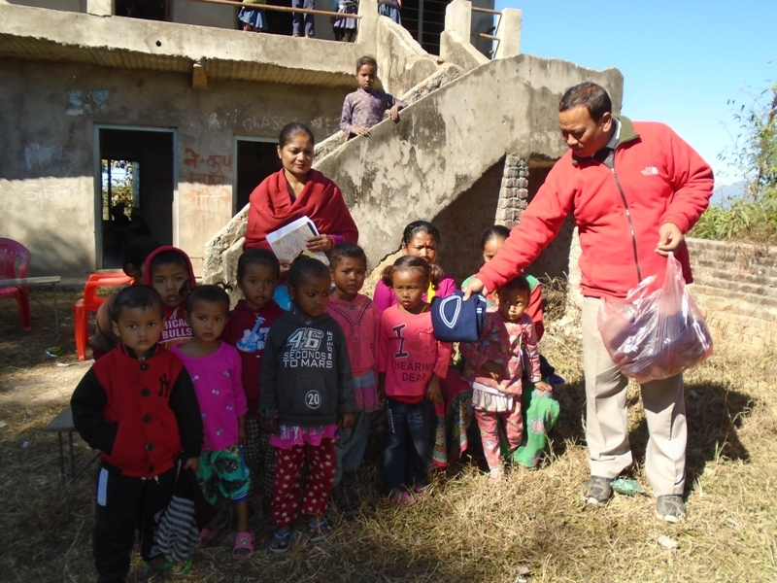
Early childhood kids receiving sweater protecting them from the cold.

- Support to grade 1-3 school kids:
Under this project 24 kids received educational materials. Each child received one and half dozen copy, one and half dozen pencil, one eraser and one pencil cutter from the project.These supports help them for their regular schooling.
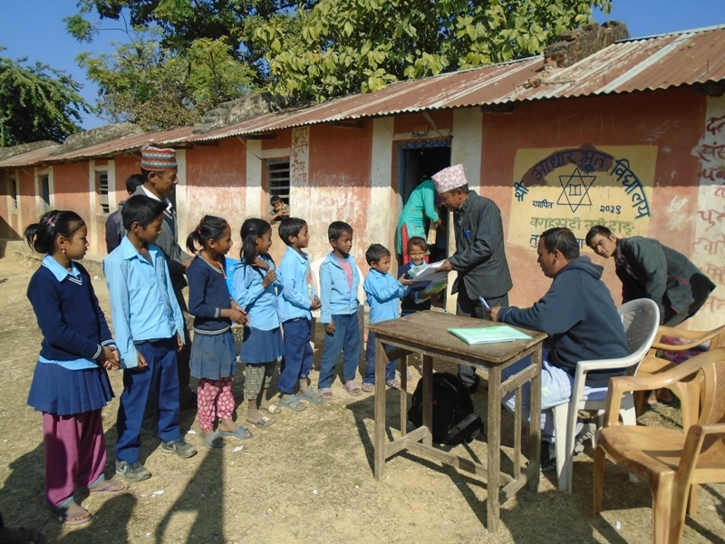
Grade 1-3 kids receiving educational material.

- Support to grade 4-7 school kids:
Altogether, 41 kids received educational materials support. Each child received one and half dozens of copy, one pen, one bottle of pen ink, one set of geometric box and one dictionary (Nepali to English). These supports have been a great help for them for their regular education.
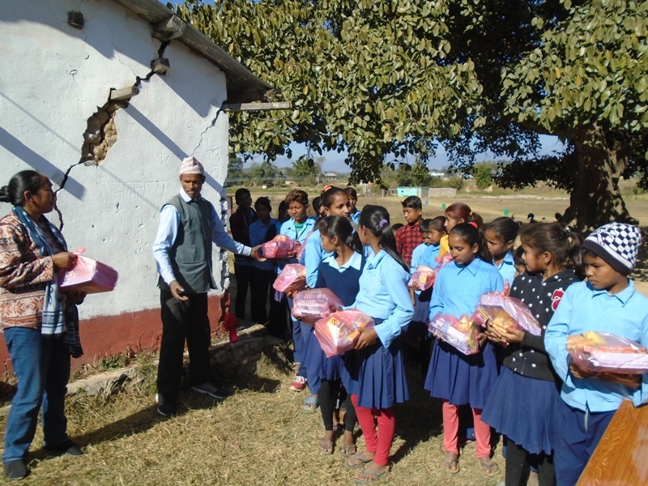
School education material received by grade 4-7 students.

- Support to grade 8-10 school kids:
Under this project, 19 students received educational materials. Each child received three dozen copies, one pen and one bottle pen ink, one set geometric box and one dictionary from the project.
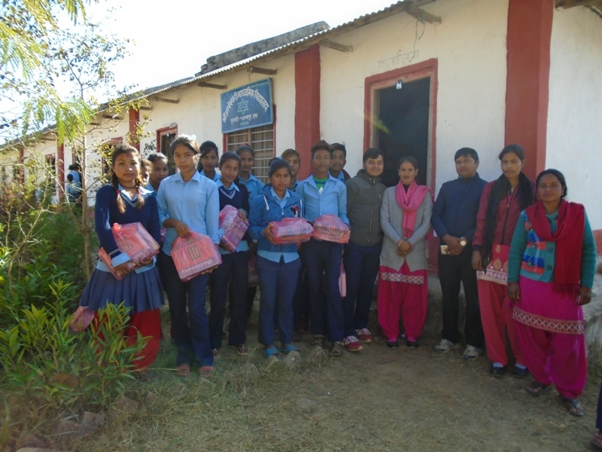
Grade 8-19 student received educational material.

Details of grade wise support received children's data of five schools in dang district:
Grade | Girls | Boys | Total | Category
Early childhood development | 8 | 4 | 12 | 12
Grade 1 | 6 | 3 | 9 | 24
Grade 2 | 3 | 5 | 8
Grade 3 | 4 | 3 | 7
Grade 4 | 9 | 3 | 12 | 41
Grade 5 | 8 | 6 | 14
Grade 6 | 3 | 4 | 7
Grade 7 | 3 | 5 | 8
Grade 8 | 6 | 1 | 7 | 19
Grade 9 | 4 | 3 | 7
Grade 10 | 3 | 2 | 5
Total | 57 | 39 | 96 | 96

- Organizing orientation sessions on preparedness, sanitation and hygiene:
To build up the capacity of a community to cope with natural disaster including flooding, the project also provided the opportunity to gain knowledge and skills through orientation session on preparedness, sanitation and hygiene. In order to raise awareness within the community about personal hygiene, people learned about right ways for hand washing, proper usage of toilets, water purification, food hygiene and menstrual hygiene management. This orientation session was conducted with BASE's support. During training, children's parents and some of the community people also joined the orientation session. The project raised awareness about hygienic habits for more than 100 individuals.

- Challenges and measures taken
- There was a late and unfair availability of the list of names of affected children/families by the concerned officials/authority. The project team visited the concerned community and institutions (schools) and recollected the data.
- The number of affected children was higher than the number of materials that could be distributed.
- The project team consulted the respective institutions (schools) during the time of distribution.
- Due to the flash flood, people were badly affected. They lost their food grains, clothes and utensils along with other goods. In such a situation, the project, even though with limited resources, helped the community and enabled children to pursue their education at school. For the relief support, government authorities established help mechanisms through other agencies. The support which has been distributed to children has become useful for their regular education.
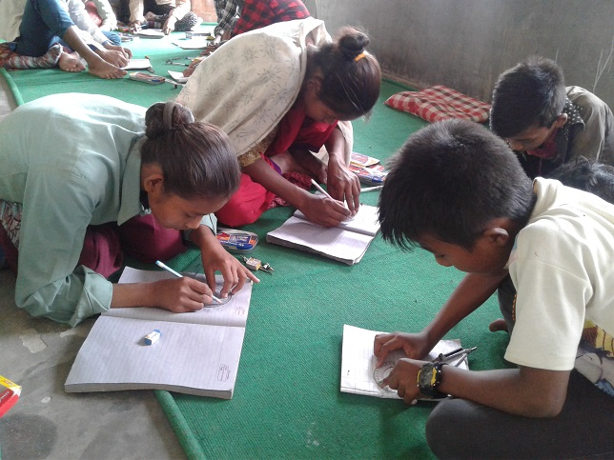
Children are able to continue to work at schools with education material provided by BASE.

Cause of delay for the first report: The Nepalese government announced general elections in Nepal in two phases (Nov. 26th, 2017 for the first phase and on Dec. 7th, 2017 for second phase). The election commission of Nepal issued the election code of conduct from the effective date prior one month of vote casting date. Due to the election code of conduct, we were not allowed to implement any developmental activities in the community and due to above situation BASE was unable to put forward the project initiatives including education support to flood affected child in the community in time. For this reason, there has unfortunately been a delay in reporting to Global Giving.
Long-term impact of the project
The project will build the capacity of the community to cope with natural disasters including flooding as the community people have been prepared to the Local Disaster Reduction and Mitigation Plan (LDRMP) with the support of BASE field volunteers. During the education materials distribution ceremony, there was a talk program and messages were delivered on how to keep safe the food, grains, educational materials including other properties of the community. The children also received a training on how to behave when a flash flood occurs. It was also raised awareness on the necessity to drink purified water during and after flooding. It improves their livelihoods and health. Community groups have been formed on the project site and organized networks will be mobilized on the long-term and be ready to respond to flooding and disasters. The community people have been applying what they learned and changed their crop pattern which has minimized the destruction of crops and increased the productivity. The children who received educational materials are pursuing their education which is good for their future. This initiative also contributed to achieve of Nepal government' Sustainable Development Goal #4 Ensure inclusive and equitable quality education and promote lifelong learning.

Thank you for your support.

