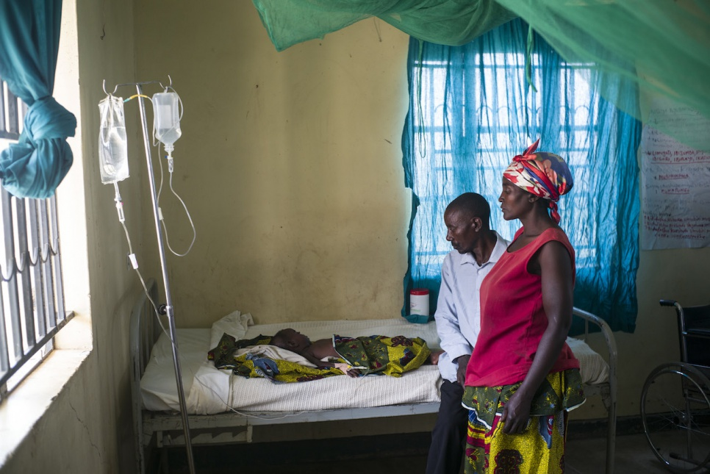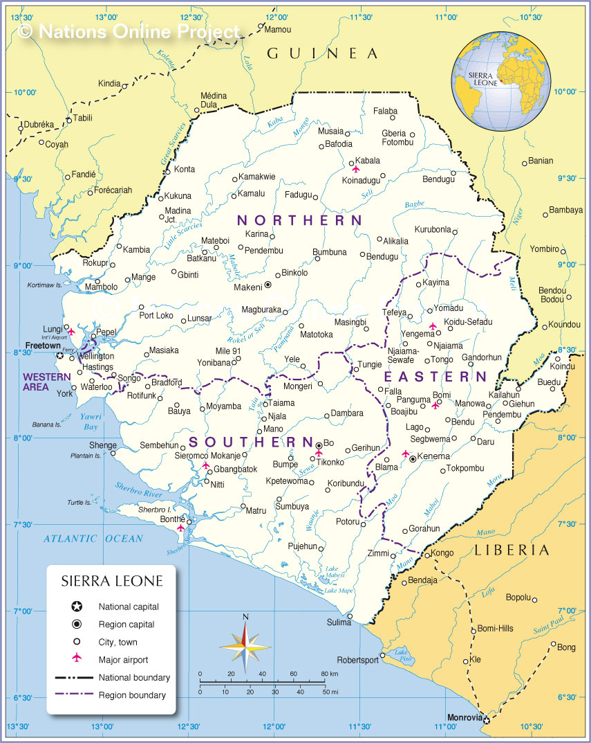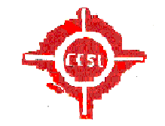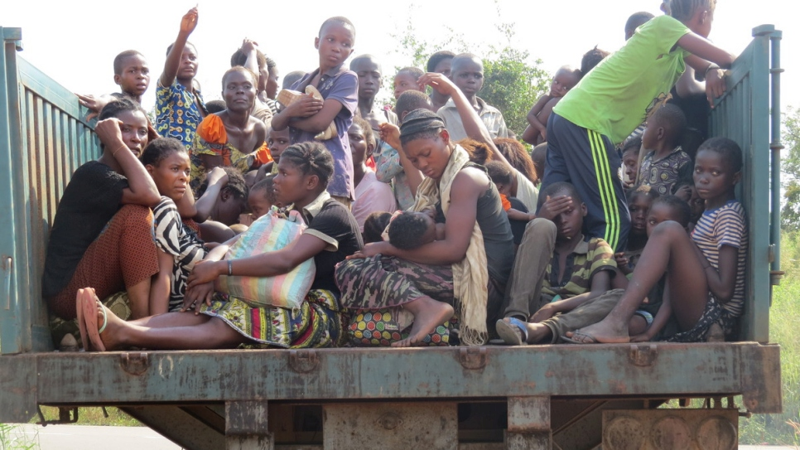

The health of those forced to flee is a major priority for HDPSL. The UNHCR 1951 refugees convention states that refugees should enjoy access to health services equivalent to that of the host population, while everyone has the right under international law to the highest standards of physical and mental health.

We are devoted as humanitarian sector, that HDPSL would do all its uttermost best in working closely with other partner organizations in implementing health programmes…etc.;

Couple of years ago, Amanda and her husband fled the war conflict from the North in Kambia District, today they are living with their daughter in the other part of Bombali District in one of the resort settlement, where malaria is rift. She is among the 45% of those who sleep under a mosquito net donated by HDPSL.

Malaria is a big problem for the family says Amanda. Since we have received the nets, it is not like before as we used to go to the hospital every month, but now not any more…etc;

Page 3

The Health Development Project has being in collaboration With the CCSL for the past years and it has proformed its duties on health issues and other humanitarian activities…

PUBLIC HEALTH:

Health Development Project-Sierra Leone (HDPSL)

VOL: 1…. Spring 2012

Council of Churches Sierra Leone: ( CCSL)

Hundreds of thousand of people are affected by humanitarian emergencies each year. As HDPSL has worked so hard out of approximately 6 million people living within the country people affected by humanitarian emergencies in 2012/13 are 1.6 million were people living with HIV. Of these half a million people (60%) were women and youths mostly from the interior part of the country like the East and Southern region. Many were displaced, lack access to essential HIV services and suffered as a result of shortages that could have been avoided. With much effort, HDPSL is trying to combat and minimized such incidents and give access to victims free and fair services of HIV treatments. Etc;

Women and children arriving at Masomgbala chiefdom for their weekly consignment of foodstuffs and medication. Etc;

HDPSL and its partners has developed multi storey gardens to feed its beneficiaries wherein this can served them for the multiple coming years thereby sustaining their living with their families .In terms of infant feeding, natural disaster can cause both physically and mentally devastating, where by most women cant afford the energy or strength while some are malnourished and cant breastfeed their kids. So HDPSL has made it possible for these families to get sufficient food in keeping them fit to breastfeed their children in the long run or near future. Etc;

#### FOOD SECURITY & INFANT FEEDING:

Health and nutrition programmes are delivered with an emphasis on primary health care and support for secondary hospital care. Our healthcare interventions are based on needs, risks and vulnerabilities, which are determined by a health and nutrition partner and or HDPSL staffs.

Among forcibly displaced population in development countries, the top five killers of children under the age of five are malaria, malnutrition, measles, diarrhoea and respiratory tract infections. Our priorities and those of our partners at the start of an emergency are measles immunization, nutritional support, control of communicable diseases and epidemics, implementation of the reproduction health measures and public health surveillance.

As the situation stabilizes, these services are enlarged. In more developed and urban settings, public health priorities among adults shift toward cardiovascular and chronic diseases and cancers…

There is a clear link between nutrition and public health. Communicable diseases brought on in part by malnutrition are responsible for thousands of preventable deaths each year. Mass population movements can result in high rates of malnutrition, sickness and death. Shortage of food also makes people more vulnerable to sexual abuse and exploitation. Poor quality diets and vitamin and mineral deficiencies contribute to delayed childhood development and also HIV/AIDS…etc;

## HEALTH AND NUTRITION:

HIV- IN HUMANITARIAN EMERGENCY:

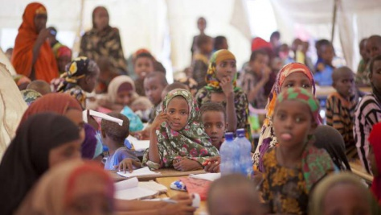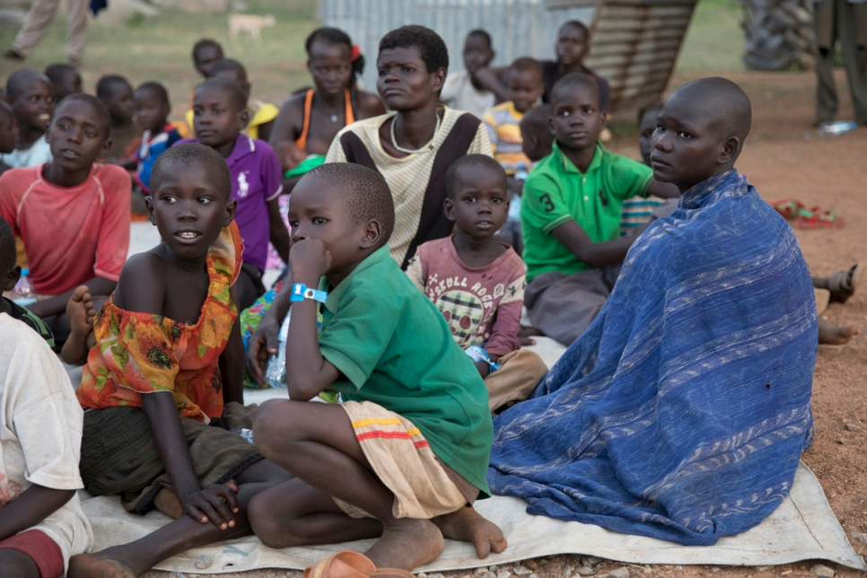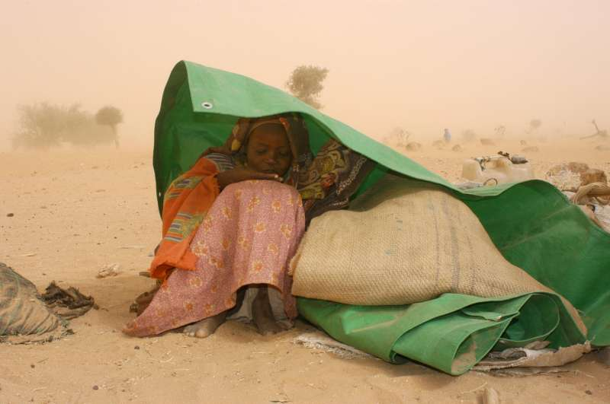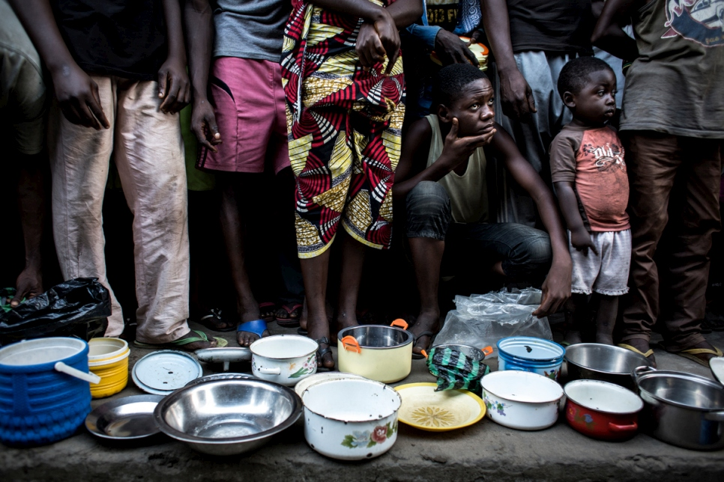

##### The Health Development did not only pursue their aims and objectives on health issues, but also deters their objectives on other humanitarian efforts like education, shelter, gender based & adolescence, Migration and Protection, Innovation, environment and disaster, advocacy, livelihood, etc; Since we are partners the past years, its marvellous to say well done to this charitable organization to keep the flames burning…

Wars, conflict and persecution in the past years have forced thousands to flee their homes and seek refuge and safety elsewhere. The need to ensure an education for children in crisis settings has never been more urgent. Displaced children are often the most marginalized and hardest to reach, facing challenges in accessing quality education such as extreme poverty, social exclusion, trauma, and language barriers. We estimate that only one in two displaced children have access to primary school, only one in four have access to secondary school, and less than one per cent access higher education opportunities. Partnerships such as CCSL, DFID, provide an opportunity to make a positive impact on the lives of children, their families and their communities. These contributions have allowed our country operations to focus on some of the most vulnerable children in displaced situations and design activities to enroll and keep them in school.

In times of displacement, education is crucial. It can foster social cohesion, provide access to life-saving information, address psychosocial needs, and offer a stable and safe environment for those who need it most. It also helps people to rebuild their communities and pursue productive actions and rebuild their communities.

HDPSL, according statistics report finds that most displaced people after the war are five times more likely to be out of school than the country’s average. Only 50 per cent of displaced children have access to primary education, compared with the nation average of more than 90 per cent.

The gap widens as these children become older, with only 22 per cent of displaced adolescents attending secondary school compared to a global average of 84 per cent. At the higher education level, less than one per cent of displaced attend university, compared to 34 per cent at the country` level.

Education is a basic human right, enshrined in the 1989 Convention on the Rights of the Child and the [1951 Refugee Convention](http://www.unhcr.org/1951-refugee-convention.html). It is also a vital aspect of our work at HDPSL.

Of the half million displaced under our care, 6 hundred thousand are of school-going age between 5 and 17. Access to education for this marginalized group is limited. More than half have no school to go to. Some hundreds of thousands displaced children are not in primary school and likely 2 hundreds thousand displaced adolescents are not in secondary school. So with the help of the government and other international NGO´s boost a lot in making this displaced children dreams comes true…etc;

### Health Development Project on Education:

SHELTER:

### :597778003.jpg

Shelter is a vital survival mechanism in times of crisis or displacement. It is also key to restoring personal security, self-sufficiency and dignity.

At HDPSL, a core part of our protection mission is to guarantee access to adequate shelter in humanitarian emergencies. We provide tents, distribute plastic sheeting and develop emergency strategies, tools and guidelines, rushing aid and restoring a sense of home to those who need it most.

The Organization also helps vulnerable communities to overcome crises and become more resilient through disaster preparedness activities.

Its mandate includes strengthening the capacities of its member local NGO´S to conduct effective emergency relief, disaster preparedness, and health and community care programmes. It also represents these societies at an international level.

The CCSL and HDPSL have been working together for more than 8 years, then known as the League Societies, and was given the CCSL Award in 2009 for its invaluable help in responding to the needs of both the Tonkolili & Bombali displaced.

The partners have signed several accords, including a 2010 Memorandum of Understanding covering the development of guidelines on training and equipment for HDPSL field personnel. It also covers the first aid training, which CCSL provide to HDPSL staff.

Under the Inter-Agency Standing Committee’s cluster approach to humanitarian crises, the CCSL and HDPSL co-chair the emergency shelter cluster.

Staff and volunteers with the national Red Cross and other local NGO´S, meanwhile, sometimes help displaced populations. They provide food, water, relief items, health care and psychosocial support to vulnerable people in HDPSL-run settlements.

The HDPSL mission is to improve the situation of the most vulnerable, coordinating emergency nationally, and to assist to people affected by natural and man-made disasters, including the forcibly displaced, and in health crises. Etc;

* [ABOUT US](http://www.unhcr.org/about-us.html)

Climate change and the environment have a big impact on our work at HDPSL, as well as the lives of millions of forcibly uprooted people around the country.

Many of them rely on the environment for survival, particularly during emergencies – for food, shelter, energy, fire and warmth, medicine, agriculture, income-generation activities and more. Unsustainable use of natural resources can lead to environmental degradation, with lasting impacts on natural resources and on the well being of the displaced and host communities. Additionally, competition over scarce natural resources, such as firewood, water and grazing land, can lead to friction. Etc;

ENVIRONMENT, DISASTERS & CLIMATE CHANGE:

We seek to ensure that all forcibly displaced people are able to make a safe and sustainable living that meets their basic needs, contributes to their dignity and provides for the full enjoyment of human rights.

HDPSL helps the displaced to achieve self-reliance by building their skills and knowledge, as well as providing access to the resources, training, assets, inputs, services and markets they need.

Our work in this area is guided by several core principles – including protection, diversity, equity, access and sustainability – outlined in HDPSL country Strategy for Livelihoods (2012-2018).

HDPSL has deter its best in working to promote economic inclusion of those forced to flee their homes by advocating for their right to work and building their livelihoods through market-oriented programmes.

With your support, we strive to empower them to build strong social, economic and cultural ties with their host communities, and to strengthen their capacity to claim their rights.

##### LIVELIHOODS:



Surgeon Specialist for HDPSL, on innovation interest is willing to see all its inhabitants have the full access to communication;

Displaced people are living without the connectivity they need to obtain vital information, communicate with loved ones, access basic services and link to the local, national and global communities around them.

Through creative partnerships and smart investments, we aim to ensure that all displaced, and the communities hosting them, have access to available, affordable and usable mobile and Internet connectivity. 10% lack the access to mobile, Internet services, and infrastructure for communications, HDPSL is putting all this to most of their working communities in making their environment a better place once and for all etc;

Council of Churches Sierra Leone (CCSL)

1219 KINGHAMMA ROAD, HILLCUT AVE;  
[Freetown], [Sierra Leone][SL -1240]

Health Development Project-Sierra Leone:

(HDPSL) – Printed on 24. 06. 2012.

Vol: XII -20mnsl

By Christina Adolf Kennington.

INNOVATION:

Spring 2012

Lorem Ipsum Dolor