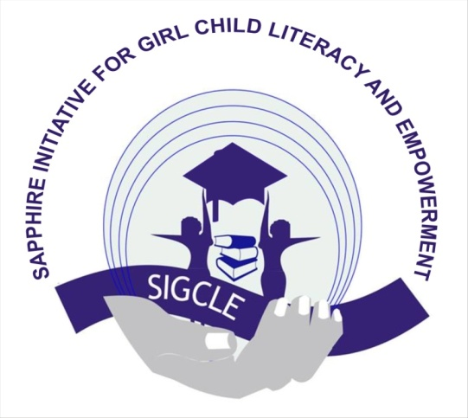

Sapphire Initiative for Girl-Child Literacy and Empowerment (SIGCLE)

No 12 Suez Crescent, Ibrahim Abacha Estate, Wuse Zone 4, Abuja.
E-mail : sigclepinitiative@gmail.com
Website : www.sigcle.org.ng

PROJECT SUBMISSION ON RENOVATION OF HOSTEL AND BUILDING OF TOILETS FOR GIRL CHILD VOCATIONAL TRAINING SCHOOL SABON BWARI NIGER STATE- NIGERIA

THE PROJECT: It is an established fact that exploitation, slavery, poverty and deprivation are synonymous with the fate of many girls and women, in many communities due to lack of quality education and a provision for solid socio-economic support. Many global development plans does not include or consider girls and their issues, and problems become “invisible”. More than 62 millions girls around the world have no access to education. Worldwide and collectively, girls age 5 to 14 spend more than 160 million hours more on house hold chores than boys of the same age globally, one in four girls is married before age 18. In Nigeria, and many other African countries, women and girls have been badly discriminated and relegated as second class citizens due to customs and traditional practices.
In the Northern part of Nigeria, girls are deliberately withdrawn from schools and forced to get married, hence denying them the opportunity to receive adequate training. Following, (SIGCLE) visited the Girl Child advocacy training school Bwari Nigeria as part of their thematic area to educate the girl child, provide school desk, books, build and renovate school structures, discovered that they Lack of portable water, living in Dilapidated hostel building, Lack of bathroom and toilet facilities, No availability of student mattress, Licking of hostels roofing sheets, and Lack of power plant in the school.
On the premise of the above existing problems, the Sapphire Initiative for Girl Child Literacy and Empowerment (SIGCLE) considers it appropriate, with passionate commitment to assume responsibility for championing this cause partnering with you, to renovate the hostels and build three (3) new toilets, towards proffering a lasting solution to the affected individuals, families and communities of this Vocational Training School.
With Budget Summary of: Six Million Three Hundred And Fifty Nine Thousand, Five Hundred Naira Only (N 6,359,500.00)
TARGET
Renovation of hostels and building of toilets at the Girl Child Vocational Training School at Sabon-Bwari Niger State Nigeria, giving Good Education and building the future of our Nation Nigeria.
OBJECTIVE
- To renovate the hostels of the Girl Child Vocational Training School at Sabon Bwari Niger State Nigeria.
- To build three (3) new toilets Girl Child Vocational Training School at Sabon Bwari Niger State Nigeria.
- To reduce the number of out of school girl child by 30% by 2019 in Nigeria
GOAL
SIGCLE will ensure a conducive and just environment for the girl-child, women and persons with disability to access education, empowerment and attain their full potential by initiating legislation and enforcement of conventions and agreements towards socio-economic growth in communities of Nigeria
BUDGET SUMMARY
ITEM | UNIT | UNIT COST (N) | TOTAL COST (N)
BUILDING MATERIALS

- Cement  - Blocks  - Sand  - Gravels  - Iron rod  - Water tank  - Transportation  SUB TOTAL | 105 Bags  1780  20 trucks  5 Trips  50 pcs  4 Tanks  - | 2500  300  40,000  35,000  10,000  80,000  - | 262,500.00  534,000.00  800,000.00  175,000.00  500,000.00  320,000.00  150,000.00  2,741,500.00
ROOFING
- Long Span Zinc  - Nails  - Plastering Sand  - work Man  - Wood ( Both)  - Ceiling  SUB TOTAL | 26 Rolls  5 Boxes  9 Trucks  7  -  50 bundles | 25,000  15,000  45,000  20,000  -  20000 | 650,000.00  75,000.00  405,000.00  140,000.00  500,000.00  1,000,000.00  2,770,000.00
FINISHING
Paint  Doors  Windows  Tiles  Toilet pipes and sitter  Work Man  SUB TOTAL | 5 Gallons  6 Doors  16  18  -  - | 10,000.00  28,000.00  15,000.00  5,000,00  -  - | 50,000.00  168,000.00  240,000.00  90,000.00  200,000.00  100,000.00  848,000.00
GRAND TOTAL |  |  | 6,359,500.00

SIX MILLION THREE HUNDRED AND FIFTY NINE THOUSAND, FIVE HUNDRED NAIRA ONLY
Thank You.
Sign: Mrs Agnes ojeba Abiodun
Executive Director ( SIGCLE) NGO

