Global Giving Report September 2021
Sustainably facing coffee rust threat in Mexico. (29075)
Moving from shade coffee plantations to an agroforestry system

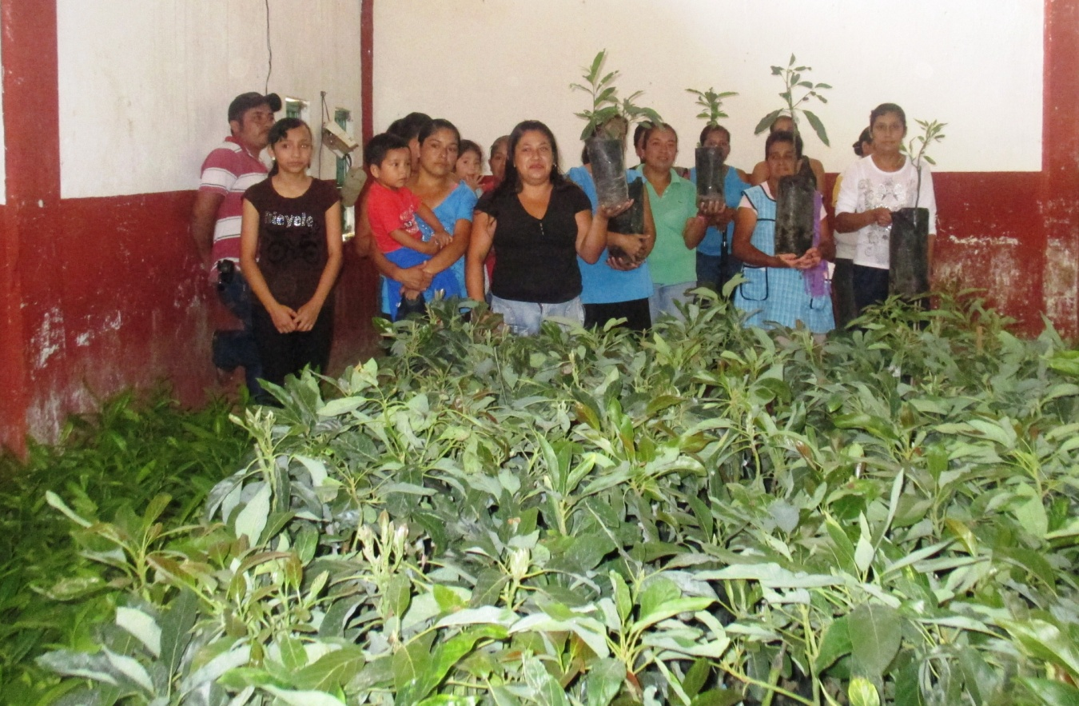
Women receiving fruit and forest trees to diversify their coffee plantation
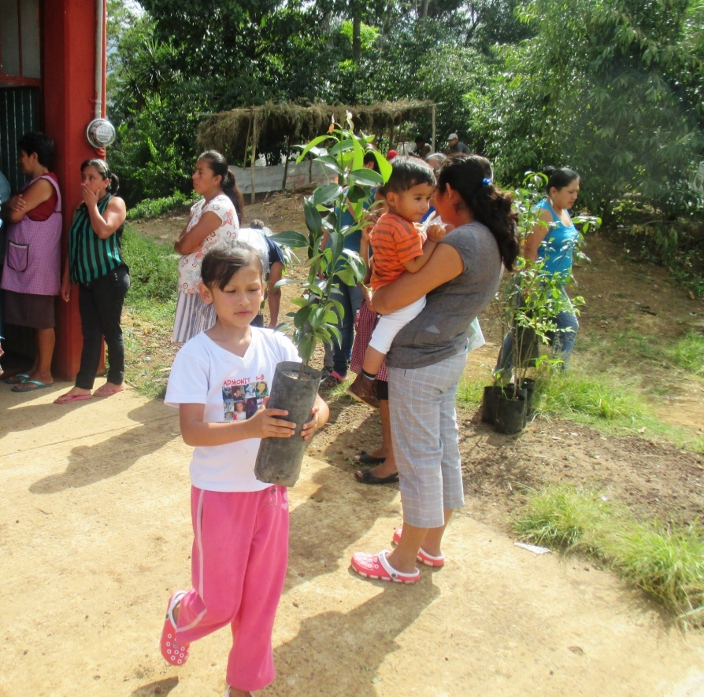
Girl wants to plant her own tree
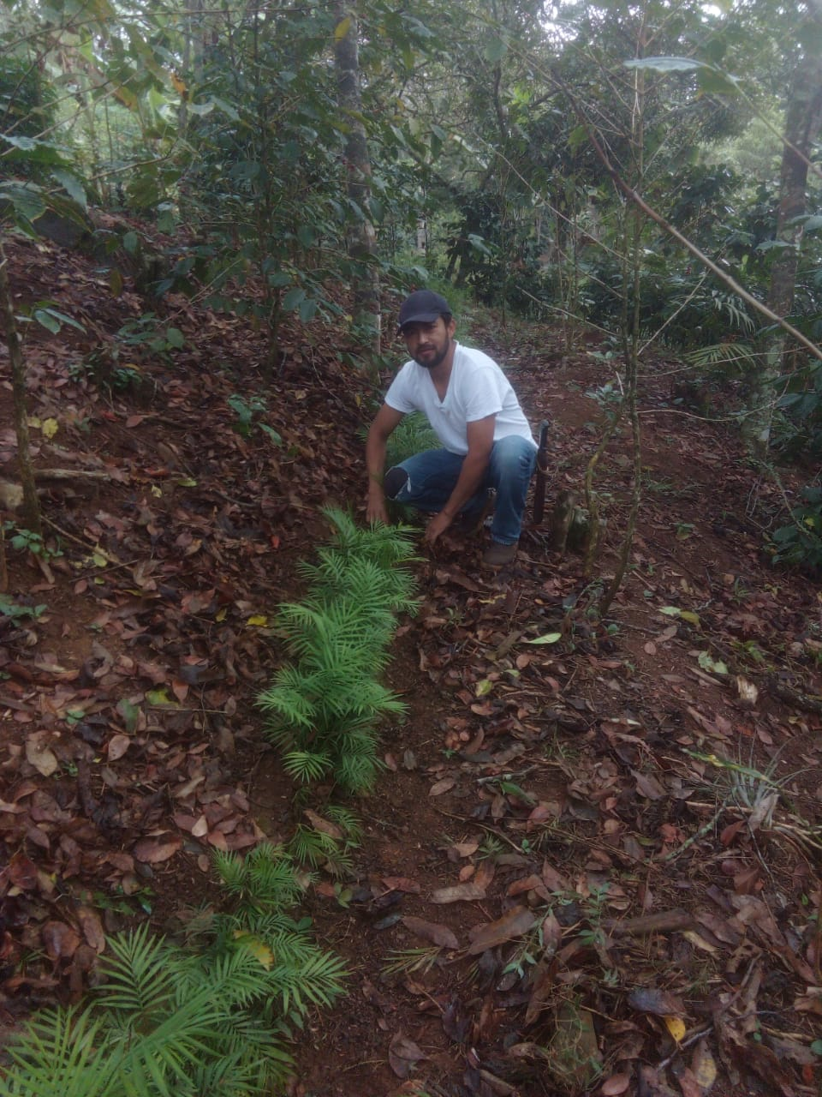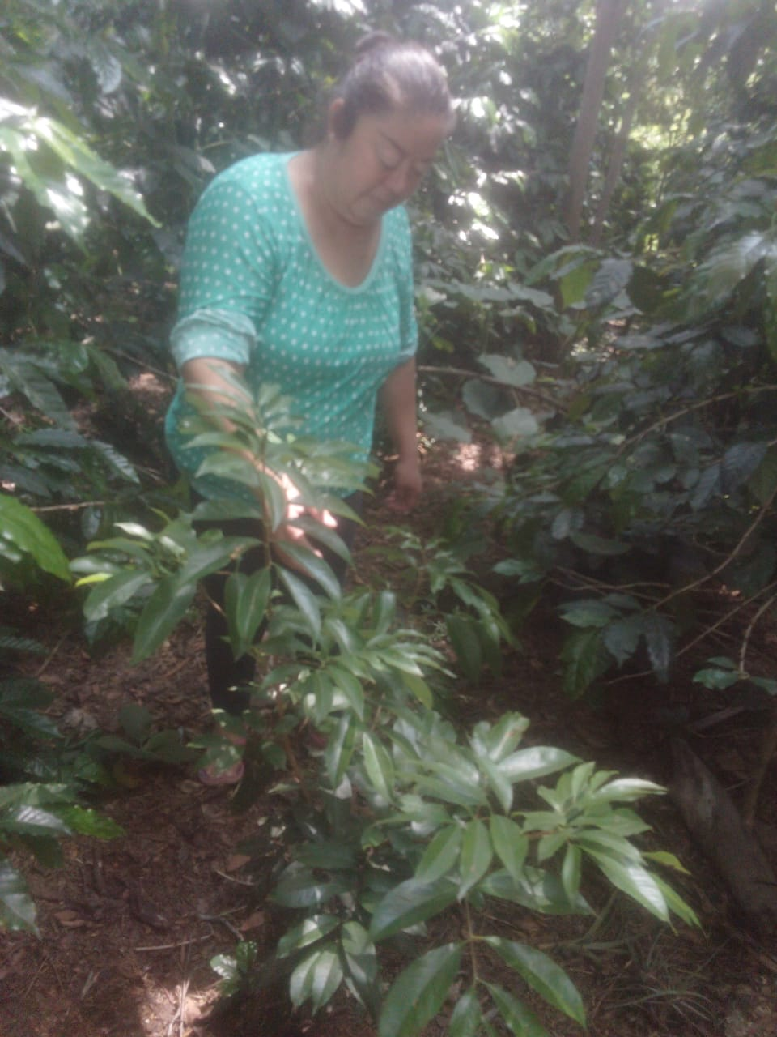
Coffee farmer planting camedor palm in contour lines to protect the soil
Maria shows us how the lychee she planted has grown
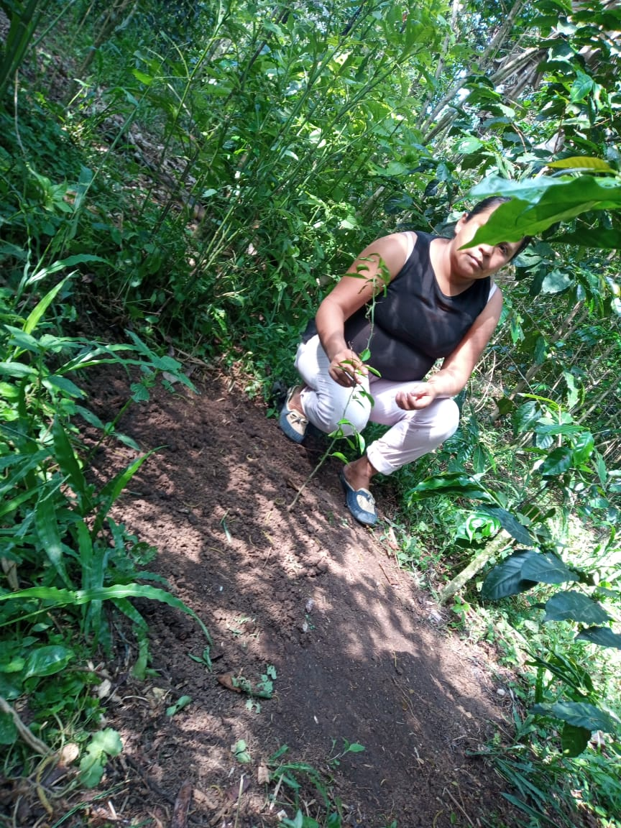
Guadalupe shows us the Cedar that he incorporated into the coffee farm as his family's heritage
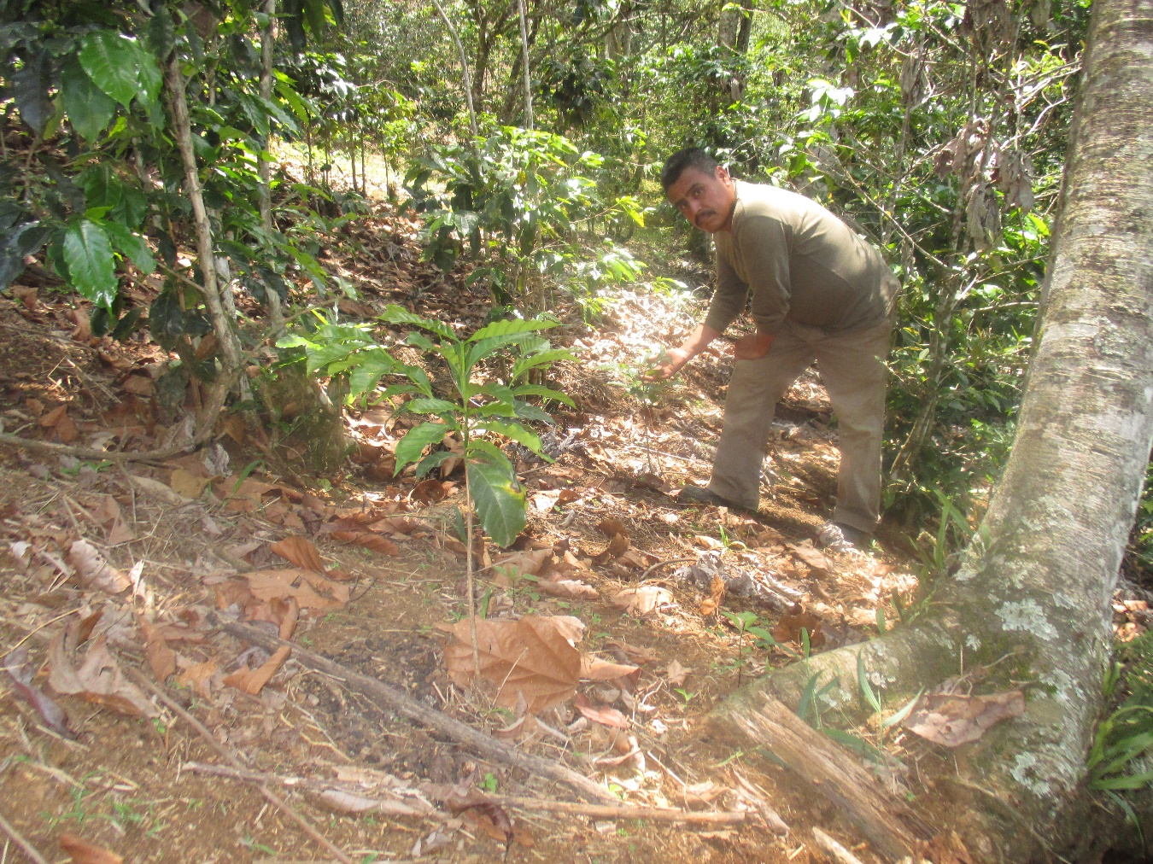
Guadalupe shows us the Cedar that he incorporated into the coffee farm as his family's heritage

