Gobal Giving Report January 2021

Dear Donors
In this quarter, the activities of the project “Sustainably facing coffee rust threat in Mexico. (29075)” consisted of working on food security as one of the pillars of the family economy.
Years ago, in the central zone of Veracruz, was common that peasant families used their patio or ‘solar’ for food production, medicinal plants, and for raising poultry. With the rise of coffee prices, almost all productive spaces were occupied by coffee activities. Also, the work time of the different members of the family were concentrated in coffee production. This is how gradually all the diversification of patios has been displaced, turning these spaces into patios for drying coffee grain and into areas to process coffee.
However, with the fall or coffee prices and with the infection of rust in coffee plantations, many families are reincorporating food production into their family economy.
In this quarter, we concentrated our activities on responding to this interest of coffee families in three lines of work: raising laying hens, strengthening the vegetable garden and building energy-saving stoves.
Laying chicks: With your donations, we bought laying chicks and paid technical assistance so the hens have a protein and calcium enriched diet to ensure good growth and favorable conditions for laying.
Hence the planting of mulberry trees is being promoted as a source of protein for the hens. The incorporation of corn with limestone powder mixed with commercial food is proposed also. Over time, new ways of enriching the diet with local products will be promoted so that families stop buying industrial food.
Vegetable Garden: In this quarter we worked on three elements that have hindered the constant production of vegetables throughout the year. The type of seed, the sowing of seedlings and the protection of the garden in the rainy season.
While we manage to produce our own seed, we bought seed from a new supplier, hoping to have a higher germination rate. Regarding seedlings, sowing is being tested in medium containers with a rich substrate, placed in trays with a water source that allows watering the seedlings by capillarity (from below). In this way, irrigation will not mistreat the small leaves that are unfolding. With this system, the substrate is kept with the necessary humidity for the growth of the seedling and transplantation to the cultivation bed is carried out when the seedling is larger and stronger. (See photo below)

Finally, food safety requires good and healthy sources of heat to prepare food. The wood-saving stoves that have been built for five years are still in high demand. At the end of the year, 30 new saving stoves were built. Now 309 saving stoves have been built in this project.
In this case, the women proposed a new adaptation to increase the efficiency of the stove. We hope to increase firewood savings, which so far have been 30% compared to the open stove that are commonly used. In the next report we will have the results or this adaptation.
We greatly appreciate those who have supported these activities to take place. This project is allowing families from three communities to improve their living conditions

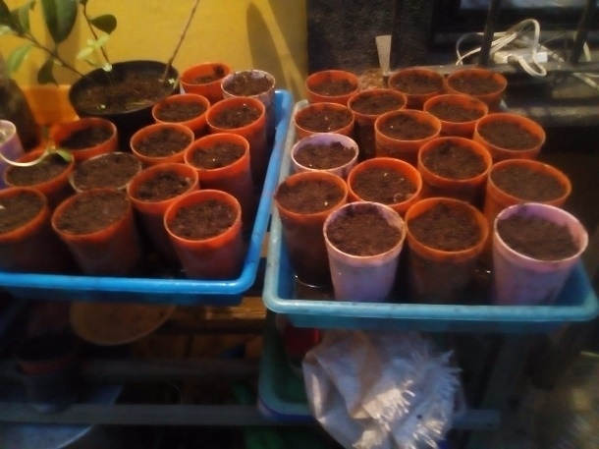 |  | 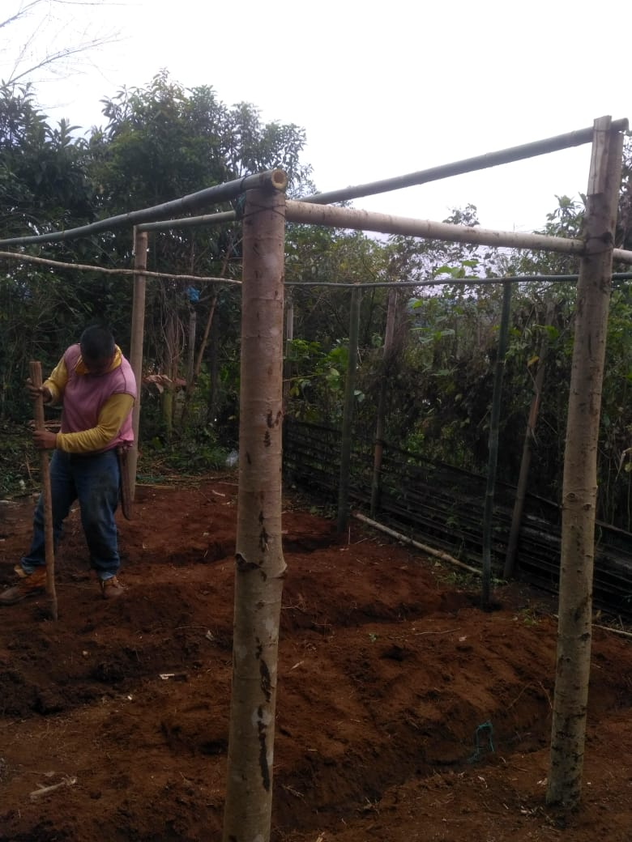
Watering the seedlings by capillarity |  | Building the structure to protect the vegetable garden from the rain
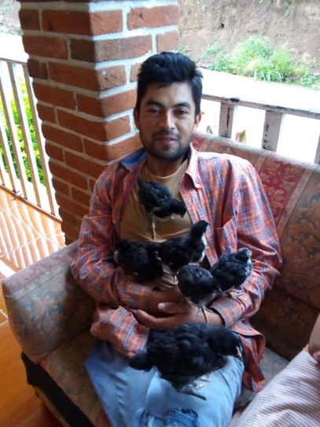 |  | 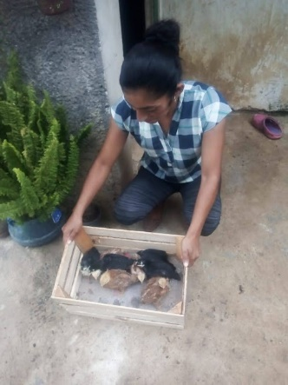
Chiken
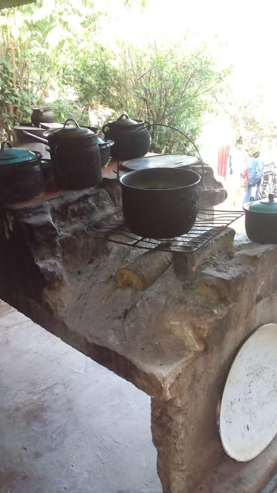 |  | 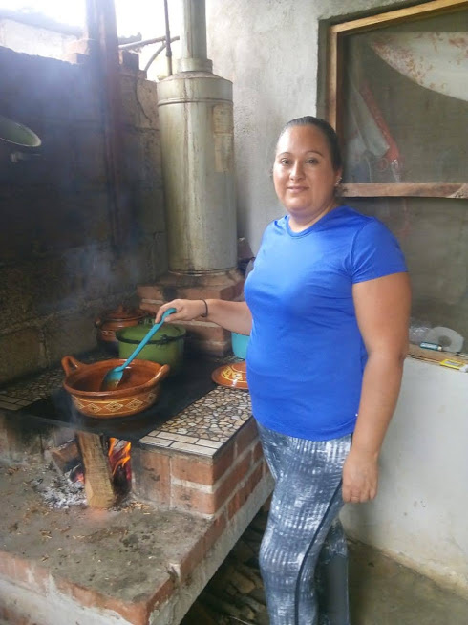
Open stove commonly used |  | Saving stove

