PERTUBUHAN PEMBANGUNAN BAKAT MALAYSIA
No.44, Jalan Tiram 1, Taman Tiram,
09600 Lunas, Kedah
(019-5277941

“DREAM BIG ACHIEVE BIG”
PROJECT A ( 2017)
UNESCO MULTIMEDIA CONTEST
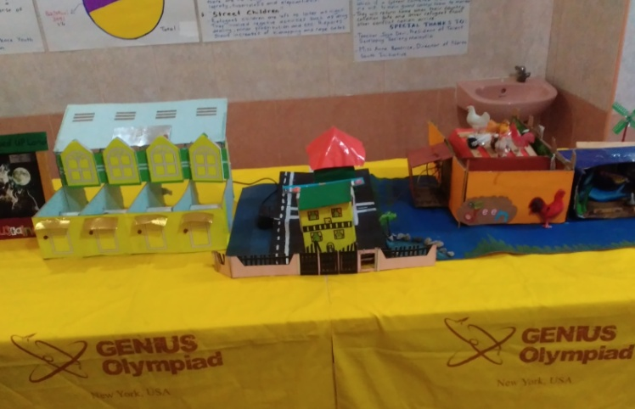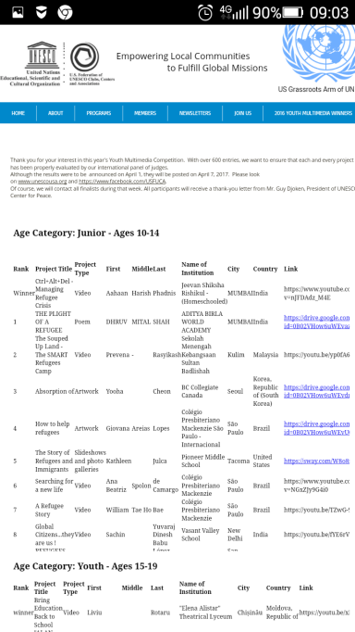
Won 2nd ranking

PROJECT B
EUREKA INTERNATIONAL COMPETITION
July 24 to July 28
1. Guidance and workshop on being innovative- completed
2. Selection of best projects- completed
3. Registered the projects- completed
4. Guidance on project development – completed
5. Guidance on booth preparation , banner , power point presentation etc- on
going
6. Training for judging presentation- To be

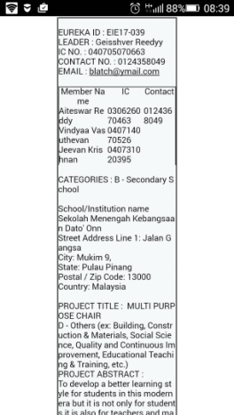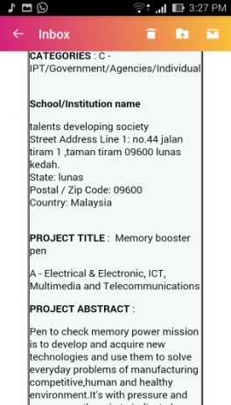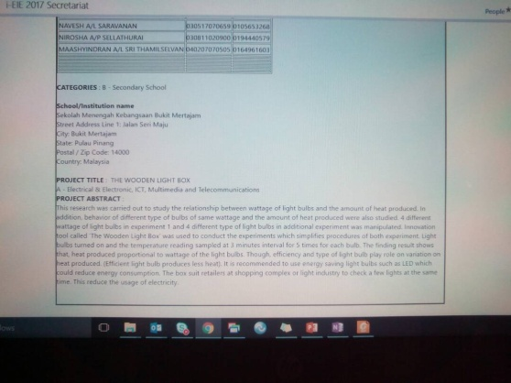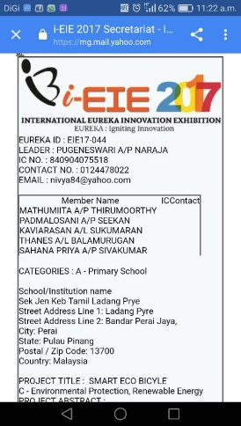
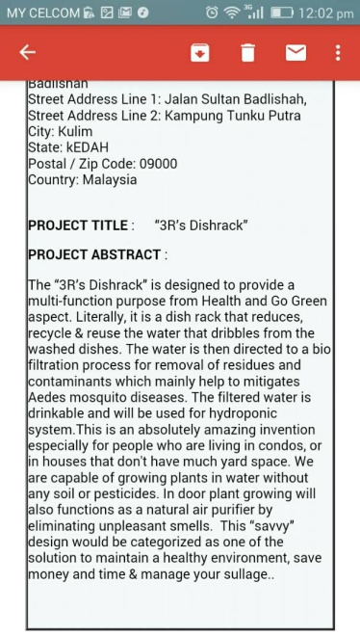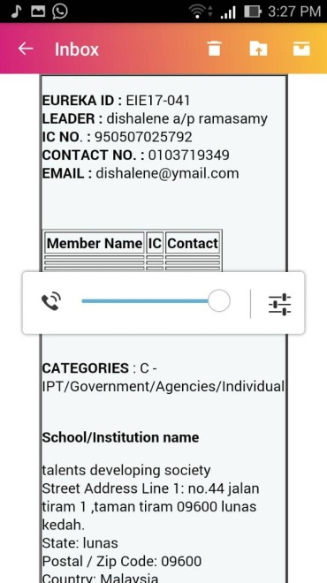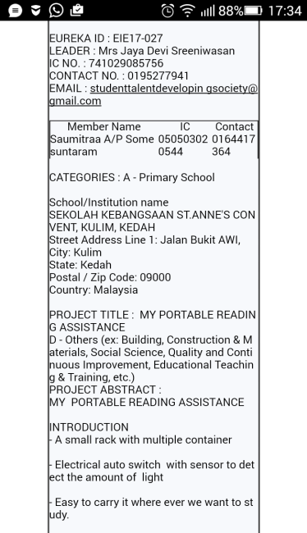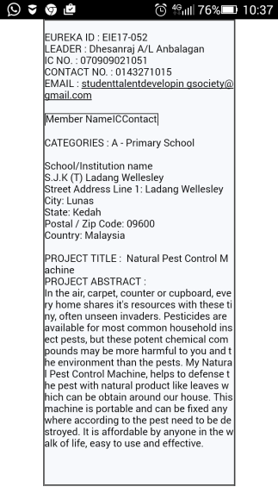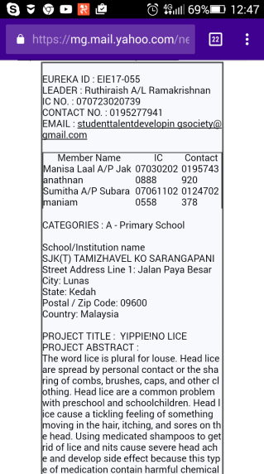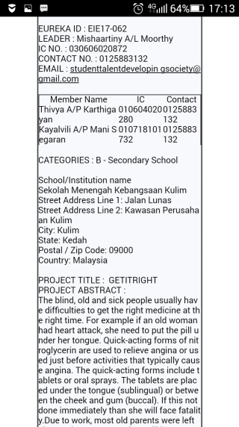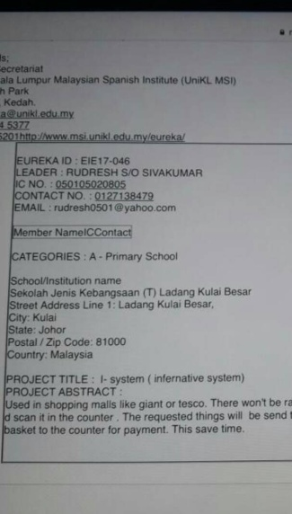

PROJECT C
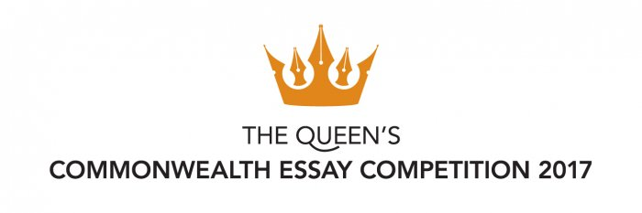
- The competition is open to all citizens and residents of the Commonwealth aged 18 and under and is open from 21 September until 1 May 2017.
- Guidance for participants from :
a. Sekolah Menengah Kebangsaan Sultan Badlishah
b. Sekolah Rendah St Anne Convent
c. Sekolah Menengah Kebangsaan Simpang Empat
d. Sekolah Menengah Kebangsaan Bandar Tasik Mutiara

PROJECT D
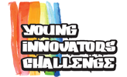
Project Development and Guidance

Inspiring the new generation of INNOVATORS
Promoting Interest in STEM
This program aspires to bring back the awe of discovery and the fun of creativity in STEM subjects using a future-focused platform: embedded systems. Students work on a project that is in their area of interest, which drives them to explore the hardware and software aspects of an embedded system and discover new interests in other areas like science and mathematics.
Preparing for the Future
This program creates an environment where students can develop their life skills through the process of trying things out to figure out how things work and applying what they’ve learned into their projects. Life skills—such as communication, critical thinking, and tenacity—equip students to thrive in the classroom and when they enter the workplace.
Creating Life-Long Learners
By introducing open-source hardware and software to students, this program teaches students that they can learn on their own because information is available online. Ultimately, the program aspires to impress upon students that their time in school is only the beginning to life-long learning.

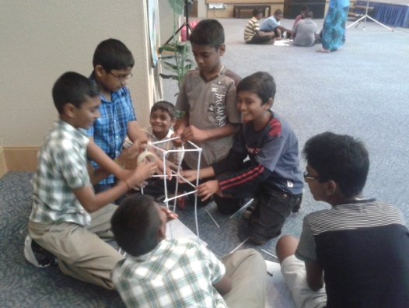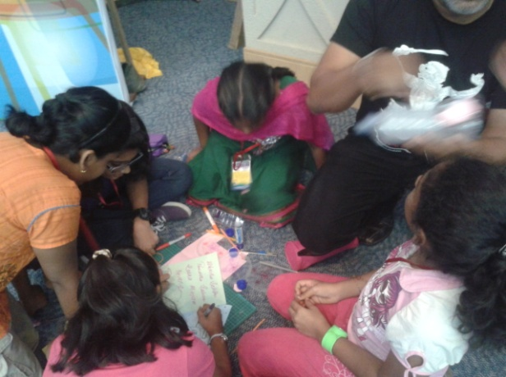
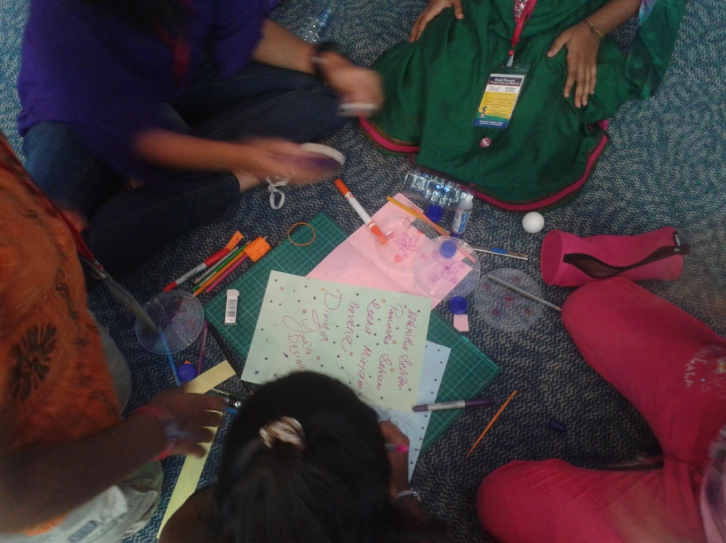

Project E
URBAN SOS :HOUR CITY
http://www.aecom.com/careers/urban-sos/
To propose new solutions to tackle housing, transportation, or economic development challenges and to re-imagine what a future “hour city” . A city of sustainable

Project “ Shelter for homeless animal”
Recycle materials were used to build shelter for homeless animals with minimal cost.
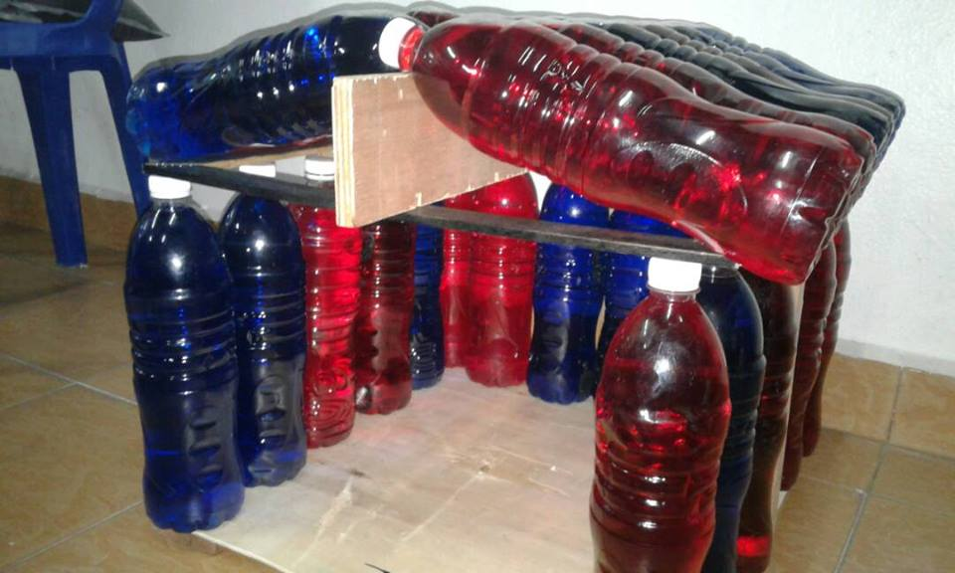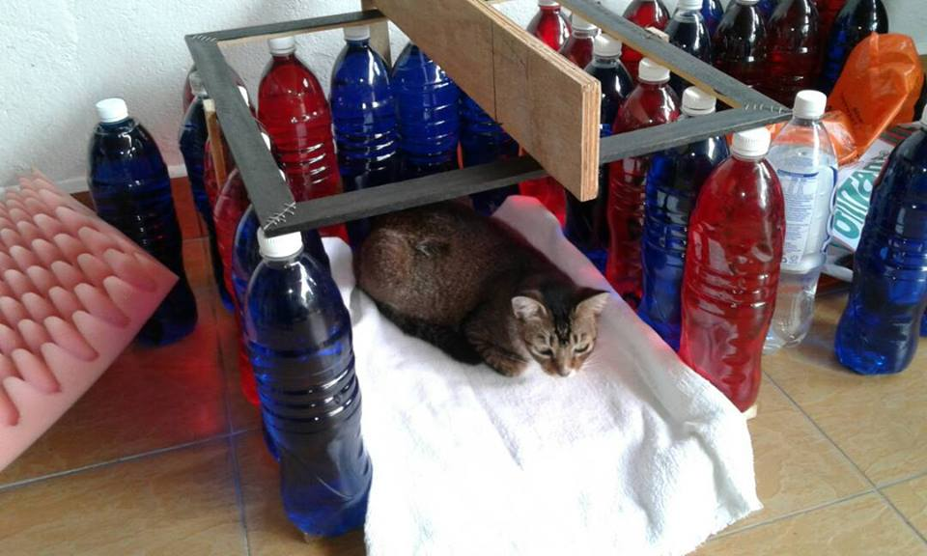
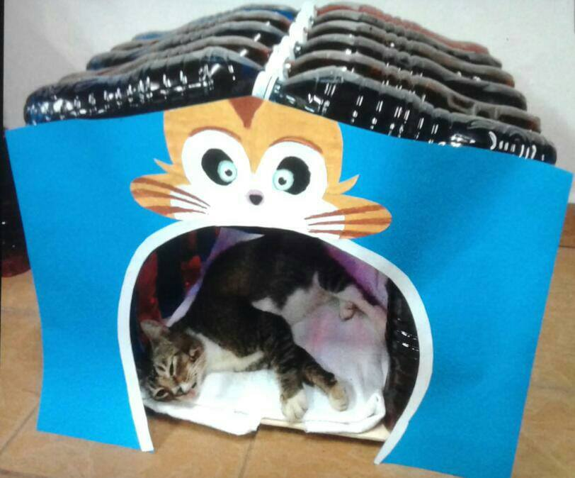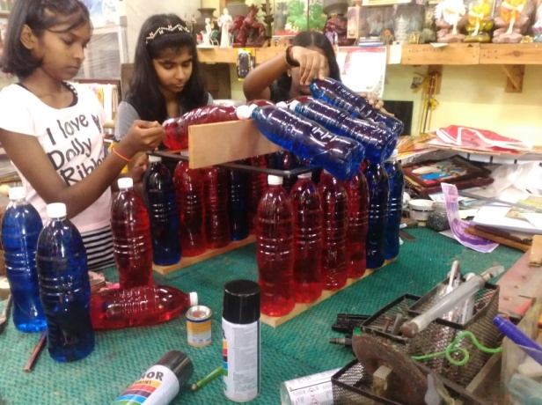

Project F
HIGH LEVEL THINKING
WORKSHOP

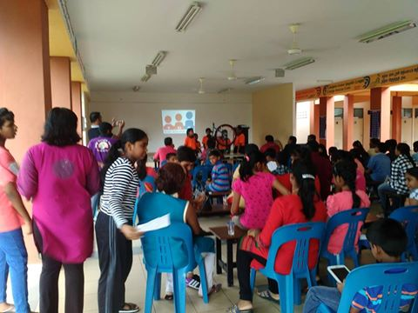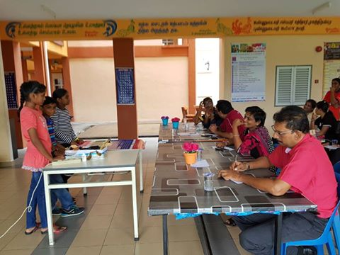

PROJECT F
SJKT LADANG SUNGAI ULAR LIBRARY FUNDING Helping this school to win global funding through
http://www.schoolenterprisechallenge.org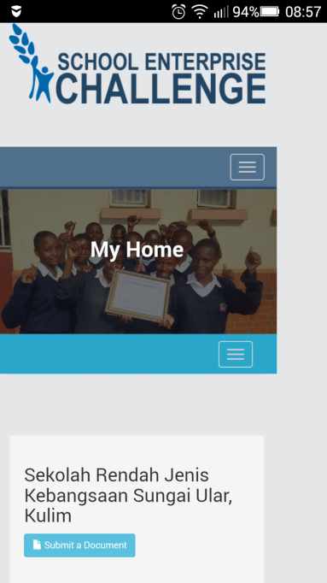
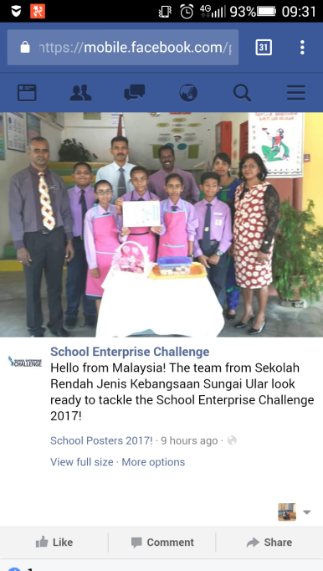
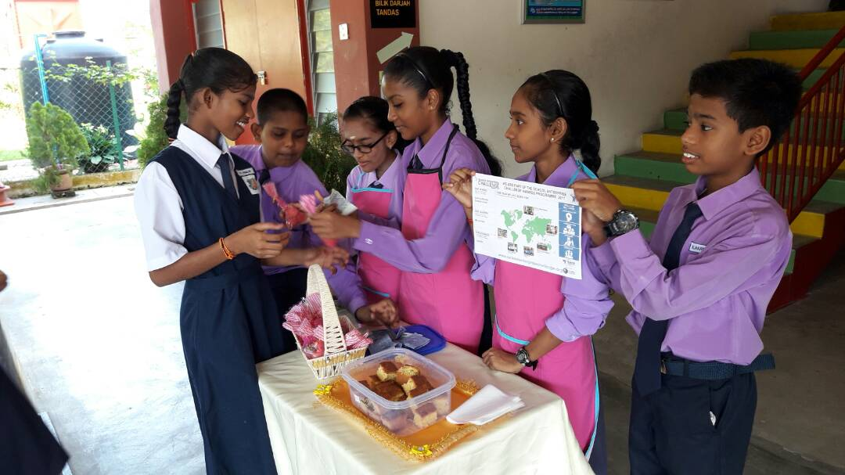
Berikut merupakan keputusan rasmi bagi Pertandingan Pusat Sumber Sekolah Cemerlang Peringkat Negeri Kedah 2017
Kategori Sek Rendah :
1)SK TEMBAK ( Pendang)
2)SJK T LDG SG ULAR ( Kulim)
3)SK LAGUNA MERBOK ( Kuala Muda Yan)

Kategori Sek Menengah:
1)SMK TAMAN HITECH (Kulim)
2)SMK PEKULA JAYA ( Kuala Muda Yan)
3)SMK PULAU NYIOR ( Kubang Pasu)

Johan Keseluruhan:KULIM BANDAR BAHARU
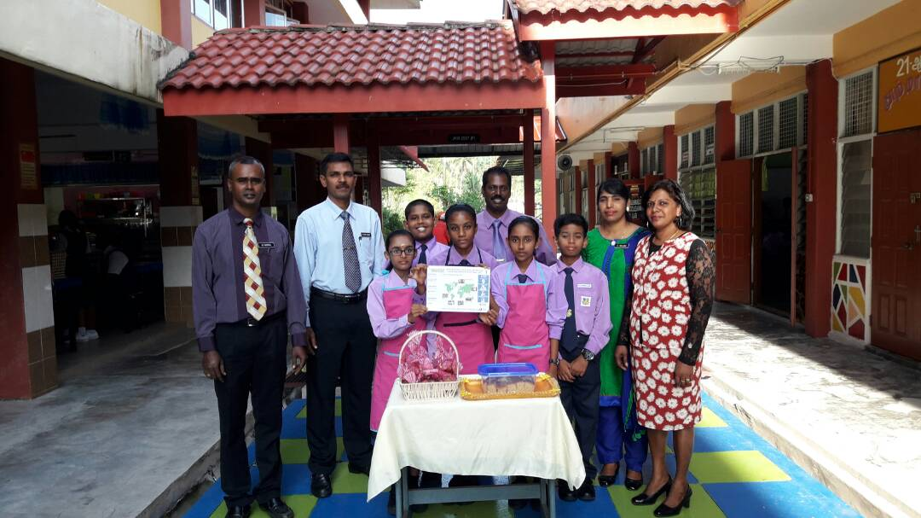

PROJECT G
PROJECT F
St Anne Convent Students, project enter the largest global movement of children driving change in their communities by unleashing their 'I CAN ' superpower. Creating sustainability city and youth empowerment
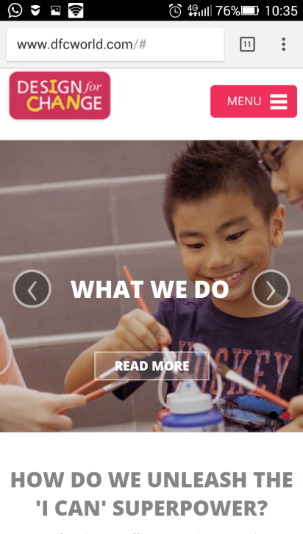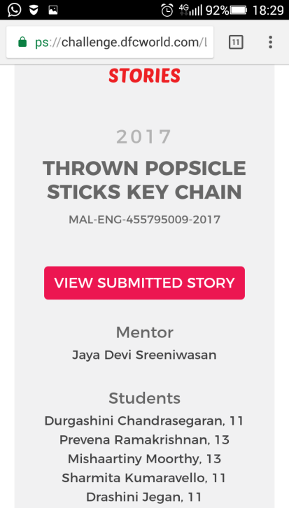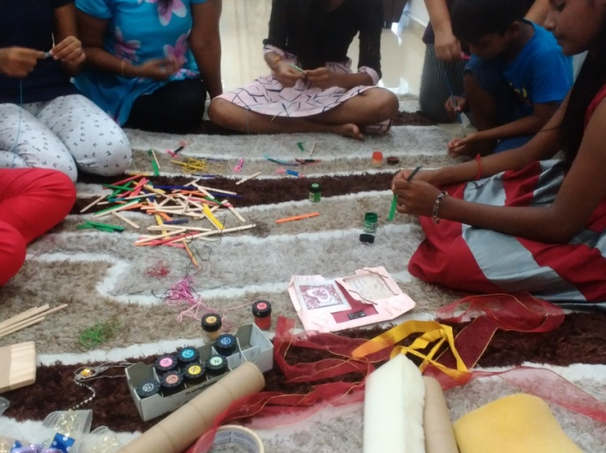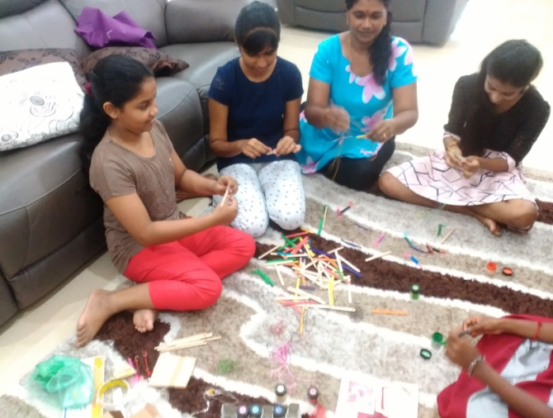

PROJECT H
http://www.mypengguna.com
Guiding Students in essay, art and blog competition.
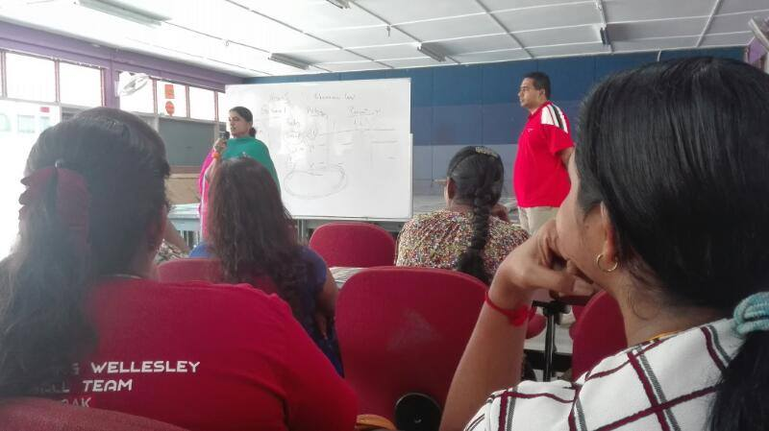

PROJECT I
Talented and UPSR 7As scored, underprivileged student, Hemavarthini Shanmugam, SMK Sultan Badlishah, Form 2 students was helped not only in Deam Big, Achieve Big but welfare such as groceries, school needs and other. Her father is a drug addicts and in jail for theft. She has 6 siblings whom 4 of them are excelling in study.
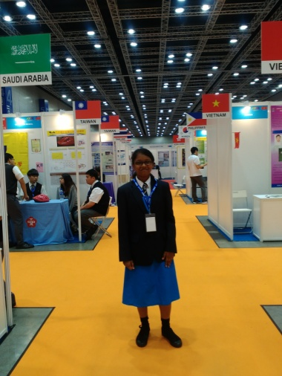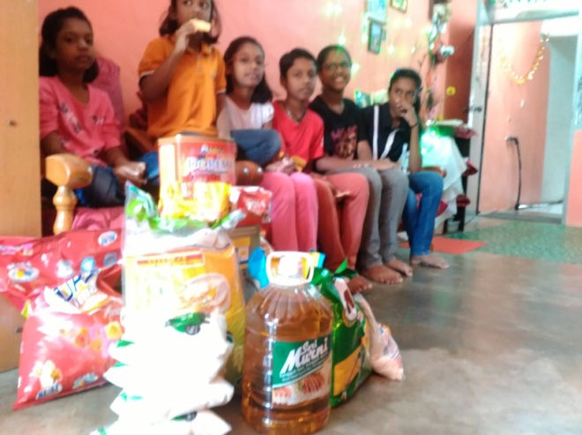
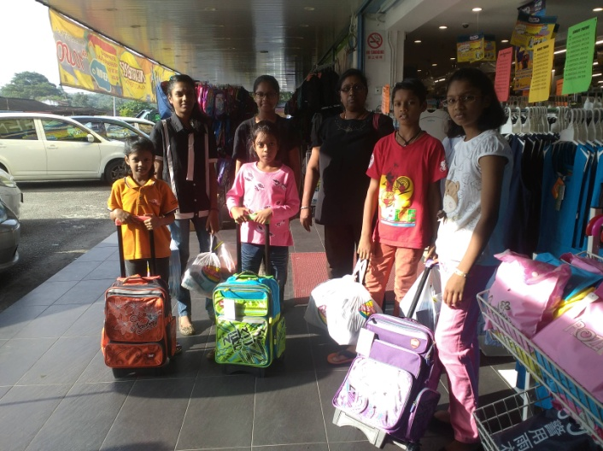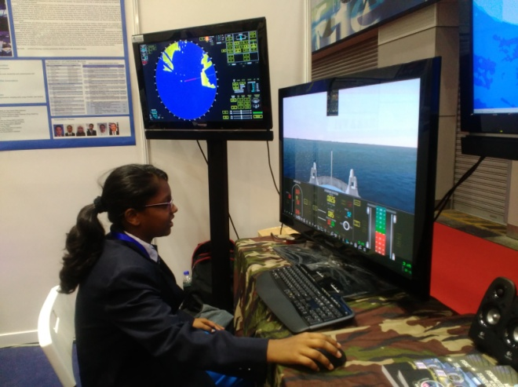

Testimonial
My name is Heemavarthani d/o Shanmugam, 14 years old from Sekolah Menengah Kebangsaan Sultan Badlishah Kulim, Kedah. I am involved in Talent Developing Society activities such as trainings, workshop, project development and others since I was in standard 5. Although I am from a broken family with separated parents and staying with very old grandparents, I scored 7as in my UPSR. My first winning in The Star-Nie short story writing competition when I was in standard 5, has motivated me that poor background does not stop anyone from being success in life.
Winning in prestigious competition such as ITEX Malaysia and Asia Pacific ICT Awards, have made tremendous confident in my life. By being excellent in academic and extra co curricular activities will help me a student of scholarship. I also learned to manage my time between studies and other activities and I am glad that I am spending my time for good.

