Janaseva Foundation, Pune

Apple- Global Giving

Project Proposal for

“Care and School Education of
Children Living on Street”

September 2017- April 2018
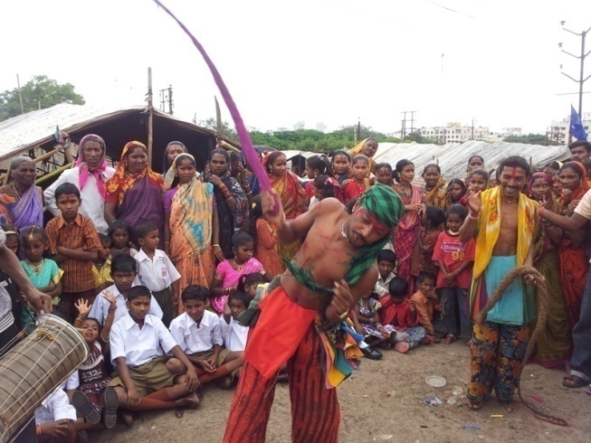
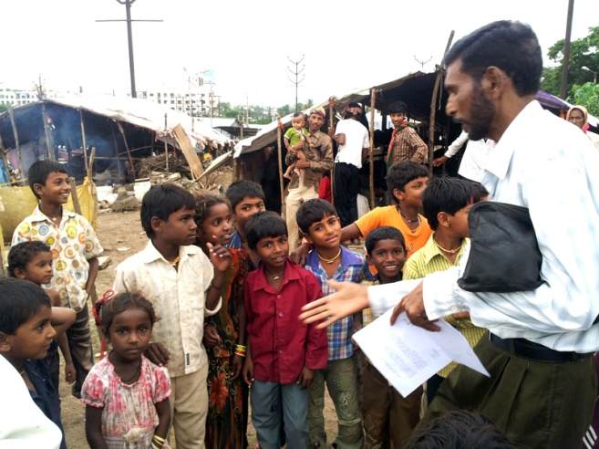
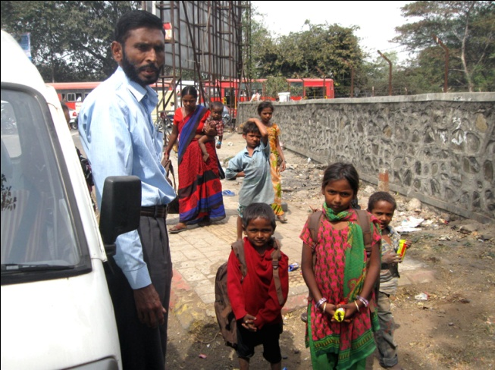
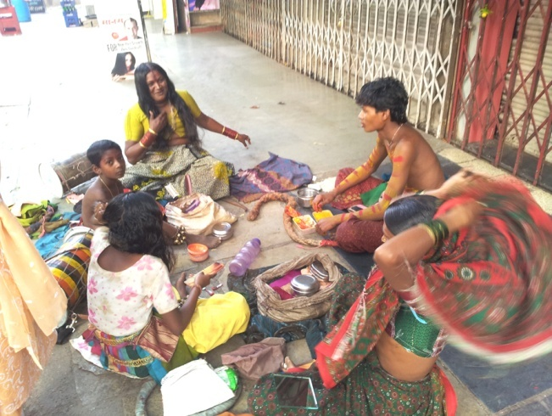

Care and Education of Street Children
By Janaseva Foundation

Story- A Child in Help!
By- Dr. Vinod Shah, Chairman, Janaseva Foundation

“He is a very bright child uncle, he should come to school!” everyone stopped eating and started staring at me as soon as I said this. We were celebrating 10th birthday of my friend Neel. He asked me to give him a birthday gift which no one could give him and hence it came to my mind that what would be a better gift than permission from his parents for schooling for a boy living in the slums and begging on the roads of Pune city for livelihood. When I looked at uncle and auntie, they were sharing those typical confused looks which parents in our society have when it comes to educating their child. But I already decided to persuade them so nothing could stop me. I continued, “Uncle and auntie, I know what are you thinking, isn’t it about how will you manage if Neel goes to school as he will not beg anymore?” Uncle and auntie both nodded at the same time. “But don’t you think that if he goes to school, educates himself and gets a job in a big company in future, he will earn more than he is earning right now by begging? Your conditions were vulnerable therefore you had no choice but to beg, but Neel he has a golden chance to transform his and your life then why should he waste such opportunity and live the same miserable life which you did! It also might happen that he becomes next TATA, Birla or Ambani, then you will have your own house and you don’t have to stay in these slums.” Uncle stopped me and asked, “Where did you learn all these big things, who taught you?” I simply answered, “My teacher in the school!” Auntie asked, “How did you start going to school? Who convinced you?”
Who convinced me to go to school, many memories of last few years gathered in my head and I started narrating them my story. Oh! As it’s my story I forgot to introduce myself. I am Suresh Pawar. I am the 3rd son of my parents and we live in slums in hadapsar area in Pune city of Maharashtra state in India. This might sound like a joke to many people in this world, but our family business is begging as we belong to the Potraj community of the society who survives and lives on the things received by begging. Hence I with my family of 6 people used to beg on the streets. I deliberately said ‘used to’ because I don’t beg anymore, I go to school, I learn and I will be an educated and responsible citizen of India in the future. I am studying in 7th standard currently.
This was my background, coming back to Neel’s birthday I asked auntie, “Do you remember few years back one madam visited our area?” Auntie said, “Yes, she found you and your friends begging on the road, right?” I said, “Yes that madam! She saw me begging on the main road, came near me and asked me that why do I beg. So I told her about our community. Then she asked me to take her to our slum and my house. I asked her why then she replied that she wanted to meet my parents. While coming here, she started telling me about her Foundation. She is working in Janaseva Foundation run by Dr. Vinod Shah and Mrs. Shah and they have adopted more than 40 children who used to beg on the roads. Mrs. Meena shah took the oath to be parent of these poor begging children and educate them. Their project ‘Care and Education for street children’ is transforming life of poor children like me by helping them to educate themselves. Day by day number of children adopted by them increased with the help of MSW staff. Currently they have adopted more than 1500 children. As we reached my home, I introduced her to my parents and she started questioning them about our lives and livelihood and was noting down every detail my parents told her. Then she left and came back after 2 days. She asked my parents to allow me to go to school. My parents refused to do so as no one in our whole family ever went to school and money coming in would be less if I go to school. Then she started convincing them, she told them how important role the education plays in our life. My father said that it is not possible for us to pay the fees of my school as whatever we earned was spend on fulfilling our basic necessities and still we could not get ourselves food for 2 times. Then she told them about the Foundation which bears all the expenses of the adopted child. As the number increased to 1000 they started appealing to the individual donors. These noble people in the community started giving approximately US$ 160 per year for each child. My parents became happy when she told them that all the expenses related to my school would be done by the Foundation and other donors. After that day, she came twice or thrice again to my place to convince me and my parents for going to school. Finally my parents gave me the permission to go to school. Next day MSW madam took me to the government hospital to get my age proof. Then she helped me in taking admission in school. First day of my school was terrible; I was so scared that I ran away from the school. Madam again met me and counseled me and boosted my confidence by telling me stories of other children who regularly go to school. MSW madam told me the importance of cleanliness and hygiene and gave me a kit which had toothbrush, toothpaste, soap, towel etc. I promised her that I would take bath every day henceforth. Then I decided to myself that everyone was taking efforts for me and I would not let them go for waste. I started going to school regularly and few days later my fear was gone. Madam also sent me to the special coaching class so that I could cope up with other children in my class. I received the uniform, shoes, school bag, stationary, raincoat, winter clothing and sports material also. I started liking the school, made new friends and I started participating in all sorts of programs and competitions in my school. I won prizes in running, drawing and other competitions. Teachers were happy with me as I showed them improvement and interest in studies in short period. I started learning judo, wrestling and karate in the school. Now I have decided to myself that I will complete my education and practice these games and I will become doctor or police man in the future and will always practice these games for physical health. This transformation and changes in my attitude happened because of my school teachers, madam and the Foundation who were ever ready to help me in all sorts of problem”.
Neel’s parents were stunned by my story and were very impressed with the transformation in my life. Auntie was speechless; uncle asked me, “Where can I meet your madam?” I became so happy that I could convince them and get the permission for Neel to go to school. I hugged uncle as Neel was 50th friend of mine whose parents I convinced so that to send him to school. I still cannot forget the bright smile on Neel’s face as it was indicating that he received the best gift for his birthday.
I took leave from everyone as I had to finish my homework for tomorrow. On the way back to my home, I saw one familiar car coming into the slums. I waited there as Dr. Vinod Shah came out of the car. I ran to him to tell him my 50th persuasion story but he was already aware of it and that’s why he came to meet me. He congratulated me and said he was very happy to hear my inspiring stories, is proud of me, will help me and my friends in every possible way! Immediately he gave a school bus for us as we were 50 children going to the school and also because our place was far from the school. Another thing I decided to myself that day was, I will always help the others like me! And try to transform their life like Janaseva Foundation did mine!

The Janaseva Foundation helps in transforming life of a street children by giving him education, necessary material, food, clothing and doing health check-ups on regular basis. They have adopted more than 1500 street children out of which 600 are financed by the Foundation and 400 by corporate companies, individual donors. Yet there are more 500 children who need help. Life is a precious gift by the God to humans and children begging on the roads are wasting it. These children are the futures hence help us in building a strong future!

Contents

1. Name and Contact details of the NGO

2. About the NGO

3. Project Duration

4. Location

5. Target Group

6. No. of Beneficiaries

7. Aim of the Project

8. Need for the Project

9. Infrastructure

10. Implementation Procedure

11. Monitoring

12. Project Continuity
Janaseva Foundation

1. Name and Contact details of the NGO

Name of the NGO : Janaseva Foundation

Contact Details of the NGO :
Indulal Complex, 1st floor, Above Rupee Bank, Lal Bahadur Shastri Road, Navi Peth, Pune – 411 030. Maharashtra. India.
Tel. : +91-20-24538787/8, Telefax : +91-20-24537373
Email : janasevafoundationpune@gmail.com vinodshaha@hotmail.com
Websites :http://janasevafoundation.org, http://kmsnursingschool.org

2. About the NGO

Janaseva Foundation founded on 15th January 1988 is a Public Charitable Trust. It is registered under Bombay Public Trust Act 1950 having Reg. No. E/1193 Pune, Dated 23/05/1988. It is also registered under Section 80G, and has FCRA certificate. Foundation is managed by a board of trustees and has received Special Consultative Status from United Nations Organization and is also accredited by it.

In the year 2014-2015 Janaseva Foundation along with Duke University of North Carolina, USA and Research article titled “Fifteen Dimensions of Health and their associations with Quality of Life among Elderly in Rural Villages in Maharashtra, India”, co-written by research team of Janaseva Foundation and Duke University was published the January 2017 in Indian Journal of Gerontology, Vol. 31, No. 1 Jan 2017.

Janaseva Foundation participated in many conferences organized by WHO including expert meeting group of WHO to review the document on long term and palliative care for elderly in its office at New Delhi on 17-18 March 20016 and at Bangkok from 26-28 October 2016 and also had organized National Consultation on Active and Healthy Aging in India sponsored by WHO from 15th to 17 December 2010.

Ministry of Social Justice & Empowerment, Government of India, recommended Janaseva Foundation to run a Regional Resource Training Centre for Vidarbha (Maharashtra), Gujarat and Madhya Pradesh.

The philosophy of the foundation is 'Service to Man is Service to God'. Foundation has been serving the poor and downtrodden, sick, elderly, disabled, destitute, poor girls and women, poor boys and girls from rural areas through its various projects e.g. (1) Old Age Homes (2) Rural Hospital and Mobile Health (4) Day Care Centre (5) Nursing School (6) Destitute Rehabilitation Centre.(7) Research Centre (8) Village development, (9) Skill Development Centre

3. Project Duration

September 2017- April 2018

4. Location:Pune, Maharashtra, India

Locations in Pune city
- Katraj Area
- Pudhari vasti
- Wondercity
- Khadi machine
- Gujar vasti

- Hadapsar Area
- Birajdar nagar
- Gosavi vasti
- Malwadi
- Hingane mala
- Pandhare mala
- Sasane nagar

- Vishranwadi area
- Phulenagar vasti
- Kathe vasti
- Vadar vasti
- Bhimnagar vasti
- Lohgaon potraj vasti

- Khadki area
- Rangehills vasti
- Viman nagar
- Tingre nagar – potraj vasti
- Ramwadi – Devkar vasti

- Kothrud
- Sambha nagar vasti
- Sinhagad vasti
- Tapodham vasti
- Potraj vasti
- Maldhaka vasti

- Wagholi area
- Vadar vasti

- Gangadham vasti

- Seven loves vasti

5. Target group : Street (Beggar) children
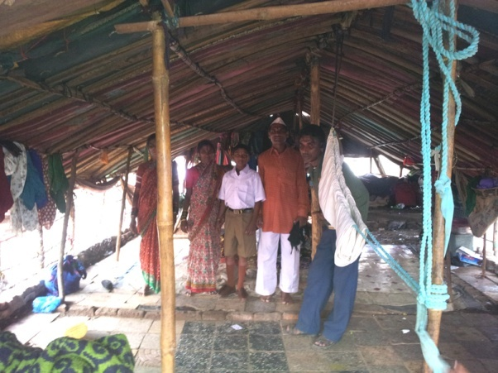
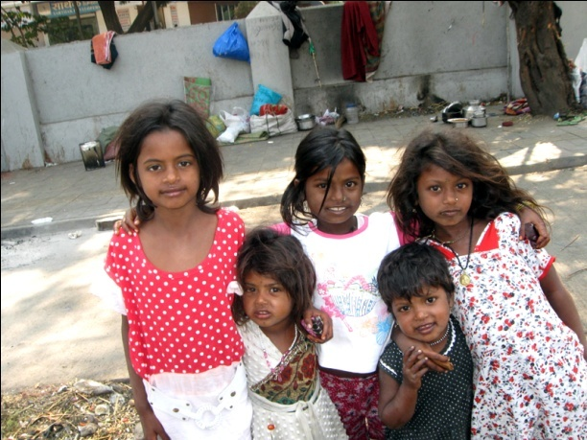

6. No. of beneficiaries:500 children

7. Aim of the Project
- To provide school education to the street children and help them in their overall development
- To provide them with all the essential commodities of daily use e.g. clothes, towels, beds, toothpaste, tooth brush etc.
- To provide them non formal education e.g. manners, teach cleanliness and personal hygiene, arrange lectures on such related topics
- To provide medical checkup, lab investigations
- To provide recreation activities e.g. outdoor games / outings - visiting gardens, arranging picnics

8. Need for the project

There are more than 2000 children living on streets / slums in Pune. They are children from poor families, of beggars, nomadic tribes who do road shows and earn their livelihood. Most of these children either beg on the road or help their parents and some sell different articles e.g. flower, books, toys, and also offer to clean the vehicles at the signals. For such children reality is very harsh and future is bleak.

Many of these children are orphans (street children) or have single parent with low income. Due to poverty and the need to work for livelihood these single parents are unable to provide attention to their children and the children often roam on the roads when there is no one at home to take care of them. This affects their school education and unless proper intervention is not made they are likely to miss the education altogether and there is also a danger of these children turning into social miscreants.

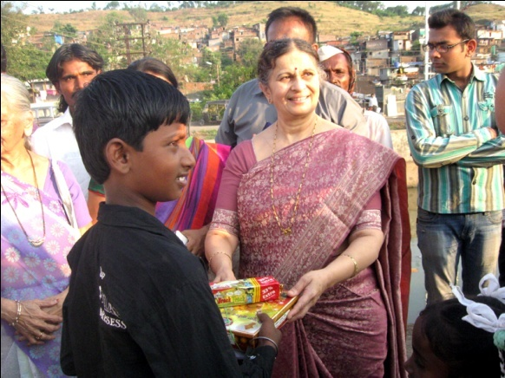
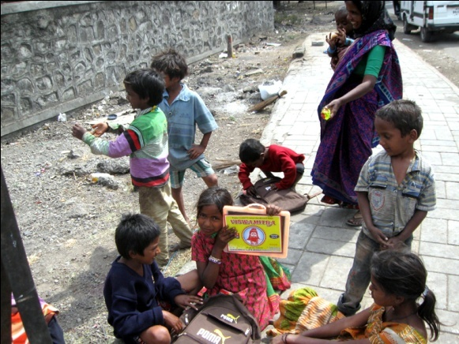

9. Infrastructure

Foundation has experienced MSWs, vehicles and necessary staff. Foundation has previouslyenrolled 80 children from nomadic tribe called potraj into various schools and has also enrolled 200 children from road / slums into schools. Foundation has recently been donated a bus for transporting the children to schools and back by Sodhani Foundation.
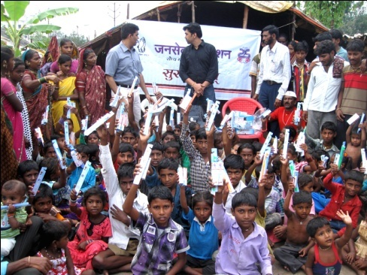
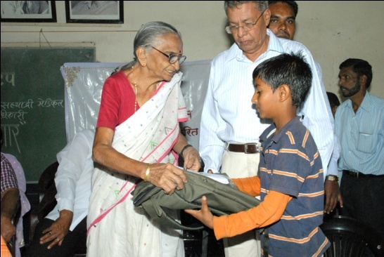

10. Implementation Procedure

Our MSW staff has visited various slums and have identified ~ 500 school going children / children who need to be enrolled into schools. We have then counseled the parents and children several times. We did their thorough medical checkup and also gave medical treatment to those who need it. At the time of admission, case study of each child is taken along with the photograph. Then we obtained various documents that are required for school admission and then contacted the principals of various schools and got these children admitted in various schools. We have provided school bags, books, notebooks and other school materials. Every 15 days our social workers visit each school and obtain the progress report and they meet the children every day. They are counseled often along with their parents to prevent school drop outs. These children are also be taught by our teachers. We are teaching those children manners, discipline, cleanliness and hygiene. We are preventing these children from begging on the road and those who really need to work are allowed to sell some articles on the road for few hours. We have provided them raincoat, sweater and few dresses. We show our appreciation to the skills of these children e.g. singing, road shows and try to enhance those skills that are useful.

For the children living on road foundation has provided school bags with lights so that they can study in this light. We are trying to get another bus for these added children.

We provide recreation for these children e.g. picnics, visiting gardens, showing movies and arranging outdoor games and extra-curricular activities etc.

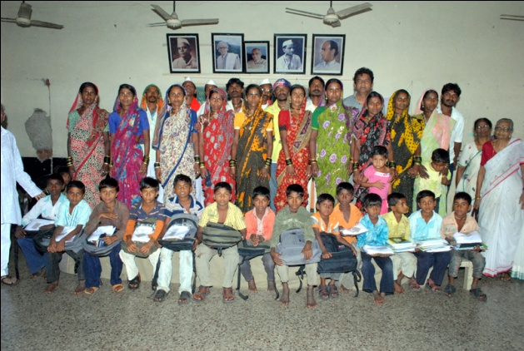
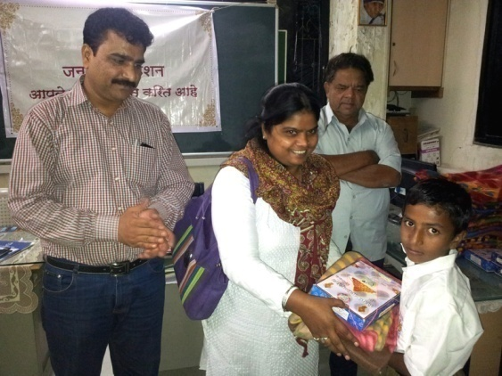

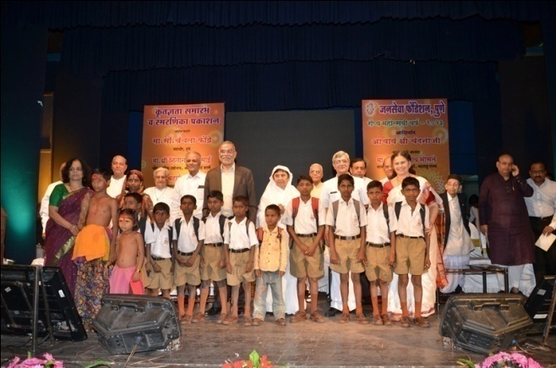
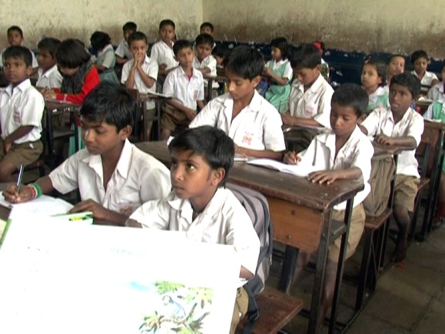

11. Monitoring

- We are maintaining record of each student (name, age, address, case study, school information, special needs, progress, material distributed, picnics arranged, medical checkup details etc.).
- Our MSW staff is meeting the school authorities every 15 days and obtain the progress reports. They also meet the children and their parents at least once a week. They inform the chairman about their visits and observations.
- Trustees of the foundation visit these children, evaluate the progress, communicate with the concerned MSW’s and discuss with them the progress, needs, cost etc.
- Our teacher is in touch with these children daily and submit their evaluation to the office of the foundation.
- We keep proper record of all the material distributed to these children and maintain all the concerned bills properly.
- We do the medical check up of these children frequently.
- We will provide the quarterly / half yearly / yearly feedback to the donor(s) / sponsors in the format given by the donor(s) / sponsors.
- Donors / Sponsors are requested to visit these sites and children

12. Sustainability of the Project

The Foundation remains in touch with corporate houses like Accenture, DSM, Charities Aid Foundation, Oriental insurance, etc. for CSR purposes and philanthropists. The Pune Municipal Corporation is very keen to help us in this project.

There will be a periodic monitoring by the Foundation to ensure the progress and continuous benefits to the beneficiaries. This project ensures the long-term advantages for the street children as it will help them in their overall development. Janaseva Foundation will pursue this goal relentlessly to make sure this project is sustainable and viable.

Dr. Vinod Shah, MD
Chairman
Janaseva Foundation, Pune

