Project related Success Stories, Case Studies, & Photographs

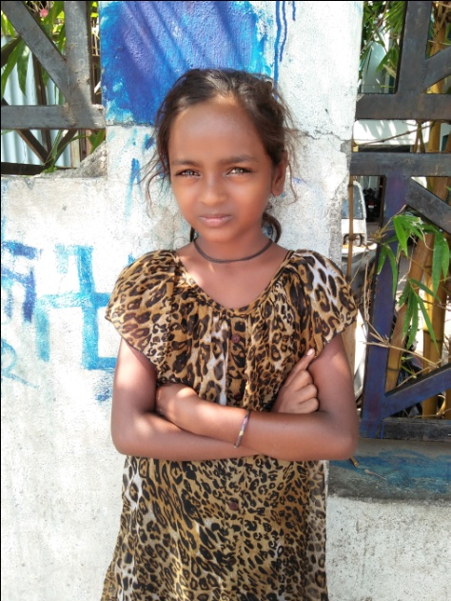
Akanksha Safi Shinde, aged 10 years is from Phulenagar area, Yerwada, Pune. She is from backward caste family. This clan is called Paradhi and they now either sell small articles at traffic signals or beg on the road. Her family consists of parents and 4 children and they live in shabby shelter made of tree leaves. There is of course no electricity connection, water, toilet facilities. She was very unclean, ill mannered when she was contacted and her parents told that it is custom not to send daughters to school. Even after counseling they refused to yield. Finally they were told the success stories of other girls from same clan and also the importance of education. Finally they relented and allowed Akanksha to go to school. We obtained age certificate for her and got her admitted in Lokmanya Tilak Vidyalaya, Yerwada, Pune.

As per her age she is enrolled in 5th class and is attending the school regularly. She is now able to read and write and is showing interest in studies. We conduct special coaching classes for these children to teach them to read and write and to teach other subjects thereafter so that they can catch up with other children.

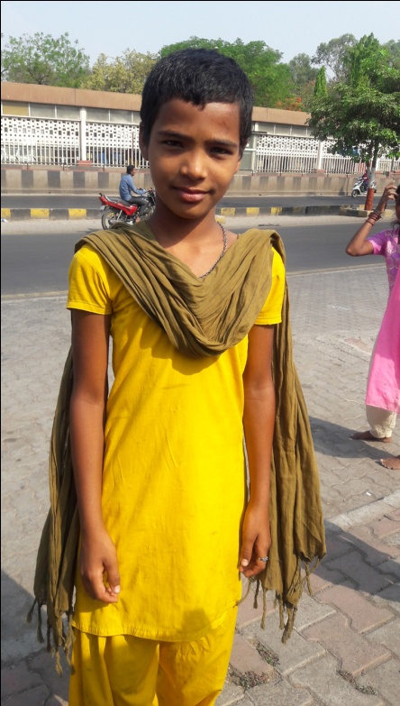
Trisha Sunny Kamble, aged 11 years is from Phulenagar area, Yerwada, Pune. She is from backward class. There are 6 members in her family, parents, 2 daughters and 1 brother. She is the eldest. Her parents and the children beg on the road for their livelihood. Their residence is shabby shelter made of tree leaves and contains a place for fire and 2-3 utensils only and does not have electricity and water supply and toilet. She never went to any school and when contacted she was found begging on the road. She was very dirty, her hair were grown and un-mended, her nails were uncut and dirty, her teeth were unbrushed and yellow, had lot of lice in hair and her clothes were torn. She showed inclination to go to school. When our social worker visited her shelter they found it very untidy and dirty and her mother was drunk and was fighting with her husband using foul language. They showed no interested after initial counseling. After repeated counseling they gave permission to enroll Trisha in school.

Our social worker obtained age certificate for her and got her admitted in Lokmanya Tilak Vidyalay, Phulenagar, Yerwada, Pune. As per her age she is enrolled in 5th class and is attending the school regularly. She is now able to read and write and is showing interest in studies. We conduct special coaching classes for these children to teach them to read and write and to teach other subjects thereafter so that they can catch up with other children.

We counseled her many times to imbibe cleanliness and good manners in her and had to provide medicines for lice besides providing other logistic support. She has now shown progress and after school hours does household chores and looks after her younger brother and sister. She now remains clean. Seeing this her younger brother and sister are also sent to school.

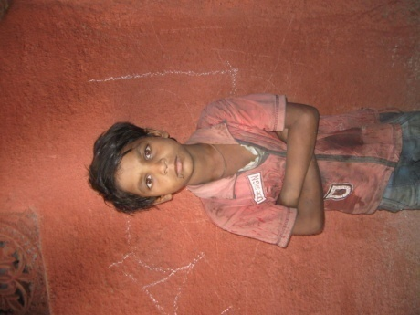
Master Akshay Ganesh Sakat, aged 9 years was found begging on the road in Phulenagar area of Pune by our Social Worker while doing the survey of such children. Total 110 such children were found. While doing survey she surveyed his family which consists of parents and 4 children. Family is schedule caste and try to live by collecting and selling scrap and by sharpening knives, however income from this is not enough and they live in a shabby tent like place made up of various scrap material. They do not get proper food and at a time go without it. There is of course no toilet, place to bath, water and electricity. They cannot afford to send their children to school and to augment family income send Akshay to beg on the road. We Akshay was contacted he was extremely unclean, his nails were grown, hair were long and uncombed and his clothes were worn out, torn. We took his history, talked with him and his parents and conveyed importance of school education to them. We did repeated counseling with them and finally they agreed to send Akshay to school. We then provided him soap, toothpaste, toothbrush, sweater, blanket, towel, clothes etc. and did his medical check up. We then obtained birth certificate for him and enrolled him in nearby school and as per his age he was admitted in 3rd class. We provided him school bags, uniform, shoes, books and other school material. However, the big problem was to educate him as he had never gone to any school and is totally illiterate. We therefore arranged special coaching for him by hired teacher, and also arranged help with studies nearby his residence. We also arranged sports teacher and are providing him nutritious diet.

He is now showing improved cleanliness and hygiene. He takes bath, brushes his teeth, maintains his hair clean and combed etc. He is able to communicate with other children and is now able to read and write.

Academic - Children are doing very well in studies. In academic year 2015-16, 11% of our students passed out with A grade*, 38% with B and 49% with C
(*School grading system- A-Excellent, B-Good, C-Average, D-Poor)

Further, 97% students received special mention in their report cards for first language, 80% for mathematics and 45% for English (2nd language)

Overall development - In academic year 2015-16, 73% students received special mention in their report cards for sports, 57% for drawing.

Our students have been actively participating in creative contests organized by school or other institutions and have performed exceeding well e.g. they won Interschool dance completion and drawing competition organized by well known corporate

There has been remarkable improvement in attitude of these children as evident by their well-mannered behavior, hygiene, cleanliness and communication skills. They look more self assured than ever before

About 40-50% of children were underweight, 10% anemic when they were first enrolled into our programme. With daily meals and regular heath checkup with necessary medical intervention, their health has improved significantly

Parents are relieved that their children are looked after for larger part of the day fulfilling their basic necessities- food & clothing.

