SUPPORT FOR FLOOD-HIT VICTIMS IN 56 VILLAGES OF RADHANPUR, BANASKANTHA (GUJARAT)

Organization profile

AWAG (Ahmedabad Women’s Action Group) has been actively involved with the issue of domestic violence inflicted on women in Gujarat, since 1981. The organization strives to assert the individuality of women by supporting them to get social justice in their struggle to survive and develop as equal human beings. AWAG considers raising awareness as the first step towards empowerment; with income generation as the second. A woman’s right to her body, her duty towards keeping it in health and avoiding blind faith are considered equally important. The habit of savings is promoted. Thus, AWAG has a holistic approach towards women’s empowerment wherein women's rights are seen as human rights.

Main Issue

AWAG has been working in Radhanpur, Banaskantha since 1992. The area consists of 56 villages and AWAG works for the development of all 56 villages. Over the years, AWAG has been raising awareness of local women to their rights and entitlements. Majority of the issues currently have been about lack of access to primary health care, ignorance about health and hygiene and lack of awareness about social justice. Through our wide network of community leaders, AWAG closely monitors government facilities such as water supply, drainage, sanitation, education and health centre availabilities. Together with the village leader (Sarpanch) and local women, we do advocacy for village development for such issues which need immediate attention. Since many years, focussing domestic violence, AWAG has done major work on law awareness in Radhanpur. Recently, through the support of GlobalGiving AWAG has been instrumental in raising awareness about personal health hygiene and use of affordable sanitation towels to the women in 56 villages in Radhanpur.

Profile of Radhanpur

Radhanpur constitutes of a population of about 40,000 people of which 19,150 are women. The area is prone to extreme weather conditions – both drought and flooding. There is high level of poverty with literacy rate of 65.34% (Lower than state and national averages). Radhanpur faces a range of social issues and constraints.

Need and Project activity
This monsoon, the state of Gujarat especially the districts of North Gujarat have had the highest amount of rainfall seen in the last decade. The data further reveals that the four districts — Banaskantha, Morbi, Surendranagar and Patan — have received more than 100% of their annual rainfall figures. Incessant rains continued to lash several parts of Gujarat, after which over 7,000 people were shifted to safer places. While the State government has been carrying out relief operations, since AWAG has been working in Radhanpur, Banaskantha since a number of years, we plan to carry out support operations that will involve the following activities:

- Transportation of food, clothes and other utilities gathered from local donors to the needy people in the villages
- Provide first-aid medicines for the flood-affected victims especially women and children
- Provide supplementary nutrition for the flood-affected victims especially women and children
- Provide awareness related to maintaining hygiene of their surroundings

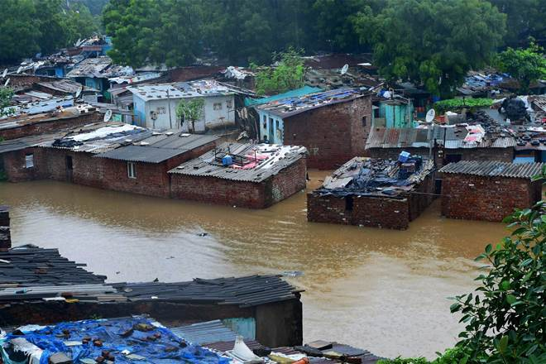

Timeframe:
90 days (micro project).

Budget

Activity | Total Cost (INR) | Total Cost (USD)
- Transportation of food, clothes and other utilities gathered from local donors to the needy people in the villages@ Rupees 3000/- per tripx56 villages | 1,68,000.00 | 2619.07
- Provision of first-aid medicines for the flood-affected victims especially women and children | 1,00,000.00 | 1558.97
- Provision of supplementary nutrition food packs consisting of dates, grams, peanuts, and jaggery for the flood-affected victims especially women and children | 2,00,000.00 | 3117.94
TOTAL | 4,68,000.00 | 7295.98

