By
Final Report of Relief Project 2017
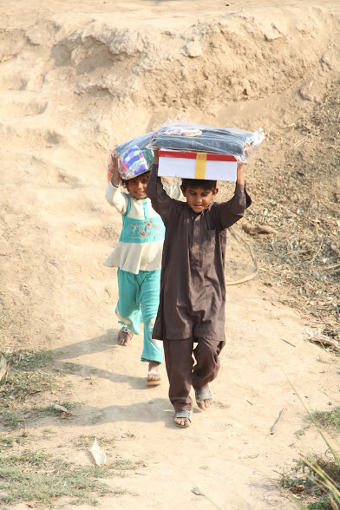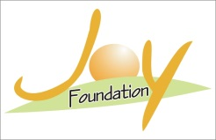
Joy Foundation
Pakistan

SUPPORT BY

Title of Project: - Emergency appeal for flood affected children in Pak

Reporting Period: One Month

Reported By:-
Yaqoob Sadiq
Project Incharge
Joy Foundation
Toba Tek Singh-36050, Punjab, Pakistan

Introduction:

The heaviest rains in 50 years have triggered flash floods in Azad Jammu & Kashmir and Punjab province of Pakistan where approximately 1300 villages have been swallowed up by flood waters along with livestock and harvest. Many people have died and thousands have stranded since heavy monsoon rains showered across northern Pakistan overflowing Chenab, Jhelum and Sutlej rivers.
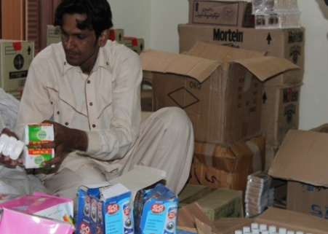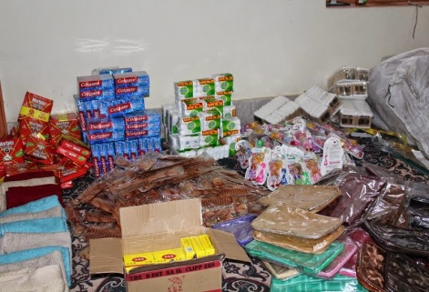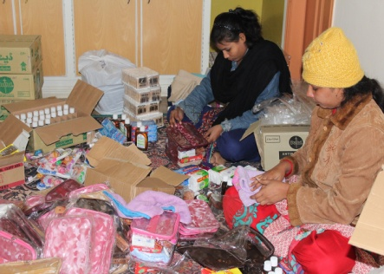

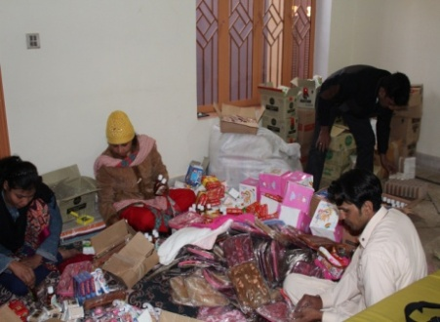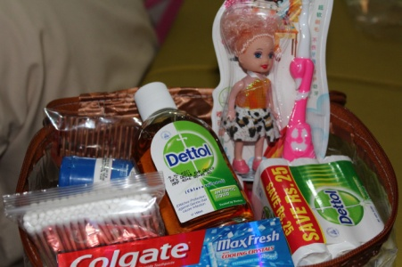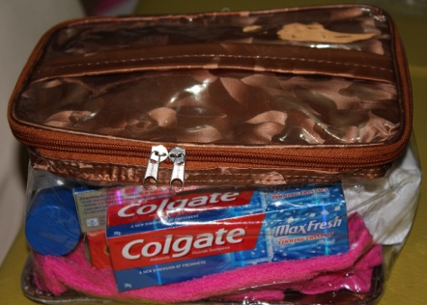

Punjab government has declared emergency in 21 districts that are directly hit by the floods in the river Jhelum and especially in the Chenab. Health officials fear outbreak of gastroenteritis, fever and skin diseases in the flood-hit areas.

Assessment visits:-

During the assessment visits Joy Foundation organizes management committees in the areas which will help the Joy Foundation to organize peaceful distribution in the area among the children. During assessment visits our team observe that children have many hygiene problems in their lives which will create problems for health many of are sick because of that. Joy Foundation team decided that we help the children for better health through Hygiene kits and medical camps. Joy Foundation prepare request for Hygiene Kits for children and submit to Global Giving for these children which also approve by Global giving and with short time its will be funded by our support on global giving.

Objects of the project:-

Joy Foundation overall objective is to help the affected children in target communities to restore their living condition with hygienic practices.

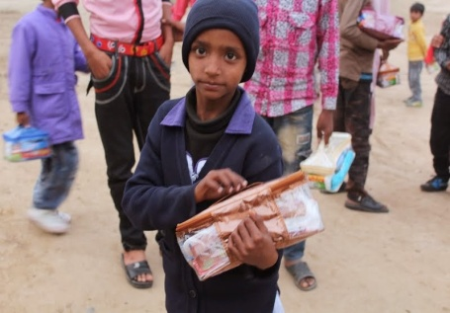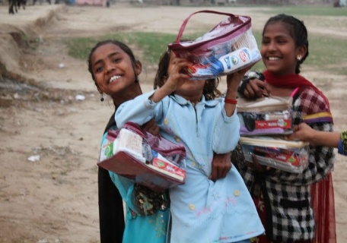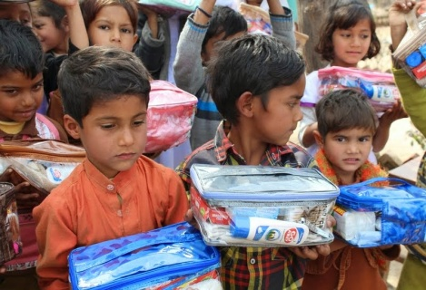

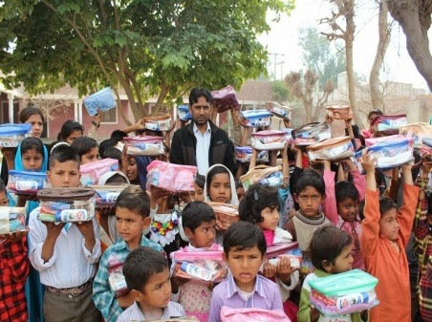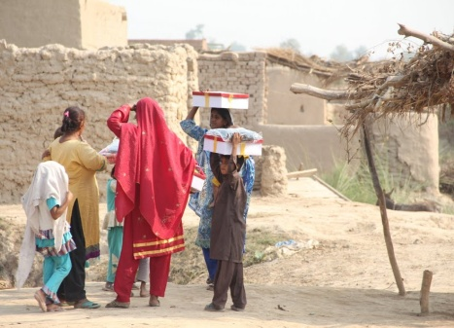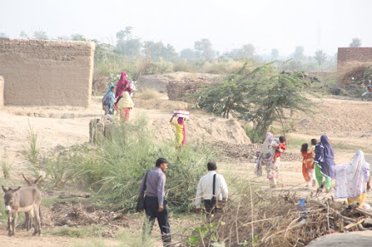

The specific objectives are:

- To educate the affected children with hygiene by organizing hygiene sessions and providing hygiene kits.
- To organize medical camps

Relief Team:-

We have very good young team which works hard to help the children during this distribution. Some of the Volunteers also help the Joy Foundation during flood emergency work. This time for the medical camps Dominican sisters of Malta help us for the medical camps. Our teams were as under:

Relief Team
1:- Yaqoob Sadiq
2:- Shazia Jalal
3:- Kashif Pono
4:- Rashid Masih
5:- Naqash Gill
6:- Manaz Maqbool

Medical Team
- Dr. Sr. Surria OP
- Dr. Sr. Carmela Agius OP
- Sr. Parveen OP
- Shamoun Patras

Target areas:-
1:- Bela Chotra
2:- Mozza Dhabi Balochan
3:- Munday Sayedaan
4:- Chak No: - 192 Kotla
5:- Chak No: - 323 Kiampur

Hygiene Kits Distribution among Children:-

After the assessment visits in the targeted areas and with the help of target area committees we prepares the lists of the children those are selected for the hygiene kits. After getting these lists our team prepares the hygiene kits for the children and start distribution. During our distributions among the children our medical teams also organize medical camps for the affected children and give them free medicines. We give hygiene kits packages to the children in 5 selected communities for the project. Our relief team work hard and complete this work in giving time. Children and their parents were happy after receiving these gifts and paid thanks to our team and our donors for taking care of the children.

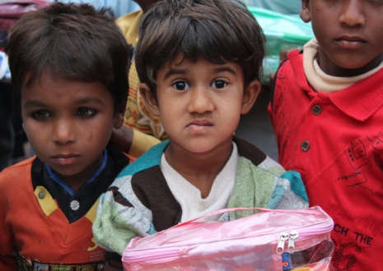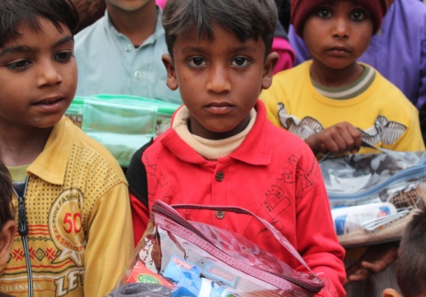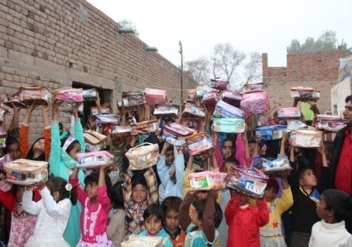

Free Medical Camps in affected areas:
Successful medical camps were possible only with the support of our donor, doctors, helpers, local committee and volunteer team of Joy Foundation. Joy Foundation made awareness in flood affected area to enhance them with full information of the medical camp. Apart from limited time that it took to advertise, we were overwhelmed by the response, and managed to see a vast number of patients contrary to our expectations. Praise God for enabling us to successfully carry out all the medical camp and secondly we are grateful Dominican sisters of Malta and there team who came to the services in a good number with courage and dedication to render their services with one heart.
The organization's objective of setting up free medical camp in affected areas was to assist the poor people who could not get proper medical services in the area. The outcome of the medical camp was extremely positive as over 371 patients of various ages were reviewed and treated for different types of ailments.

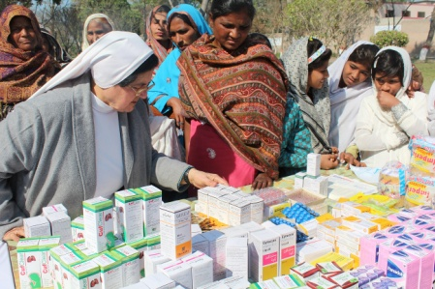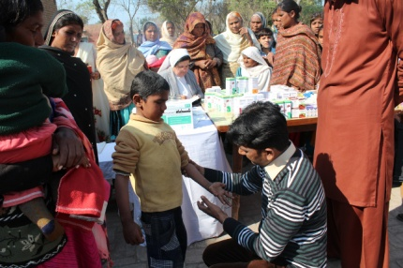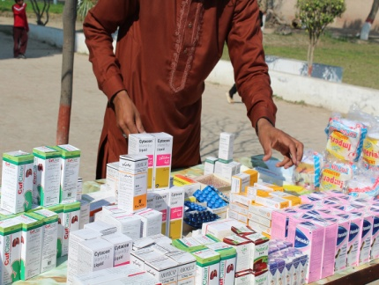

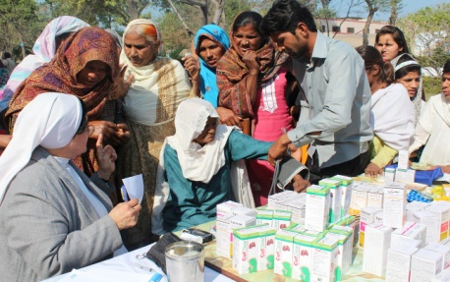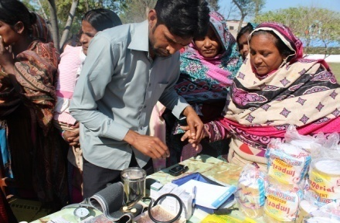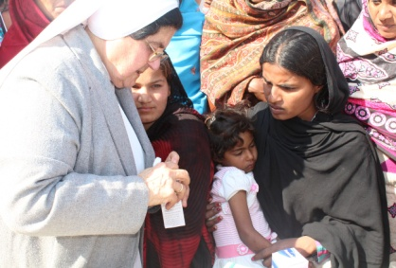

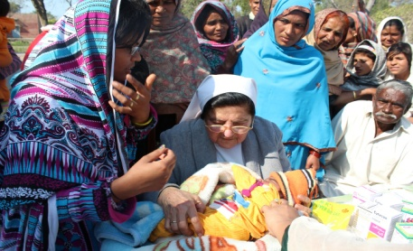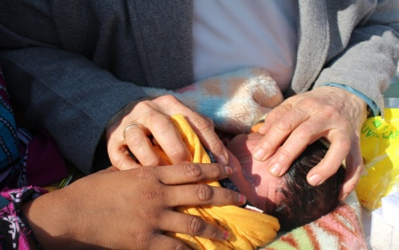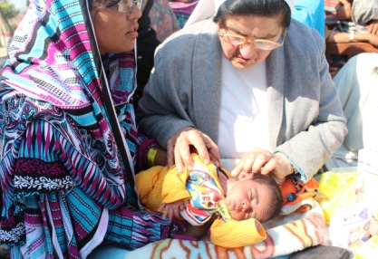

Our health professional team
- Dr. Sr. Surria OP
- Dr. Sr. Carmela Agius OP
- Sr. Parveen OP
- Shamoun Patras

ACHIEVEMENTS

Praise God the organization achieved its objective with the provision of free medical services to the needy Children to their expectations. In a medical camp of one day the following services was provided in five camps:

No | Disease | Number of patients
1 | Chest Infection | 125
2 | Cough/Fever/flu | 105
3 | Eyes and ear infection | 25
4 | Skin Allergy | 15
5 | Malaria fever | 22
6 | Diarrhea | 42
7 | Dangi Fever | 12
8 | General Service | 25
 | Total | 371

Achievements of the project

a) Local committees and team of young volunteers and team of children also participate during the relief work. They also help the Joy Foundation team for the packing of goods and loading and unloading.
c) Joy Foundation organizes very successful free medical camp in the affected area in which we recover 371 patients and give them free medicines.
d) It’s also big achievement of Joy Foundation team that they organize the community and make the local committees which help Joy Foundation to organize peaceful distribution and free medical camps with children.

Challenges of the project

- Weather is big challenge during the project because it’s very cold sometime rainy and has lot of fog. It’s very difficult to travel and work in these days but our team work hard and complete all the activities successfully.
- Purchasing the goods packing is also big challenge for the Joy Foundation. Thanks God complete everything on time.
- Due to large number of patients the services of our medical camp were stretched to its limits.

Word of Thanks

On behalf of all Joy Foundation team and people those got relief with your kind support I would like to say thanks Global giving team and all their support and hope that Global giving also trust and support Joy Foundation in their future work. Please continue to pray for us.

