

**Title of the project: HELP RE-OPEN RUGARAMA ICT CENTER**

**Applying Organization:**

SOLIDARITE POUR LA PROMOTION DES JEUNES (SPJ)

HQ: Village NGULI, Cell: CYAHI; Sector: RUGARAMA ; District: Burera; Northern Province

Tel: 0781285425/0787676317.

Website: [www.solidarite-spj.org](http://www.solidarite-spj.org)

E-mail: info@solidarite-spj.org

1. **DESCRIPTION OF APPLYING INSTITUTION**

*SOLIDARITE POUR LA PROMOTION DES JEUNES (SPJ)* is a non government organization operational in Rwanda, with its Headquarters in Burera District, Northern Province. The vision of SPJ is to be the champion of socio-economic prosperity of the rural people while enhancing sustainable development. SPJ carries out its activities under six programmes namely Environmental Protection and conservation Programme (EPCP), Integrated Rural Development Programme (IRDP), Women Empowerment (WEP), Youth Empowerment and Development Programme (YEDP), Human Rights Protection Programme (HRPP) and Rural Initiative Support Fund Programme (RISF). More details can be found on SPJ official website: [**www.solidarite-spj.org**](http://www.solidarite-spj.org)**.**

**2. PROBLEME STATEMENT**

RUGARAMA ICT CENTER was operational since July 2014. This was the centre wherein rural young people especially the school leavers were trained on computer literacy and Project Management and Business management. It was opened in attempt to help unemployed youth to acquire technical skills that would enable them create their own useful jobs. However, since November 2016 the centre was flooded by the runoff water from Muhabura volcano and destroyed all the computers and their accessories. As result the centre was closed and the beneficiaries of the centre are the prey of unemployment which undoubtedly led them to juvenile delinquency. Besides the local people can no longer access to public services especially since the government embarked on e-government. The people have to travel to Musanze town (30Km) so that they can access to such public services.

To reverse the situation, firstly SPJ through its Environmental Protection and Conservation Programme (EPCP) initiated the project entitled “*Erosion control through hillside development*” in order to raise people’s awareness about environmental issues through ¶environmental friendly solutions / approaches by excavating anti-erosion trenches. Secondly SPJ tried to resort to donors in attempt to secure other computers and their accessories so as to reopen the centre without further delay. It’s in this case that the project proposal is sent to Global Giving to seek financial support.

**Contact person**:

NTEZIYAREMYE SOSTHENE (0787676317): Executive Secretary

**Description of the current situation and measures to be taken**

Since the runoff water flooded the computer room and destroyed all the computers and their accessories, training on computer literacy was stopped. Trainees could benefit only training on Project Planning and Management (PPM), Entrepreneurship, Problem-solving skills and Business management. The reopening of the centre requires efforts for curbing the runoff water through the excavation of anti-erosion trenches, tree-planting, mobilizing people on Improved resilience to climate change through community-based, eco-friendly hillside development for optimum and sustainable agricultural production, and grant seeking to donors. As results people are sensitized and mobilized, and anti-erosion trenches are being excavated and now ***the project proposal is written and submitted to Global Giving in attempt to secure financial assistance of Thirty four Million Eight Hundred Thousand Rwandan Francs (RWF 34,800,000***) that will be used to buy the computers and their accessories.

**Budget of the project**

***The total budget of the project is: RWF 39,600,000***

Contribution from beneficiaries: RWF 800,000

Contribution from SPJ: RWF 4,000,000

Amount requested from donors: **RWF 34,800,000**

**Note:** This project has never been submitted to any donor else.

The beneficiaries (local people) have been involved and they are still involved in the excavation of anti-erosive trenches. This work was estimated to Eight hundred thousand Rwandan francs (RWF 800,000). Besides the local population are also involved in measures that will contribute to curb the runoff water from Muhabura. They are mobilized such that everyone is planting trees in his farm along the way of the runoff water.

**Financing Plan**

Contribution from local people: **RWF 800,000**

Local Contribution (SPJ + Beneficiaries): **RWF 4, 000,000**

**Amount requested from Global Giving**: **RWF 34,800,000**

***Total funds for the action: RWF 39,600,000 (USD 41,429***)

DETAILED BUDGET

|  |  |  |  |
| --- | --- | --- | --- |
| **Designation** | **Quantity required** | **Unit cost in RWF** | **Total cost in RWF** |
| 1.Computers (Desktops)+ accessories | 60 | 300,000 | 18,000,000 |
| 2.Tables | 60 | 80,000 | 4,800,000 |
| 3.Projector | 2 | 450,000 | 900,000 |
| 4.Chairs | 60 | 40,000 | 2,400,000 |
| 5.Power regulator | 60 | 40,000 | 2,400,000 |
| 6.Power supply | 30 | 35,000 | 1,050,000 |
| 7. Flipchart | 100 | 5,000 | 50,000 |
| 8. Wet board marker | 1 | 6,500 | 65,000 |
| 9. Scanner | 1 | 90,000 | 90,000 |
| 10. Printer | 1 | 250,000 | 250,000 |
| 11. Photocopy(Copier) | 1 | 600,000 | 600,000 |
| 12. Excavation of AETs | 10KM | 708,500 | 7,085,000 |
| **Total of equipment + materials** |  |  | **34,800,000** |
| **Total cost in USD** |  |  | **41,429.00** |

Note:

**\*The cost of equipment and materials:**

(*SPJ* will contribute *RWF 4,000,000* while the donor will contribute ***RWF34, 800, 000 (USD41, 429)***

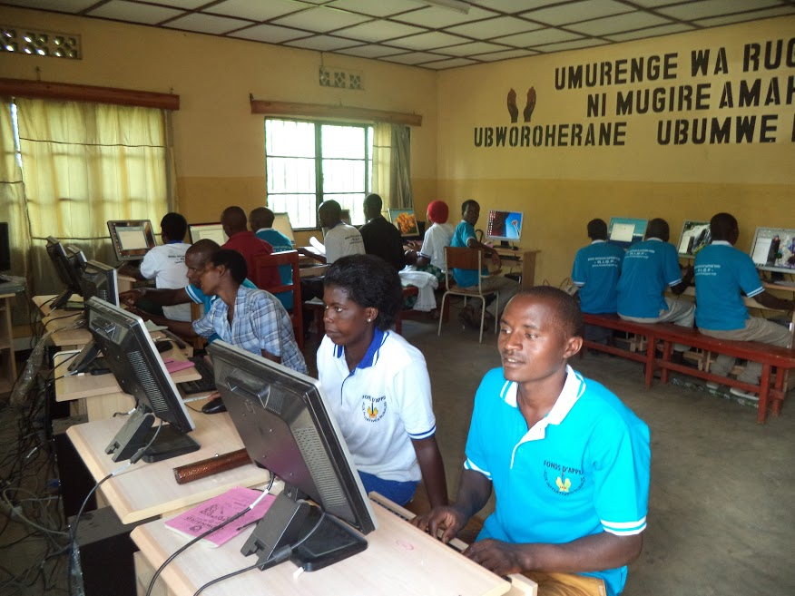

Trainees on training before the flood

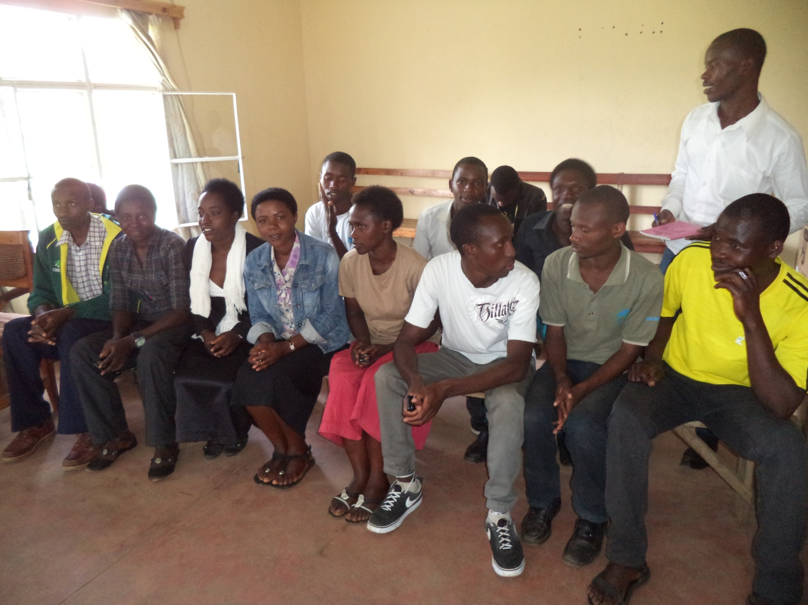

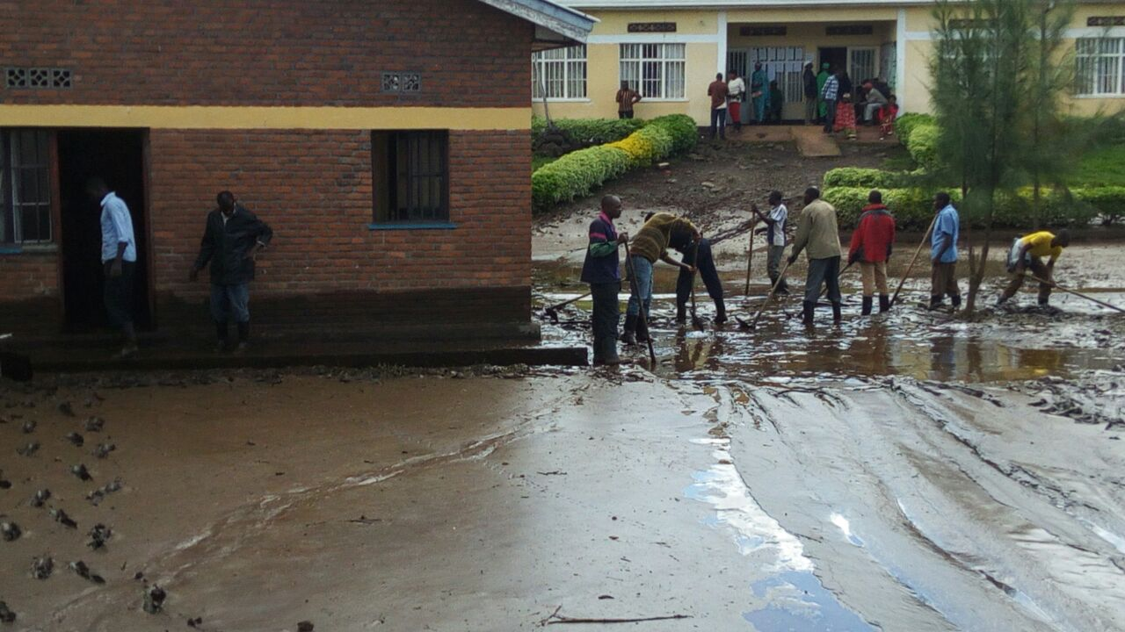

Beneficiaries trying to clean the front yard of the centre

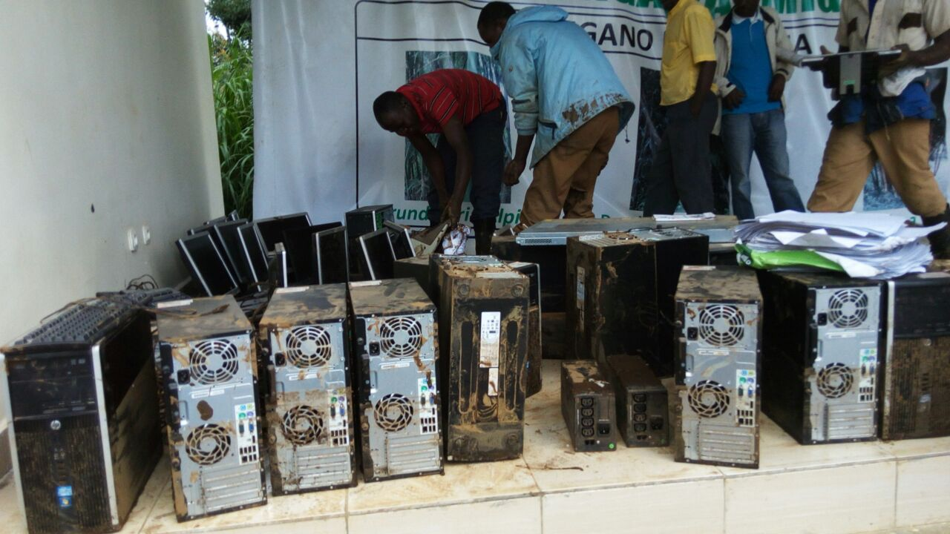

Damaged computers removed from the flood

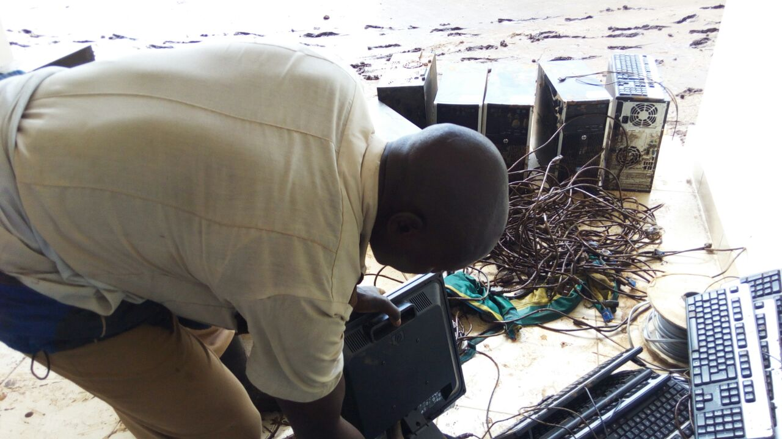

IT officer trying to repare some computers but in vain

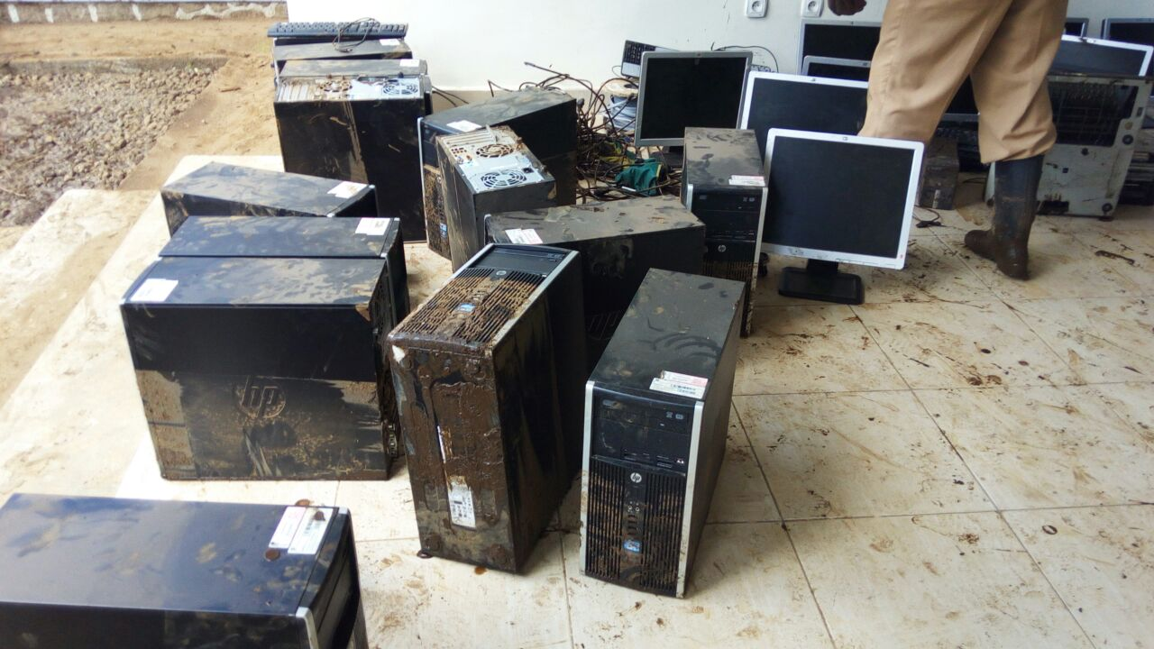

Damaged computers on the floor

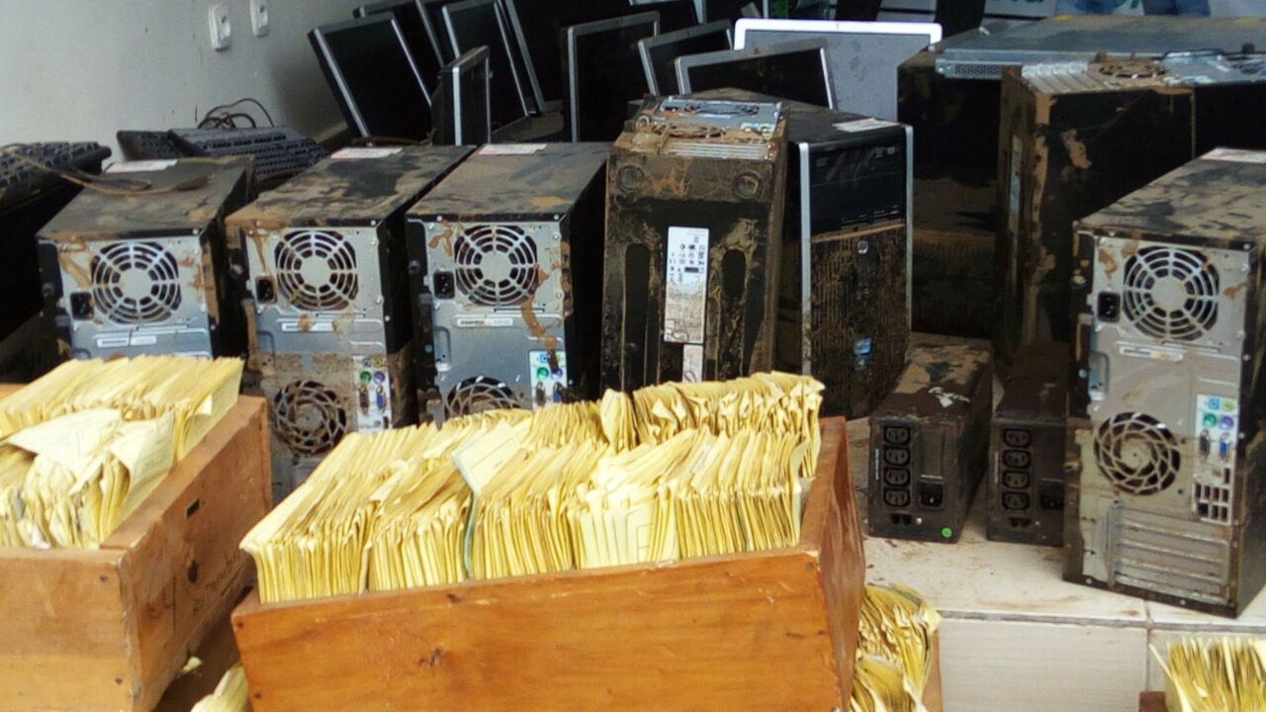

Damaged computers and other documents

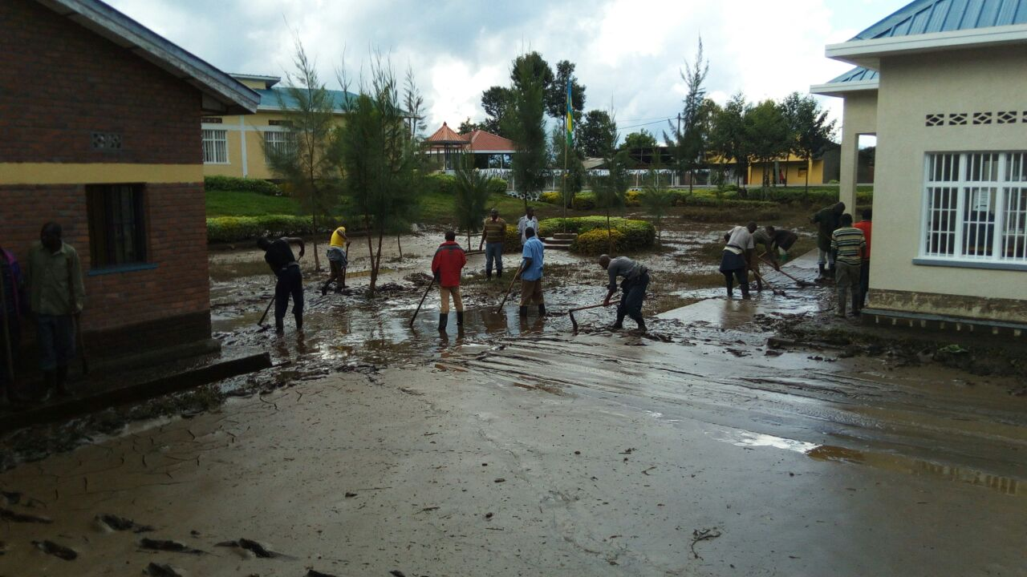

Beneficiaries working hard to drain the flood from the front yard of the ICT centre

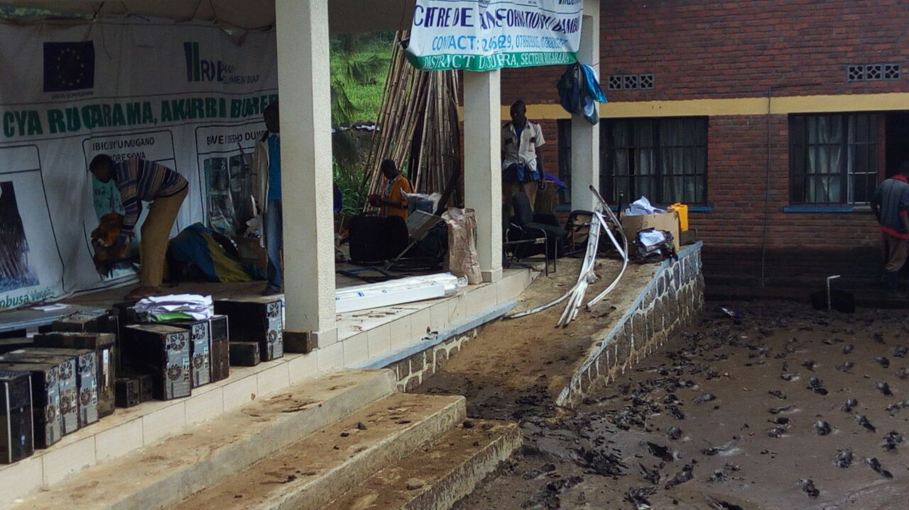People try to separate the destroyed computers from the mud

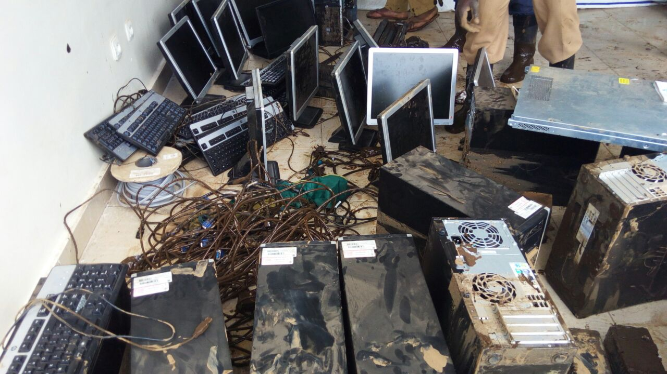

Destroyed computers and their accessories

**SPJ ORGANIZATIONAL STRUCTURE**

Executive Secretary

Executive Committee

GENERAL ASSEMBLY

Admin. Assistant

Programme Manager (IRDP)

Programme Manager(HRPP)

Programme Manager (YEDP)

Programme Manager (WEP)

Programme Manager( EPCP)

Field officer

Field officer

Field officer

Field officer

Field officer

Coordinator (RISF)

Secretary/Receptionist

Accounts Officer

IT officer