In Nepal Karuna-Shechen is helping 58 rural communities impacted by the 2015 earthquakes move beyond devastation and build a better tomorrow.

In collaboration with local grassroots organizations, we provide villagers with tools for their own sustainability and resilience. Our support funds the rebuilding of schools and infrastructure while also invests in long-term improvements and education that enhance quality of life and overall well being.

Our solar program trains local village women in the installation and repair of solar home lighting systems (that we supply) in their villages. The systems include an invertor, bulbs, cords, and batteries that can light a small home. Having solar light means families no longer are dependent on dangerous kerosene lamps and fires to read, study, cook, and help them to lead normal lives after the trauma of the earthquakes.
One of the women who participated in this training is Sanu Maiya Tamang, age 32, from the Nuwakot district. Sanu lost everything in the earthquakes. She and other village women trained under our program for two intensive weeks in Kathmandu to become a solar engineers, and then returned to their earthquake-affected communities to install solar home lighting systems. We also set-up local repair and maintenance shops in their villages to keep the program sustainable.
“I loved the training,” Sanu recounts. “None of us had any prior knowledge of solar electricity. The most challenging part was to learn about the different wires and tools. But the most wonderful part of this training was how all the women bonded. Exchanging about our difficult lives also gave us strength and motivated us to make a real long-lasting change.”
Women play a leading role in reducing poverty and inequality and can help create a more compassionate world. Our solar engineer program empowers them to reach their full potential and to become active agents of change in their communities. Their enthusiasm are the keys to the long-term success of our programs.
“Our projects empower villagers,” explains Sanjeev Pradhan, Karuna-Shechen’s Nepal Field Director. “We train them and encourage them to build on their own know-how to create better living conditions for themselves and to share what they have learned with neighboring villages. This philosophy of building self-sufficiency is the bases of all our programs.”
We plan to support a total of 58 rural communities as part this strategy. Please join us in this effort!

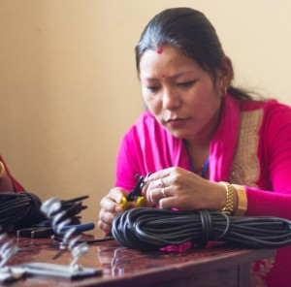
Motivated villagers like Sanu (above) are actively involved in our earthquake program.

