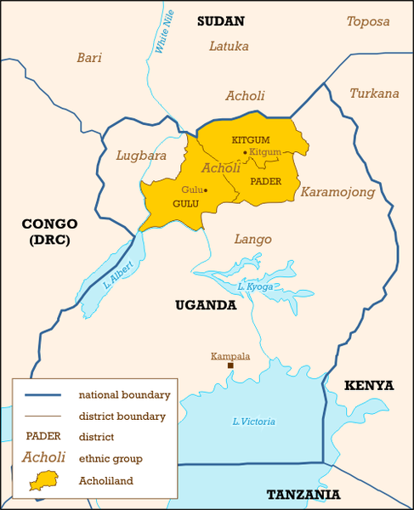  History  The Acholi Quarter is a slum in Kampala formed mostly of people from the Acholi tribe who were forced to flee northern Uganda during the fighting that took place in the early 2000’s. Many people in the Acholi Quarter work in a local stone quarry, where men haul rock and women break it into pieces. Young, uneducated women in the slums have very few choices: work in the quarry, marry young, or work in the sex trade.  The Beads Project was started in 2012 to give the young women in the Acholi Quarter independence and a chance to complete their education, while earning a steady and secure income. Through the project, the women also learn about women’s health issues, and gain friendship and support from each other. |  | Get in touch  To arrange a visit and support The Beads Project please call the number below.  Contact Info  Phone: +256776526344  youthsportuganda.org/programs/beads-project
  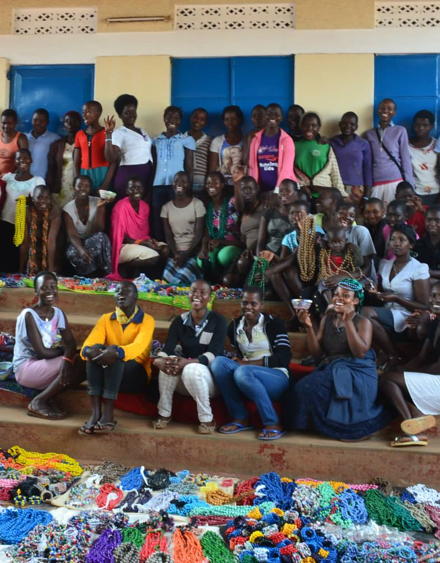
  The Beads Project
  Acholi Quarter, Kampala

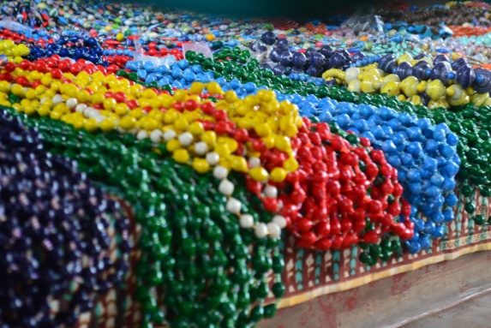  What is The Beads Project?  The Beads Project is a group of 50 women between the ages of 15-25, living in the Acholi Quarter slum of Kampala, who have come together to make beads and crafts. This project provides a vital source of income for these at-risk women. It often covers their school fees in addition to helping to provide for themselves and their families. Their colourful bracelets and necklaces are sold in markets throughout the city.  This project does more than provide an income; it is also a place for these girls and women to develop friendships and gain guidance and support from the group. The Beads Project empowers young, at-risk women by giving them a steady source of income and enabling them to take control of their lives. |  |  | Christine’s Story  Christine, age 15, is one of eight children, born in northern Uganda. At age three, she was abandoned by her mother. When her father, a farmer, was arrested in the fighting that took place in northern Uganda, she and her siblings were forced to stay with their grandmother. They fled from the fighting in 2004 and moved to the Acholi Quarter slum in Kampala. She now stays with an aunt and uncle. Her father has returned to the north where he is a farmer. Before joining the Beads Project she worked long days in the quarry along with her siblings. The Beads Project has helped her learn how to take care of herself. The close community within the group has also helped Christine understand what it feels like to be loved. By gaining a steady income without the long, strenuous days of working in the quarry, Christine is better able to focus on her studies. She hopes to go to university to pursue business, journalism or teaching following secondary school.  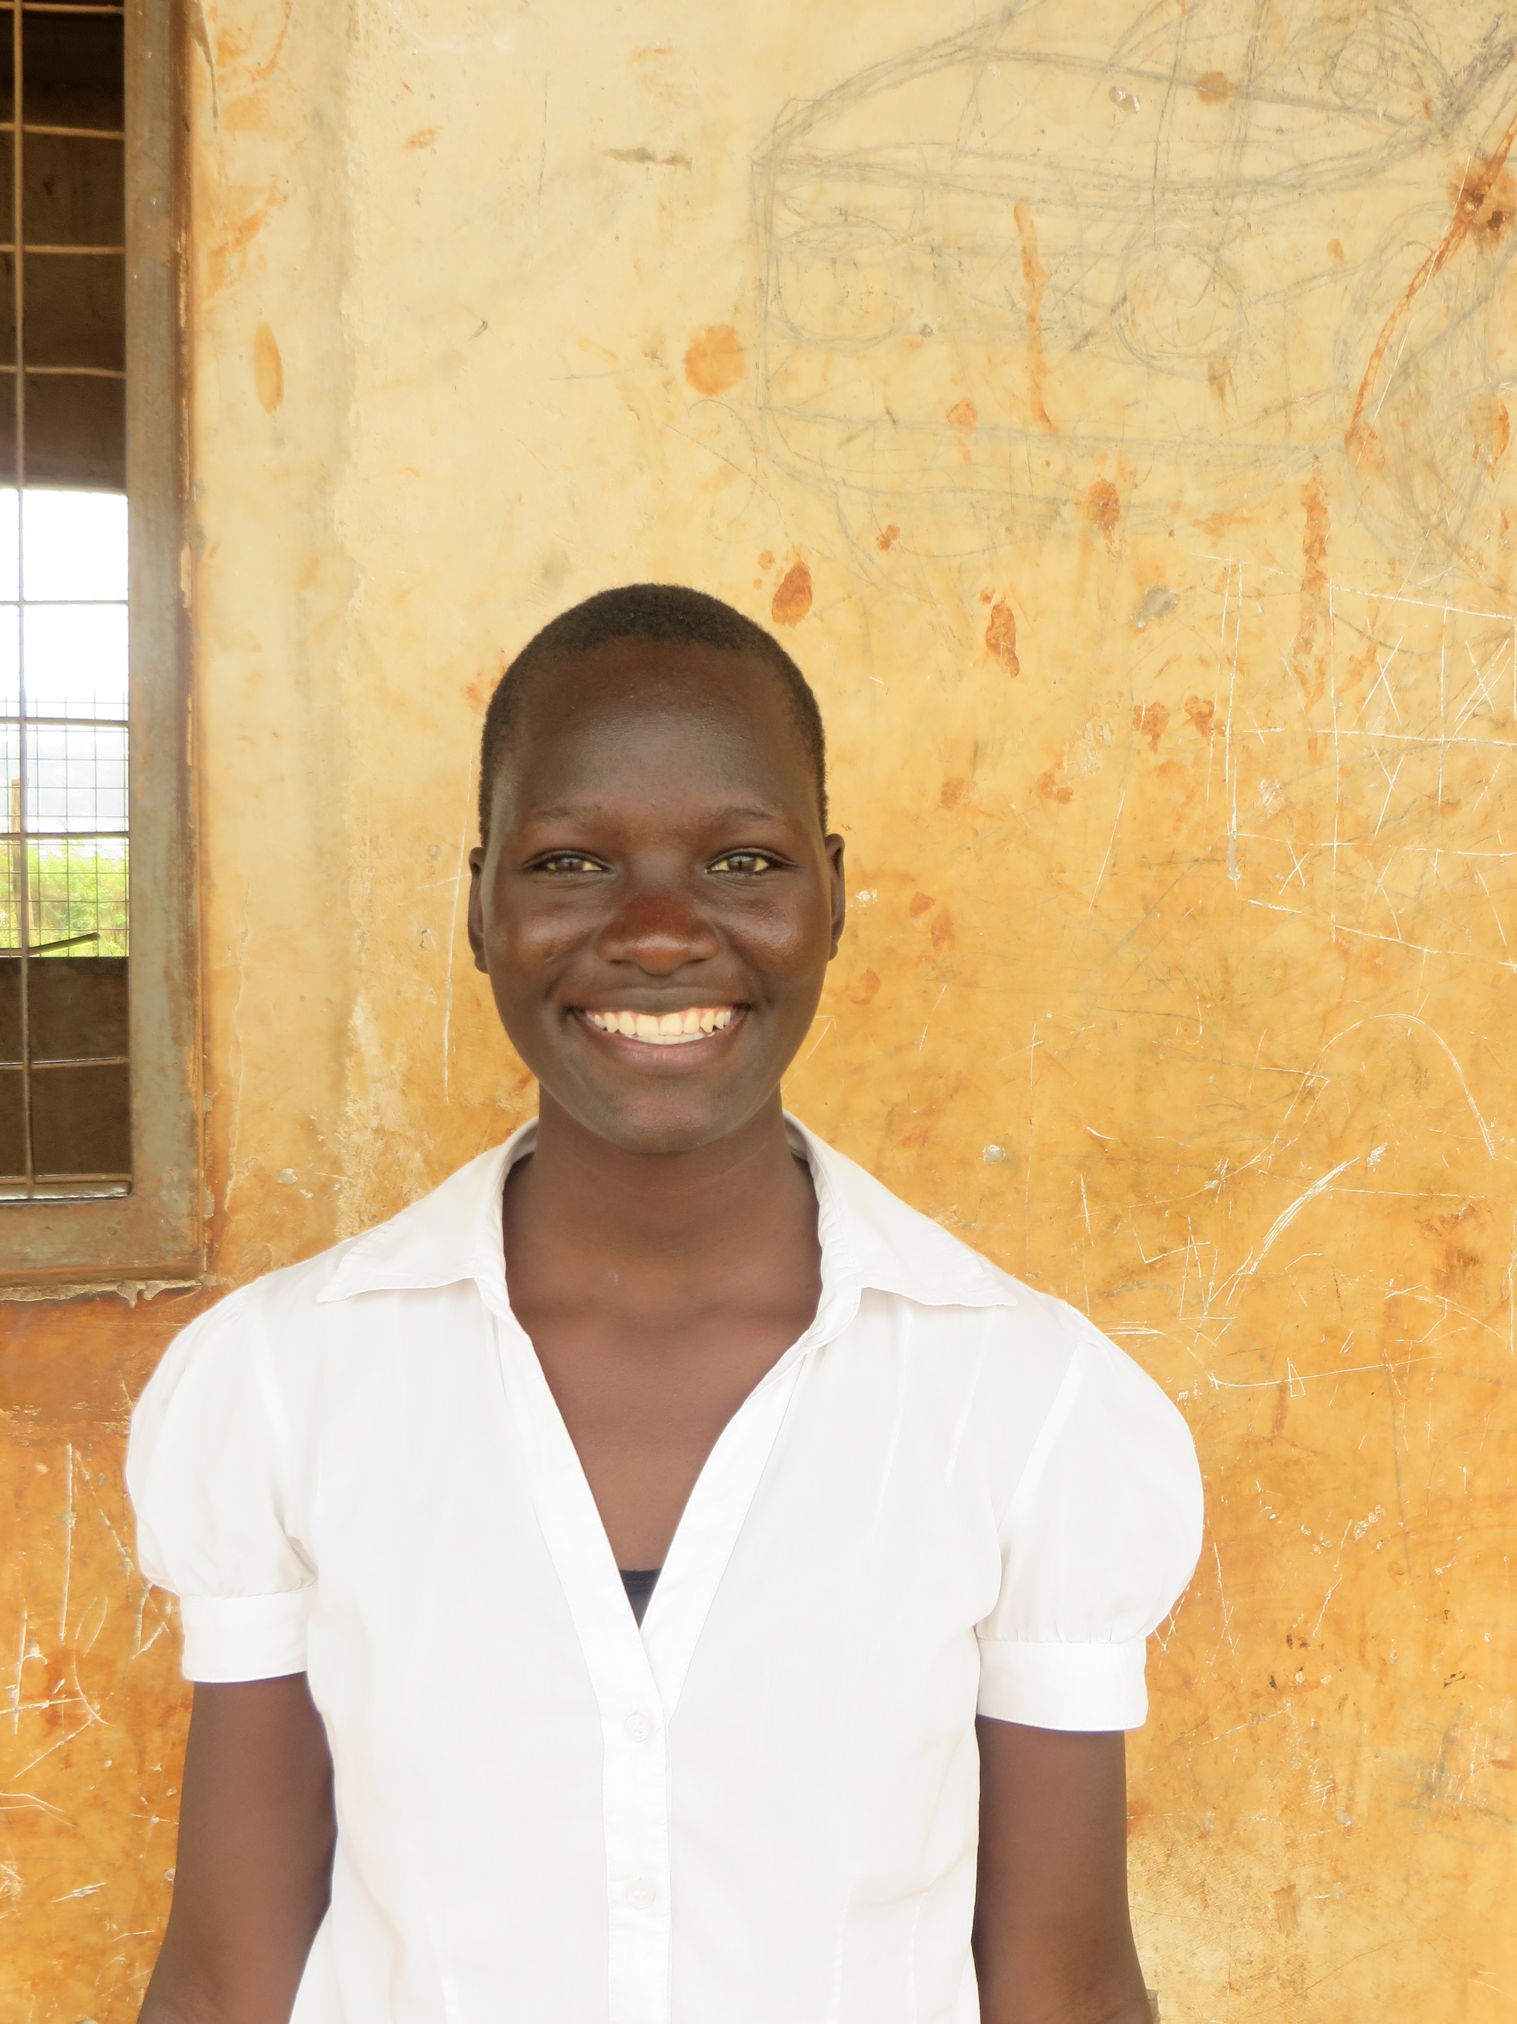 |  |  | “The close community within the group has helped Christine understand what it feels like to be loved.”  Deborah’s Story  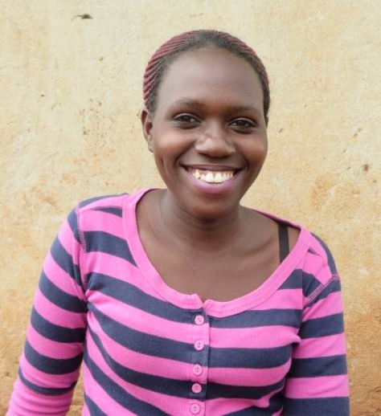  When Deborah first came to Kampala in 2003 she had to work in the quarry with her mother just to have enough money to eat and go to school. Working in the quarry was exhausting and paid poorly, leaving little time to study. Now that Deborah is part of the Beads Project she can attend university during the day and work during the evenings. She has also been able to make many close friends through the Beads Project, while finishing a telecommunications degree.

