### Famine crisis threatening the lives of millions

#### Time is running out for children, unless urgent action is taken

**Famine is threatening the lives of approximately 80 million people – more than half of whom are children – in 13 countries, spanning across three regions:** more than 2.5 million children face imminent risk of death from severe acute malnutrition (SAM), close to 12.5 million children and adolescents are in danger of missing out on their education, and almost 17 million people – including children – would require access to health services. The countries affected by this famine crisis are:

* Lake Chad Basin region: Cameroon, Chad, Niger and Nigeria
* Eastern Africa region: Democratic Republic of the Congo, Ethiopia, Kenya, Somalia, South Sudan, Sudan and Uganda
* Middle East/Northern Africa region: Djibouti and Yemen

**This *can* be prevented.** **Children cannot wait – but we need your help.**

**Investing now is not only critical to address the immediate, urgent need; it is also more efficient and cost-effective.** If we wait, the costs to reach one child can increase almost thirty-fold in the coming months, due to increased costs to deliver life-saving supplies more quickly by air versus sea if the needs for children escalate to critical levels, in addition to recovering from the devastation famine will have already caused.

Below is an overview of the pending impact famine could have in four of the thirteen countries, if we do not act now:

* In northeast **Nigeria**, the number of children with SAM is expected to reach 450,000 this year in the conflict-affected states of Adamawa, Borno and Yobi. If UNICEF receives the necessary funds to reach all children suffering from SAM with treatment, the mortality rate can be reduced to less than one percent. If UNICEF cannot reach those children, one in five is likely to die.
* **Somalia** remains in a state of chronic humanitarian crisis, with 6.2 million people facing acute food insecurity, representing more than half the population. Approximately 185,000 children are severely malnourished. Without urgent assistance, the drought could lead to considerable deterioration in children’s well-being, with a likely sharp rise in the caseload of children requiring urgent treatment for malnutrition – likely to increase to reach 370,000 – if the risk of famine is not averted.
* In **South Sudan**, famine was recently declared on February 20, 2017. Combined with the renewed conflict in July 2016, this has deepened the humanitarian crisis in South Sudan. Women and children are facing immediate risks of violence, displacement, life-threatening diseases and hunger. The country is facing a critical food security crisis, with an estimated 31 percent of the population experiencing severe food insecurity as of December 2016, and children among the most vulnerable. The situation is expected to deteriorate even further, with more than 270,000 children likely to be affected by severe acute malnutrition.
* **Yemen** is currently experiencing the highest levels of acute malnutrition in recent history: 3.3 million children and pregnant or lactating women are suffering from acute malnutrition, and more than 460,000 children under five from severe acute malnutrition. The ongoing conflict and food insecurity will have long-term implications on the health and overall development of children in Yemen.

#### unicef response

Conflict and displacement, exacerbated by drought and water scarcity, are leaving almost 80 million people in need – more than half, or nearly 43 million, are children. To meet the needs of all those threatened by this famine crisis in the 13 affected countries, UNICEF requires $1.27 billion. UNICEF will provide life-saving needs for the children affected, with support going towards nutrition programs to screen children for malnutrition and provide them with therapeutic food; health services such as vaccinations; water, sanitation and hygiene programs to prevent deadly diarrheal diseases; protection for children affected by the conflict and displacement; access to education; and cash assistance to the most vulnerable families.

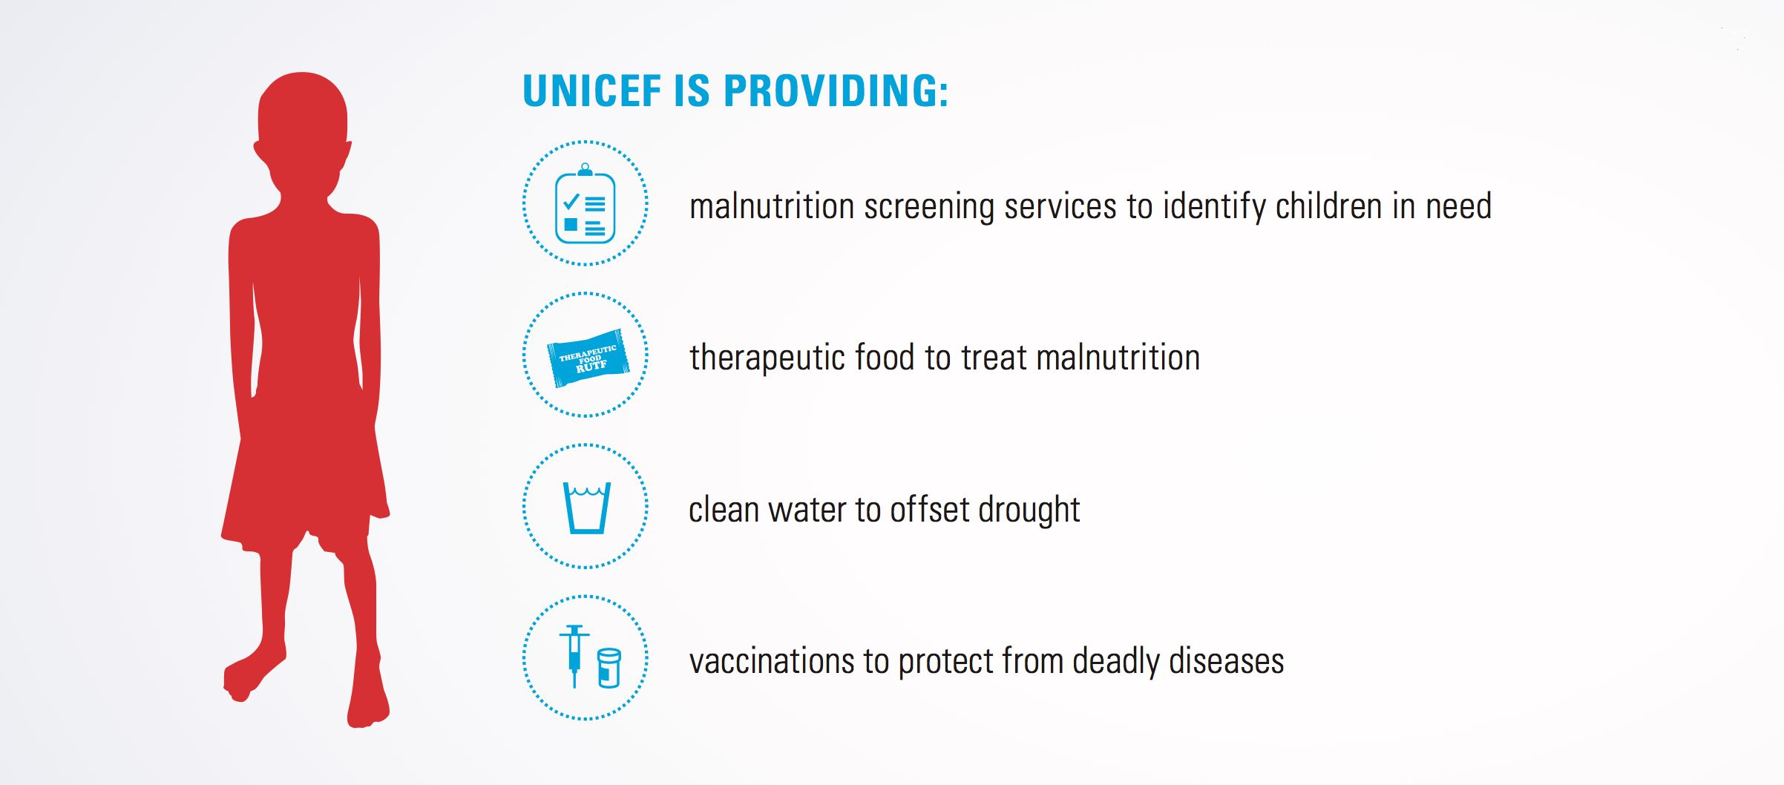

**UNICEF and partners are working around the clock. Below is an overview of UNICEF’s response in four of the thirteen countries that are threatened by the famine crisis**:

* **Nigeria:** UNICEF will reach 3.9 million people with emergency health services, treat over 220,000 severely malnourished children under the age of five and provide more than one million people access to safe water. In addition, UNICEF will also help immunize 1.8 million children against measles and provide access to schools or temporary learning facilities in safe learning environments for 1.3 million children.
* **Somalia:** UNICEF is supporting 1.7 million children under the age of five, including treatment to 277,500 children suffering from severe malnutrition, 340,000 children under five vaccinated against measles and 87,600 children with increased access to safe and protected learning opportunities in emergency-affected environments.
* **South Sudan: UNICEF has screened 24,508 children for malnutrition, provided key messages on infant and young child feeding to almost 7,000 women, and provided 5,413 school-aged children and adolescents access to education in emergencies, which includes a safe learning space, teaching and learning materials, teaching by trained volunteers and sanitation facilities close to the learning space. UNICEF plans to reach more than 207,000 children under the age of five with treatment for severe acute malnutrition.**
* **Yemen:** UNICEF has scaled up activities to respond to malnutrition through health facilities, mobile teams, community health workers and volunteers reaching hard-to-access communities and displaced families. UNICEF is also supporting treatment for severely malnourished children, and providing families with cash assistance and water, sanitation and hygiene services. In 2017, UNICEF plans to admit 323,000 children under five suffering from severe acute malnutrition for treatment and ensuring 4.5 million children under five receive micronutrient support.

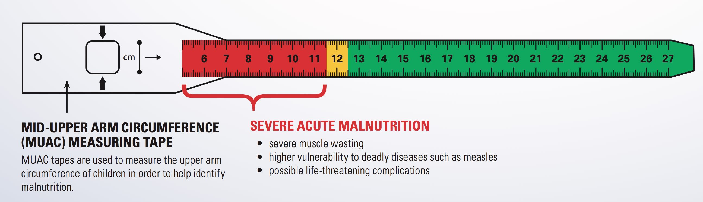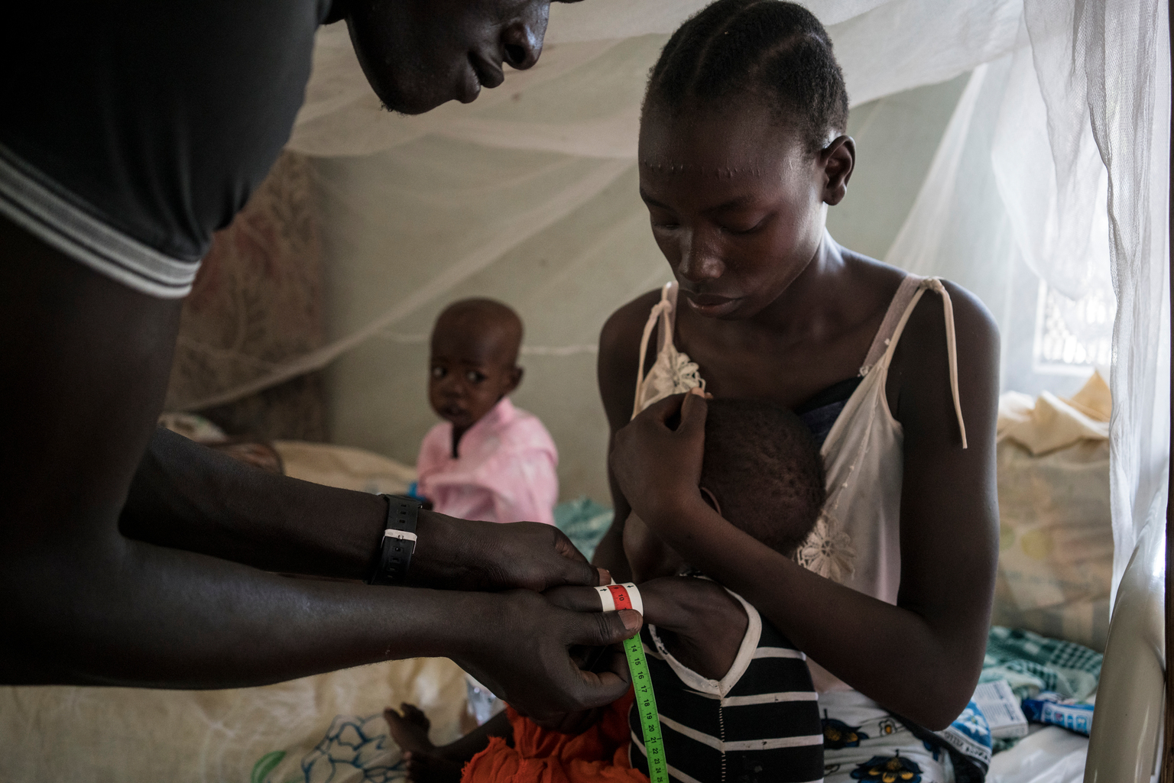

In Al Sabbah Children’s Hospital in South Sudan, a young mother tries to calm her son who is suffering from severe acute malnutrition as a nutrition officer uses the Mid-Upper Arm Circumference (MUAC) measuring tape to assess the degree of malnutrition.

© UNICEF/UN057596/Knowles-Coursin

#### please join us

In the difficult months ahead, UNICEF will focus on providing critical assistance as quickly and robustly as possible to prevent children from dying. As the scale of this famine crisis is expected to grow, UNICEF is committed to reaching children that are the most vulnerable and hardest to reach, and ensuring the needs of children remain a top priority.

. . . . . . . . . . . . . . . . . . . . . . . . . . . . . . . . . . . . . . . . . . . . . . . . . . . . . . . . . . . . . . . . . . . . . . . . . . . . . . . . . . . . . . . . . . . . . . . . .

**The United Nations Children’s Fund** (UNICEF) works in more than 190 countries and territories to put children first. UNICEF has helped save more children’s lives than any other humanitarian organization by providing health care and immunizations, clean water and sanitation, nutrition, education, emergency relief and more. UNICEF USA supports UNICEF’s work through fundraising, advocacy and education in the United States. Together, we are working toward the day when no children die from preventable causes and every child has a safe and healthy childhood. For more information, visit [unicefusa.org](http://www.unicefusa.org).

To learn more, contact:

**Some NameHere**, UNICEF USA

125 Maiden Lane, New York, NY 10038

[insertname@unicefusa.org](mailto:insertname@unicefusa.org)

(212) 000-0000

****The Impact of Your Support

We hope you will consider a gift to support UNICEF’s life-saving programs to immediately respond to the needs of the children affected by this famine crisis. Following are examples of the impact your gift could provide as part of UNICEF’s overall response across the 13 countries:

**$0.37** could provide 1 life-saving, ready-to-use therapeutic (RUTF) packet to help 1 severely malnourished child begin their road to recovery of full health.*

**$12** could provide life-saving, therapeutic milk to treat 2 severely malnourished children.

**$24** could provide an emergency water and hygiene kit for one family.

**$55** could provide150 packets of ready-to-use-therapeutic food (RUTF) to bring 1 severely malnourished child back to health.*

**$60** could help pay for school supplies to help at least 20 children continue their education.

**\*** *Actual cost per packet will vary depending on shipping costs to each country.*

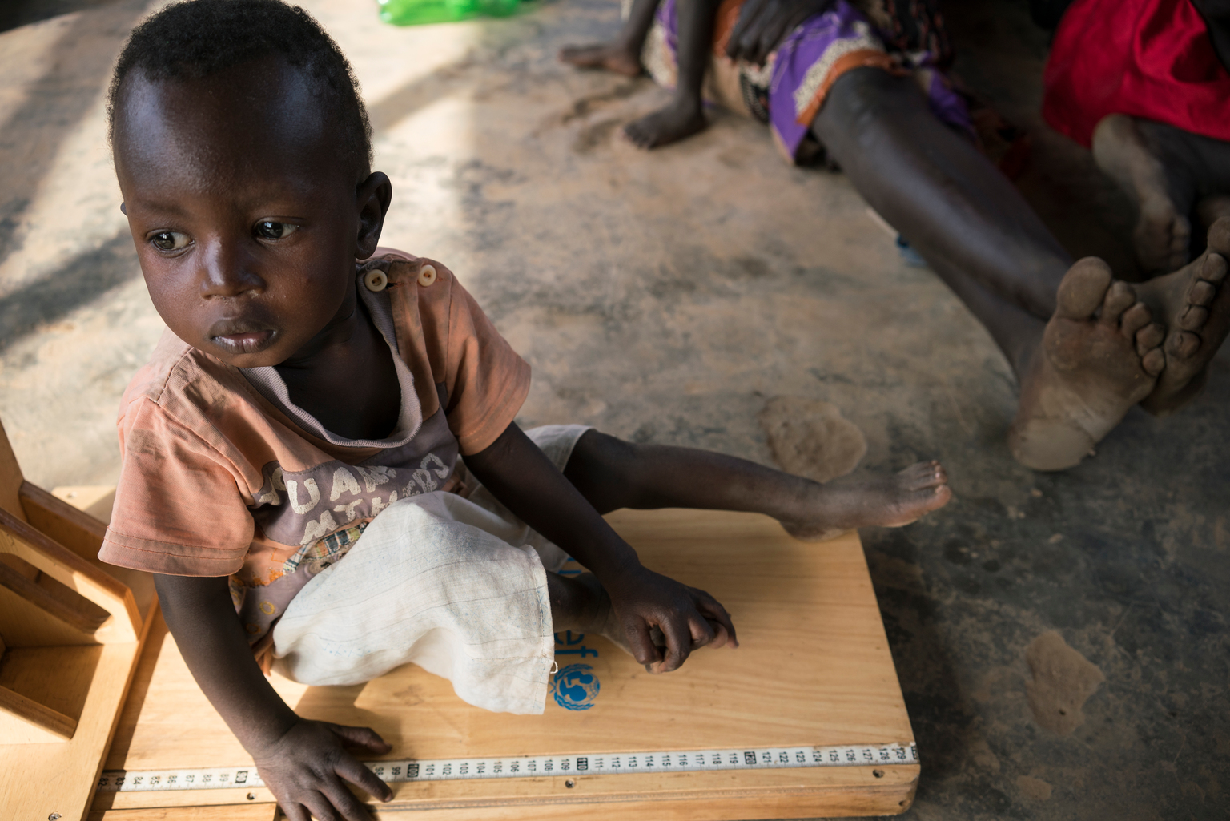

A young boy is being measured for his height, which is part of a malnutrition screening at a UNICEF-supported outpatient therapeutic program in South Sudan.

© UNICEF/UN057596/Knowles-Coursin