LWOB Student Divisions

At a Glance
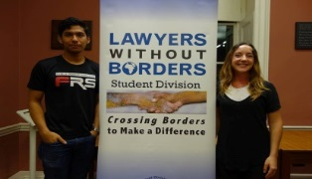
With Lawyers Without Borders’ official recognition, LWOB Student Divisions give young people the opportunity to engage with pro bono work and human rights issues, fostering a culture of engagement in pro bono that we hope will then follow them into their future legal careers. Investing in our students is an essential means of strengthening pro bono work globally and in the long-term. Currently there are 13 UK Student Divisions and one new Student Division in the US. We have received interest from students at universities in the US, Brazil, Australia and Turkey, some of which are in the process of applying for affiliation.

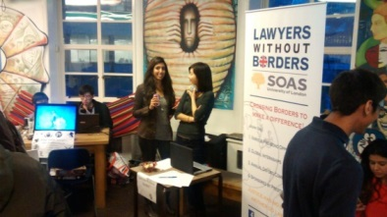
There are three main elements to student divisions: (1) Outreach and awareness raising; (2) Fundraising; and (3) Research projects. Several research projects have been undertaken this year, including research for LWOB’s Trafficking in Persons (TIP) in Tanzania, research into TIP in the pharmaceutical industry's supply chain, and assistance with the current artistic freedoms project with the Artistic Freedom Center in California.

Rule of Law Innovation Challenge
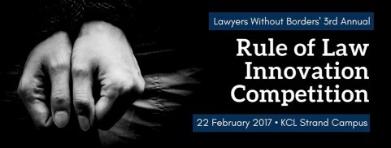
In February 2017, LWOB held its third annual Rule of Law Innovation Challenge (ROLIC), a high-spirited competition among LWOB Student Divisions in the UK designed to challenge students to develop innovation tools for LWOB programs in the developing world. ROLIC is the highlight of the Student Division calendar, and this year, five teams competed. Each entry included an oral presentation, concept narrative and innovative deliverable designed for legal concepts relevant to an ongoing LWOB Rule of Law project.
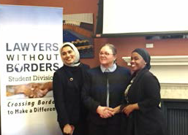
Two LWOB firms, Linklaters and Ropes & Gray, each provided associates and trainees to act as the judges for the competition. In follow up meetings with both firms, the lawyers at Linklaters and Ropes & Gray have agreed to take the entries as a starting point and finesse them into completed deliverables for current Wildlife and Human Trafficking programs LWOB has planned for Tanzania.

Spotlight
Each of our divisions holds conferences, events, fundraising, talks and debates throughout the year. Below, you can find a small snapshot of just some of the work undertaken by our divisions this year.

Aberdeen University 
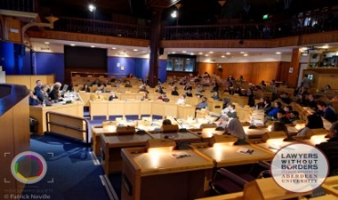
Human Rights Conference 2017
Aberdeen division’s third annual LWOB Human Rights Conference was held at King’s College Conference Centre, with tickets selling out in advance. The topic of the conference was ‘Burkini ban: achieving successful integration or limiting civil liberties?’

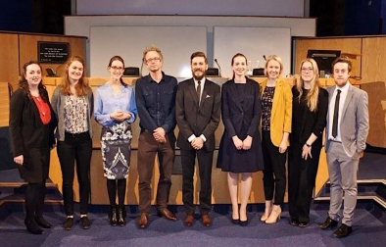
Panellists for the conference were Tom Lewis (Director of the Centre of Conflict, Rights and Justice at the University of Nottingham Trent School of Law), Noor Mahmudah Mohd-Nor (Principal of the Al Noor Islamic School, Aberdeen ), Dr Thomas Hochmann (professor of law at the Université de Reims Champagne-Ardenne, France), Vladimir Bujanda Valiente (Principal Solicitor for Midlothian Council), Thiago Alves Pinto (second year, DPhil in Law at the University of Oxford) and moderator Daria Shapovalova (lecturer at University of Aberdeen Law School).
King’s College London 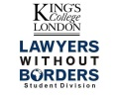

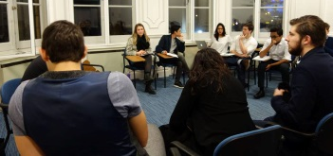
Student Division Debates
In November, students from the KCL and QMUL LWOB Student Divisions debated on a pressing human rights issue recently brought to the international spotlight by Edward Snowden. The motion was "This House Believes That: the right to privacy can be justified in the name of the national interest."

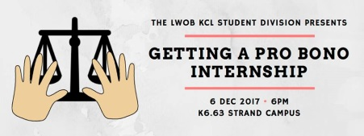
Events
In December, the division organized a free event titled ‘Getting a Pro Bono Internship.’ The aim was to teach students about opportunities in the pro bono sector of the legal industry, and how students could go about securing an internship. The event consisted of a presentation and Q&A session, with two guest speakers: Ms Natalie Sedcca, senior associate for the Civil Liberties team at Hodge Jones & Allen LLP, and Mr Sanjit Nagi, an LLM student at UCL, and at the time, head of the various LWOB Student Divisions in the UK.

Durham 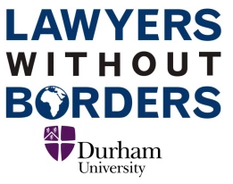

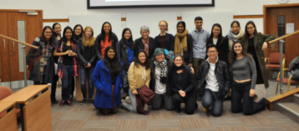
Human Rights Law and Intellectual Property Forum
In March, the student division hosted Alison Firth, an experienced professor and barrister, who gave a talk titled "Interpretive development: Does human rights law have lessons for intellectual property?"
In the run up to the event, the students also wrote 3 articles titled ‘What is Intellectual Property and Why Do We Need To Protect It?’, ‘What is the TRIPS Agreement?’ and ‘What is the Margin of Appreciation Doctrine?’
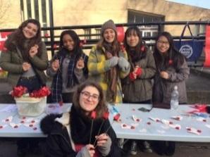
  - Fundraising
Durham Student Division has organized some particular innovative fundraising events this year. At Christmas, the students sold their own handmade Christmas cards, and for Valentine’s Day, they sold roses, chocolates and cards. At other points in the year, the students have also sold hot chocolate to raise money (always a winner in cold English winters!)
SOAS 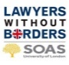

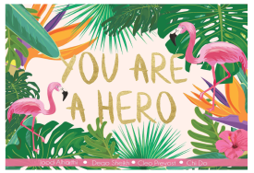
TIPTAN Storybook
SOAS are currently working with LWOB and Ropes & Gray to create a Choose Your Own Adventure storybook. The book is part of LWOB’s TIPTAN project (Trafficking in Persons Tanzania). The aim is to create a book that will teach children some of the indicators of trafficking, and methods of staying safe.

London School of Economics 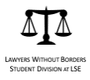
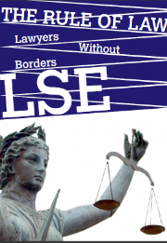
Student Journal
In March, the LSE Student Division published the first edition of their student journal The Rule of Law. The journal featured 8 articles on the topic of the Rule of Law, covering areas such as Brexit, Populism, International Humanitarian Law, and studies of specific countries, such as Malaysia and China.

Brooklyn Law School
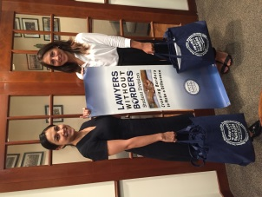
Our Newest Addition to LWOB Student Divisions
Brooklyn Law School recently visited LWOB Headquarters in New Haven to speak with our Executive Director Christina M. Storm about setting up their new student division. We are very excited to welcome them to our network!

