The Chelly Foundation
Report from Nop Ess, In-Country Coordinator for Cambodia

The Chelly Foundation is a nonprofit organization improving the education of children in Cambodia. The Foundation was established by Mr. Jason R. Baron who currently lives in the United States. Jason’s goal with the organization is to keep alive the generous spirit of his mother, Chelly Baron, who passed away in 2012 from multiple sclerosis in the care of my sister Nan Nop and others.

Our Mission: is to help bring about positive changes in people’s lives through literacy, education and other means. It means that the Foundation gives poor students in my home village and others a chance to get a better education in order to be productive members of society.

A number of projects have been set up in Chumkiri District, Kampot Province, including in my home village of Snay Anh Chet. Many children in Cambodia, especially in rural areas like Chumkuri, drop out of secondary school or don’t go to college because their parents don’t have the ability to support their learning. Lack of education is a main reason that Cambodia currently lacks adequate human resources.

The Chelly Foundation Projects, 2015-2016:
- First Project
January, 2015: donation of school supplies
The first project of The Chelly Foundation was the donation of school supplies (text books, notebook, pens, pencils, rubbers, rulers and pencil sharpeners) to students at Prey Khajay Primary School, located in Chumkiri District. The donation activity was organized and attended by myself and my sister. The event was participated in by teachers, commune chief and 460 students. Currently, the school supplies continue to play a vital role at the school.

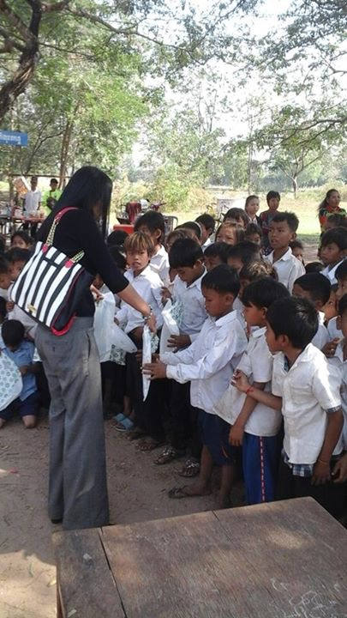
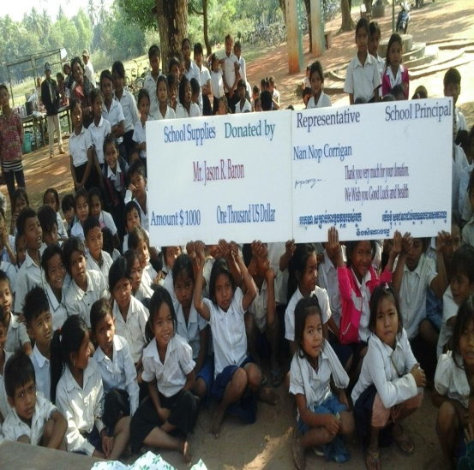
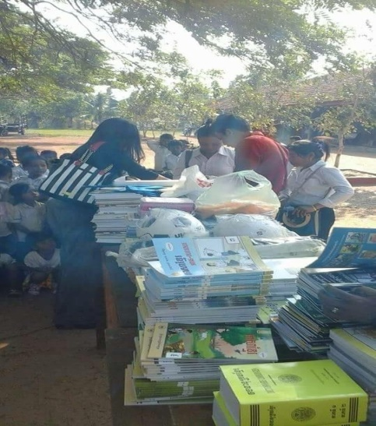

January, 2016: donation of library equipped with 3 computers and books
The second project of The Chelly Foundation was the construction of a standing library at the Hun Sen Chumkiri high school in Chumkiri District. The construction of the building took three months, coordinated by myself with volunteer assistance by a number of men from the District. After the completion of construction, Jason and Nan came to dedicate the The Chelly Library and participated in a ceremony in the presence of the principal of the school, teachers, and many hundreds of students.
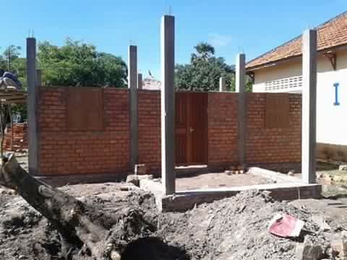
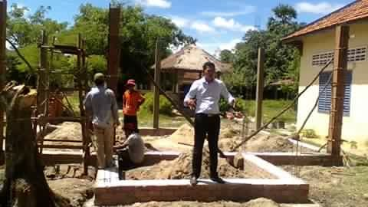
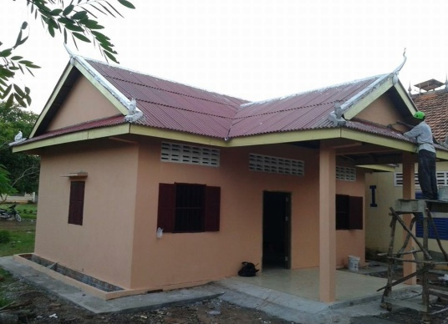

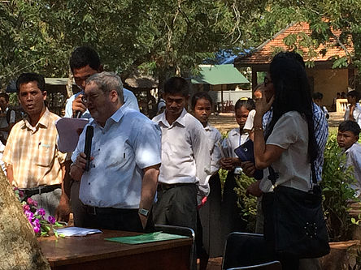
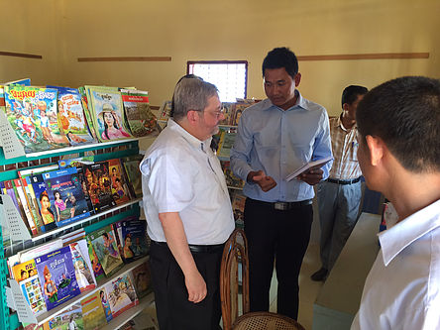
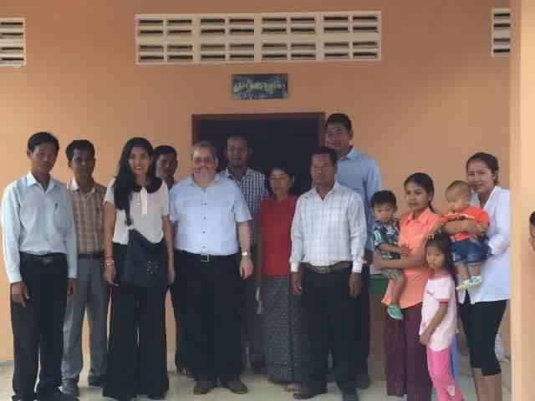

Currently, the library plays a very significant role for high school students who need to conduct their research. The library, equipped with 3 computers, and a diversity of reading materials, has been accessed by many dozens of students. Every day, students are very happy with reading in the library. It is the first library at a school in the entire Chumkuri district. The library also welcomes students form different schools who would like to conduct their research. Moreover, The Chelly Foundation hired 3 part-time librarians in order to facilitate the students and control all materials. Additionally, they have created specific programs for students who attend in library classes.
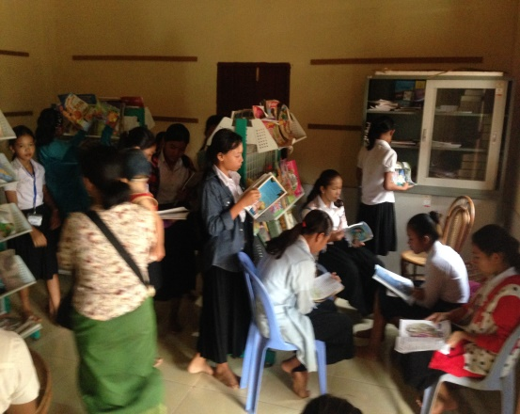
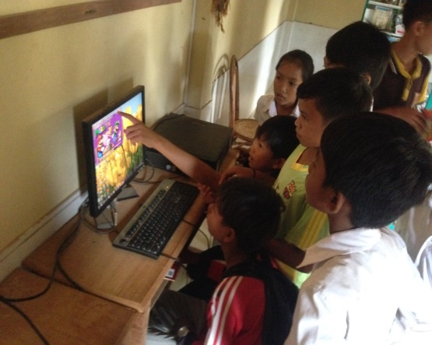
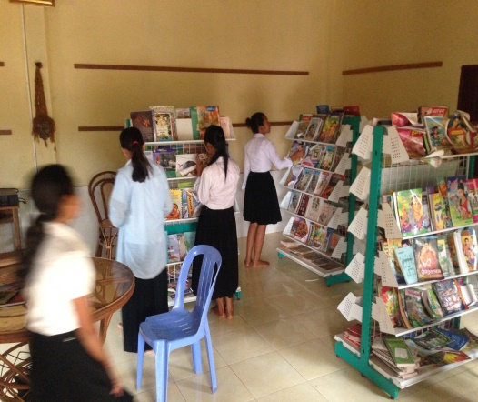

The Library has drawn students’ attention in reading. Reading is very important for students, for the more you read the more knowledge you have. The library allows students to borrow books with for a period of 1 week before returning them back. If students would like to extend the period they have to inform the librarians. Every day, students from the high school and many other schools come to borrow the books to read at home.
- The Third Project
May, 2016: Starting The Chelly Foundation English Class
The third project of The Chelly Foundation is providing free English lessons for students at the Hun Sen Chumkiri high school. Understanding English is very important for students’ future jobs. Classes are given from Monday to Friday with 5 – 6 hours of teaching periods per day. In the past academic year of 2016, there have been 400 students registered. For those students who have registered, they receive an English text book for free. The class is taught by a teacher who has 5 years’ experience in both private schools and public schools. We closely work with public teachers in order to improve the ability of students in terms of their language skills, and after only 8 months, we have seen many of the students demonstrating improvement in those skills.
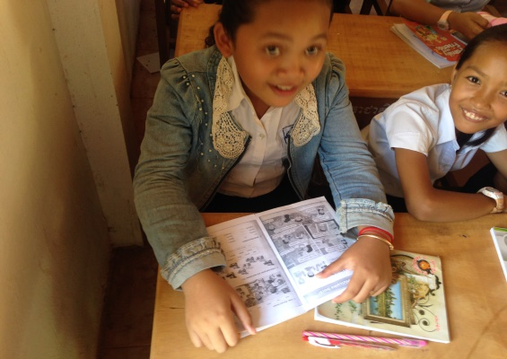
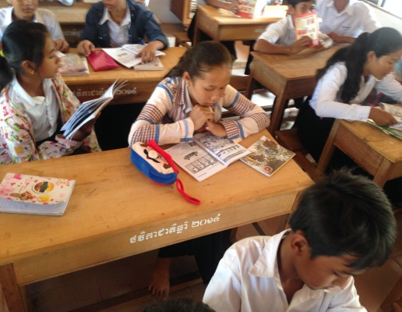
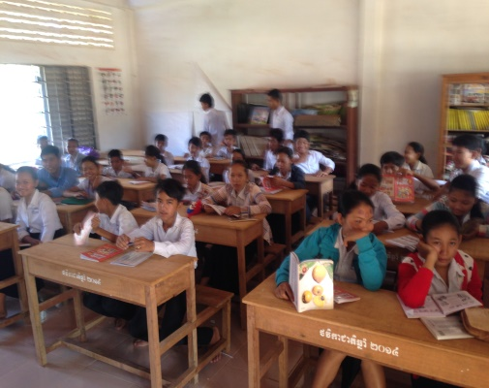

- The Fourth Project
Scholarship Program: 2015 and 2016
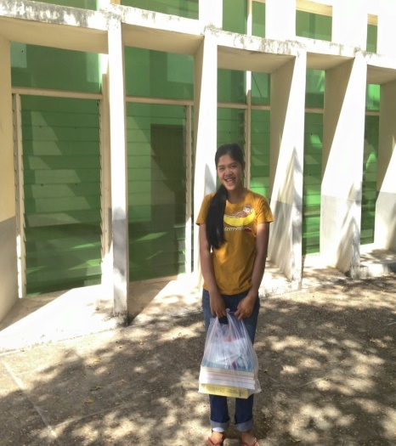
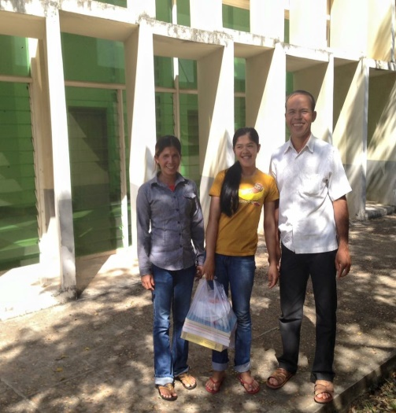
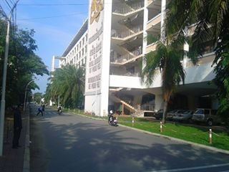
- Starting In November, 2015, The Chelly Foundation has offered scholarships to students from Hun Sen Chumkiri High, in order to attend the Royal University of Phnom Penh (RUPP). Our scholarship program is open only to students who have demonstrated a love for studying, and they must come from a poor family. The first scholarship was offered to a student named Monov, who lives in the Snay Anhchit village. She is a student who comes from a very poor family. Manov passed her first year exams and currently is studying in the second year at the university, majoring in Chemistry.

- In October, 2016, the program expanded to awarding an additional 5 young women from Hun Sen Chumkiri High school and 1 student from Meas Sophea Baneav High School, both located in Chumkiri District, to attend the Royal University of Phnom Penh. This makes a total of 7 scholarships currently in operation. In 2016, we had set up a second scholarship examination for students who passed their national examination (for grade 12), where the candidates must also have come from a very poor family. The initial selection of the candidates was done by myself, along with their teachers of English and principals. There were 16 students selected to be the candidates in our scholarship examination, which involved three subjects on the test:
- English
- General Knowledge
- Math
Five students passed the exam and were awarded a scholarship.
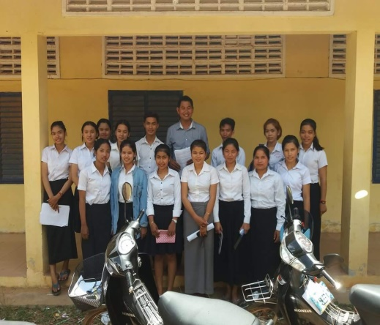
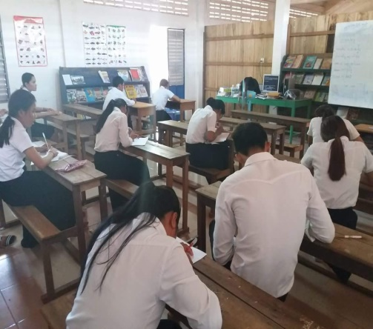
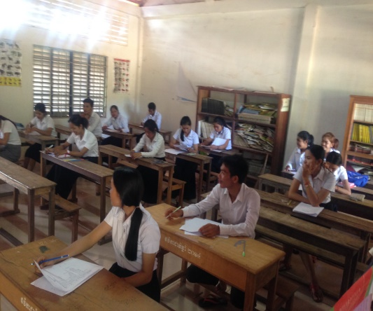

For 11 of the students who did not pass this second exam, The Chelly Foundation provided them an opportunity to attend vocational training with an award of $200 each, in order for them to get better jobs Beside the vocational training, students can attend second language classes in English, Korean, Chinese, Japanese or French, in order to get jobs in a factory or company with better pay. When they have a job, they are able to support their family. The concern of The Chelly Foundation is to help as many poor students as possible to get out of poverty.

- The Fifth Project
June, 2016: Donation of playground
The fifth project of The Chelly Foundation was the donation of a playground at the Prey Khajay Primary School located in Snay Anhchit village. The school consists of approximately 460 students. It is the first playground that exists in a public school anywhere in the District – none exist in the countryside anywhere. Not only do students, but also teachers and older people in the village play there, and everyone is very happy with the playground. It is the first fun activity at a school for many rural area children. Playgrounds only exist in private schools and NGO schools in the city or in some other provinces. Ever since the playground was put in place at the school, students have been coming to school more regularly.

Activities of students

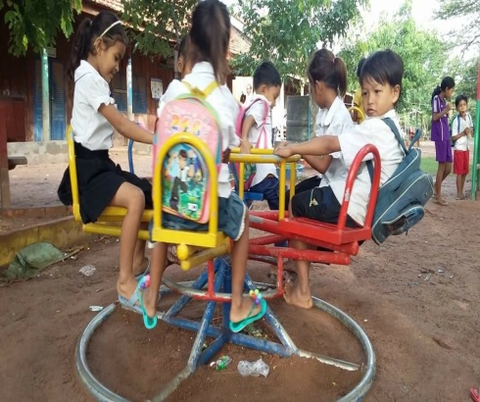
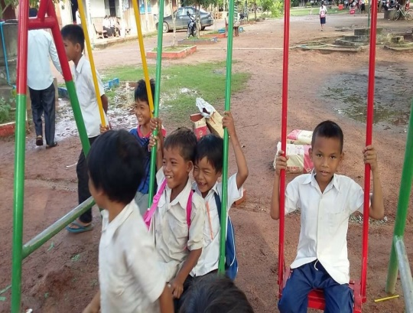
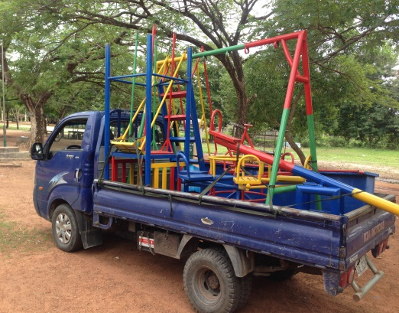

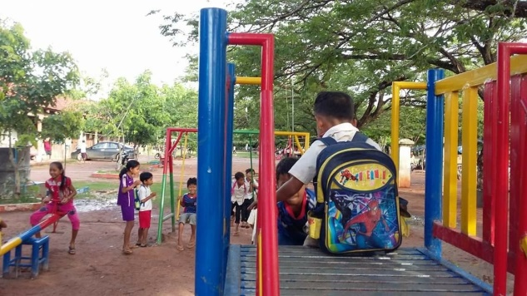

- The Sixth Project
July, 2016: donation of 8 bicycles, uniforms and school supplies
The sixth project of The Chelly Foundation has been the donation of 8 bicycles, uniforms and school supplies to children attending the Prey Khajay primary school and secondary school. The 8 students were selected from poor families who live very far away from school. All of these children have been coming to school on foot, having to walk 6-10 kilometers everyday to school. Lack of a bicycle is one of the main reasons that force students to drop out of school. Understanding the students’ difficulties, The Chelly Foundation decided to donation 8 bicycles to 8 students in order to motivate them to continue their studies. Both the students and their parents are very happy with our donation. They said that it is the best thing that could have been done to encourage their learning. Uniforms are also very important for students to have. Some students only own one uniform, so they have to clean it every day after class. They would like to pay their very deepest thanks to The Chelly Foundation that donated these fundamental things to help their studies.
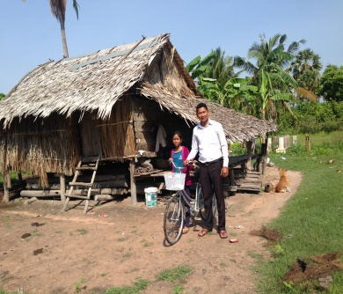
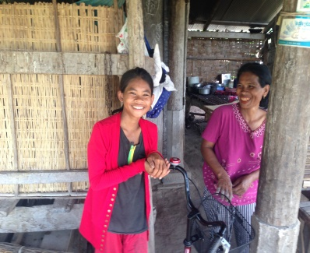
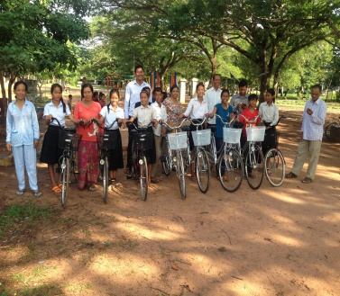
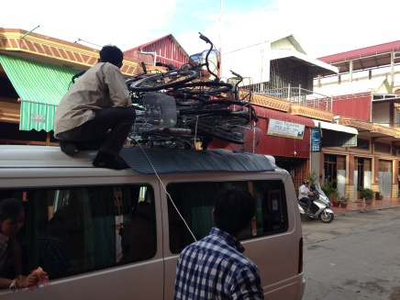
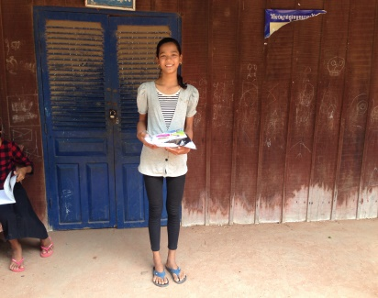
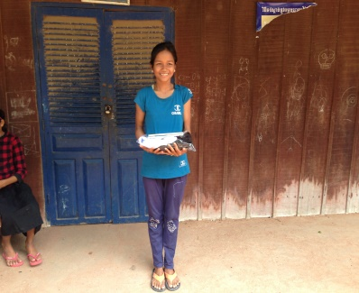
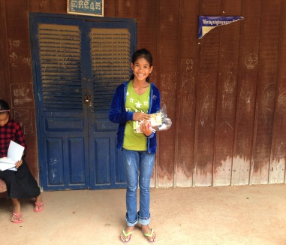
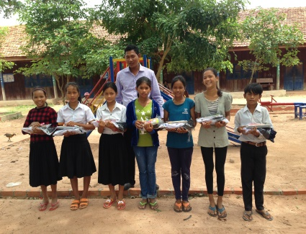

- Seventh Project
February, 2016: donation of 3 computers to Meas Sophea Baneav High School
The seventh project of The Chelly Foundation was a separate donation of 3 computers to Mea Sophea Baneav High School, located in Baneav village, Chuk District, Kampot province (a “magnet” school). Currently the computers are used to train high school students how to use Microsoft Word and Excel. The training program is set up by the principal in order to build up their basic knowledge before they start university. Beside the training program, the teacher also allows students to conduct their research for learning. All computers provide Internet access for students’ learning. The computer training program is the first program to be set up at this public school. I very much appreciate the principal setting up this program for grade 12 students. Technology is very important for students.
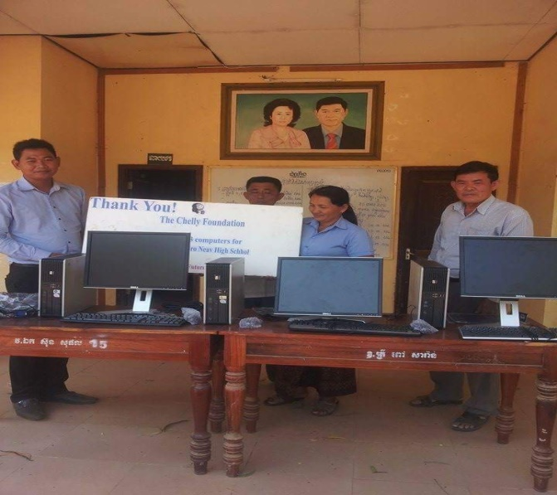
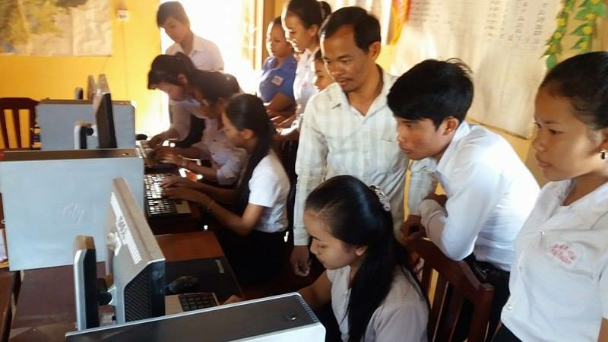

- Eighth Project
August, 2016, donation of bathroom facilities
The Chelly Foundation has constructed 4 toilets at Hun Sen Prey Khlay High School, located in Prey Khlay Commune, Chumkiri District. After visiting several times at school, I found that none of the students at the school had access to toilets and so were having difficulties with hygiene. As there was no toilet in the school, they have to go back home or go behind the bush. This causes difficulty especially for girl students who live very far away from school. I went to meet the principal, and he expressed his real concerns with this issue. He said that it is not safe for girl students far away from school. Currently, the bathroom’s construction is done, and the toilets will be allowed for use for all students for the new academic year.
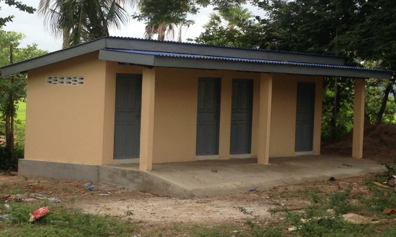
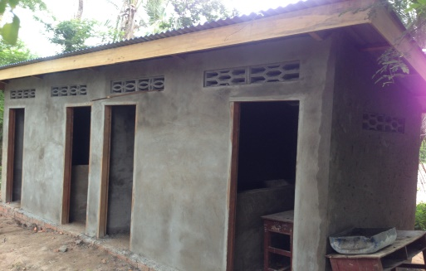
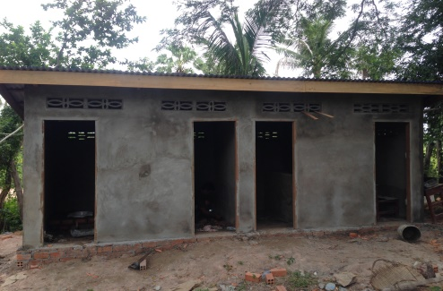

Bathroom: Donated by The Chelly Foundation

The Chelly Foundation Fun Activity: Field Trip to Angkor Wat Temple.
On 31 August, 2016 – 1 September, 2016, The Chelly Foundation organized the field trip for 23 older people to visit Angkor Wat Temple located in Siem Reap province. It was a remarkable activity for those elders from my home village. None of them had been to the temple before. We ended up taking them to different temples in the Angkor area. They were so excited. During the trip, The Chelly Foundation also gave them gifts such as scarves, shoes, and a souvenir photo with frame. They all pay their very deepest thanks to The Chelly Foundation that helped make their dreams become true.
