Organisation Profile

Organisation Name: YOUTH FOR SOCIAL DEVELOPMENT (YSD)
About YSD: Youth for Social Development (YSD) is a not-for-profit independent social research and development organisation aspiring to improve the lives of urban and rural poor in Odisha specifically the most vulnerable people, children, youth and women on issues related to governance, participation, youth and child development and climate change since 2006.
Our Vision: YSD envisions a just, equitable and sustainable society where all people have access to their social, economic and democratic rights and the capacity to achieve their full potential and lead a dignified life.

Our Mission: To facilitate sustainable social and economic development of marginalized communities in urban and rural Odisha through research, policy advocacy, participatory community action and people’s empowerment.

Founded Year: 2005
Address: YSD, 6th Medical Bank Colony, Bapuji Nagar, BERHAMPUR-760 004, Ganjam, Odisha, India
Contact Details: Tel: +91-680-3205464/2283398, E-mail: ysdbam@gmail.com / info@ysdindia.org , website: www.ysdindia.org
Chief Functionary: Mr. Bibhu Prasad Sahu, Secretary, Mobile: +91-9937190060,
E-mail: bibhu@ysdindia.org
Registration: Societies Registration Act, 1860, Regd. No: GJM No. 7422/61 of 2005-2006 dated 17th February 2006
Details of FCRA: Foreign Contribution Regulation Act. 1976, Regd. No: 104910159
Tax Exemption: Registered under 12AA Income Tax, 1961, Regd. No: 28/2010-11
PAN No. AAAAY0652P
TAN No. BBNY00029B
Awards & Recognition: Winner, India NGO Award, 2010 (East)
Accredited to Credibility Alliance, New Delhi
Winner e-NGO Challenge Ward (South Asia), 2014 (Advocacy Category)
Winner of Youth4Asia Solution Search Award, 2016 by Asian Development Bank

Thematic Intervention:

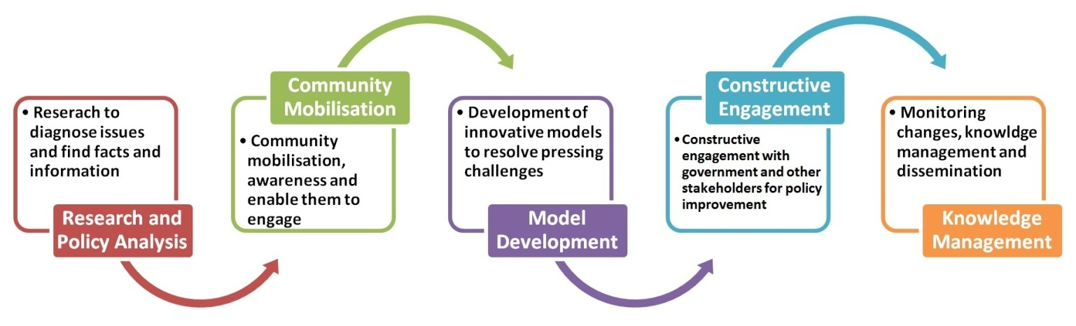
Theory of Change

