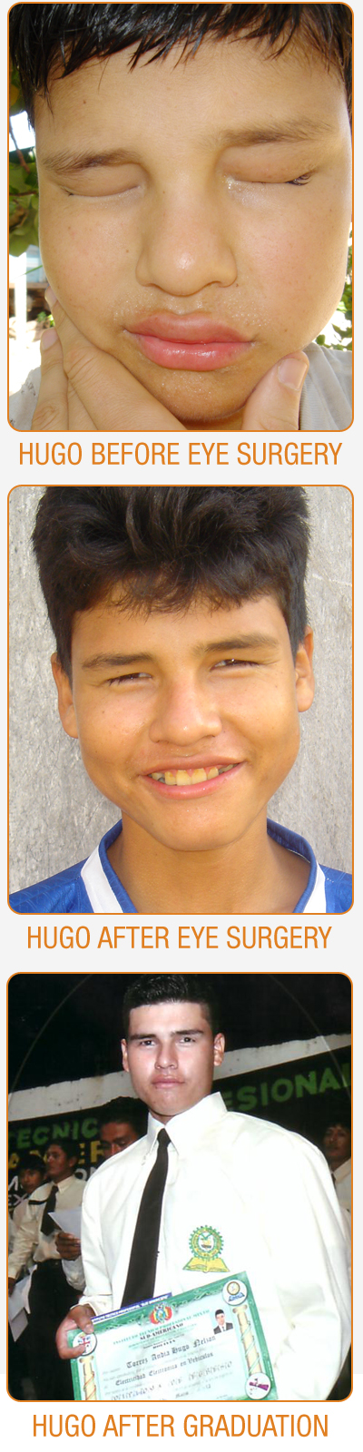
March 31, 2013

Name/Address of Supporter

Dear :

On behalf of Drs. Jonathan and Darlene Melk and the families we work with in Bolivia, thank you for your generous donation of $50, made in March 2013 in honor of Jon and Darlene’s marriage and dedicated to the opening of La Escuelita. The Rosa Vera Fund had a great year. Some of the highlights are:

- We are more than ½ way to raising the funding needed for a specialized hearing aid implant for 12 year-old Maria, an orphan who we've been supporting for the past five years. Maria’s hearing loss is complicated (she was born without an ear canal), but with the right sort of hearing aid, she will be able to hear. She is so excited and asks all the time when it is her turn to get her hearing aid.

- Hugo made it! A few years ago, Hugo was nearly blind due to a condition called trichiasis, which causes the eyelashes to grow inward. After two simple operations totaling less than $260, Hugo's sight was restored, he quickly caught up in school, and applied for one of our educational scholarships to become a mechanic. He graduated, is able to support his siblings, and hopes to open his own shop. With the help of our donors Hugo has been able to break free of crushing poverty.

These are just two of the amazing cases that the RVF worked on this year. If you check out our website (www.RosaVeraFund.org) you will see the actual faces of the women and children we work with. Many of the children would not be alive today without your support. For that, we thank you!

Unlike almost any other nonprofit out there, we can honestly say that 100% of our donations are used for the families - not one penny is taken out for administrative expenses. You can be sure that your donation really counts.

Finally, please feel free :] to recommend the RVF to any of your friends who might be interested. We have found word-of-mouth recommendations to be the most effective way to increase our base of supporters. Thanks!

Sincerely,
Karen M. Melk
Secretary, Rosa Vera Fund

For your tax purposes, this receipt serves as our official acknowledgment of your contribution, in accordance with section 170(f)(8) of the Internal Revenue Code. The Rosa Vera Fund did not provide any goods or services in whole or partial consideration for this contribution. Thank you again for your support. (EIN 33-1209818)

