Afforestation campaign a measure to rescue Balaka district from deforestation
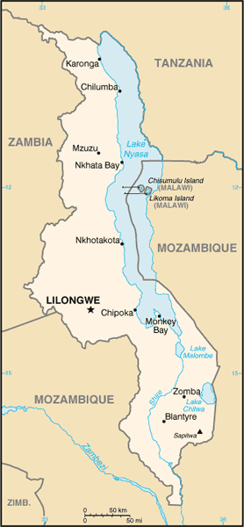
Malawi is a landlocked country in south-eastern Africa, bordered by Tanzania, Zambia, and Mozambique. Malawi is 118,000km², but one fifth of the country is made up of Lake Malawi, so actual land area is 94,080km². The Great Rift Valley runs through the country from north to south, and Lake Malawi lies to the east. Land is made up of mountains, plateaux, hills, valleys, flatlands, and lakeshore. Three-fourths of estimated Malawi’s 15 million people rely on smallholder agriculture for their livelihoods. Increasing population has accelerated deforestation which has resulted into poor soil and water management, and increasing poverty and land degradation. This has directly impacted crop production and reduced food security and human health of millions of Malawians
Since the late 1970s, growing concerns have also been expressed about the “energy” or “fuelwood” crisis caused by tobacco production, with emphasis being placed on deforestation caused by the outstanding rate of soil nutrient depletion and considerable usage of wood.

Tobacco production is considered to pose “a particularly difficult dilemma for development,” as it generates a range of employment, income, foreign exchange, and other cash-contributing effects, while “the damage to public health and to the environment in the long term appears substantially to outweigh the benefits.

Among the underlying causes of tobacco-related deforestation include the usage of wood in the farm-based process of curing the crop that is, drying the leaves and the global shift of production into low-cost producer countries of the developing world which typically have fragile natural environments.

Tobacco farming requires substantial amounts of wood for a variety of purposes, such as curing, and poles and sticks for barn construction.

Despite the government’s efforts in dealing with deforestation increased population growth has also increased the rampant of deforestation as charcoal is the only source of energy.

Who are we: Philadephia Foundation is a local established community based non-profit organization working for the course of weaker community in providing support to the local hard to reach Malawians in finding sustainable solutions to their problems and improve their living standards.

Our registration number is R.G. 20754/IM/5.2005 and our certificate of incorporation number is TR/INC 6397. Malawi government embarked on the national decentralisation programme in 1999 after the adoption of the policy and the enactment of the local government act in 1998. The policy aims at enhancing community participation in governance and development by devolving political, fiscal and administrative authority to the District council. The act and policy empower local authorities to plan and execute their own development activities. The Malawi Growth and Development Strategy (MDGS) as a national development policy document provide the national framework for the development of the District development plan.

Balaka district development plan was prepared to guide public, non-governmental organisation, private and other developmental partners in achieving its goals.

Mission statement

Philadephia Foundation serves to inspire and empower the needy hard to reach communities and support them to find lasting solutions to alleviate poverty, human health, social injustice and improve their social status and living standards.

Vision
Striving to find lasting solutions to improve living standards of the local hard to reach people

Core values

Accountability
We take personal responsibility for using our resources efficiently, achieving measurable results and being accountable to every resource under our custody.

Ambition
We are demanding of ourselves and our colleagues, set high goals and are committed to improving the quality of everything we do for the needy hard to reach communities.

Collaboration
We respect and value each other, thrive on our diversity and work with partners to leverage our global strength in making a difference for needy Malawians

Creativity
We are open to new ideas, embrace change and take disciplined risks to develop sustainable solutions for the needy hard to reach people

Integrity
We aspire to live to the highest standards of personal integrity and behaviour; we never compromise our reputation and always act in the best interests of the needy.

Philadephia Objectives
- To improve the health status of the hard to reach people by increasing awareness, support access to quality health services.

- To support in establishment of sustainable livelihood programs and support them improve on the already existing skills and provision of information to enable access to credit and market as a way of reducing poverty.

- To support global warming initiatives by encouraging sustainable promotion of climate and environment by sound practices on agro forestry , planting of trees and proper waste management.

- To empower Women, Girls and under privileged through education and provision of sustainable income generating activities.

- To support farmers in acquiring skills and resources that will boost their production.

- To support the local community in understanding issues of human rights and enable them take their roles and rights responsibly.

- To support in provision of good clean water and improved sanitation.

Philadephia Foundation Organogram

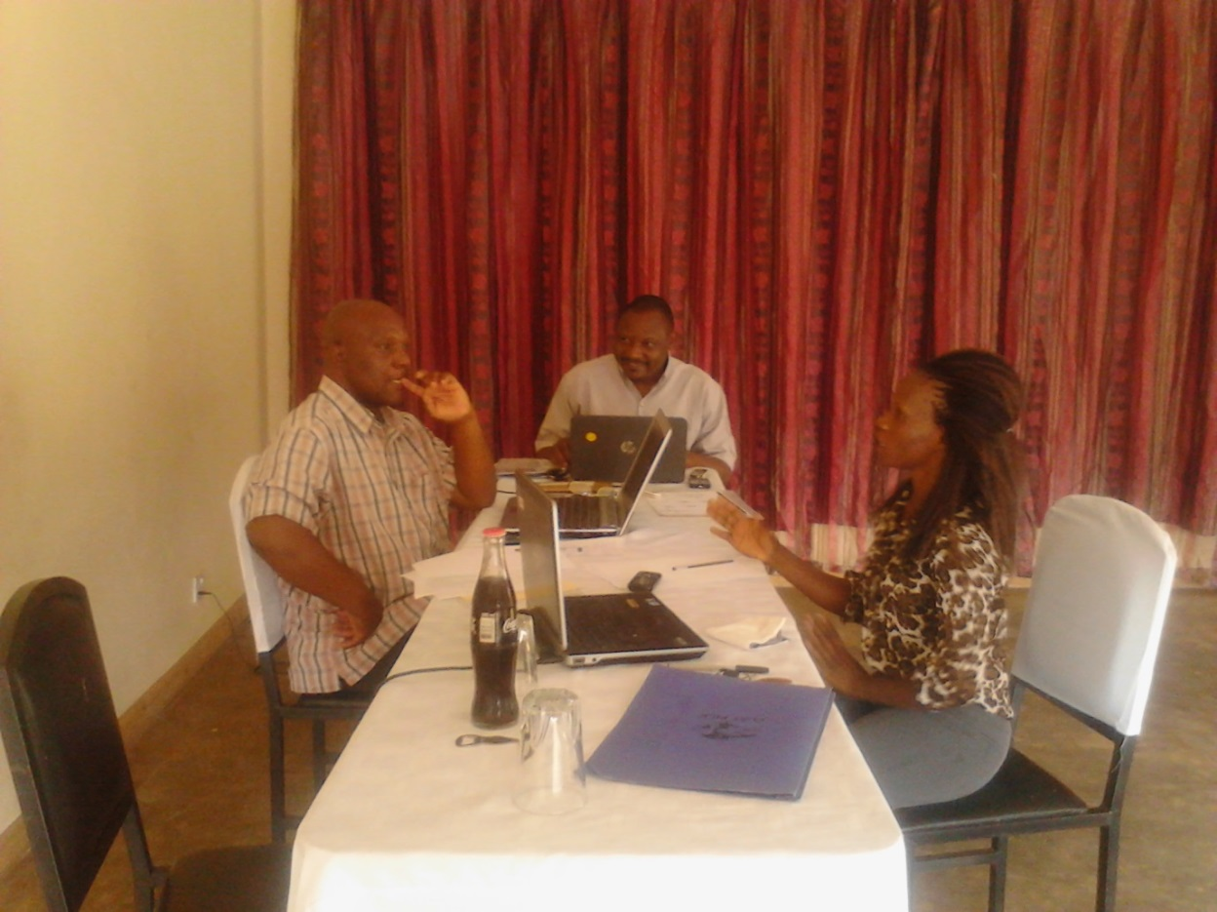
Executive Director, Project Manager & Programme Manager

Location:

Philadephia Foundation is located at a remote area of Balaka called Mfulanjobvu in Eastern Region of Malawi. The area has population of not less than fifteen thousand people most of them leaving below poverty line.

People of this area are of different cultures. This makes it difficult for them to accommodate their views and do things together. Facing current challenges, we need to share the knowledge and importance of living without discrimination.

Philadephia has seven core areas of interests namely:-

Food Security

The main aim is to ensure that the community has enough food and sustainable means of getting food

Health

Ensure that community has access to health information and is living free from preventable diseases and at least have access to health services

Environment

Ensuring community to understand the importance of living in a conducive environment where they have basic need and sensitise them on global warming and climate change.

Human Rights

Ensure that the community knows their rights particularly this time when Albinism is at a threat in Malawi.

Livelihood

Ensuring that the community is having income generating activities and sustainable means of getting basic needs in their lives.

Education/Youth Development

Ensure that all children are going to school. Offer assistant to orphans and less privileged children in order for them to complete school. Support the youth in having information that will lead them to be responsible future leaders.

Water and Sanitation

Ensure that the community has good clean, safe water and good sanitation for a healthy living.

Project Justification
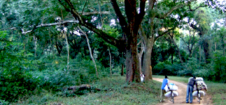
Malawi has a sub-tropical climate, and experiences a rainy season from December to March, a cold dry
Malawi had big trees like this

season from April to August, and a hot dry season from September to November.

Malawi had big forest at Chikangawa, Dedza, Zomba and Dzalanyama which used to have big ever green trees. A number of National parks and game reserves were adding to the beauty of the land.

Deforestaration has massive effects on the steep slopes and along the valleys of a range of mountains. This has contributed to climate change. The rain pattern has changed and floods cause much damage as there are no trees to reduce soil erosions.

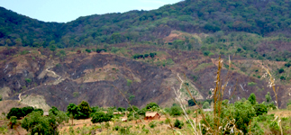
Malawi was previously heavily forested. However, according to the Food and Agriculture Organization of the United Nations (FAO), forest cover is now just 27.2% of the total land area of Malawi. The Southern Region, where Balaka is located is heavily populated and deforestation is rampant.

The challenge for Malawi for the future, with its rapidly growing population, is to help communities to develop a more sustainable approach to the environment.
Deforestation in the steep slopes

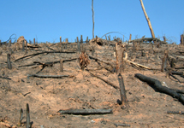
Nearly all these large hardwood trees have been cut down for charcoal, timber and firewood. Once trees have been cut down and burnt, the soil is exposed to erosion from the rain.

Match of the country was originally covered by forest but, over the years, people have been cutting down trees and burning them where they fail to open up areas for farming — this is commonly known as “slash and burn” agriculture. In the past, these areas were farmed for one to three years, and then the farmer would move on, cut down some more forest, and start all over again. Whilst the population of Malawi was small, the environment was able to recover as the trees would regenerate but now, with the population doubling every 25 years (in July 2011, the population of Malawi is estimated to be 15 million — see Malawi Facts and Figures), there is increased pressure on available land. Today, more than 80% of Malawians live in the rural areas and are subsistence farmers.
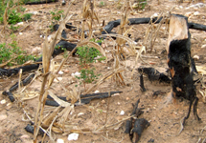
Often the land on the steep slopes is very marginal and produces poor crops

During President Hastings (Kamuzu) Banda’s time in office following Malawi’s independence from Britain in 1964 until 1994, the forests in Malawi were protected. However, with the arrival of multi-party politics and democracy in 1994, the people believed that they had the freedom to do what they liked, and huge areas of forest have been cut down in the past 17 years to provide more farmland to produce food. The result is that much of the country has very few forests left and, in fact, it is not possible to see a large tree in many places in south and central Malawi.

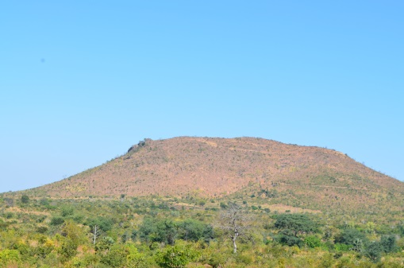
In Balaka district, the area in which Philadephia Foundation is working, had big forests but has disappeared very quickly because of its dense population and people from other areas of Malawi are also moving into the area cutting down trees illegally for charcoal. The deforestation in the hills is causing a major change to the landscape and to the climate. As soon as the trees are cut down, soil is exposed to rain and, in many places, most of top soil is washed away into rivers and eventually into Lake Malawi. This is leaving hills infertile so that trees and crops do not grow well, and the soil that is being deposited in the lake is affecting fish stocks which, together with over-fishing, is causing a dramatic reduction in the number of fish that are being caught in lake Malawi as well
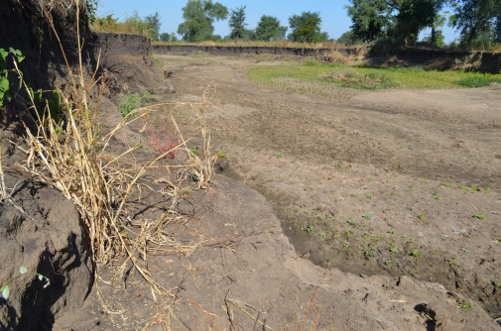
The eroded soil washes down the rivers and eventually into the lake. This carries away with it all the fertile soils into the lake as well and leaves the bare ground with gullies
This is an example of gully erosion due to deforestation

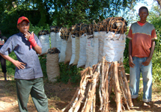
Wood is the main fuel in Malawi, and 95% of homes still use wood or charcoal for cooking. Nearly everybody uses three-stone fires for cooking, and each fire consumes about three large bundles (weighing about 30kg each) of wood per week. In many areas, wood is now becoming very scarce. Although the government has a number of laws to restrict the sale of wood and charcoal without a licence, the practice is very common throughout the country. The use of charcoal for cooking is more common in the major towns, but charcoal production and the sale of charcoal is illegal. However, despite this, the people in rural areas produce many bags of charcoal which are transported to towns. This fuel is incredibly wasteful as it uses a considerable number of trees to produce one bag of charcoal.

Most houses in Malawi are made from bricks, and these are commonly made by putting clay soil into moulds and then drying them in the sun. These sun-dried bricks are then built into a large kiln and vast amounts of wood are used to fire them. In October/November, it is normal to see people burning their bricks all over the country, but there is no restriction on this activity at the moment. To make enough bricks for a small family house would require three large mango trees or the equivalent.
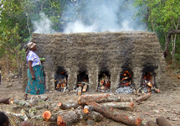
Brick kiln, which is burnt for 24 hours, uses three large trees to fire enough bricks for one small house
Sawyers cut down hardwood trees in the forest, usually without permission There is now very little hardwood available in Malawi for timber production. Sawyers walk up into the hills and cut down the best hardwood trees to make planks for building and for furniture.

Although wood is such an important resource in Malawi, the Malawians have been very poor at managing their woodland and replanting their trees.

Methodology

Afforestation practices shall be incorporated in the traditional farming systems and thus into existing deforested land. History has shown that most organization have been planting trees in the district but sustainability hasn’t been achieved as it is found that these trees are either not cared for and die or uprooted.

Philadephia shall use another approach of involving local people who shall be sensitized on effects of deforestation and importance of afforestation and incentives shall be given to every surviving tree by the end of each year. This shall act as a motivation for the farmers. Fast-growing multipurpose trees shall be planted to become part of a diverse and more stable means of afforestation.

The project will buy tree seedlings and distribute them to farmers and other local people. Demonstration plots on the practice of conservation of trees shall be established on farmers’ plots. These shall be used to:

1. Raise awareness on the potentials of conservation forests as a sustainable option.

2. Show that conservation of trees can be used to increase the resilience of small scale farmers to changing climatic conditions

3. Show that using afforestation can improve the climate change by reducing floods and droughts and in the long run increase and maintain agricultural yields without the need to move from place to place;

4. Show that afforestation can make farmland previously considered as degraded or impoverished to be highly fertile.

5. Farmers shall be given incentives for any sustained tree after every year for five years. This shall be in form of money.

Expected results at the end of the project:

Our project area called Mphenzi shall have all its unused land afforested

Activities

To arrive at the above results the following activities shall be undertaken.

- Sensitize key stake holders (farmers and extension worker) operating in Balaka District on the root causes and adverse effects of deforestation soil degradation on farm productivity and the environment
- Provide tree seedlings to farmers and local people for planting in all bare grounds

Sustainability
Trees shall be

Monitoring and Evaluation

The Project M & E officer shall monitor progress of the project by conducting review meetings throughout the implementation period and shall keep records at all times.
The impact of the project shall be assessed during evaluation through assessment of the each house hold wood lot.

Reports shall be submitted to the trustees and the donor.
After completion of the project a financial report shall submitted to the donor highlighting successes and challenges.

