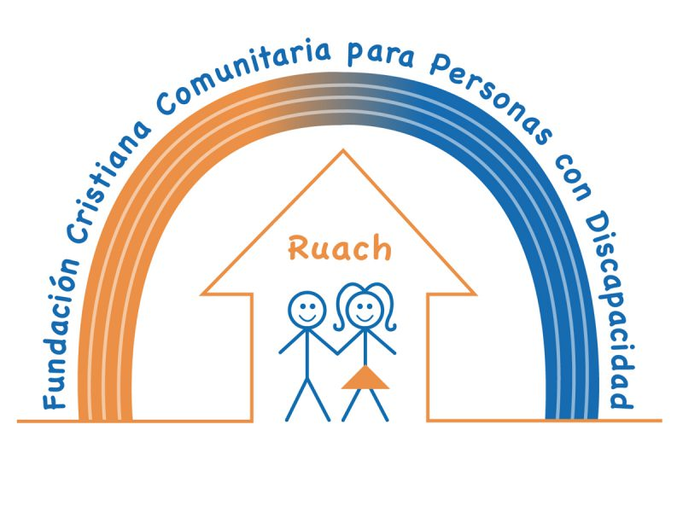
The Christian Community Foundation for Persons with Disabilities Ruach wants to thank you.
Give and you will have plenty. -Lao Tse
You supported us this year and therefore you are part of our team. Together we are working to improve the rights of people with intellectual disabilities over 15 years in Juigalpa, Nicaragua. We are raising awareness of the talents these people have and with this we are building a better world for everyone. We achieved many goals this year. Thank you for your help!
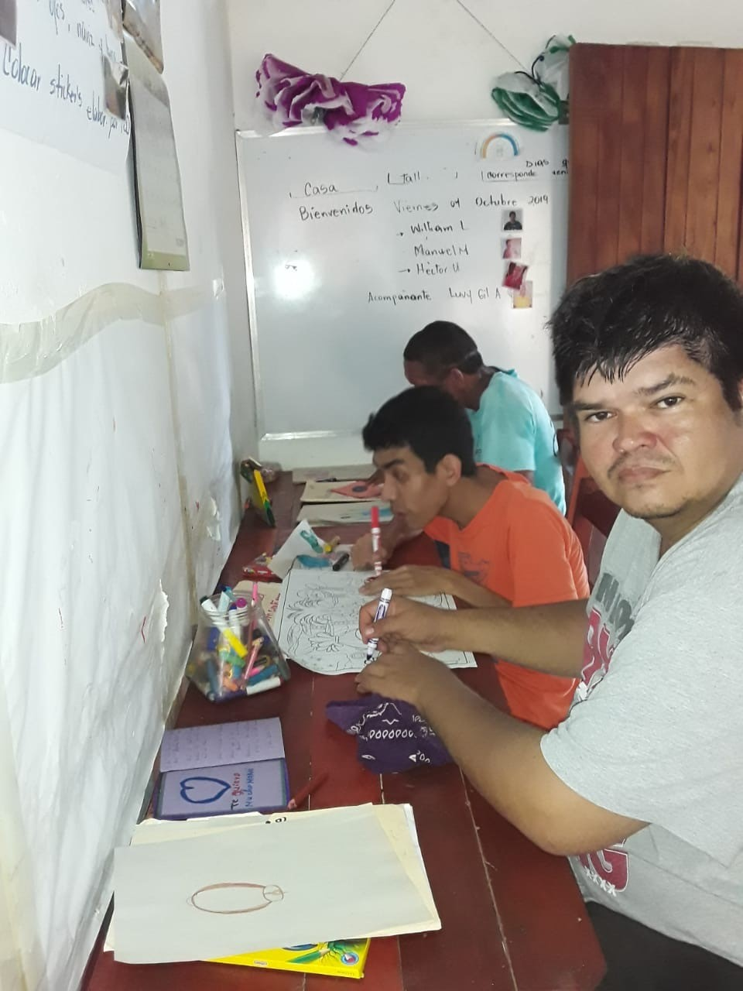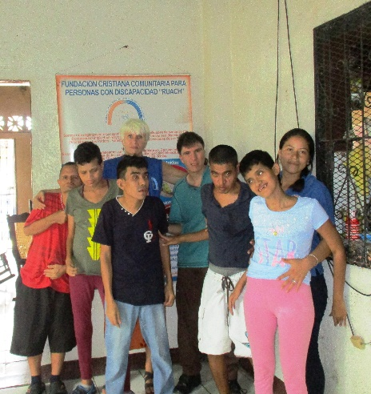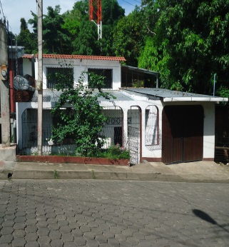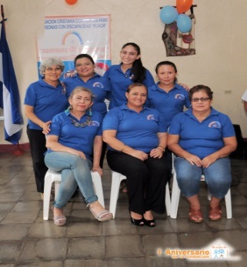
Together we can make a difference. This is a fact.
Can we count on you in 2020?
We send you all our love this Christmas and blessings for the New Year

