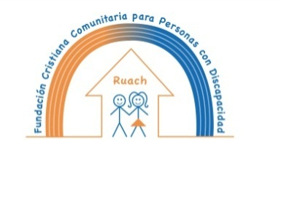
“ La Fundación Cristiana Comunitaria para personas con discapacidad Ruach”
will let you know: Thank you!

Unity is power. Together we are making a difference.
Thanks of being part of our work!

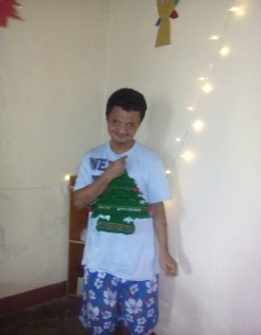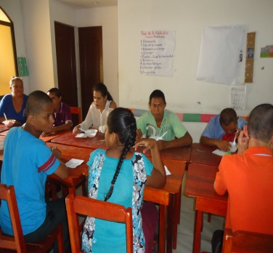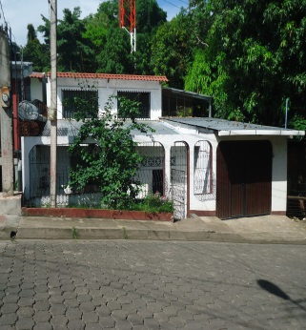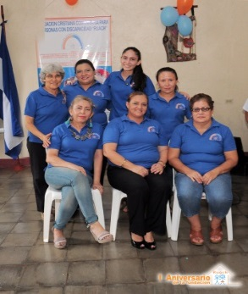
If our work inspires more and more people, we will be able to make more progress in
contributing to a better world, not only for intellectually disabled persons, but for every one.
Can we count on you in 2018?

Merry Christmas and a happy New Year!

